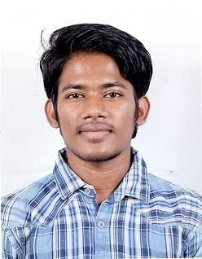**AMIT KUMAR SAHNI**

Email – sahniamitkumar2017@gmail.com

Mob – 9677205952

# CAREER OBJECTIVE

To use and enhance my knowledge for the development of company and for myself.

# EDUCATIONAL QUALIFICATION

|  |  |  |  |  |
| --- | --- | --- | --- | --- |
| **Qualification** | **Name of school / College** | **Board / University** | **Percentage/ CGPA** | **Year of passing** |
| B.Tech (CSE) | SRM Institute Of Science and Technology, Chennai, Tamil Nadu | SRM UNIVERSITY | 80.17% | 2021 |
| 12th | Sri Chaitanya Vidya Niketan, Visakhapatnam, Andhra Pradesh | CBSE | 84.20% | 2015 |
| 10th | Sri Sathya Sai Vidhyapeeth, Sri Sailam, Kerala | CBSE | 9.4 | 2013 |

**TECHNICAL SKILLS**

C++, Data Structures & Algorithm

# PERSONAL DETAILS

Father’s name: Bindeshwar sahni

Permanent address: Near Hanuman Mandir, Mohallah – Madarpur, Maulaganj.

District - Darbhanga. P.O.- Lalbagh, 846004. Bihar

Date of birth: 24/10/1997

Linguistic proficiency: English & Hindi