MA 226
Monte Carlo Simulation

Assignment - 2
(18-01-2013)

AMIT MITTAL

(Roll No.: 11012304)
Department of Mathematics
Indian Institute of Technology Guwahati

Assignment

All the following problems are for the following general linear congruence generator :

- Generate the sequence of numbers for and ranging from 0 to 10. Also, generate the sequence of numbers for and ranging from 0 to 10. Observe the sequence of numbers generated and observe the repetition of values. Tabulate these for each group of values. How many distinct values are appearing before repetitions? Which, in your view, are the best choices and why?
(Use only C or C++ code)

- Generate a sequence with (take as per your choice). Try to group the values in the ranges and see their frequencies (i.e. the number of values falling in a group). For at least 5 different values of the number of values generated, tabulate the frequencies in each case, draw bar diagrams of these data and put in your observations.
(Use both R and C / C ++ code)

- Generate a sequence with . Plot in a two-dimensional graph the points i.e., the points What are your observations?

Question-I

All the following problems are for the following general linear congruence generator :
x_{i+1} = (a*x_{i} + b) mod m
u_{i+1} = x_{i+1} /m
Generate the sequence of numbers x_{i} for a = 6, b = 0, m = 11 and x₀ ranging from
0 to 10. Also, generate the sequence of numbers x_{i} for a = 3, b = 0, m = 11, and
x₀ ranging from 0 to 10. Observe the sequence of numbers generated and observe the repetition of values. Tabulate these for each group of values. How many distinct values
are appearing before repetitions? Which, in your view, are the best choices and why?

C++ CODE :
#include <iostream>
#include <cstdio>

using namespace std;

double func_rand(int x, int M){
return (double)x/M;
}

int func_val(int prev, int A, int B, int M){
int next;
next = ((A*prev) + B)%M;

return next;
}

int main(){
int init, val;

for(init = 0 ; init < 11 ; ++init){
val=init;
printf("x%d=%d\t",init, init);
do{
printf("%d\t", val);
val = func_val(val, 6, 0, 11);
}while(val!=init);
printf("%d\n", init);
}
printf("\n");

for(init = 0 ; init < 11 ; ++init){
val=init;

printf("x%d=%d\t",init, init);
do{
printf("%d\t", val);
val = func_val(val, 3, 0, 11);
}while(val!=init);

printf("%d\n", init);
}
return 0;
}
OUTPUT
a=6 , b=0 , m=11:
X_{i} | X₁ | X₂ | X₃ | X₄ | X₅ | X₆ | X₇ | X₈ | X₉ | X₁₀
X₀
X₀=0 | 0
X₀=1 | 1 | 6 | 3 | 7 | 9 | 10 | 5 | 8 | 4 | 2
X₀=2 | 2 | 1 | 6 | 3 | 7 | 9 | 10 | 5 | 8 | 4
X₀=3 | 3 | 7 | 9 | 10 | 5 | 8 | 4 | 2 | 1 | 6
X₀=4 | 4 | 2 | 1 | 6 | 3 | 7 | 9 | 10 | 5 | 8
X₀=5 | 5 | 8 | 4 | 2 | 1 | 6 | 3 | 7 | 9 | 10
X₀=6 | 6 | 3 | 7 | 9 | 10 | 5 | 8 | 4 | 2 | 1
X₀=7 | 7 | 9 | 10 | 5 | 8 | 4 | 2 | 1 | 6 | 3
X₀=8 | 8 | 4 | 2 | 1 | 6 | 3 | 7 | 9 | 10 | 5
X₀=9 | 9 | 10 | 5 | 8 | 4 | 2 | 1 | 6 | 3 | 7
X₀ 10 | 10 | 5 | 8 | 4 | 2 | 1 | 6 | 3 | 7 | 9

a=3 , b=0 , m=11:
X_{i} | X₁ | X₂ | X₃ | X₄ | X₅
X₀
X₀=0 | 0
X₀=1 | 1 | 3 | 9 | 5 | 4
X₀=2 | 2 | 6 | 7 | 10 | 8
X₀=3 | 3 | 9 | 5 | 4 | 1
X₀=4 | 4 | 1 | 3 | 9 | 5
X₀=5 | 5 | 4 | 1 | 3 | 9
X₀=6 | 6 | 7 | 10 | 8 | 2
X₀=7 | 7 | 10 | 8 | 2 | 6
X₀=8 | 8 | 2 | 6 | 7 | 10
X₀=9 | 9 | 5 | 4 | 1 | 3
X₀ 10 | 10 | 8 | 2 | 6 | 7
OBSERVATIONS

For and the value of x₀ = 0, the period is 1 i.e. always remain 0. And for each x₀ varying from 1 to 10, the period is 10 i.e. there are 10 distinct values in the sequence after which the sequence starts repeating.

And for and the value of x₀ = 0, the period is 1 i.e. always remain 0. And for each x₀ varying from 1 to 10, the period is 5 i.e. there are 5 distinct values in the sequence after which the sequence starts repeating.

RESULT

For the case when more random values are generated and also they are more uniformly distributed, therefore it is the better choice.

QUESTION-II

Generate a sequence u_{i} with m = 244944, a = 1597, 51749 (take x₀ as per your choice). Try to group the values in the ranges 0 - 0.05, 0.05 - 0.10, 0.10 - 0.15, ... and see their frequencies (i.e. the number of values falling in a group). For at least 5 different values
of the number of values generated, tabulate the frequencies in each case, draw bar diagrams of these data and put in your observations. (Use both R and C / C ++ code)

C++ CODE :

#include <iostream>
#include <cstdio>

#define LL long long

using namespace std;

double func_rand(LL int val, LL int m){
return (double)val/m;
}

LL int func_val(LL int val, LL int a, LL int b, LL int m){
LL next_val;
next_val = ((a * val) + b) % m;

return next_val;
}

void function(LL int initial, LL int a, LL int b, LL int m, int end){
LL int val, count = 0, array[20] = {0};
int index, quot;
double random;

val = initial;
random = func_rand(val, m);

while(count<end){
val = func_val(val, a, b, m);
random = func_rand(val, m);

quot = random/0.05;
array[quot]++;
++count;
}

for(index = 0 ; index<20 ; ++index){
printf("%lf - %lf\t%lld\n", 0.05*index, 0.05*(index+1), array[index]);
}
}

int main(){
LL int index, a[5] = {100, 1000, 2000, 4000, 5000};
LL int init_values[5] = {5, 73, 128, 23451, 2341};
LL int bound = 1000;

for(index = 0; index<5; ++index){
printf("x0=%lld\n", init_values[index]);
function(init_values[index], 1597, 0, 244944, bound);
cout<<endl;
}

cout<<"x0 = "<<init_values[4]<<endl;
for(index = 0; index < 5; ++index){
printf("Bound = %lld\n", a[index]);
function(init_values[4], 1597, 0, 244944, a[index]);
printf("\n");
}

printf("\n\n\n");

for(index = 0; index<5; ++index){
printf("x0=%lld\n", init_values[index]);
function(init_values[index], 51749, 0, 244944, bound);
cout<<endl;
}

cout<<"x0 = "<<init_values[4]<<endl;
for(index = 0; index < 5; ++index){
printf("Bound = %lld\n", a[index]);
function(init_values[4], 51749, 0, 244944, a[index]);
printf("\n");
}

return 0;
}

R CODE :

func_rand <- function(val, m){
return(val/m);
}

func_val <- function(val, a, b, m){
return(((a*val)+b)%%m);
}

func <- function(initial, a, b, m, end){
count<-1;
arr<-array(20);
tab<-array();

for(i in 1:20)
{
arr[i]=0
}

val <- initial;
random <- func_rand(val, m);

while(count<=end){
val <- func_val(val, a, b, m);
random <- func_rand(val, m);

tab[count] = random;

quot <- round(random/0.05);

arr[quot] <- arr[quot] + 1;
count <- count+1;
}

max<-0;
for(i in 1:20){
cat(sprintf("arr[%d]\t%d\n", i, arr[i]));

if(arr[i]>max){
max=arr[i];
}
}

bins<-seq(0, 1, by=0.05);
hist(tab, bins,freq = TRUE, include.lowest = TRUE, right = TRUE, density = NULL,
angle = 45, col = '#1E90FF', border = NULL,
main = paste("Histogram of frequencies for\nxo=", initial, " and total values
generated=",end), xlim=range(0,1), ylim=range(0,(max+15)), xlab = arr ,
axes = TRUE, plot = TRUE, labels = FALSE);

dev.copy(jpeg,paste('a=',a,'x0=',initial,'bound=',end,sep="",".jpg"));
dev.off();
}

main <- function(){
a<-c(100, 1000, 2000, 4000, 5000);
init_values<-c(5, 73, 128, 23451, 2341);
bound<-1000;

for(index in 1:5){
func(init_values[index], 1597, 0, 244944, bound);
}

for(index in 1:5){
func(init_values[4], 1597, 0, 244944, a[index]);
}

cat("\n\n\n");

for(index in 1:5){
func(init_values[index], 51749, 0, 244944, bound);
}

for(index in 1:5){
func(init_values[4], 51749, 0, 244944, a[index]);
}
}

OUTPUT

Frequency table for :

X₀ | X₀ = 5 | X₀=73 | X₀=128 | X₀=23451 | X₀=2341
Intervals
(0.00-0.05) | 40 | 38 | 50 | 49 | 56
(0.05-0.10) | 46 | 55 | 53 | 52 | 46
(0.10-0.15) | 50 | 49 | 46 | 49 | 45
(0.15-0.20) | 43 | 59 | 45 | 50 | 46
(0.20-0.25) | 54 | 55 | 51 | 48 | 52
(0.25-0.30) | 47 | 43 | 51 | 51 | 56
(0.30-0.35) | 51 | 50 | 53 | 53 | 57
(0.35-0.40) | 50 | 57 | 49 | 51 | 46
(0.40-0.45) | 46 | 44 | 48 | 51 | 56
(0.45-0.50) | 49 | 48 | 55 | 49 | 57
(0.50-0.55) | 63 | 53 | 53 | 50 | 35
(0.55-0.60) | 51 | 48 | 52 | 50 | 57
(0.60-0.65) | 54 | 53 | 51 | 48 | 49
(0.65-0.70) | 58 | 48 | 47 | 50 | 52
(0.70-0.75) | 53 | 47 | 49 | 48 | 47
(0.75-0.80) | 60 | 56 | 46 | 53 | 56
(0.80-0.85) | 52 | 48 | 54 | 50 | 51
(0.85-0.90) | 44 | 42 | 48 | 49 | 57
(0.90-0.95) | 46 | 53 | 53 | 51 | 42
(0.95-1.00) | 43 | 49 | 46 | 48 | 43

Frequency table for

The x₀ I have chosen to fix is x₀=2341
Here N denotes the number of elements the sequence starting with X₀

N | N=100 | N=1000 | N=2000 | N=4000 | N=5000
Intervals
(0.00-0.05) | 7 | 56 | 100 | 209 | 247
(0.05-0.10) | 3 | 46 | 95 | 196 | 248
(0.10-0.15) | 4 | 45 | 96 | 196 | 245
(0.15-0.20) | 5 | 46 | 104 | 196 | 256
(0.20-0.25) | 5 | 52 | 107 | 203 | 257
(0.25-0.30) | 3 | 56 | 96 | 205 | 247
(0.30-0.35) | 3 | 51 | 102 | 201 | 251
(0.35-0.40) | 3 | 46 | 100 | 195 | 253
(0.40-0.45) | 3 | 56 | 101 | 206 | 250
(0.45-0.50) | 5 | 57 | 101 | 205 | 251
(0.50-0.55) | 5 | 35 | 87 | 184 | 238
(0.55-0.60) | 7 | 57 | 107 | 206 | 256
(0.60-0.65) | 9 | 49 | 109 | 197 | 257
(0.65-0.70) | 8 | 52 | 96 | 199 | 247
(0.70-0.75) | 7 | 47 | 95 | 197 | 245
(0.75-0.80) | 3 | 56 | 112 | 202 | 261
(0.80-0.85) | 6 | 51 | 99 | 203 | 250
(0.85-0.90) | 7 | 57 | 103 | 212 | 253
(0.90-0.95) | 6 | 42 | 93 | 193 | 244
(0.95-1.00) | 1 | 43 | 97 | 195 | 244

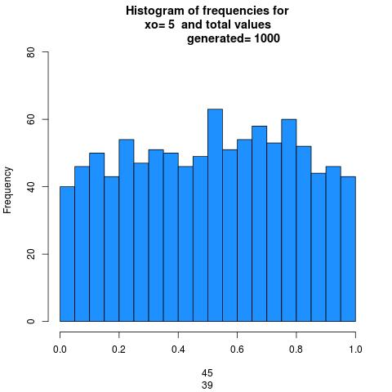
HISTOGRAMS FOR THE FIRST FREQUENCY TABLE:

X₀ =5
a=1597
b=0
m=244944
n=1000

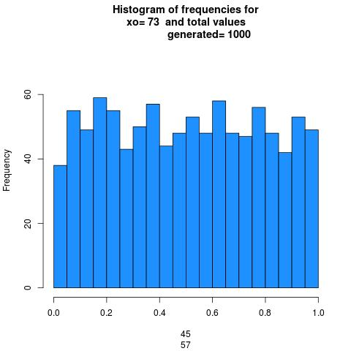

X₀ =73
a=1597
b=0
m=244944
n=1000

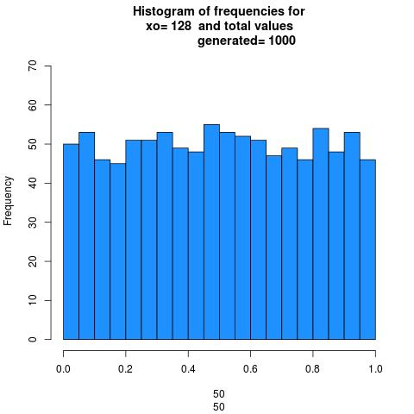

X₀ =128
a=1597
b=0
m=244944
n=1000

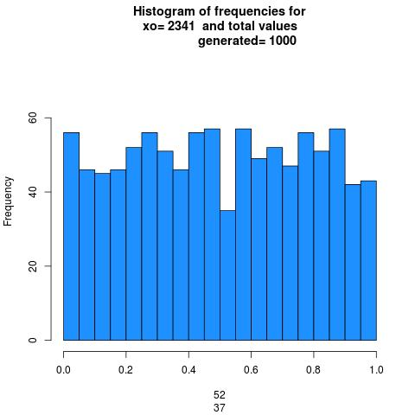

X₀ =2341
a=1597
b=0
m=244944
n=1000

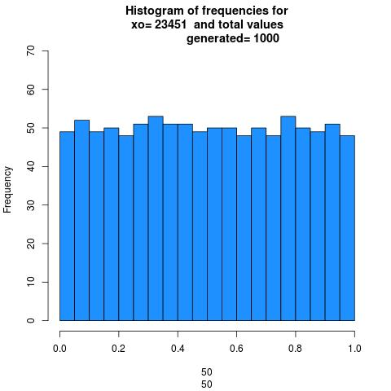

X₀ =23451
a=1597
b=0
m=244944
n=1000

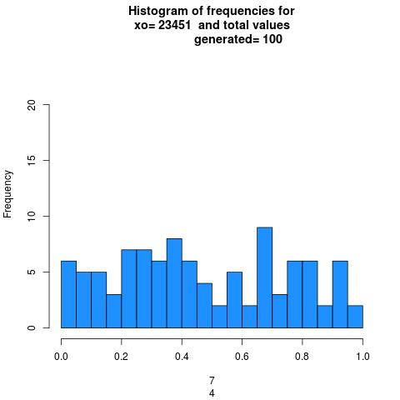
HISTOGRAMS FOR THE SECOND FREQUENCY TABLE:

X₀=23451
a=1597
b=0
m=244944
N=100

X₀=23451
a=1597
b=0
m=244944
N=1000

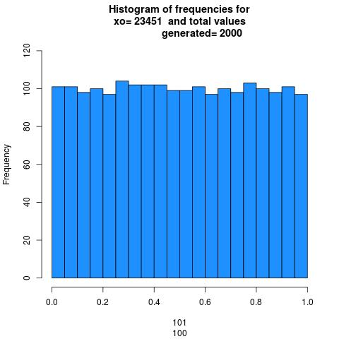
X₀=23451
a=1597
b=0
m=244944
N=2000

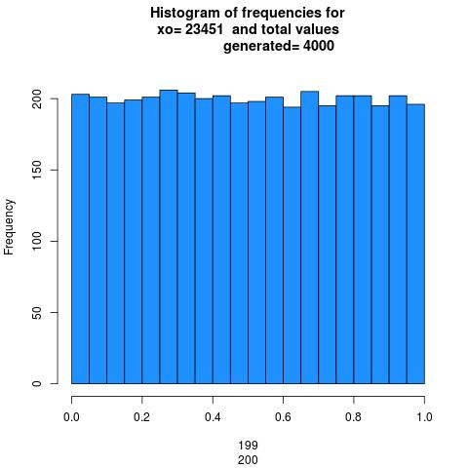

X₀=23451
a=1597
b=0
m=244944
N=4000

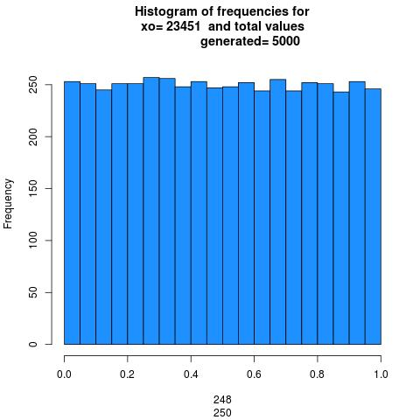

X₀=23451
a=1597
b=0
m=244944
N=5000

OUTPUT

Frequency table for :

X₀ | X₀ = 5 | X₀=73 | X₀=128 | X₀=23451 | X₀=2341
Intervals
(0.00-0.05) | 50 | 53 | 55 | 50 | 52
(0.05-0.10) | 50 | 48 | 51 | 48 | 51
(0.10-0.15) | 49 | 50 | 50 | 52 | 51
(0.15-0.20) | 48 | 49 | 50 | 50 | 48
(0.20-0.25) | 50 | 50 | 49 | 46 | 48
(0.25-0.30) | 50 | 51 | 49 | 56 | 50
(0.30-0.35) | 50 | 50 | 50 | 45 | 50
(0.35-0.40) | 50 | 51 | 49 | 50 | 51
(0.40-0.45) | 52 | 50 | 51 | 52 | 49
(0.45-0.50) | 49 | 48 | 50 | 52 | 50
(0.50-0.55) | 49 | 52 | 50 | 51 | 48
(0.55-0.60) | 49 | 50 | 52 | 49 | 52
(0.60-0.65) | 52 | 52 | 49 | 53 | 50
(0.65-0.70) | 48 | 49 | 48 | 48 | 49
(0.70-0.75) | 51 | 51 | 49 | 47 | 48
(0.75-0.80) | 51 | 48 | 49 | 56 | 52
(0.80-0.85) | 52 | 51 | 50 | 46 | 49
(0.85-0.90) | 51 | 49 | 48 | 48 | 52
(0.90-0.95) | 50 | 49 | 50 | 51 | 49
(0.95-1.00) | 49 | 49 | 51 | 50 | 51

Frequency table for

The x₀ I have chosen to fix is x₀=2341
Here N denotes the number of elements the sequence starting with X₀

N | N=100 | N=1000 | N=2000 | N=4000 | N=5000
Intervals
(0.00-0.05) | 11 | 52 | 102 | 205 | 254
(0.05-0.10) | 15 | 51 | 106 | 211 | 260
(0.10-0.15) | 3 | 51 | 100 | 202 | 255
(0.15-0.20) | 4 | 48 | 99 | 196 | 245
(0.20-0.25) | 3 | 48 | 97 | 196 | 244
(0.25-0.30) | 4 | 50 | 103 | 204 | 255
(0.30-0.35) | 5 | 50 | 99 | 197 | 247
(0.35-0.40) | 5 | 51 | 101 | 201 | 250
(0.40-0.45) | 6 | 49 | 97 | 199 | 248
(0.45-0.50) | 3 | 50 | 100 | 200 | 252
(0.50-0.55) | 4 | 48 | 99 | 196 | 245
(0.55-0.60) | 4 | 52 | 101 | 201 | 251
(0.60-0.65) | 4 | 50 | 100 | 200 | 249
(0.65-0.70) | 3 | 49 | 98 | 198 | 249
(0.70-0.75) | 6 | 48 | 100 | 198 | 246
(0.75-0.80) | 5 | 52 | 103 | 205 | 257
(0.80-0.85) | 4 | 49 | 97 | 196 | 244
(0.85-0.90) | 4 | 52 | 101 | 200 | 252
(0.90-0.95) | 4 | 49 | 97 | 196 | 245
(0.95-1.00) | 3 | 51 | 100 | 199 | 252

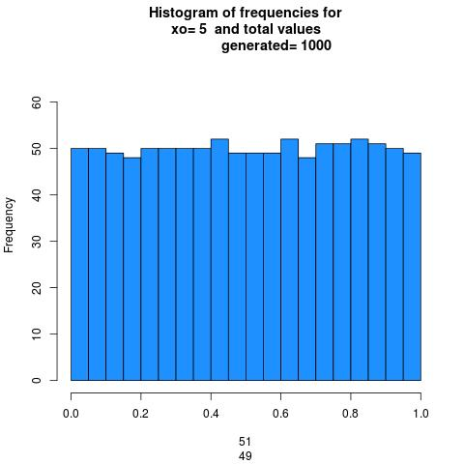
HISTOGRAM FOR THE FIRST FREQUENCY TABLE:

X₀ =5
a=51749
b=0
m=244944
n=1000

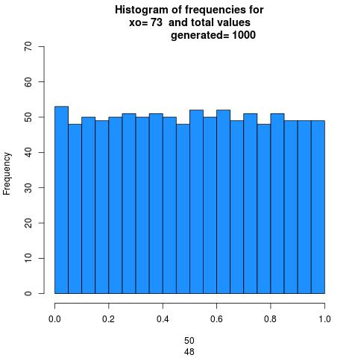

X₀ =73
a=51749
b=0
m=244944
n=1000

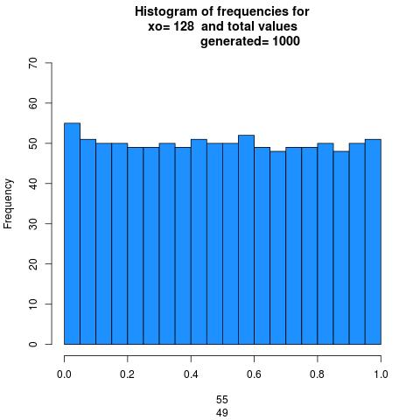

X₀ =128
a=51749
b=0
m=244944
n=1000

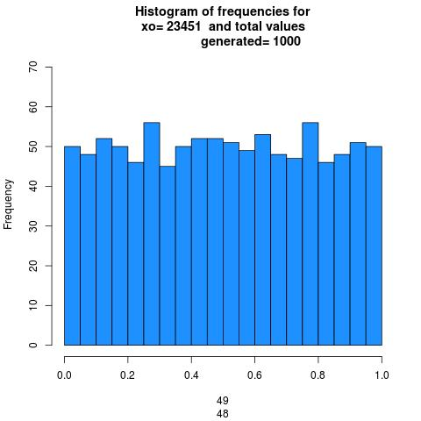

X₀ =23451
a=51749
b=0
m=244944
n=1000

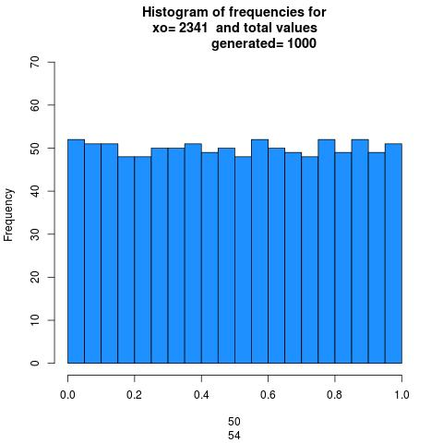

X₀ =2341
a=51749
b=0
m=244944
n=1000

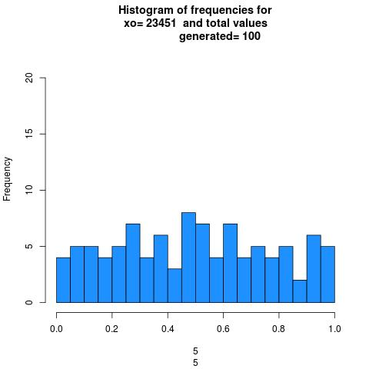
HISTOGRAMS FOR THE SECOND FREQUENCY TABLE:

N=100
X₀ =23451
a=51749
b=0
m=244944

N=1000
X₀ =23451
a=51749
b=0
m=244944

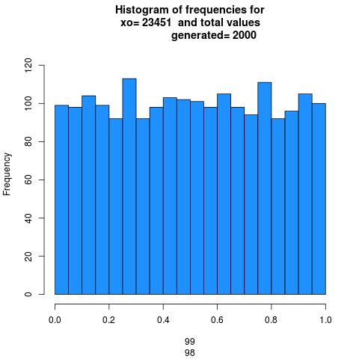

N=2000
X₀ =23451
a=51749
b=0
m=244944

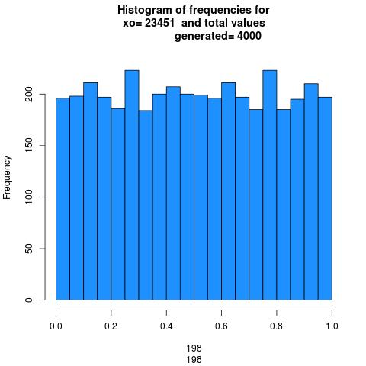

N=4000
X₀ =23451
a=51749
b=0
m=244944

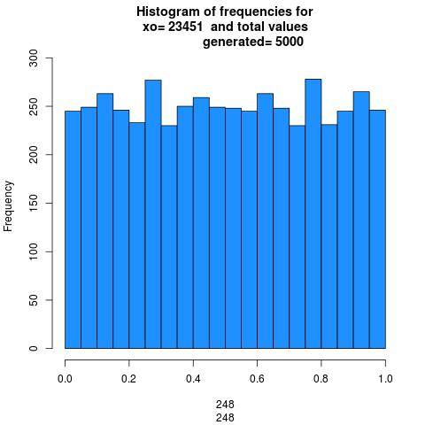

N=5000
X₀ =23451
a=51749
b=0
m=244944

OBSERVATIONS

- The seed value x₀ only determines the length of the cycle and as such do not have any effect on the distribution of the random values generated if other parameters remain constant.
- As the number of iterations increase, the distribution becomes more and more uniform and the frequency of each interval becomes almost same.
- The higher the value of 'a' i.e. the multiplying factor, the change between the consecutive values of random number in the sequence is more evident.

RESULT

- The higher the value of 'n' i.e. the number of iterations, more uniform the distribution of the generated random values become.

QUESTION-III

Generate a sequence with . Plot in a two-dimensional graph the points i.e., the points What are your observations?

RCODE :
func_rand <- function(val, m){
return(val/m);
}

func_val <- function(val, a, b, m){
return(((a*val)+b)%%m);
}

func <- function(initial, a, b, m, end){
count<-1;
arr<-array(20);
x<-array();
y<-array();

for(i in 1:20)
{
arr[i]=0
}

val <- initial;
random <- func_rand(val, m);

val <- func_val(val, a, b, m);
random <- func_rand(val, m);
prev<-random;

while(count<=end){
val <- func_val(val, a, b, m);
random <- func_rand(val, m);

y[count] = random;
x[count] = prev;

prev = random;
count <- count+1;
}

plot(x,y);
dev.copy(jpeg,paste("Graph.jpg"));
dev.off();
}

main <- function(){
func(172, 1229, 1, 2048, 1000);
}

OUTPUT

The plot of comes to be be as follows:
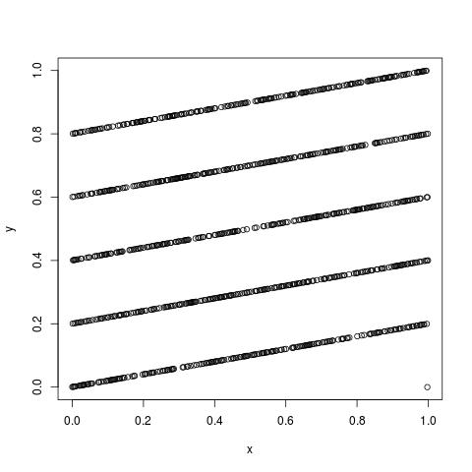

OBSERVATIONS

- We can clearly see from the plot of that we have got parallel lines separated uniformly for each other(around 0.2 units).
- In RANDU generator, X_{i} = 65539X_{i−1} mod 2³¹ plot we get all the random numbers fall entirely on 15 hyperplanes . And here we got all the random numbers on the straight lines in the 2d plot. This is because 'm' is 2048 in this case which is equal to 2¹¹ which was 2³¹ in the case of RANDU Generator.

RESULT

- Due to serial correlation between successive values of the sequence u_{n} the plot between u_{i} and u_{i+1} is a set of parallel lines. This is a direct consequence of Marsaglia's theorem which says that of Linear Congruential Generator(LCG) is used to choose points in a n-dimensional space, the points will lie on at most m^{1/n} hyperplanes. That is why in this case we observe a set of parallel lines.
- As the plot obtained consists of parallel lines, this is a not a good function for generating random numbers.

