MA 226
Monte Carlo Simulation

Assignment - 3
(25-01-2013)

AMIT MITTAL

(Roll No.: 11012304)
Department of Mathematics
Indian Institute of Technology Guwahati

Question1:

Implement the linear congruence generator xi+1 = axi mod m to generate a sequence xi and hence uniform random numbers ui . Make use of the following set of values of a and m:
(a) a = 16807 and m = 231 − 1. (b) a = 40692 and m = 2147483399. (c) a
= 40014 and m = 2147483563.
Group the values into equidistant ranges for the values of ui . Tabulate the proportions and draw a bar diagram for the above. What do you observe ? Do it for 1000, 10000 and 100000 values.

For part (a) do the following: Plot the values (u_{i} , u_{i+1}) on a unit square. Now,zoom into the range u_{i} ∈ [0, 0.001].
What are your observations ?

C++ code:

#include <iostream>
#include <cstdio>
#include <cmath>

#define LL long long

using namespace std;

double func_rand(LL int val, LL int m){
return (double)val/m;
}

LL int func_val(LL int val, LL int a, LL int b, LL int m){
LL next_val;
next_val = ((a * val) + b) % m;

return next_val;
}

void function(LL int initial, LL int a, LL int b, LL int m, int end){
LL int val, count = 0, array[20] = {0};
LL int index, quot;
double random, prev;

val = initial;
random = func_rand(val, m);

while(count<end){
prev = random;
val = func_val(val, a, b, m);
random = func_rand(val, m);

printf("%lf , %lf\n", prev, random);

quot = random/0.05;
array[quot]++;
++count;
}

for(index = 0 ; index<20 ; ++index){
printf("\"%.2lf\", %lld\n", 0.05*(index+1), array[index]);
}
}

int main(){
LL int index, a[3] = {1000, 10000, 100000};
LL int init_value = 3452;

for(index = 0; index < 3; ++index){
function(init_value, 16807, 0, pow(2, 31) - 1, a[index]);
printf("\n");
}

printf("\n\n\n");

for(index = 0; index<3; ++index){
function(init_value, 40692, 0, 2147483399, a[index]);
cout<<endl;
}

printf("\n\n\n");

for(index = 0; index<3; ++index){
function(init_value, 40014, 0, 2147483563, a[index]);
cout<<endl;
}

printf("\n\n\n");

return 0;
}

Histograms For a=16807 , m=2^31 – 1 with value of n varying

For n=1000
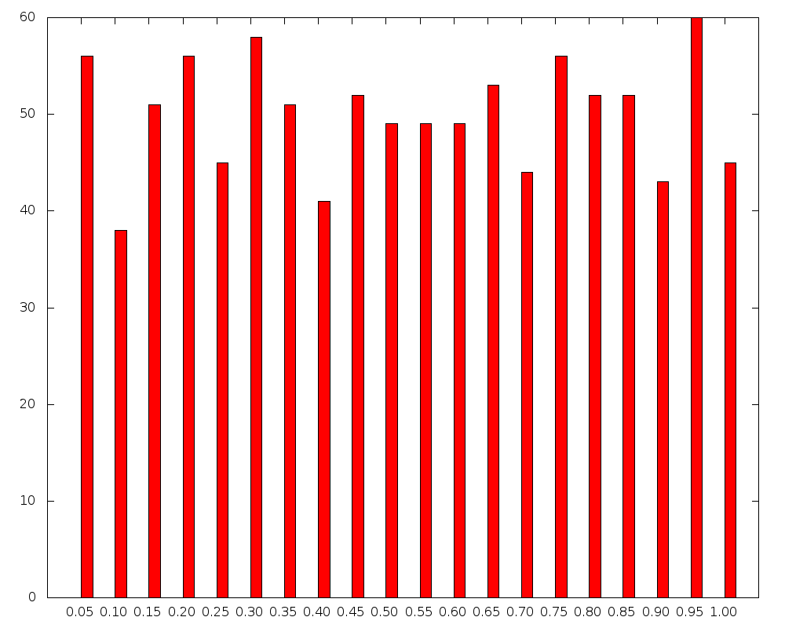

For a= 16807 and number of iterations = 1000 and m=2^31 - 1

Interval Frequency
"0.00-0.05" 56
"0.05-0.10" 38
"0.10-0.15" 51
"0.15-0.20" 56
"0.20-0.25" 45
"0.25-0.30" 58
"0.30-0.35" 51
"0.35-0.40" 41
"0.40-0.45" 52
"0.45-0.50" 49
"0.50-0.55" 49
"0.55-0.60" 49
"0.60-0.65" 53
"0.65-0.70" 44
"0.70-0.75" 56
"0.75-0.80" 52
"0.80-0.85" 52
"0.85-0.90" 43
"0.90-0.95" 60
"0.95-1.00" 45

For n=10000

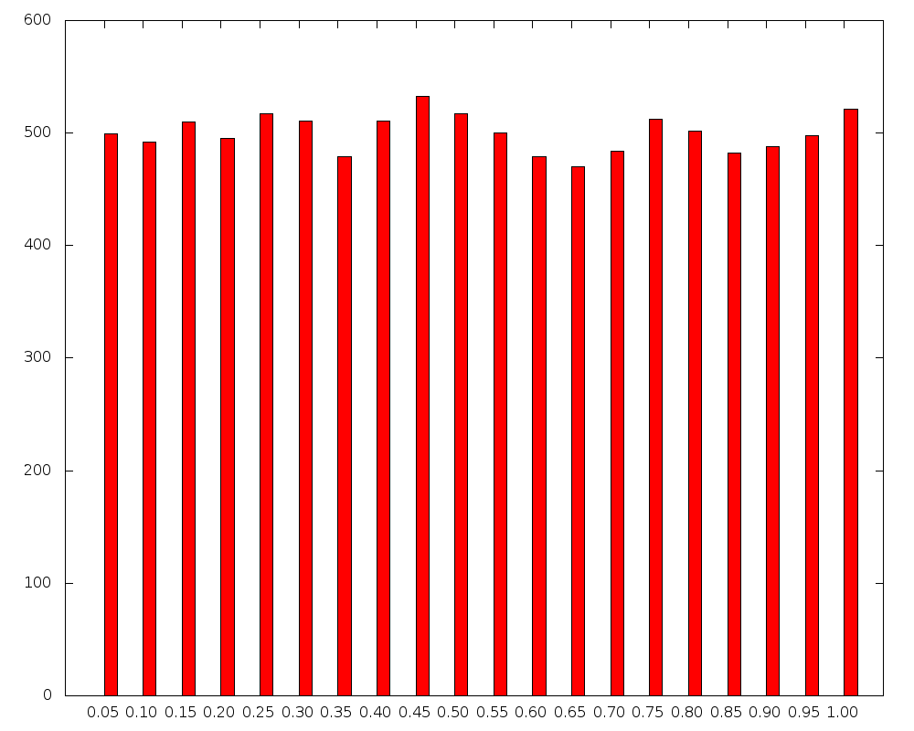

For a= 16807 and number of iterations= 10000 and m=2^31 - 1

Interval Freq
"0.00-0.05" 499
"0.05-0.10" 492
"0.10-0.15" 510
"0.15-0.20" 495
"0.20-0.25" 517
"0.25-0.30" 511
"0.30-0.35" 479
"0.35-0.40" 511
"0.40-0.45" 533
"0.45-0.50" 517
"0.50-0.55" 500
"0.55-0.60" 479
"0.60-0.65" 470
"0.65-0.70" 484
"0.70-0.75" 512
"0.75-0.80" 502
"0.80-0.85" 482
"0.85-0.90" 488
"0.90-0.95" 498
"0.95-1.00" 521

For n=100000

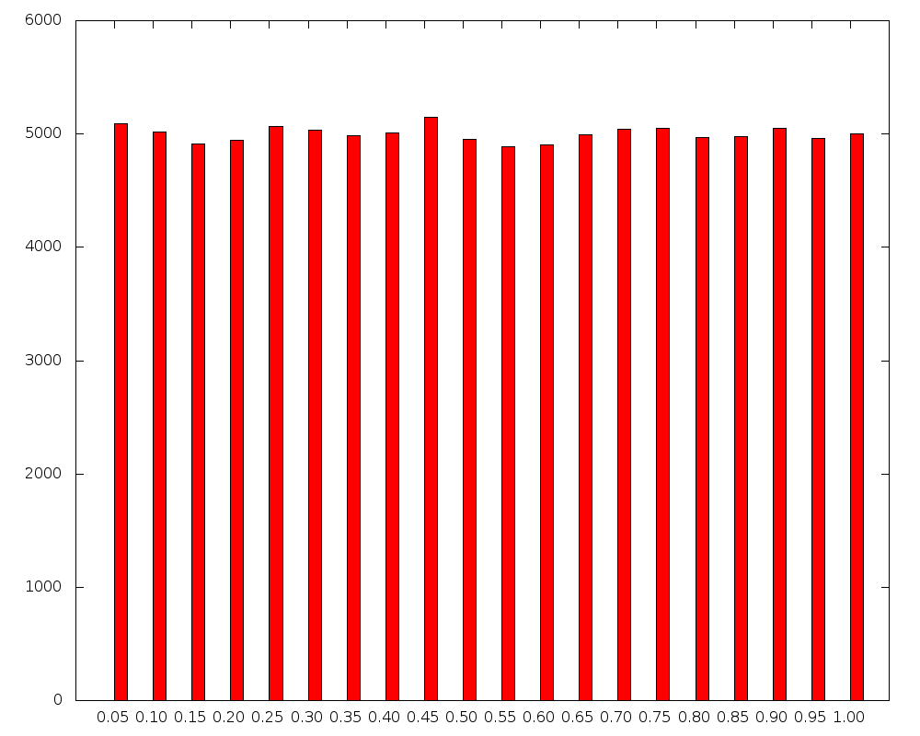

For a= 16807 and number of iterations= 100000 and m = 2^31 - 1

Interval Freq
"0.00-0.05" 5087
"0.05-0.10" 5014
"0.10-0.15" 4912
"0.15-0.20" 4948
"0.20-0.25" 5066
"0.25-0.30" 5034
"0.30-0.35" 4987
"0.35-0.40" 5012
"0.40-0.45" 5150
"0.45-0.50" 4954
"0.50-0.55" 4888
"0.55-0.60" 4900
"0.60-0.65" 4996
"0.65-0.70" 5044
"0.70-0.75" 5049
"0.75-0.80" 4972
"0.80-0.85" 4978
"0.85-0.90" 5048
"0.90-0.95" 4958
"0.95-1.00" 5003

Histograms for a= 40692 , m=2147483399 with value of n varying

For n=1000
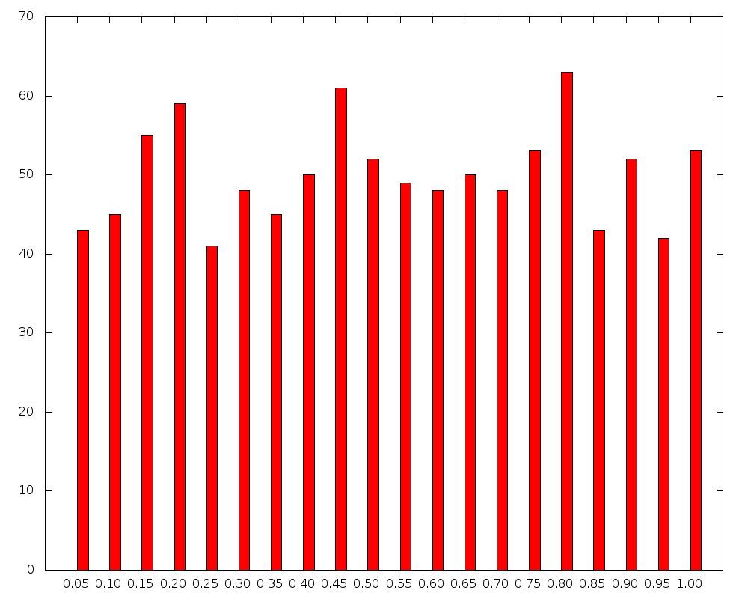

For a= 40692 and number of iterations = 1000 and m=2147483399

Interval Freq
"0.00-0.05" 43
"0.05-0.10" 45
"0.10-0.15" 55
"0.15-0.20" 59
"0.20-0.25" 41
"0.25-0.30" 48
"0.30-0.35" 45
"0.35-0.40" 50
"0.40-0.45" 61
"0.45-0.50" 52
"0.50-0.55" 49
"0.55-0.60" 48
"0.60-0.65" 50
"0.65-0.70" 48
"0.70-0.75" 53
"0.75-0.80" 63
"0.80-0.85" 43
"0.85-0.90" 52
"0.90-0.95" 42
"0.95-1.00" 53
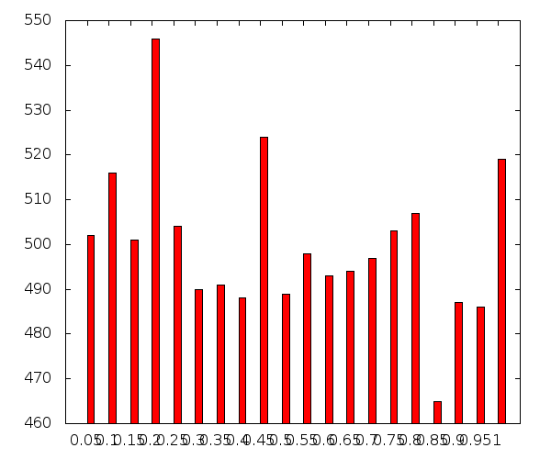

For n=10000

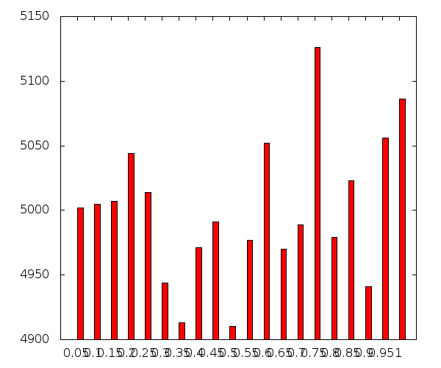

For n=100000

Histograms For a= 40014 , m=2147483563 and value of n varying

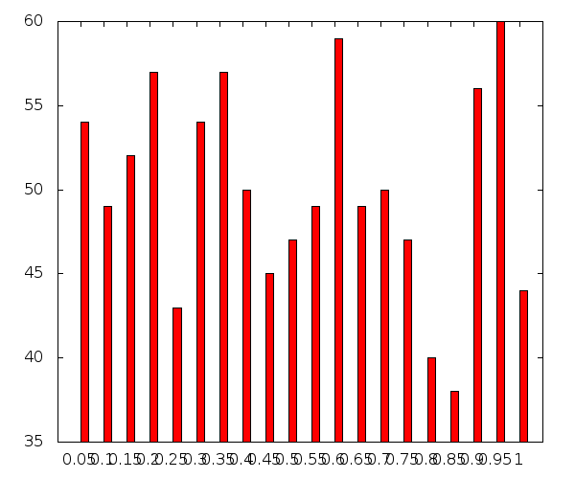

For n=1000

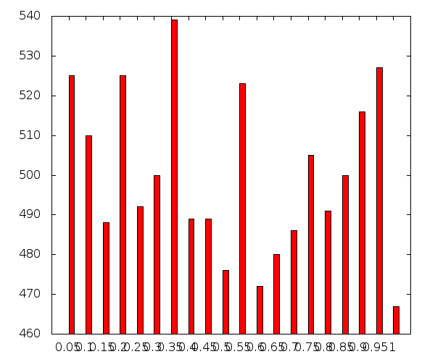

For n=10000

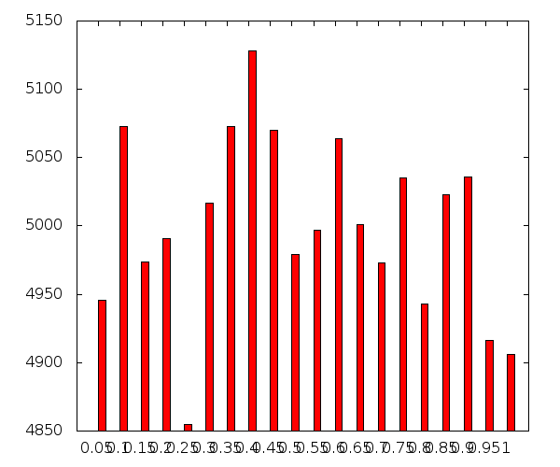

For n=100000

For a= 40692 and number of iterations= 10000 and m=2147483399

Interval Freq
"0.00-0.05" 502
"0.05-0.10" 516
"0.10-0.15" 501
"0.15-0.20" 546
"0.20-0.25" 504
"0.25-0.30" 490
"0.30-0.35" 491
"0.35-0.40" 488
"0.40-0.45" 524
"0.45-0.50" 489
"0.50-0.55" 498
"0.55-0.60" 493
"0.60-0.65" 494
"0.65-0.70" 497
"0.70-0.75" 503
"0.75-0.80" 507
"0.80-0.85" 465
"0.85-0.90" 487
"0.90-0.95" 486
"0.95-1.00" 519

For a= 40692 and number of iterations= 100000 and m=2147483399

Interval Freq
"0.00-0.05" 5002
"0.05-0.10" 5005
"0.10-0.15" 5007
"0.15-0.20" 5044
"0.20-0.25" 5014
"0.25-0.30" 4944
"0.30-0.35" 4913
"0.35-0.40" 4971
"0.40-0.45" 4991
"0.45-0.50" 4910
"0.50-0.55" 4977
"0.55-0.60" 5052
"0.60-0.65" 4970
"0.65-0.70" 4989
"0.70-0.75" 5126
"0.75-0.80" 4979
"0.80-0.85" 5023
"0.85-0.90" 4941
"0.90-0.95" 5056
"0.95-1.00" 5086

For a= 40014 and number of iterations= 1000 and m=2147483563

Interval Freq
"0.00-0.05" 54
"0.05-0.10" 49
"0.10-0.15" 52
"0.15-0.20" 57
"0.20-0.25" 43
"0.25-0.30" 54
"0.30-0.35" 57
"0.35-0.40" 50
"0.40-0.45" 45
"0.45-0.50" 47
"0.50-0.55" 49
"0.55-0.60" 59
"0.60-0.65" 49
"0.65-0.70" 50
"0.70-0.75" 47
"0.75-0.80" 40
"0.80-0.85" 38
"0.85-0.90" 56
"0.90-0.95" 60
"0.95-1.00" 44

For a= 40014 and number of iterations= 10000 and m=2147483563

Interval Freq
"0.00-0.05" 525
"0.05-0.10" 510
"0.10-0.15" 488
"0.15-0.20" 525
"0.20-0.25" 492
"0.25-0.30" 500
"0.30-0.35" 539
"0.35-0.40" 489
"0.40-0.45" 489
"0.45-0.50" 476
"0.50-0.55" 523
"0.55-0.60" 472
"0.60-0.65" 480
"0.65-0.70" 486
"0.70-0.75" 505
"0.75-0.80" 491
"0.80-0.85" 500
"0.85-0.90" 516
"0.90-0.95" 527
"0.95-1.00" 467

For a= 40014 and number of iterations= 100000 and m=2147483563

Interval Freq
"0.00-0.05" 4946
"0.05-0.1" 5073
"0.1-0.15" 4974
"0.15-0.20" 4991
"0.20-0.25" 4855
"0.25-0.30" 5017
"0.30-0.35" 5073
"0.35-0.40" 5128
"0.40-0.45" 5070
"0.45-0.50" 4979
"0.50-0.55" 4997
"0.55-0.60" 5064
"0.60-0.65" 5001
"0.65-0.70" 4973
"0.70-0.75" 5035
"0.75-0.80" 4943
"0.80-0.85" 5023
"0.85-0.90" 5036
"0.90-0.95" 4916
"0.95-1.00" 4906

Plot of (u_{i ,} u_{i+1)} on a unit square for a= 16807 , m= 2^31-1 and n=1000

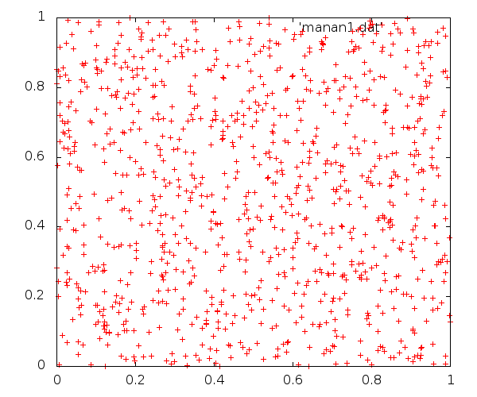

Plot of (u_{i, ,}u _{i+1}) on a unit square for a= 16807,m= 2^31-1 and n= 10000

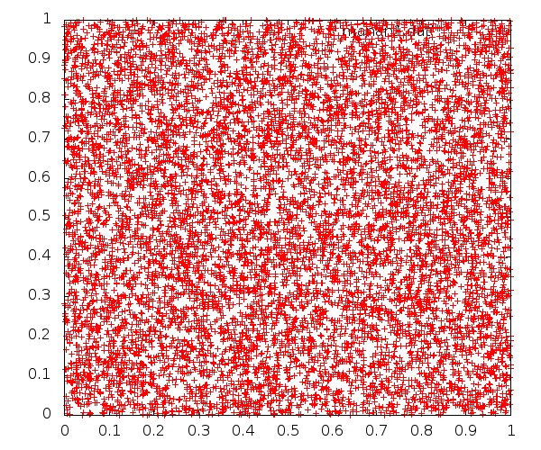

Plot of (u_{i, ,}u _{i+1}) on a unit square for a= 16807,m= 2^31-1 and n= 100000

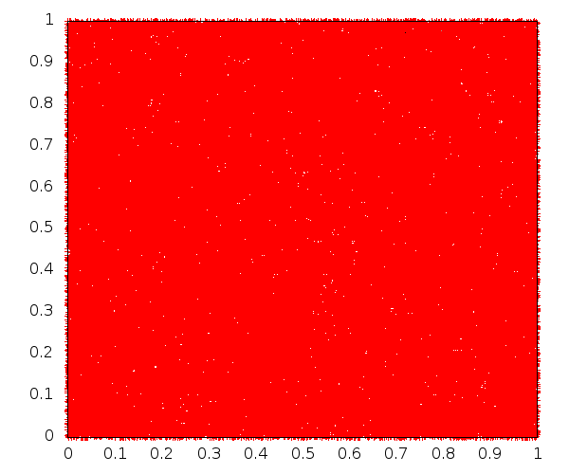

OBSERVATIONS

- As the value of 'n' (The number of iterations) increases,the values of u_{i} converge towards a uniform distribution.
- On plotting the graph of (u_{i,} u_{i+1)} we observe that the random numbers generated are uniformly concentrated in the range [0,1].Also,the density of these random numbers increases as the number of iterations increase.
- On zooming into the given interval of [0,0.001],we observe that the density of random numbers generated decreases significantly. However,the density increases as the number of iterations increase.

RESULT

1.Since,the values of u_{i} generated are uniformly distributed in the interval [0,1],we conclude that the given random value generator is efficient.
2.Also,as the number of iterations increases,the density of the random values in the given interval increases. This observation strengthens our conclusion about the efficacy of the given generator.

Question2:

Consider the extended Fibonacci generator :
Ui = (Ui−17 + Ui−5 ) mod 231 .
(a) Use the linear congruence generator to generate the first 17 values of Ui . (b) Then generate the values of Ui (say for 1000, 10000 and 100000 values). (c) For each of the above set of values plot (Ui , Ui+1 ). (d) Observe (give the values) the convergence of the
sample mean and sample variance towards actual values, and generate a probability distribution with, say, 1000 values generated. (e) Compute the autocorrelation of lags
1, 2, 3, 4, and 5 with 1000 generated values.

C++ code:

#include<iostream>
#include<cmath>

using namespace std;

void call(long long int w, long long int r, long long int l)
{

long long int i,p=0,x,a[20]={0},q,t=0,j;
float *b,mean,sum=0,var=0,sum2=0,autocorrlag[6];
long long int *g;
g=new long long int [r];

b=new float[r];
double u,c=.05;

x=3452;
cout<<"For a= "<<w<<"and number of iterations= "<<r<<"and m="<<l<<"\n";
for(i=0;i<17;i++)
{
g[i]=x;
x=(w*x)%l;

u=(double)x/l;

b[i]=u;
}

for(i=17;i<r;i++)
{
g[i]=(g[i-17]+g[i-5])%l;

u=(double)g[i]/l;

b[i]=u;

}

for(i=0;i<r-1;i++)
cout<<b[i]<<","<<b[i+1]<<"\n";

for(i=0;i<r;i++)
sum=sum+b[i];

mean=sum/r;
for(i=0;i<r;i++)
var=var+(b[i]-mean)*(b[i]-mean);

cout<<"Mean is "<<mean<<"\n";
cout<<"Variance is "<<var/r<<"\n";

if(r==1000)

{
for(j=1;j<=5;j++)
{
for(i=j;i<r;i++)
{
sum2=sum2+(b[i+1]-mean)*(b[i]-mean);

}
autocorrlag[j]=sum2/var;
cout<<"The auto correlation of lag for l= "<<j<<" is "<<autocorrlag[j]<<"\n";
}
}
}
int main()
{
long long int y;
y=pow(2,31);
call(16807,1000,y);
//call(16807,10000,y);
//call(16807,100000,y);

return(0);

}

Plot of (u_{i ,} u_{i+1}) for a constanat value of 'a' and 'm' with n=1000

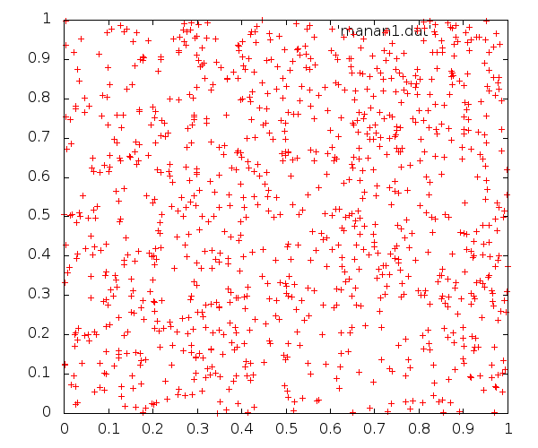

Plot of (u_{i,}u_{i+1}) for a constant value of 'a' and 'm' with n=10000

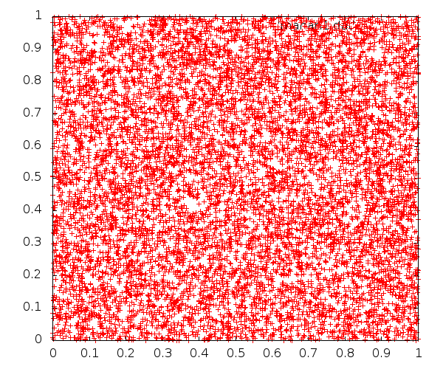

Plot of (u_{i,}u_{i+1}) for a constant value of 'a' and 'm' with n=100000

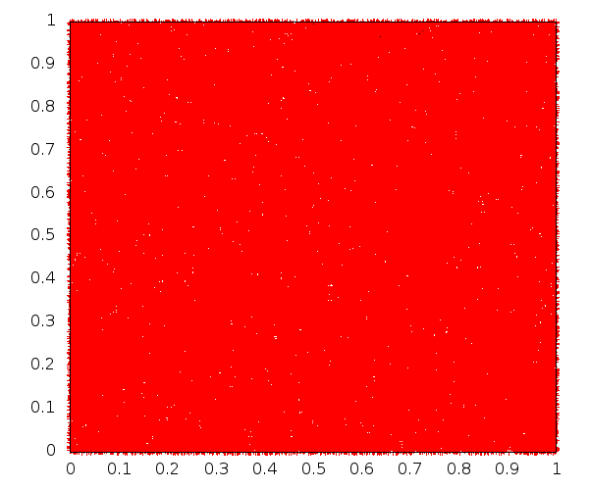

OBSERVATIONS

Values of the Autocorrelation Lag for a=16807 , m= 2^31-1 and n=1000

The auto correlation of lag for 1 is -0.0246358

The auto correlation of lag for 2 is -0.0501137

The auto correlation of lag for 3 is -0.0755329

The auto correlation of lag for 4 is -0.101046

The auto correlation of lag for 5 is -0.127207

Values of the mean and variance for a= 16807 , m= 2^31-1 and varying n

For n=1000:
Mean: 0.502815
Variance: 0.0808772

For n=10000:
Mean: 0.500095
Variance: 0.0808772

For n=100000:
Mean: 0.500401
Variance: 0.0833761

RESULT

1.The autocorrelation lag decreases as the lag number increases i.e. autocorrelation lag is minimum for lag number equal to 5.

2.The sample mean lies in the range (0.500095,0.502815). The sample variance lies in the range (0.0808772,0.0833761).

3.The extended Fibonacci generator passes most statistical tests which prove its efficacy.

4.The extended Fibonacci generator has a period of 2^{k}(2¹⁷- 1) which is much longer than Linear Congruential Generators.

5.On generating the probability distribution,we find that the graph is a straight line with an positive slope. Also,the graph is monotonic increasing.

