MA 226

Monte Carlo Simulation

Assignment 4

Manan Bhutani
Roll No:11012320

Question1:
Simulate 5000 sample of exponential with mean 5. Draw the histogram and the calculate the mean, maximum and minimum. (Use R and C/C++)

C++ code

#include<iostream>
#include<cmath>
#include<cstdio>

using namespace std;

int func(int a,long long int m,int n,int b)
{
int mean=5;
long long int x=b;
double r[5000],s[5000],max=0,min=m+1,mean1=0.0;
for(int i=0;i<5000;i++)
{
x=(long long int)(a*x);
x=(x%m);
r[i]=(double)(x/(float)m);
s[i]=(double)((-1)*mean*log(1-r[i]));
mean1=mean1+s[i];
if(s[i]>max)
{
max=s[i];
}
if(s[i]<min)
{
min=s[i];
}
cout<<s[i]<<"\n";

}
cout<<"\n\n";
cout<<"Maximum is: "<<max<<"\n";
cout<<"Minimum is: "<<min<<"\n";
cout<<"\n\n";
cout<<"The mean is: "<<(double)mean1/5000<<"\n";

}

int main()
{
long long int y=4999;
func(4696,y,5000,1000);
}

End of C++ code

R code:

func<-function(a,m,n,x0)
{
mean=5;
x<-x0;
r<-c()
s<-c()

for(i in 1:n)
{
x<-((x)*(a));
x<-(x)%%(m);
r[i]<- x/m;
s[i]=(-1)*mean*log(1-r[i]);
cat(sprintf("%g %g\n",s[i],r[i]));
}

hist(s,100)
dev.copy(jpeg,paste("monte4_2.jpeg"))
dev.off()

}

main<-function()
{
val<-func(4696,4999,5000,1000);
return(val);
}

End of R code

Histogram

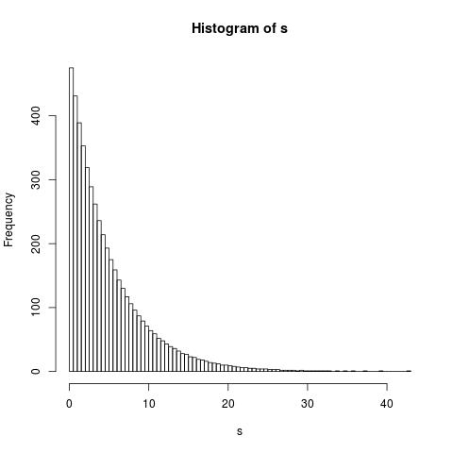

Observations

The maximum observation is: 42.585

The minimum observation is: 0.0010003

The mean of the observations is: 4.99495

Result

1.The observed mean is 4.99495 which is very close to the expected value of 5.

2.The closeness of the observed mean to the expected mean proves the efficacy of the Linear Congruential Generator used to generate the uniform random numbers.

3.The graph obtained is similar to the actual graph of exponential distribution.

Question 2:
Generate 5000 sample from Gamma with parameter n = 5 and λ = 5. Draw the
histogram and the calculate the mean, maximum and minimum. (Use R and C/C++)

C++ code:

#include<iostream>
#include<cmath>
#include<cstdio>

using namespace std;

int func(int a,long long int m,long int n,long long int b,long long int c,long long
int d,long long int e,long long int f)
{
int flag1,flag2;
float mean=0.2;
double r1[5000],r2[5000],r3[5000],r4[5000],r5[5000],s[5000],max=0,min=1,y,mean1=0.0;
for(int i=0;i<n;i++)
{
b=(long long int)(a*b);
b=(float)(b%m);
r1[i]=(double)((float)b/(float)m);

c=(long long int)(a*c);
c=(float)(c%m);
r2[i]=(double)((float)c/(float)m);

d=(long long int)(a*d);
d=(float)(d%m);
r3[i]=(double)((float)d/(float)m);

e=(long long int)(a*e);
e=(float)(e%m);
r4[i]=(double)((float)e/(float)m);

f=(long long int)(a*f);
f=(float)(f%m);
r5[i]=(double)((float)f/(float)m);

y=(float)log((float)(1-r1[i])*(float)(1-r2[i])*(float)(1- r3[i])*(float)(1-r4[i])*(float)(1-r5[i]));
s[i]=(double)((-1)*(float)mean*y);
mean1=mean1+s[i];
if(s[i]>max)
{
max=s[i];flag1=i;
}
if(s[i]<min)
{
min=s[i];flag2=i;
}
cout<<s[i]<<"\n";

}
cout<<"\n\n";
cout<<"\n"<<max<<"\t"<<min<<"\n";
cout<<"\n\n";
cout<<(double)mean1/5000<<"\n";
}

int main()
{
long long int y=4999;
func(4696,y,5000,10000,20000,30000,40000,50000);
}

End of C++ code

R code:

func<-function(a,m,n,x1,x2,x3,x4,x5)
{
mean=0.2;
r1<-c()
r2<-c()
r3<-c()
r4<-c()
r5<-c()
s<-c()
max=0;

for(i in 1:n)
{
x1<-((x1)*(a));
x1<-(x1)%%(m);
r1[i]<- x1/m;
}

for(i in 1:n)
{
x2<-((x2)*(a));
x2<-(x2)%%(m);
r2[i]<- x2/m;
}
for(i in 1:n)
{
x3<-((x3)*(a));
x3<-(x3)%%(m);
r3[i]<- x3/m;
}
for(i in 1:n)
{
x4<-((x4)*(a));
x4<-(x4)%%(m);
r4[i]<- x4/m;
}
for(i in 1:n)
{
x5<-((x5)*(a));
x5<-(x5)%%(m);
r5[i]<- x5/m;
}
min=r5[1];
for(i in 1:n)
{
s[i]=(-1)*mean*log((1-r1[i])*(1-r2[i])*(1-r3[i])*(1-r4[i])*(1-r5[i]));
cat(sprintf("%g %g %g %g %g %g\n",s[i],r1[i],r2[i],r3[i],r4[i],r5[i]));
if(s[i]>max)
{
max=s[i];
}
if(s[i]<min)
{
min=s[i];
}

}
cat(sprintf("\n%g %g\n",max,min))
hist(s,100)
dev.copy(jpeg,paste("monte4_1.jpeg"))
dev.off()

}

main<-function()
{
val<-func(4696,4999,5000,10000,20000,30000,40000,50000);
return(val);
}

End of R code

Histogram

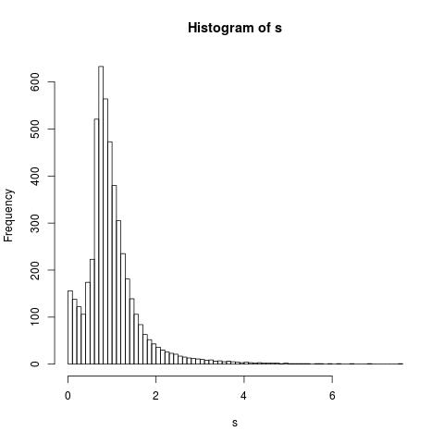

Observations

The maximum observation is: 7.55949

The minimum observation is: 0.000600332

The mean of the observations is: 0.999226

Result

1.The gamma distribution is obtained by using inverse transformation on 5 different exponential distributions.

2.The mean of the observations obtained is 0.999226 which is very close to the expected value of 1

3.The closeness of the observed mean to the expected mean proves the efficacy of the Linear Congruential Generator used to generate the uniform random numbers.

4.The histogram of the values obtained is similar to the actual graph of the gamma distribution function.
Question3:
Use the rejection method to generate from
f (x) = 20x(1 − x)^3 , 0<x<1

(Use R)

R code

