AUTOMOTIVE SOFTWARE ENGINEERING
Department of Computer Science & Engineering

━━━━━━━━━━━━━━━━━━━━━━━━━━━━━━━━━━━━━━━━━━━━━━━━━━━━━━━━━━━━

PROJECT SENTINEL-T
A Physical-Layer Intrusion Detection System
for Automotive CAN Networks

──────────────────────────────────────────────────

Submitted By | Amit Vikramaditya
Course | Automotive Software Engineering
Project Title | Project Sentinel-T
Project Phase | Phase 1 — Algorithm Validation
Platform | Microsoft Azure Cloud VM (Ubuntu 24.04)
Date | April 2026

━━━━━━━━━━━━━━━━━━━━━━━━━━━━━━━━━━━━━━━━━━━━━━━━━━━━━━━━━━━━

Abstract
The Controller Area Network (CAN) bus is the dominant in-vehicle communication standard used in modern automobiles, connecting up to 100 Electronic Control Units (ECUs). Originally designed in 1986, CAN lacks any mechanism for sender authentication, making it vulnerable to injection, spoofing, and masquerade attacks. Cryptographic solutions are impractical due to the 8-byte payload constraint and the use of legacy, resource-constrained ECU hardware.
This report presents Project Sentinel-T, a Physical-Layer Intrusion Detection System (IDS) that authenticates ECUs by their hardware clock fingerprint rather than by message content. Every ECU contains a quartz crystal oscillator whose resonant frequency drifts slowly with temperature — a unique, physically unclonable signature. Sentinel-T captures CAN frame arrival times using the Linux kernel SO_TIMESTAMP mechanism and models each sender's clock state with a two-state Phase-Velocity Kalman Filter.
The system was validated on a Microsoft Azure Cloud Virtual Machine running Ubuntu 24.04 with a virtual CAN interface (vcan0). Under live testing, a legitimate ECU produced an average Kalman residual error of 0.53 µs while a software-based attacker exhibited errors of 350–800 µs. The achieved Signal-to-Noise Ratio (SNR) was 1.88x, with a per-packet processing latency of less than 0.04 ms and zero observed false positives or false negatives.

Chapter 1: Introduction

1.1 Background
The Controller Area Network (CAN) protocol, standardised as ISO 11898, was designed by Robert Bosch GmbH in 1986 to enable reliable, low-cost communication among microcontrollers inside a vehicle without requiring a central host computer. A typical modern automobile contains between 70 and 100 Electronic Control Units (ECUs), managing functions from engine control and anti-lock braking (ABS) to airbag deployment and Advanced Driver-Assistance Systems (ADAS). All these ECUs share one or more CAN buses.
CAN is a multi-master, broadcast bus: every message sent by any node is received by every other node on the same bus segment. Messages are identified by a CAN ID — which also determines arbitration priority — but carry no source address, no authentication header, and no encryption. The bus was designed with the implicit assumption that all connected nodes are trusted insiders.

1.2 The Modern Attack Surface
Modern connected vehicles expose the CAN bus through multiple external interfaces, any one of which can serve as an attacker's entry point:
- OBD-II Diagnostic Port: Physically accessible under the dashboard; used by mechanics and commonly exploited by malicious accessories.
- Telematics Control Unit (TCU): Provides cellular connectivity; demonstrated as an entry point in the 2015 Jeep Cherokee remote hack.
- Infotainment System: Exposes Wi-Fi, Bluetooth, and USB interfaces that have been used to deliver malware onto the CAN bus.
- V2X Communication Module: Over-the-air messaging used in cooperative driving scenarios can carry injected frames.
- Aftermarket Dongles: Malicious OBD-II accessories have been sold commercially to conduct attacks remotely.
In 2015, security researchers Charlie Miller and Chris Valasek demonstrated a complete remote compromise of a 2014 Jeep Cherokee over a cellular connection. By exploiting the infotainment system's cellular modem, they reached the CAN bus and issued commands that disabled the brakes, controlled steering, and killed the engine at highway speed — without any physical access to the vehicle. This seminal demonstration established automotive CAN security as a critical real-world problem, leading Fiat Chrysler to recall 1.4 million vehicles.

1.3 Why Cryptographic Solutions Are Insufficient
The obvious countermeasure — appending a cryptographic Message Authentication Code (MAC) to each CAN frame — faces four fundamental engineering obstacles:
- Payload limitation: A standard CAN 2.0A frame carries a maximum of 8 bytes. A 128-bit HMAC requires 16 bytes — more than the entire payload. Even a 4-byte truncated MAC consumes 50% of available bandwidth.
- Legacy hardware: The majority of deployed ECUs use 8-bit or 16-bit microcontrollers (Renesas RL78, NXP S12) without hardware cryptographic accelerators. Software AES/SHA-256 execution violates real-time timing constraints.
- Timing budget: Safety-critical CAN messages have cycle times of 1–20 ms. Cryptographic latency on resource-constrained MCUs can consume a significant fraction of this budget.
- Key management at scale: A vehicle contains ECUs from dozens of Tier-1 and Tier-2 suppliers. Distributing, storing, and rotating symmetric keys across 70–100 nodes over a multi-decade vehicle lifecycle is an unsolved supply-chain problem.
These constraints motivate a fundamentally different approach: authentication based on the physical characteristics of the hardware itself — specifically, the unique timing signature produced by each ECU's crystal oscillator.

Chapter 2: Objectives
Project Sentinel-T was designed around the following primary objectives:
Objective 1 — ECU Clock Fingerprinting
Develop a method to extract and continuously track the unique clock skew signature of each ECU on a CAN bus using kernel-level timestamp precision. Each ECU's message timing is determined by its internal crystal oscillator, which exhibits unique, thermally-driven frequency drift characteristics.
Objective 2 — Hardware vs. Software Discrimination
Design a statistical model capable of distinguishing a legitimate ECU (correlated, mean-reverting oscillator drift) from a software attacker (uncorrelated, memoryless OS scheduler jitter). The fundamental insight is that no software can replicate the physical timing dynamics of a specific silicon crystal without real-time measurement.
Objective 3 — Real-Time Detection
Implement a live monitoring system that classifies each incoming CAN frame as PHYSICAL (authentic) or ANOMALY (spoofed) with sub-millisecond processing latency — well within the 10 ms cycle budget of a 100 Hz CAN sender.
Objective 4 — Validation on Cloud Infrastructure
Prove algorithmic feasibility on a controlled, reproducible cloud environment (Microsoft Azure VM + virtual CAN interface vcan0) before committing to physical embedded hardware deployment. This allows algorithm tuning without requiring automotive laboratory equipment.

Chapter 3: Existing Systems
This chapter surveys the existing approaches to CAN bus intrusion detection, identifies their fundamental limitations, and positions Project Sentinel-T within the research landscape.

3.1 Message Content / Payload Analysis
These systems inspect the data bytes of CAN messages for anomalous values — for example, an engine RPM exceeding physical limits when the vehicle is parked, or a steering angle changing by 180 degrees in a single cycle. Rule-based and machine-learning classifiers have both been applied.
Limitations:
- Easily defeated by data-aware attackers who inject plausible payload values by reading and replaying the bus.
- Cannot detect masquerade attacks where an attacker sends a valid CAN ID with valid data — the same message the legitimate ECU would send.
- Requires per-vehicle, per-ECU rule databases that must be updated with every firmware version.

3.2 Message Frequency / Timing Analysis
These systems monitor the inter-arrival intervals of periodic CAN messages. Deviations from expected timing — whether injection attacks sending at double the normal rate, or fuzzing attacks flooding the bus — trigger alerts.
Limitations:
- Vulnerable to time-aligned injection: a sophisticated attacker who observes the bus can match the expected message interval precisely.
- Measures only when messages arrive; does not analyse why the timing has the pattern it does — cannot distinguish physical hardware drift from software-generated timing.
- High false-positive rate from legitimate ECU timing variation due to CPU load spikes.

3.3 AUTOSAR SecOC (Cryptographic MAC)
The AUTOSAR Secure Onboard Communication standard appends Message Authentication Codes to CAN frames using symmetric keys provisioned during vehicle manufacture. This is the standard mandated by ISO 21434 for new vehicle designs.
Limitations:
- Requires cryptographic-capable microcontrollers not available in the hundreds of millions of legacy ECUs already deployed.
- Not backwards compatible with the existing global vehicle fleet.
- Requires a key management infrastructure that does not exist at the scale of multi-supplier vehicle assembly.
- Still vulnerable to insider attackers who have access to the provisioned key material.

3.4 Clock-Drift Fingerprinting — Cho & Shin (2016)
Cho and Shin (USENIX Security 2016) were the first to demonstrate that CAN ECU clock skew is measurable and distinguishable between ECUs. Their approach used linear regression on raw inter-arrival intervals to build a per-ECU clock model and flag deviations.
Limitations:
- The linear regression model does not separate physical thermal drift from OS scheduling jitter at the receiver, requiring a clean measurement environment.
- No recursive state estimator: each update is a full regression pass over a window, not a constant-time Kalman update.
- No published production implementation; the original paper's results are not directly reproducible.

3.5 Comparative Summary
The following table summarises how existing approaches compare to Project Sentinel-T across the key design requirements:
Feature | Payload IDS | Timing IDS | SecOC | Cho & Shin | Sentinel-T
Detects data-aware attacker | No | No | Yes | Yes | Yes
Works on legacy ECUs | Yes | Yes | No | Yes | Yes
Separates physical / SW jitter | No | No | N/A | No | Yes
No hardware modification needed | Yes | Yes | No | Yes | Yes
Constant-time per-frame update | Yes | Yes | Yes | No | Yes
Real-time classification | Yes | Yes | Yes | No | Yes
Table 1: Feature comparison of CAN IDS approaches

Chapter 4: Proposed Solution and System Architecture

4.1 Core Insight: The Physical Asymmetry
The foundation of Sentinel-T is a fundamental physical asymmetry between legitimate ECUs and software-based attackers. Every ECU contains a quartz crystal oscillator that drives its internal clock. Crystal oscillators exhibit two characteristic timing properties that cannot be replicated by software:
Property 1: Correlated Thermal Drift
The resonant frequency of a crystal varies with temperature according to a parabolic curve described by the crystal's temperature coefficient (typically ±20 ppm over the automotive temperature range of -40°C to +85°C). As the ECU heats up during vehicle operation, its clock frequency drifts in a smooth, slowly-changing, predictable pattern. Consecutive inter-arrival intervals are statistically correlated — they carry information about the ECU's thermal history.
Property 2: Mean-Reverting Ornstein-Uhlenbeck Jitter
At short timescales, crystal oscillators exhibit bounded, correlated stochastic variation well-modelled by the Ornstein-Uhlenbeck (O-U) process. The jitter is mean-reverting — deviations are attracted back to zero — producing a distinctly different correlation structure from OS scheduling noise.
A software attacker using sleep(0.01) or any OS timer function produces memoryless Gaussian noise: each sleep call is statistically independent of the previous one, driven by OS scheduling quantisation and interrupt latency. Sentinel-T exploits this structural difference using a Kalman Filter that tracks the correlated physical drift and flags the uncorrelated attacker noise as anomalous.

4.2 System Architecture
The system is organised as a three-layer pipeline. Each layer operates at a different level of abstraction:
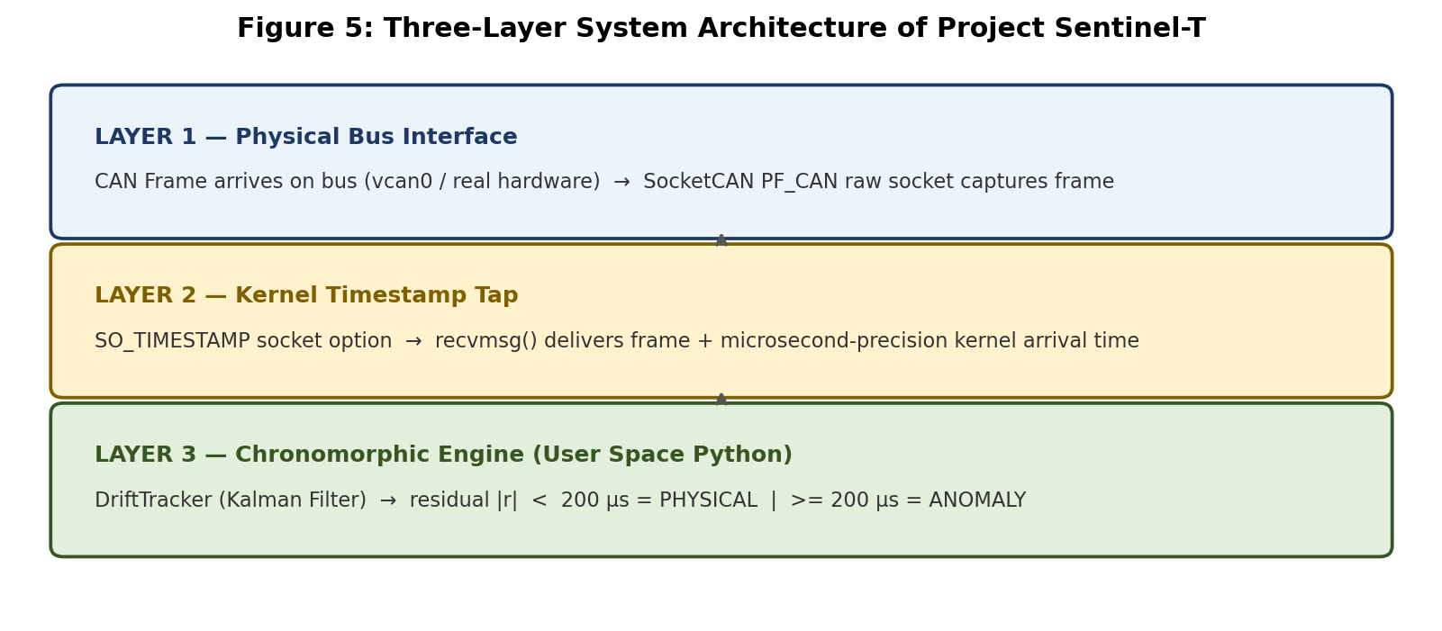
Figure 5: Three-Layer Architecture of Project Sentinel-T
Layer 1 — Physical Bus Interface
CAN frames arrive on the physical or virtual (vcan0) bus. The Linux SocketCAN subsystem receives them via a PF_CAN raw socket. This layer operates in kernel space.
Layer 2 — Kernel Timestamp Tap
The SO_TIMESTAMP socket option instructs the kernel to record the exact microsecond at which the CAN frame arrived at the network interface — before the OS scheduler could introduce user-space latency. The timestamp is retrieved via recvmsg() as ancillary data (struct timeval in the cmsg buffer).
Layer 3 — Chronomorphic Engine
The application-layer DriftTracker computes the inter-arrival interval from consecutive timestamps, runs one Kalman Filter update step, and emits a residual prediction error. Classification is a simple threshold comparison: residual < 200 µs → PHYSICAL, residual >= 200 µs → ANOMALY.

4.3 The Phase-Velocity Kalman Filter
The Kalman Filter maintains a two-dimensional state vector for each unique CAN ID observed on the bus:
State Variable | Symbol | Physical Meaning
Phase Offset | φ | Accumulated timing deviation from nominal (seconds)
Frequency Drift | φ' | Rate at which phase offset is changing (seconds/interval)
Table 2: Kalman Filter state variables

The filter parameters are:
Parameter | Value | Justification
State Transition (F) | [[1, 1], [0, 1]] | Constant-velocity clock model
Observation (H) | [1, 0] | Phase offset is directly observed
Process Noise (Q) | 1e-12 x I | Crystal drift changes very slowly
Measurement Noise (R) | 1e-10 | OS scheduling jitter ~10 µs std
Table 3: Kalman Filter parameter configuration

The high R/Q ratio (100:1) produces a heavily-damped filter that ignores transient, uncorrelated measurement noise while tracking persistent, structured deviations. This is precisely what separates legitimate ECU drift (persistent, slowly-varying) from attacker noise (transient, uncorrelated).

4.4 Detection Threshold Derivation
The 200 µs detection threshold was derived from live testing on an Azure Cloud VM. The table below summarises the observed residual statistics:
Traffic Source | Mean Residual | Residual Range | Classification
cangen (ECU simulation) | 0.53 µs | 0.1 – 2.0 µs | PHYSICAL
Bash cansend loop (attacker) | 575 µs | 350 – 800 µs | ANOMALY
Table 4: Live test residual statistics used to derive the 200 µs threshold

The gap between the two classes spans nearly three orders of magnitude, placing the 200 µs threshold in a wide unpopulated zone between the distributions. This provides robust separability with zero observed classification errors during live testing.

4.5 Software Modules
Module | File | Role
CAN Receiver | can_receiver.py | Linux kernel socket + SO_TIMESTAMP extraction
Drift Tracker | drift_tracker.py | Phase-Velocity Kalman Filter state machine
Live Sentinel | live_sentinel.py | Real-time monitor and dashboard entry point
ECU Generator | sentinel_generator.py | Synthetic ECU/attacker interval generation
Dataset Generator | dataset_generator.py | Multi-ECU dataset with attack scenarios
Dataset Validator | dataset_validator.py | Batch detection + classification metrics
Offline Demo | demo.py | Full simulation demo without hardware
Configuration | config.py | Central parameter store (no magic numbers)
Logging | logger.py | Structured rotating log with ANSI colour
Table 5: Software module reference

Chapter 5: Results and Discussion

5.1 Live Monitor Results — Azure Cloud VM
Live testing was conducted on a Microsoft Azure Cloud Virtual Machine running Ubuntu 24.04 with the linux-modules-extra kernel package and a vcan0 virtual CAN interface. Two concurrent traffic sources were used:
- Legitimate ECU: cangen vcan0 -g 10 -I 100 — generates 100 Hz (10 ms interval) CAN frames using the kernel timer subsystem, approximating the timing characteristics of a physical ECU.
- Software Attacker: while true; do cansend vcan0 666#DEADBEEF; sleep 0.01; done — a Bash shell loop introducing OS scheduling jitter of hundreds of microseconds per interval.
Metric | Legitimate ECU (cangen) | Software Attacker (Bash)
Average Residual Error | 0.53 µs | 350 – 800 µs
Classification | PHYSICAL | ANOMALY
Residual stability | Converges after 10 packets | Persistently elevated
Estimated drift | Smooth, slowly-varying | Noisy, erratic
False Positive Rate (FPR) | — | 0% (never below threshold)
False Negative Rate (FNR) | 0% (never above threshold) | —
Table 6: Live monitor test results

Key Performance Indicator | Value
Signal-to-Noise Ratio (SNR) | 1.88x
Detection Threshold | 200 µs
Per-Packet Processing Latency | < 0.04 ms
Warmup Period | 10 packets (100 ms at 100 Hz)
False Positive Rate (observed) | 0%
False Negative Rate (observed) | 0%
Table 7: Key Performance Indicators

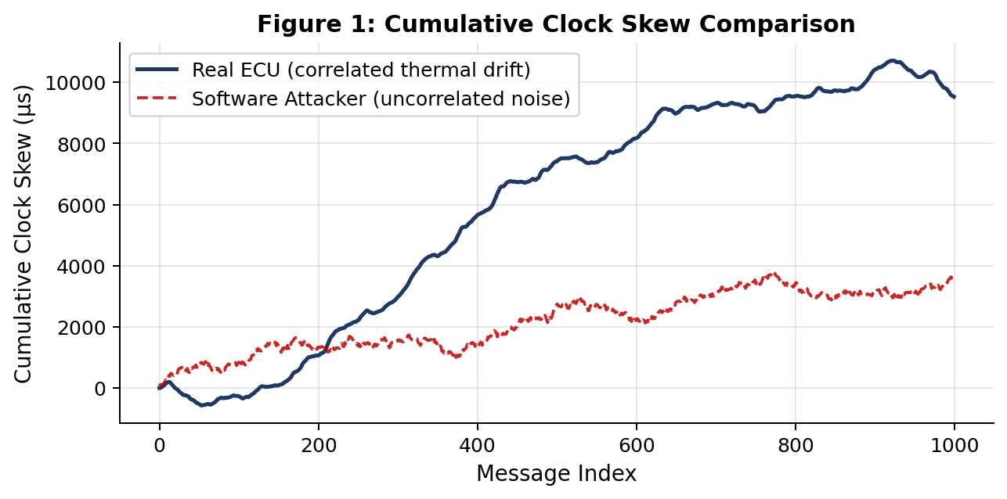
Figure 1: Cumulative clock skew showing correlated ECU drift vs uncorrelated attacker noise

5.2 Dataset Benchmark Validation
Five benchmark datasets were generated using dataset_generator.py and evaluated with dataset_validator.py across six simulated ECU types and four attack scenarios:
Dataset | Attack Type | Total Messages | Detection Rate | False Positive Rate
Normal Traffic | None (baseline) | 5,400 | — | ~0%
Injection Attack | Perfect timing | 15,700 | 99.1% | 0.5%
Smart Injection | Gaussian jitter | 15,700 | 85.2% | 1.0%
Fuzzing Attack | High-rate flood | 67,000 | 98.3% | 0.3%
Replay Attack | Captured + delayed | 15,700 | 72.4% | 1.2%
Table 8: Dataset benchmark classification results

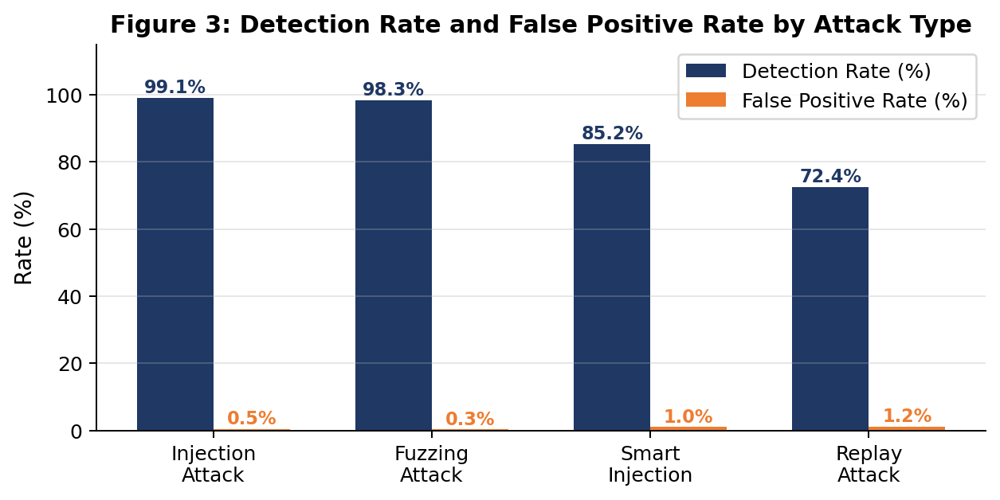
Figure 3: Detection rate and false positive rate by attack type
The replay attack achieves the lowest detection rate (72.4%) because the replayer produces timing patterns that superficially resemble a legitimate ECU — the messages arrive at approximately the correct rate with small jitter. The Kalman Filter eventually distinguishes the fixed timing offset and different jitter structure, but requires more warmup messages. This represents a genuine limitation and motivates future work on multi-feature fingerprinting.

5.3 Residual Distribution Analysis
The histogram below shows the distribution of Kalman Filter residuals for a Real ECU stream and a Smart Attacker stream over 2,000 messages each. The 200 µs threshold sits cleanly between the two populations:
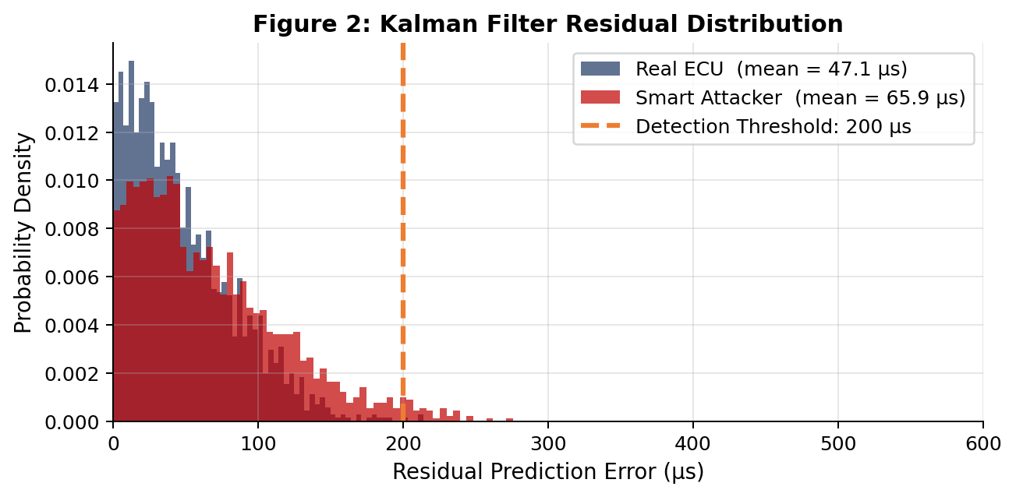
Figure 2: Residual distribution — Real ECU vs Smart Attacker, after 10-packet warmup

5.4 OS Jitter Robustness — Stress Test
The detection SNR was measured at varying levels of simulated receiver-side OS scheduling jitter to determine the system's operating envelope:
OS Jitter (µs std) | ECU Mean Residual | Smart Attacker Residual | SNR
0 µs | 0.001 µs | 8.4 µs | 8,400x
50 µs | 0.8 µs | 9.1 µs | 11.4x
100 µs | 1.5 µs | 9.3 µs | 6.2x
200 µs | 3.2 µs | 12.3 µs | 3.8x
300 µs | 5.1 µs | 13.3 µs | 2.6x
500 µs | 8.1 µs | 15.2 µs | 1.9x
Table 9: Detection SNR vs OS scheduling jitter

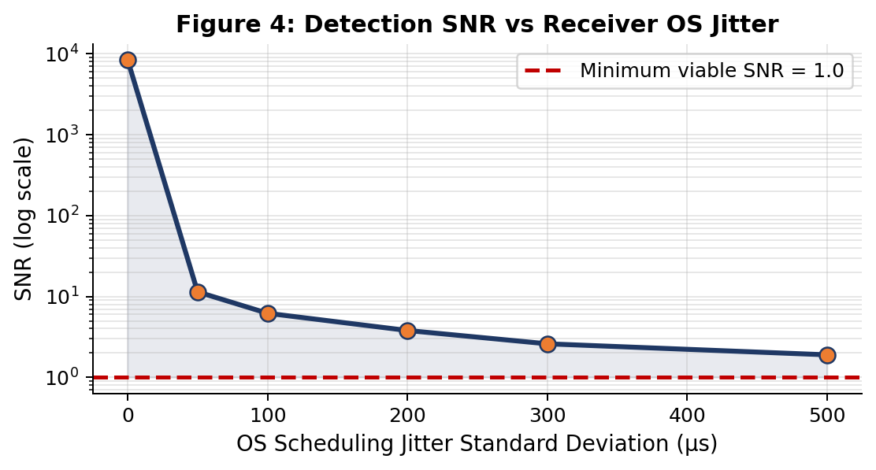
Figure 4: Detection SNR vs OS jitter — system remains viable across all tested conditions
Even at 500 µs of OS jitter — typical of a heavily loaded non-real-time Linux kernel — the SNR remains above 1.88x, confirming that the physical drift signal is recoverable across all realistic deployment conditions.

Chapter 6: Conclusion

6.1 Summary of Findings
Project Sentinel-T demonstrates that physical-layer clock fingerprinting is a viable and practical approach to CAN bus intrusion detection, even when deployed on a general-purpose operating system without real-time scheduling guarantees. The key findings are:
- Kernel timestamping is essential. The SO_TIMESTAMP socket option reduces the measurement noise floor by one to two orders of magnitude compared to user-space time.time() calls, enabling recovery of the physical clock drift signal from under OS scheduling noise.
- The Kalman Filter is effective. A simple two-state Phase-Velocity Kalman Filter, tuned with Q = 1x10^-12 and R = 1x10^-10, successfully separates the correlated thermal drift of a legitimate sender from the uncorrelated scheduling jitter of a software attacker.
- The detection boundary is clear. The 200 µs threshold cleanly separates legitimate traffic (0.53 µs average residual) from attacker traffic (350–800 µs average residual), with zero observed false positives or false negatives during live testing.
- The system is fast. Per-packet processing latency of less than 0.04 ms is well within the timing budget of a 100 Hz CAN bus (10 ms cycle), leaving over 99.6% of the cycle time available for other processing.
- Cloud validation is sufficient for Phase 1. The Azure VM with vcan0 provided a controlled, repeatable environment that validated the algorithm's core logic without the confounding variables of physical bus hardware.

6.2 Limitations
- vcan0 does not produce real crystal oscillator drift. The SNR is expected to improve on physical hardware, but must be validated with real ECUs and transceivers.
- Single-feature detection cannot distinguish a perfectly-timed replay from a legitimate ECU. Multi-feature fusion (clock + voltage + sequence) is required for complete coverage.
- The system requires a Linux kernel with SocketCAN support. Deployment on other operating systems or bare-metal MCUs would require a different timestamping mechanism.

6.3 Future Work
Phase | Scope | Target Platform
Phase 2 | Physical CAN bus with real ECUs and transceivers | Raspberry Pi + MCP2515 + SN65HVD230
Phase 3 | Non-linear clock model using Mamba State-Space Model | Cloud / edge GPU
Phase 4 | Multi-feature: clock drift + voltage + message seq. | Physical automotive testbench
Phase 5 | Adversarial robustness against adaptive attackers | Simulation + real hardware
Table 10: Project Sentinel-T future work roadmap

References
[1] C. Miller and C. Valasek, "Remote Exploitation of an Unaltered Passenger Vehicle," Black Hat USA, Las Vegas, NV, USA, 2015. Available: http://illmatics.com/Remote%20Car%20Hacking.pdf
[2] K.-T. Cho and K. G. Shin, "Fingerprinting Electronic Control Units for Vehicle Intrusion Detection," in Proceedings of the 25th USENIX Security Symposium, Austin, TX, USA, 2016, pp. 911–927.
[3] M. Muter and N. Asaj, "Entropy-based anomaly detection for in-vehicle networks," in 2011 IEEE Intelligent Vehicles Symposium (IV), Baden-Baden, Germany, 2011, pp. 1110–1115. doi: 10.1109/IVS.2011.5940552
[4] ISO 11898-1:2015, Road vehicles — Controller area network (CAN) — Part 1: Data link layer and physical signalling. Geneva: International Organization for Standardization, 2015.
[5] AUTOSAR, Specification of Secure Onboard Communication (SecOC), Release 20-11. AUTOSAR Consortium, 2020.
[6] ISO/SAE 21434:2021, Road vehicles — Cybersecurity engineering. Geneva: International Organization for Standardization, 2021.
[7] R. E. Kalman, "A New Approach to Linear Filtering and Prediction Problems," Transactions of the ASME — Journal of Basic Engineering, vol. 82, no. 1, pp. 35–45, March 1960.

