An Enhanced Multi-Modal Biometric Authentication

In this project we are designing Modified Deep Learning Neural Networks (MLDNN) algorithms to authenticate persons using different biometric features such as Face, Iris, Finger, Palm and Ear. Hence this algorithm is called as Multimodal. To implement this algorithm we have applied KLDA features reduction algorithm to reduce biometric image features and then input to MLDNN algorithm to train a model to authenticate persons. MLDNN algorithm will further extract FSL features while training itself.

To implement this project we have used below dataset which contains 5 different folders



In above screen we can see 5 different folders and each folder contains 10 different person’s biometric images and we can those images in below screen

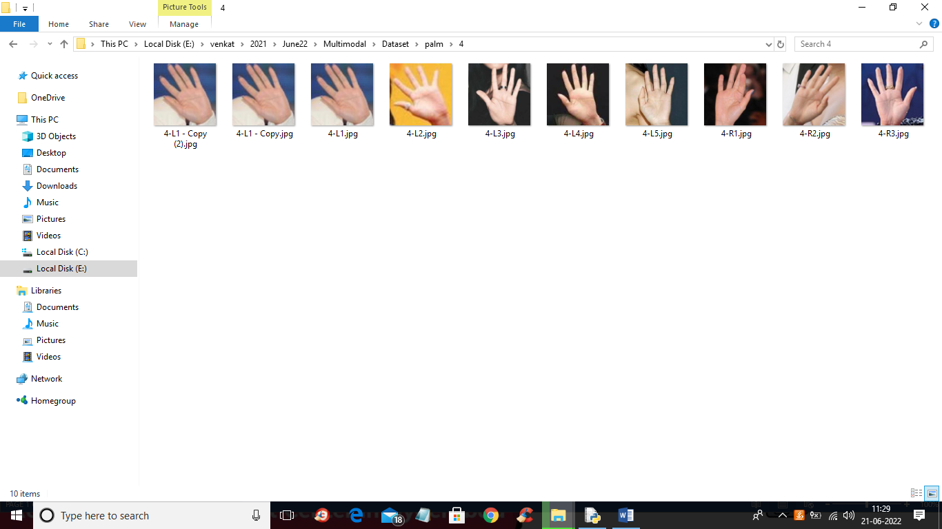

So similarly each folder will contains different biometric images.

To implement this project we have designed following modules

1. Upload Multi-Modal Dataset: using this module we will upload dataset to application
2. Preprocess & KLDA Features Extraction: using this module we will read all images from dataset and then apply preprocessing technique such as resizing image, normalize pixels and then apply KLDA algorithm to extract features.
3. Train Deep Learning Multi-Modal Model: we will input extracted features to MLDNN algorithm to train authentication model
4. Training Accuracy Graph: using this module we will plot MLDNN training and loss graph
5. Authentication from Multi-Modal Images: using this module we will upload folder with 5 different images such as ear, face, finger, iris and palm and then Multimodal MLDNN algorithm will predict person from given images

SCREEN SHOTS

To run project double click on ‘run.bat’ file to get below screen

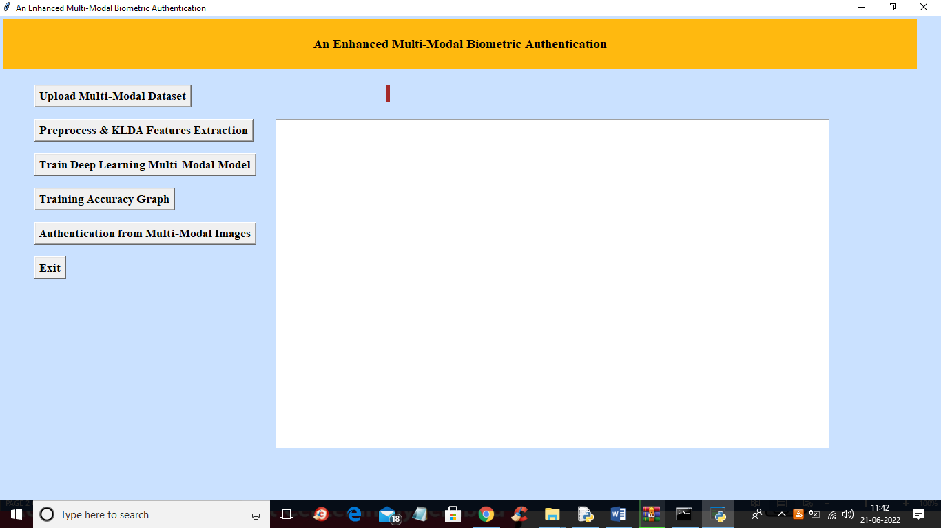

In above screen click on ‘Upload Multi-Modal Dataset’ button to upload dataset and get below output

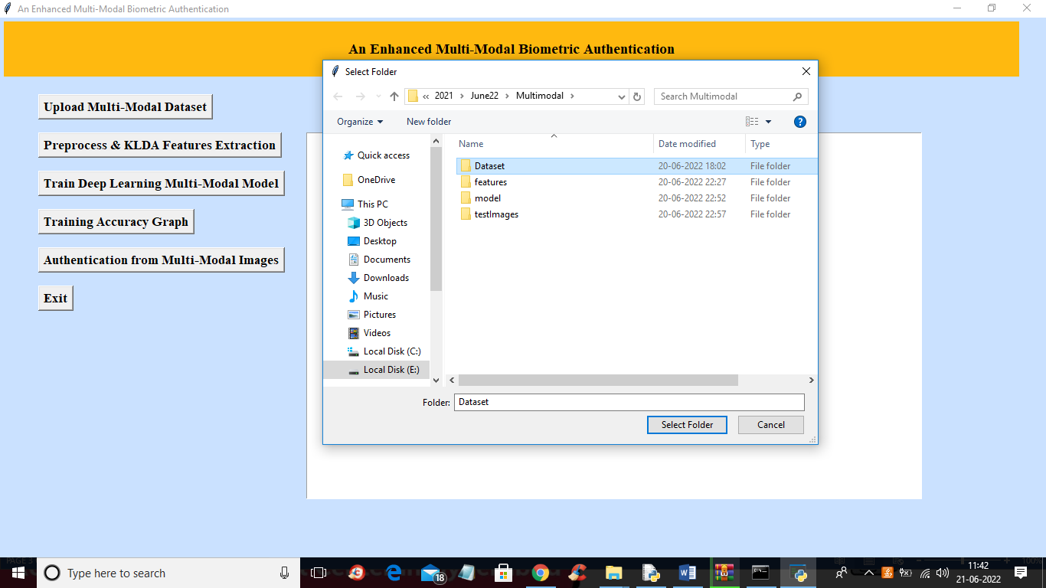

In above screen selecting and uploading ‘Dataset’ folder and then click on ‘Select Folder’ button to load dataset and get below output

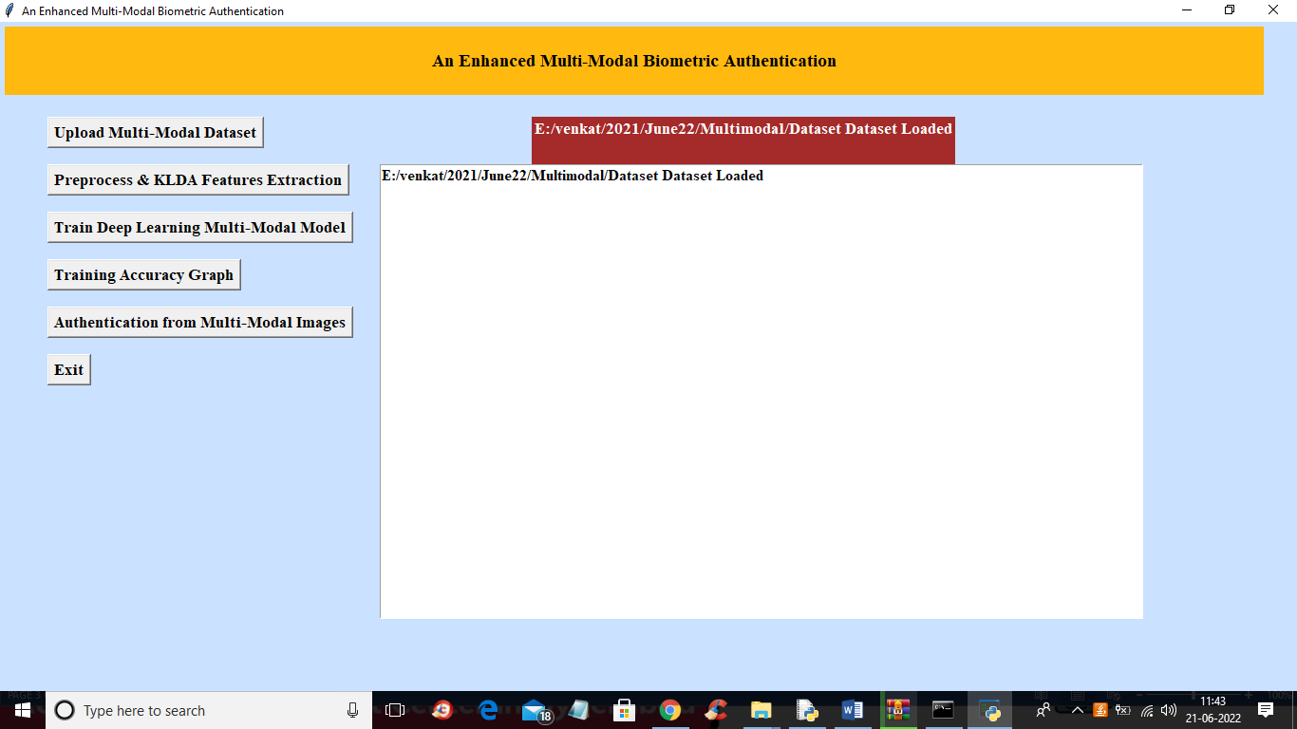

In above screen dataset uploaded and now click on ‘Preprocess & KLDA Features Extraction’ button to read all images and then extract features and then split dataset into train and test where application used 80% images for training and 20% for testing

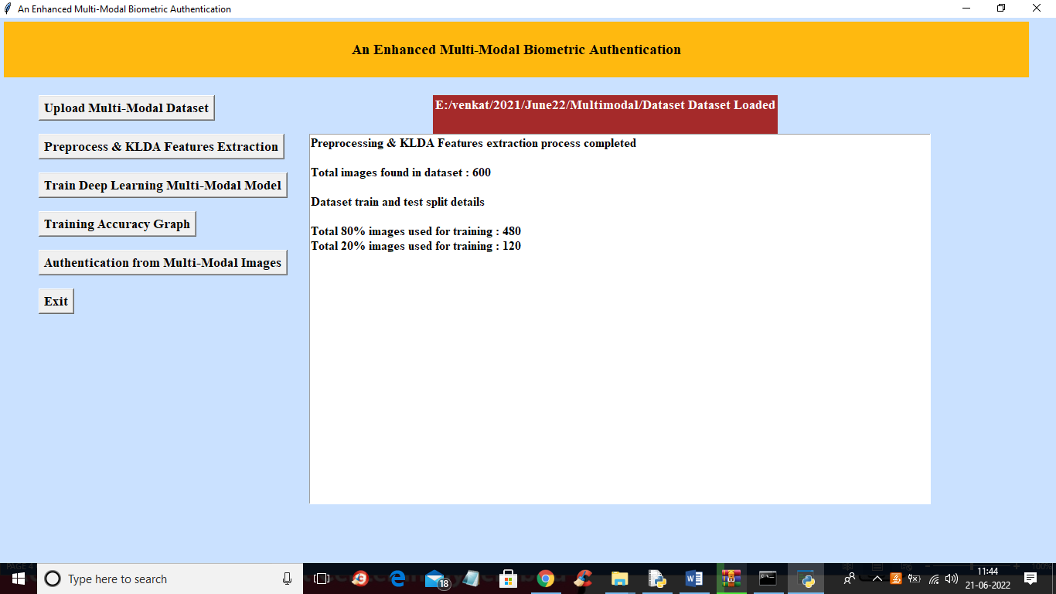

In above screen application processed all 600 images and then split dataset into train and test and now click on ‘Train Deep Learning Multi-Modal Model’ button to train model and get below output

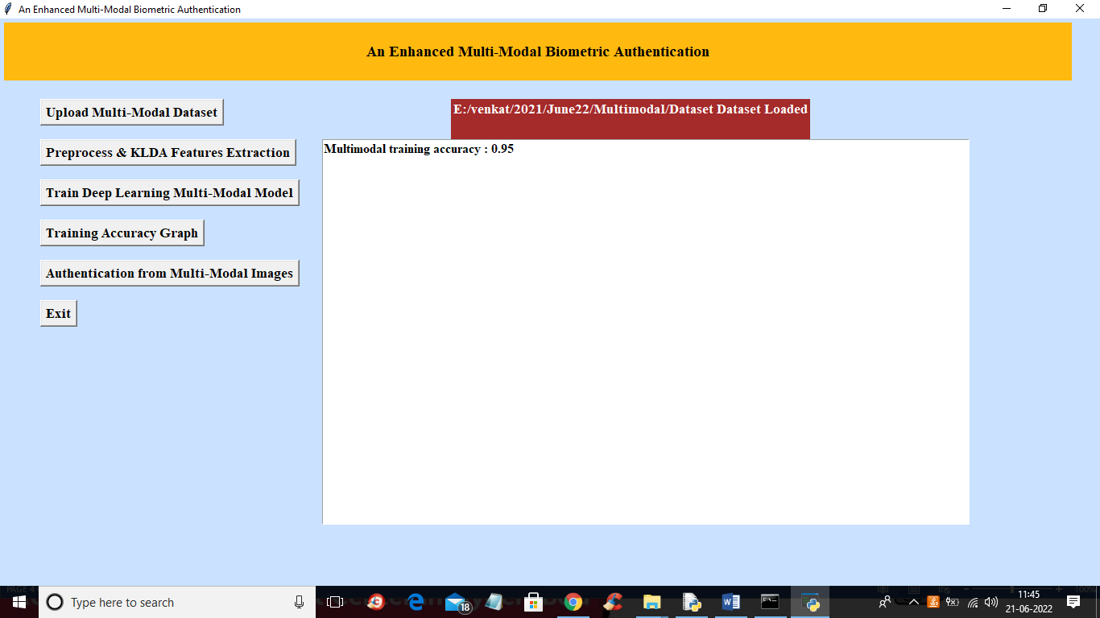

In above screen model is trained and we got model accuracy as 0.95 and now click on ‘Training Accuracy Graph’ button to get below output

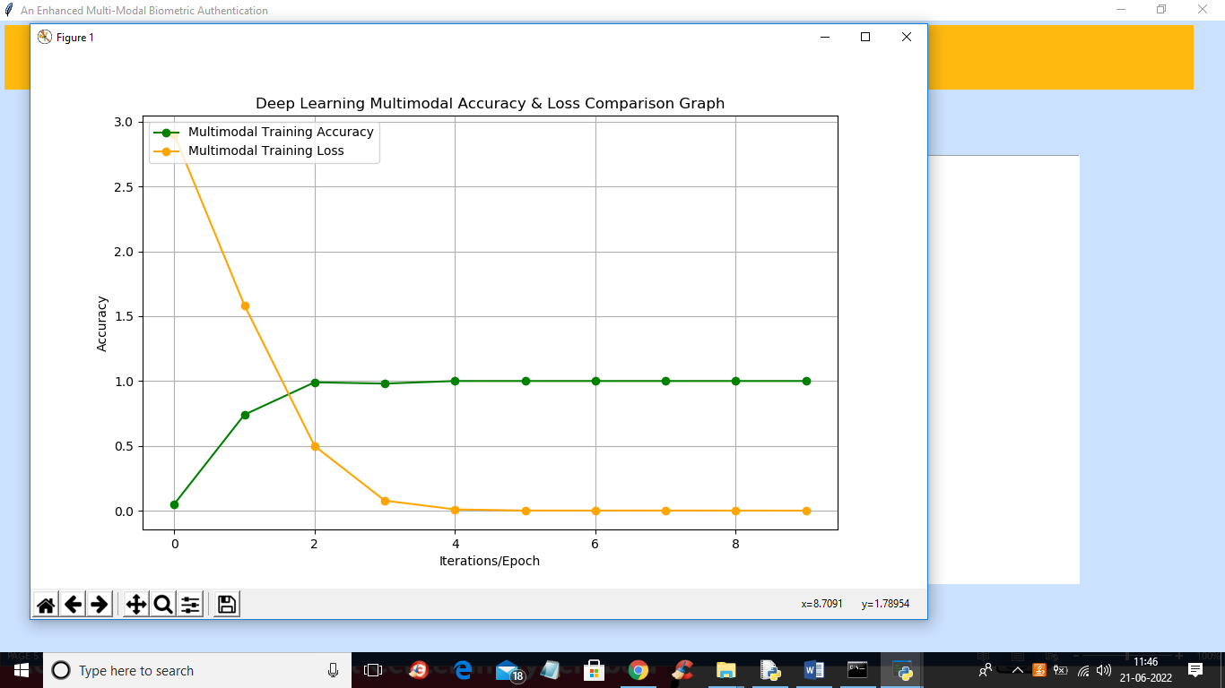

In above graph x-axis represents epoch number and y-axis represents accuracy and loss values and green line represents accuracy and yellow line represents LOSS value and in above graph we can see with each increasing epoch accuracy got increase and loss got decrease. Now click on ‘Authentication from Multi-Modal Images’ button to upload folder with face, finger, iris, palm and ear and get below output

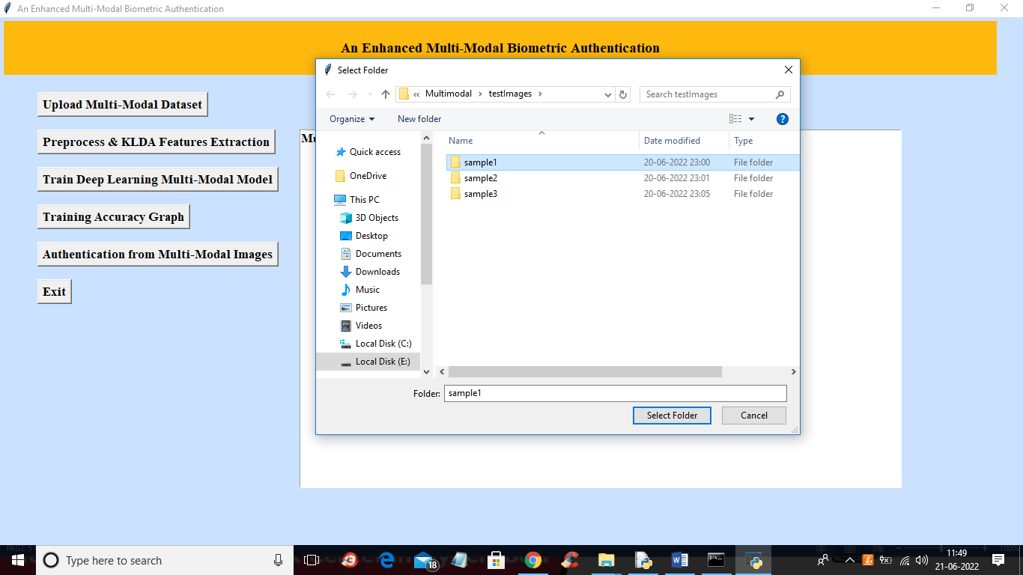

In above screen selecting and uploading ‘sample1’ folder and then click on ‘Select Folder’ button to load test images and get below output

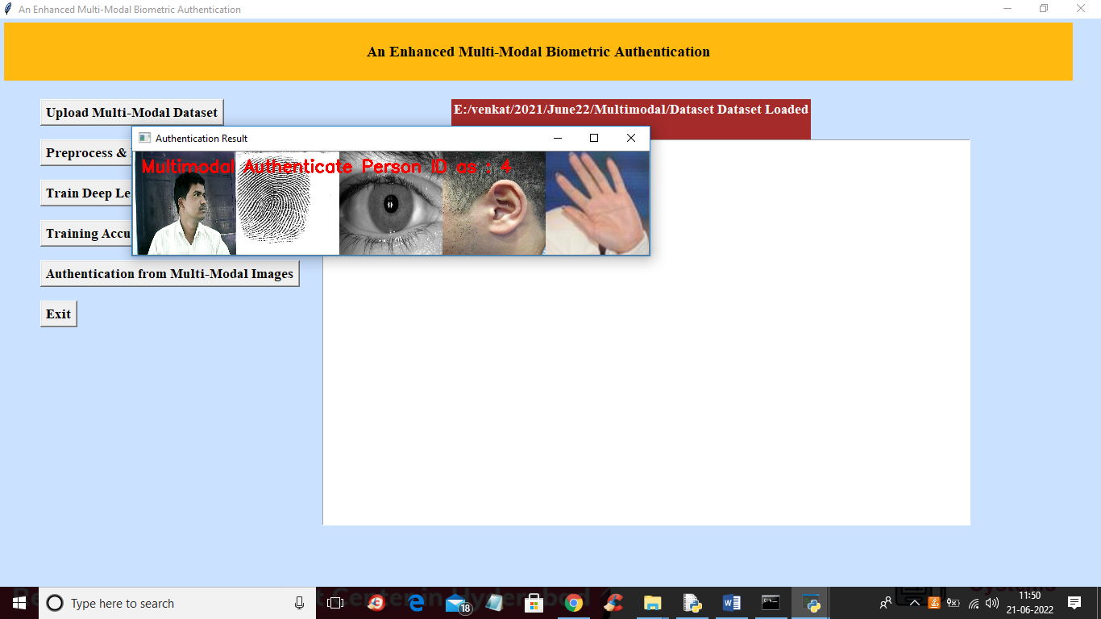

In above screen uploaded multimodal images are authenticated as person ID 4 and similarly you can upload other images and test

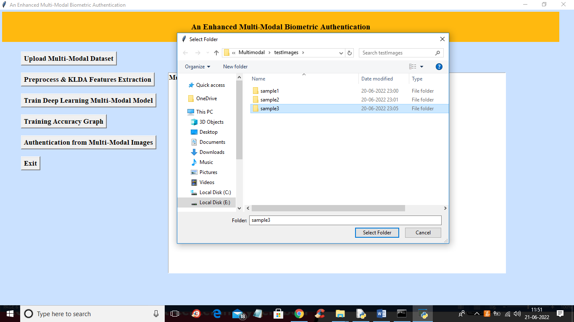

In above screen uploading other folder and get below output

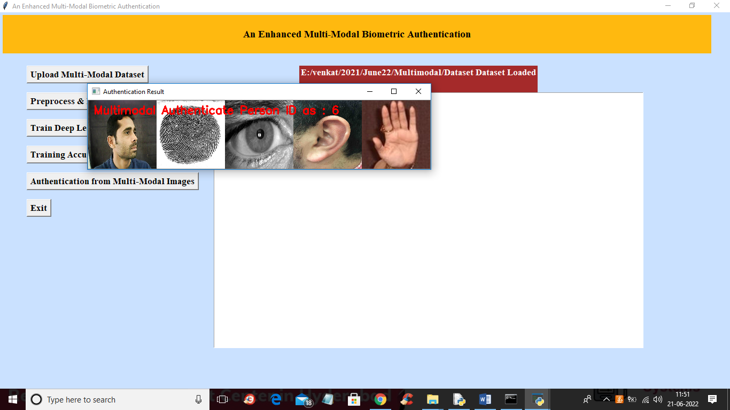

In above screen multi modal images authenticated as person ID 6