## MRS Dashboard - redesign

# Part 1: Foundation

## A Purpose-Filled Dashboard

We’ve all heard reasons why business dashboards are useful: that which we measure we improve, and the importance of a shared understanding of the state of your business.

You need to find the specific reasons why *your dashboard* will be useful to *your organization*. This section offers exercises to define and refine the purpose for your dashboard. With this purpose in mind, the real work of creating a dashboard will come more easily. Better yet, you will have a standard against which you can evaluate success. There are three key questions:

1. Who is my audience?
2. What value will the dashboard add?
3. What type of dashboard am I creating?

##### Who is my audience?

Dashboards need to start with an audience in mind. Who is the consumer of the dashboard? What are their information needs? What do they already know? What are their experiences and prejudices? As we design the dashboard, understanding the consumers of the dashboard will help us craft a product that they love to use.

A complicating factor is that most dashboards have multiple audiences. In fact, delivering the same dashboard across an entire organization has the potential benefit of getting everyone on the same page. However, a diverse audience is hard to serve well. Therefore, try to prioritize the audiences so conflicts can be more easily handled.

Here are a few of the factors to consider about your audience, and the implications for a dashboard design:

1

2

|  |  |  |
| --- | --- | --- |
|  | Questions | Implication |
| **Role** | What decisions do they make? | Structure the information to make it |
|  |  | super easy to answer high priority |
|  | What questions do they need  answered? | questions. |
| **Work flow** | In what context will they be reviewing | The form and information display |
|  | the dashboard? | needs to fit into an existing work flow. |
|  | What information are they using on a | For example, an on-the-road sales person may need information delivered |
|  | daily basis? | to her BlackBerry, not designed for an |
|  | How much time do they have to review | online wide-screen monitor. |
|  | the numbers? |  |
| **Data comfort** | How sophisticated are they with using | The dashboard’s level of detail and |
| **and skills** | data? | analytical capabilities should match |
|  | Are they proficient in Excel? | the audiences’ comfort zone. |
|  | Do they enjoy digging into the |  |
|  | numbers? |  |
| **Business and** | How familiar are they with the key | This determines the need for |
| **data expertise** | performance metrics? | embedded explanations and use of |
|  | Do they understand where the data | natural language. |
|  | comes from? |  |
|  | Are they familiar with internal company |  |
|  | or industry terminology? |  |

3

##### What value will the dashboard bring?

Dashboards can serve many purposes. Take a moment to consider what you want to get out of your dashboard. Check the top three reasons below.

* Help management define what is important
* Educate people in the organization about the things that matter
* Set goals and expectations for specific individuals or groups
* Help executives sleep at night because they know what’s going on
* Encourage specific actions in a timely manner
* Highlight exceptions and provide alerts when problems occur
* Communicate progress and success
* Provide a common interface for interacting with and analyzing important business data

##### What type of dashboard am I creating?

We’ve seen a lot of discussion about the definition of a “dashboard.” Some people argue that something only qualifies if it fits on one-page or shows real-time information or offers a comprehensive view of a business. We find those requirements too constraining.

Dashboards can come in many flavors. What never changes is good dashboards focus on the most important information and communicate this information clearly and concisely. The delivery channel, level of interactivity, timeliness of data, and analytical capabilities will vary based on the situation.

Below is a list of options for your perfect dashboard. Check the boxes that best fit your situation.

|  |  |  |
| --- | --- | --- |
|  |  |  |
| **Scope** | * **Broad**: Displaying information about | * **Specific**: Focusing on a specific |
|  | the entire organization | function, process, product, etc. |
| **Business role** | * **Strategic**: Provides a high-level, | * **Operational**: Provides a focused, |
|  | broad, and long-term view of performance | near-term, and tactical view of performance |
| **Time horizon** | * **Historical**: ☐ **Snapshot**: | * **Real-time**: ☐ **Predictive**: |
|  | Looking Showing backwards to track performance at a  trends single point in time | Monitoring activity Using past  as it happens performance to predict future |
|  |  | performance |
| **Customization** | * **One-size-fits-all**: Presented as a | * **Customizable**: Functionality to let |
|  | single view for all users | users create a view that reflects their needs |
| **Level of detail** | * **High**: Presenting only the most | * **Drill-able**: Providing the ability to drill |
|  | critical top-level numbers | drill down to detailed numbers to gain more context |
| **Point of view** | * **Prescriptive**: The dashboard | * **Exploratory**: User has latitude to |
|  | explicitly tells the user what the data  means and what to do about it | interpret the results as they see fit |

5

|  |  |  |
| --- | --- | --- |
|  | Description | Common mistakes |
| **Actionable** | It is clear the source of the problem or | It is too broad for specific groups to |
|  | necessary actions when the metric goes | impact (e.g. customer satisfaction). |
|  | up, down, flat or off-target | Focus on absolute measures rather than |
|  |  | changes (e.g. total sales vs. change in |
|  |  | sales) |
| **Common** | People in the organization recognize | It uses data definitions that aren’t well |
| **interpretation** | what the metric means | understood (e.g. leads vs. prospects). |
| **Transparent,** | How the metric is generated is shared | Attempting to create a compound |
| **simple** | and easy to understand | metric that combines a bunch of factors |
| **calculation** |  |  |
| **Accessible,** | The data can be acquired with modest | Pursuing the perfect metric that is hard |
| **credible data** | effort from a source that people trust. | to gather rather than using a close |
|  |  | proxy. |

*A note on goals:* Metrics without goals can be a waste. Unfortunately, getting people to agree to specific targets can be painful. After all, goals start us down a slippery slope toward clear accountability. Don’t give up. We’ve found that the first step is to simply get people to buy-in to the success metrics by creating clarity on definitions, showing trends, and incorporate them into the organization's vernacular. Eventually, people start to question why there isn’t a goal set. Pretend to act surprised by the cleverness of this suggestion.

6

## Creating a Solid Foundation

Part 1 of our guide should help you map where you are going before you start throwing charts on a page. In this paper we’ve addressed these topics:

* How is the dashboard going to add value to my organization?
* What type of dashboard am I creating?
* Who is the audience of the dashboard and what are their needs?
* What is the central thought-line of my dashboard story?
* What are the key metrics that will focus users on actionable information?

If you can answer with confidence the questions we’ve discussed here, you will have a solid foundation before you get into the details of your dashboard design.

In Part 2, we will discuss the form and structure of your dashboard. We will help you create a frame for your dashboard that makes it easy for users to understand what they are looking at and navigate and interact with information.

# Part 2: Structure

## Framing the Dashboard

Now that we’ve defined in Part 1 what the dashboard should accomplish for your audience, it is time to start the thinking about how your dashboard actually looks and how it works. This section offers ideas about the big-picture elements of your dashboard–the building blocks that you will use to construct the dashboard. The building blocks can be broken into four categories:

1. **Form**: In what format is the dashboard delivered?
2. **Structure**: How is the dashboard laid out to help users understand the big picture?
3. **Design principles**: What are the fundamental objectives that will guide your design decisions?
4. **Functionality**: What capabilities will the dashboard include to help users understand and interact with the information?

## Form

The conventional view has been that dashboards need to be constrained to a single page; we believe dashboards can come in many forms. A short e-mail can serve as a dashboard if it works for the recipients. Likewise, a wall-mounted 55” plasma TV showing an animated presentation has the potential to be an effective dashboard.

What’s important is selecting a form that fits the need of the situation–form follows function. The function of a dashboard is to communicate critical information to your audience in a way they can understand, delivered when and where they need the information.

8

###### Flow

A flow-based structure emphasizes a sequence of events or actions across time. Systems that fit this model include leads moving through a sales pipeline, stages of customers support, and operational processes. Notice how the sales dashboard below is built around the flow of customers from leads through the pipeline, and ultimately to won or lost orders. The commitment to the vertical flow structure makes it clear to users how to think about the sales process.

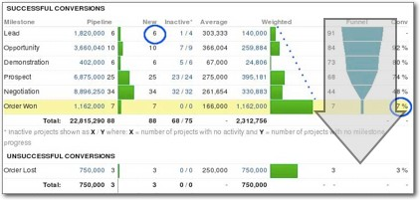

*On2biz*

9

###### Relationships

The structure of a dashboard can also emphasize the relationships between entities or measures. These relationships or connections may be mathematical, geographical, organizational, or functional. Below is a dashboard that explicitly shows the relationships between financial metrics to give users a model for understanding the factors driving net income.

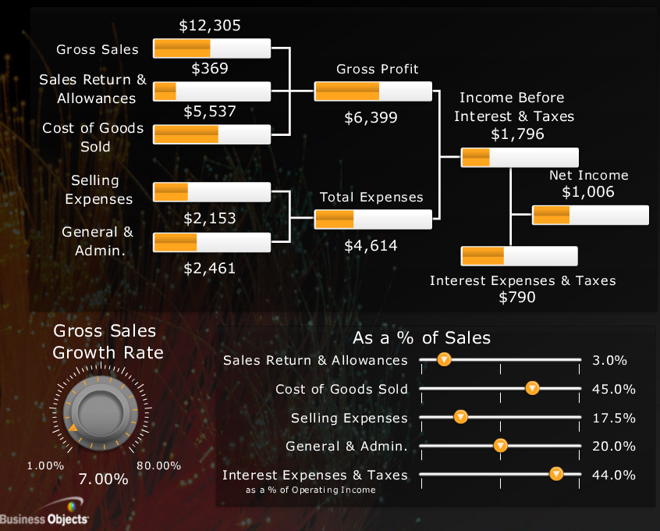

*Business Objects*

###### Grouping

The structure of last resort is to group related information into categories or a hierarchy. The simple act of putting similar things together can bring some logic and accessibility to an otherwise haphazard dashboard. The following dashboard from the New York Times financial section brings related metrics together into three categories. Based on their needs, different users will know where to start in reviewing the performance data.

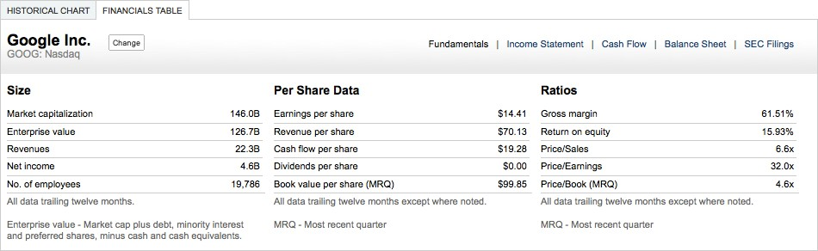

## Design principles

As you get closer to putting pencil on paper to design your dashboard, we’d like to lay out a few core design goals to use as reminders of what is important. We call these goals *design principles*. Below are a few key design principles that we use when we design

10

11

dashboards. By no means should you feel compelled to follow all of these principles; in fact, it is better to pick a one or two high priority principles to help stay focused.

##### Compactness / Modularity

Some dashboards become large and unwieldy in an effort to create a single comprehensive view of an entire business or process. Eric Steven Raymond, writing about good software design [(http://catb.org/~esr/writings/taoup/html/ch04s02.html),](http://catb.org/~esr/writings/taoup/html/ch04s02.html)) offers this guidance:

A dashboard can be broken into bite-sized pieces, each built around a key question. The GE Health Visualizer [(http://www.ge.com/visualization/health_visualizer/)](http://www.ge.com/visualization/health_visualizer/)) by information visualization guru Ben Fry offers a great example of a compact design.

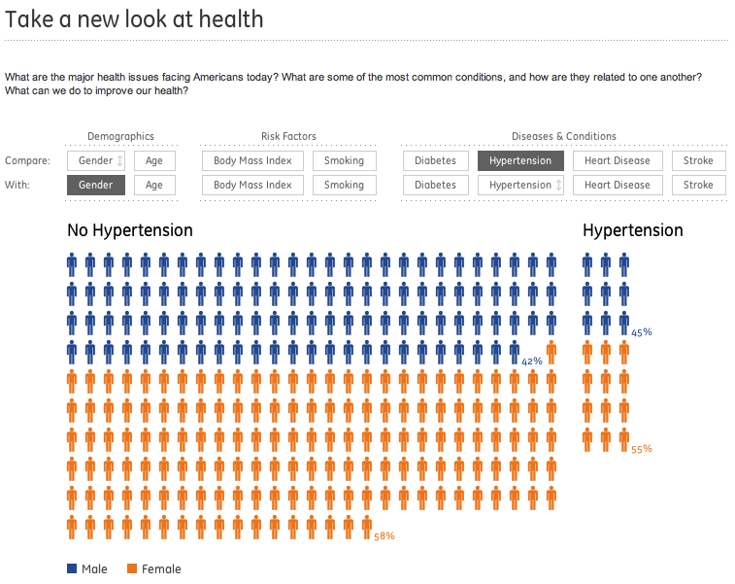

Functionality

12

As we work our way from the big picture to the nuts and bolts of your dashboard design, we want to outline common features that can make your dashboard more useful (Part 3 will offer more detail on the best ways to implement some of these features). Depending on the form that you’ve chosen, the dashboard can be much more than simply charts on a page. Interactive elements highlight key information; user configuration let users customize their view of the data; advanced visualizations make complex data easy to understand and navigate.

The first group of features are the basics that should be considered for any dashboard. A second category of advanced features can differentiate your dashboard and provide exceptional user control and value.

##### Basics

* **Drill down**: Ability to go from a summary metric or view to additional detail that provides more context and/or breakout of the information.
* **Filters**: Allow users to define the scope of the data in the dashboard to reflect their needs. Filters can either be global (refining scope for the entire dashboard) or local (refining scope for a specific chart or metric or view).
* **Comparison**: Ability to see two or more subsets of the data side-by-side. A line chart, for example, may let the user view two geographic regions as separate lines.
* **Alerts**: Highlight information based on pre-defined criteria. The alert may be activated when a metric goes outside of a particular threshold. For more detail on best practices in dashboard alerts, read this article [www.juiceanalytics.com/writing/dashboard-alerts-](http://www.juiceanalytics.com/writing/dashboard-alerts-) checklist/
* **Export / print**: Give users the ability to pull information out of a dashboard. Export to formats that let users do more with the data like Excel and CSV rather than PDF.

The Google Analytics dashboard offers elegant implementations of many of these features: