**Project Name: atoms**

**Java version: 1.8**

**Spring Boot Version: 2.5.2**

Find Project Source file below,



Extract atms.zip and import this project.

Run application as spring boot, the default tomcat server port is 8082.

**An API to get a list of all the atms**

API URL:

<http://localhost:8082/api/atoms>

It will fetch all the atms from provided api [**https://www.ing.nl/api/locator/atms/**](https://www.ing.nl/api/locator/atms/) and return well formatted JSON response

Please find the screenshot below,

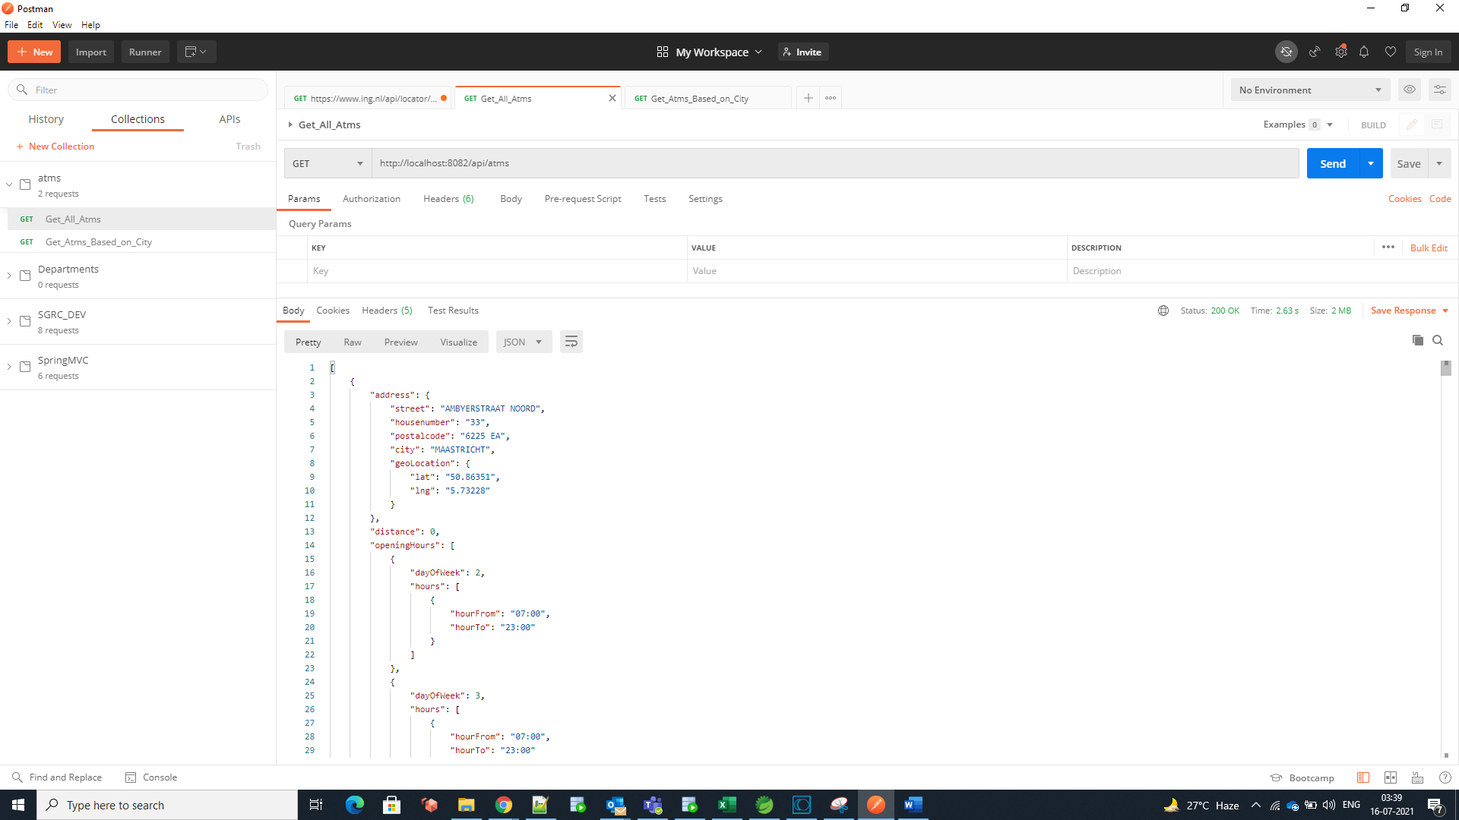

**An API to filter the atms by city**

API URL:

http://localhost:8082/api/atms/city?city=Lichtenvoorde

city will be request param, so in input we must provide to search city.

It will fetch all the atms which have the same city as taken in input

Please find the screenshot below,

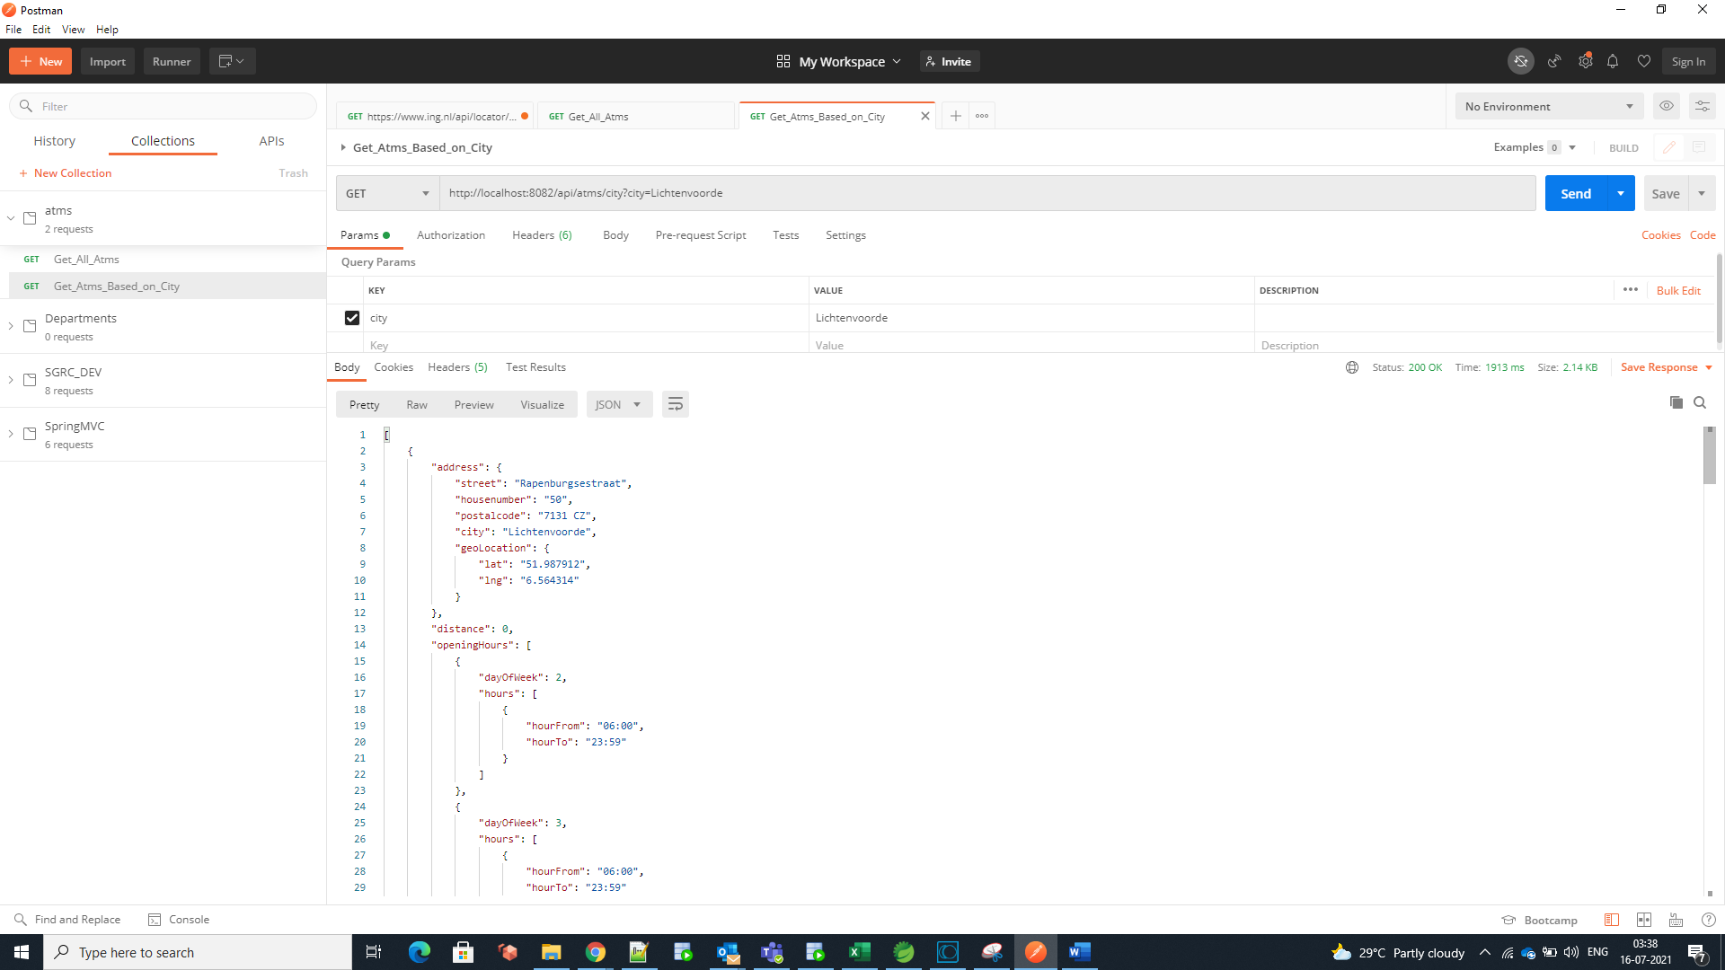

If city is not present, then showing custom message with status 404

For example,

http://localhost:8082/api/atms/city?city=Ranchi

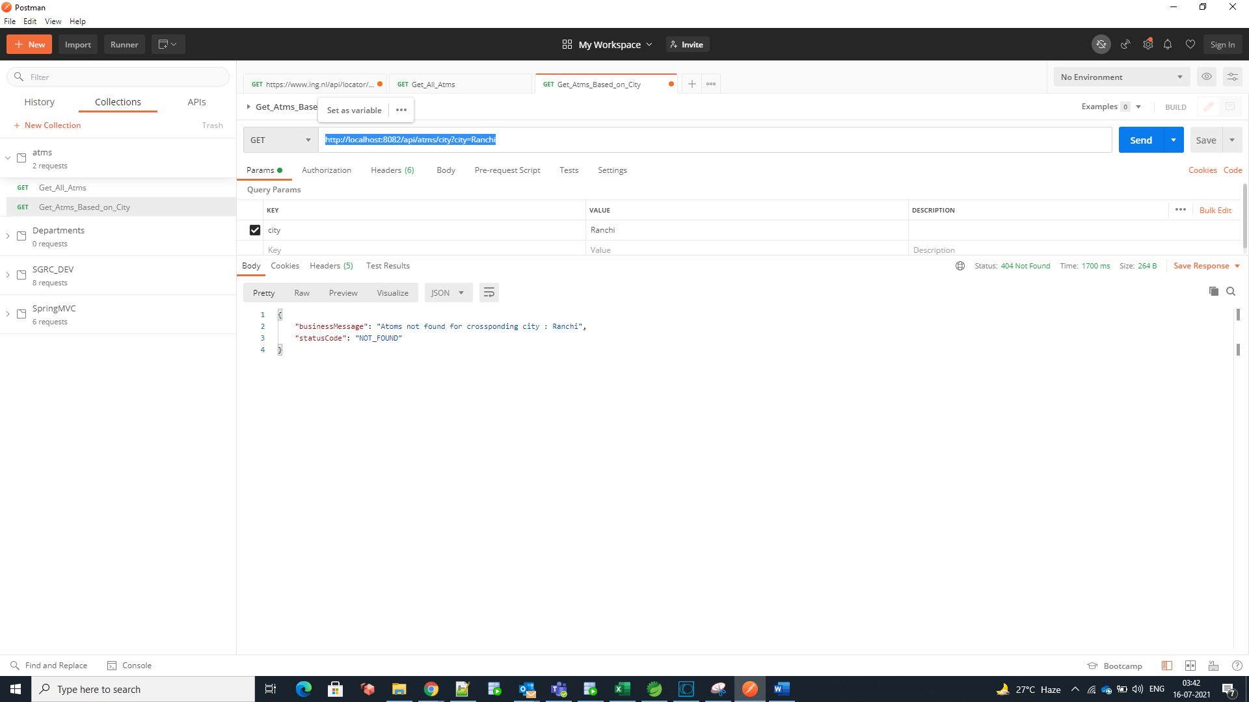

If city is blank, then throwing custom error message with status 400(Bad request)

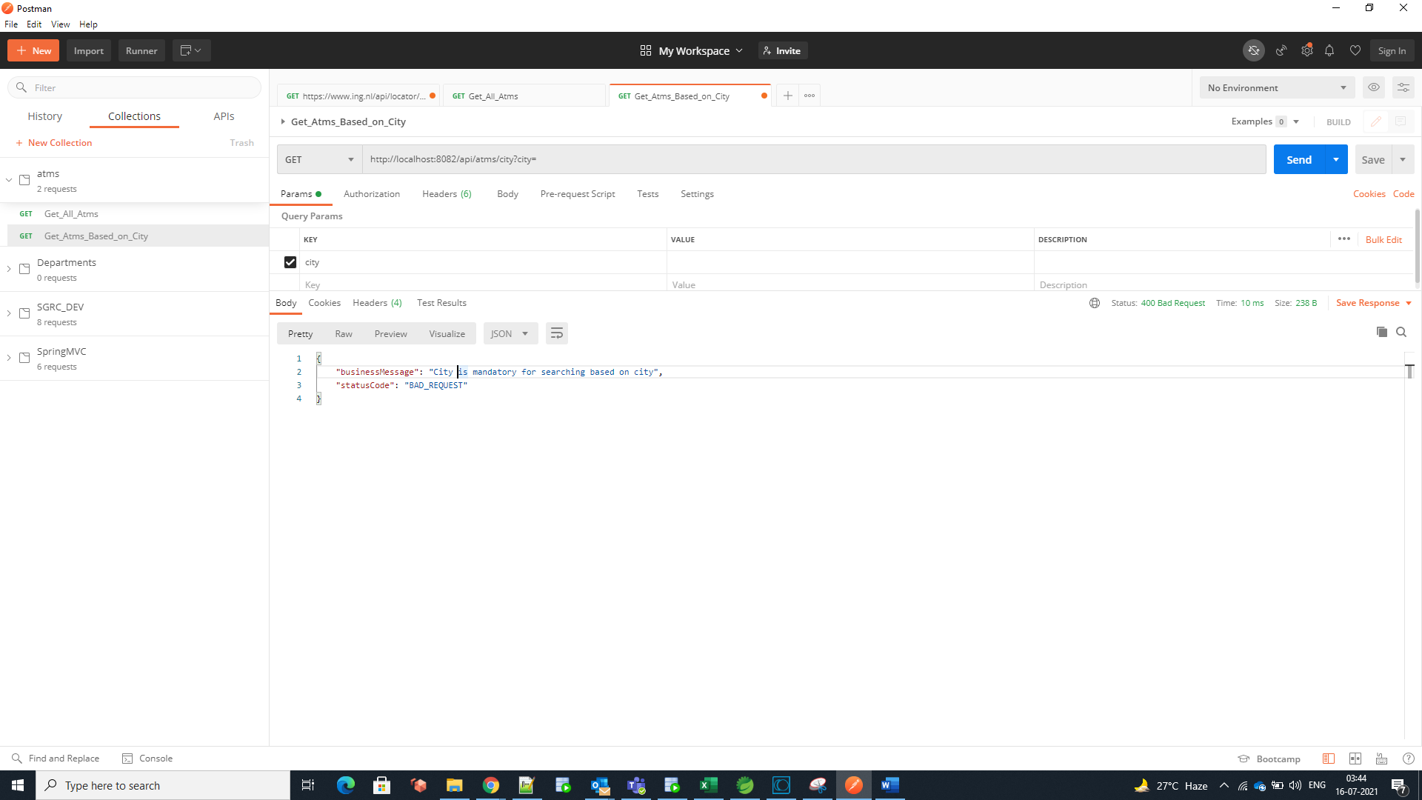

Please find the Postmen Collection below,

