

UNIVERSITY INSTITUTE OF COMPUTING



PROJECT EVALUATION-I
ON
Placement cell Automation

Submitted By: Submitted To:

Amit Tiwari Mr. Ramanjeet Singh
17MCA8145
MCA(3 YEAR/6 SEM)

S.N. | Name of Topic | Page No.
 | Softwere Requirement Specification | p
 | Data Dictionary | p
 | Data Flow Diagram | p
 | ER Diagram
 | Data Tables and Normalization
 | SQL Joins
ABSTRACT:-

“Training and placement office automation system” present web portal designed for managing training and placement data. The objective of this project is to develop a system that can be used by placement cell of a college. The aim of this paper is Automation of Training and Placement until that will include minimum manual work and maximum optimization, abstraction security. This is an web application the purpose is to design a system that provides functionalities to perform the activities related to placement services. It is based on complete modular architecture. This modularity of the architecture will allow us to replace or add modules in the future as a way to enhance a particular feature of particular situation.
INTRODUCTION

Introduction The earlier system is not computerized. All transactions in the system are done manually by maintaining records. It takes much time for a placement officer to collect and approve the details of students. There is poor communication between students and placement officer. . The proposed system is a web based application and maintains a centralized repository of all the necessary information.

The system allows students to access details of recruitments. Training and placement automation system is the data entry is done at a place of occurrence of transaction. This had reduce paper work to large extend. This get information any point of any time. The college collaboration system with training & placement term. The software for the training and placement cell of a college is a vital need for the students and the institute management for the purpose of proper placement and training of the aspiring students of the institute. It helps the students to provide their profiles to the training and placement cell of the institute, update their respective profiles (with their gradual approach towards course end), get to know about the companies coming for the on campus/off campus/pool/group poolcategories of campus interviews.

The system remains connected with the profile databases of the various students to continuously monitor the variety of scopes available for the students' placement

Problem Definition
In an existing system, all processes at the time of placement of students are handled manually by accessing the student information from respective department, which is very slow and consuming much efforts and time. This process is so difficult when the number of users increase. There are many limitations for the existing system; all the work done at placement cell is by human intervention due to which there were more chances of errors. There may be chances of loss of opportunity. Since the number of students are growing and management has to handle records of all students. It is facing a little bit problems in maintaining the records of students .It is required to design of a computerized student automation module to speed up capability

SRS (Software/Project Requirement Specification)
The Software Requirements Specification is produced at the culmination of the analysis task. The function and performance allocated to software as part of system engineering are refined by establishing a complete information description, a detailed functional and behavioral description, an indication of performance requirements and design constraints, appropriate validation criteria, and other data pertinent to requirements.

The proposed system has the following requirements:

  - System needs store information about new entry of Training.

  - System needs to help the internal staff to keep information of Placement and find them as per various queries.

  - System need to maintain quantity record.

  - System need to keep the record of Student.

  - System need to update and delete the record. System also needs a search area.
  - It also needs a security system to prevent data

OS Required

OS can be any when user or client want to acess the Program
but on developer side its made on linux and still completely portable
Operating System(User/Client) | Any
Operating System (Developer) | Any

Hardware Required:-

Need a Proper Internet Connection to communicate to the server but Developer can acess using its local server

Software Required

It’s Work on Browser and on local server it can acess using local port and when its deployed online then it can acess from anywhere
#NOTE:- Need a Proper Internet Connection

Language :-
Frontend | HTML5,JavaScript,BootStrap,CSS
Backend | Python
Framework | Django
Database | Sqlite3

Products Features:-

Login Form For Every User (Student / TPO) :-

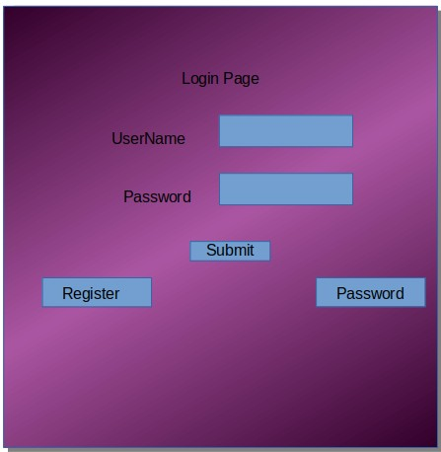
Registration Form For Student

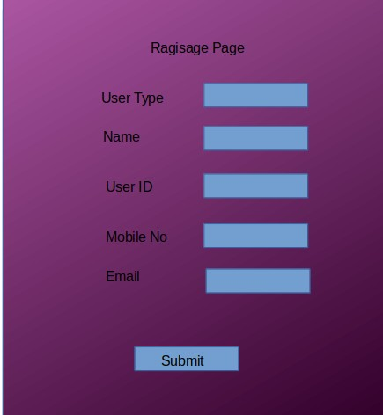

Registration Form For Student:Personal Information, Educational Information, Proffesional Information.

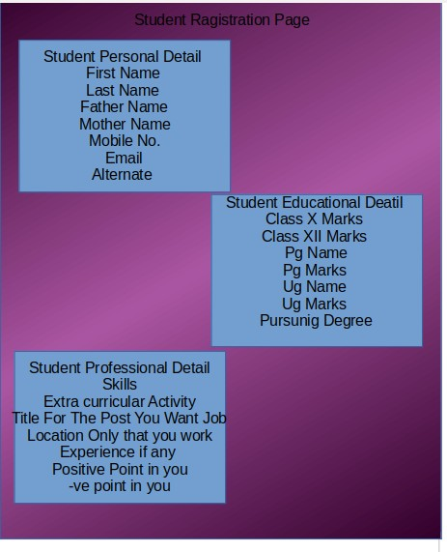

Student Dashboard :-

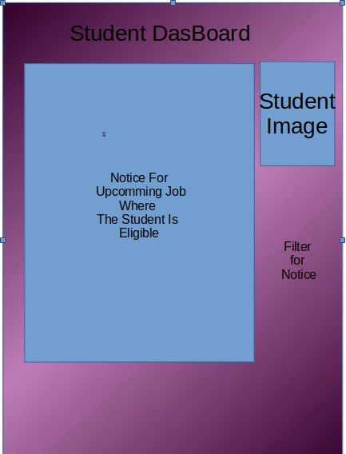
Note:- This Project is in Developing State and in future there will be more theing then now
Employer Dashboard:-

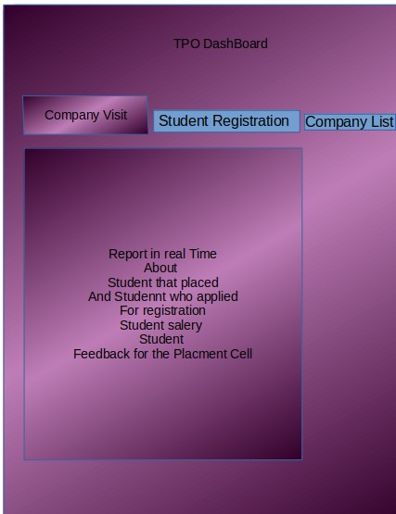
Note:- This Project is in Developing State and in future there will be more theing then now
Data Dictionary:-
Model -Student_Personal_Detail_Model
S.N. | Variable | Variable Name | Measurment Unit | Allowed Value | Description
1 | Student Gender | student_gender | Choices | * ‘Male’ or ‘Felamle’ or  ‘Other’ | Student Required to fill the gender detail
2 | Student Name | student_name | CharField | *Alphabet allowed only 120 Character | Student required to fill there Name
3 | Student UID | student_uid | CharField | AlphaNumeric Field and Allowed 120  Character only | Student Required to fill UID provided by college
4 | Student Image | student_image | ImageField | *Allowed only Image | Student Need to upload Image of himself
5 | Student Email | student_email | EmailField | *Allowed only Email | Student Need To Provide a Valid Email
6 | Student Mobile No. | student_mobile | PositiveIntegerField | *Enter a 10 Digit Mobile No. | Student Need To Provide a Valid Mobile
7 | Student Alternate Mobile No. | Student_alternate_mobile | PositiveIntegerField | *Enter a 10 Digit Mobile No. | Student Need To Provide a Valid Mobile
8 | Student Father Name | student_father | CharField | *Alphabet allowed only 120 Character | Provide by Student
9 | Father Mobile No | student_father_mobile | PositiveIntegerField | *Enter a 10 Digit Mobile No. | Provide by Student
10 | Student Mother  NAme | student_mothehr | CharField | *Alphabet allowed only 120 Character | Provide by Student
11 | Mother Mobile  NO | student_mother_mobile | PositiveIntegerField | *Enter a 10 Digit Mobile No. | Provide by Student
12 | Student Temperory Adress | student_temp_add | TextField | *AlphaNumeric allowed and special Symbol too | Provide by Student
13 | Student Parmanent Adress | student_permanent_address | TextField | *AlphaNumeric allowed and special Symbol too | Provide by Student

Model :- Student_Educational_Qualifications
S.N. | Variable | Variable Name | Measurment Unit | Allowed Value | Description
1 | Student Personal Detail  Model | student_personal_detail_model | Foreign Keyh  and OnDelete=CASCADE | Object that is created by Student Personal Detail Model | It provide to facility to manage all info as it in Student Personal Detail
2 | Student HighSchool Grade | student_highschool_grade | Choices | Allowed only A,B,C,D,E,F | Student need to Choose between given Choices
3 | Student HighSchool Marks | student_highschool_obtain_marks | CharField | Only +ve Number Allowed | Student need To Enter marks obtain in highSchool
4 | Student HighSchool Max Marks | student_highschool_max_marks | CharField | Only +ve Number Allowed | Student need To Enter Total marks high School
5 | Student Inter School Grade | student_inter_grade | CharField | Only +ve Number Allowed | Student need To Enter marks obtain in Inter School
6 | Student Inter School Marks | student_inter_obtain_marks | CharField | Only +ve Number Allowed | Student need To Enter marks obtain in Inter School
7 | Student Inter School Max Marks | student_inter_max_marks | CharField | Only +ve Number Allowed | Student need To Enter Max Marks in Inter School
8 | Student Pursuing | student_pursuing | Choisec | Student Need To Choose The Option of Yes Or NO | Student need To Chck Whether he is pursuing bachlors or not
9 | Student Bachlors In | student_bachalors | Choisec | Student Need To Choose The Option of Courses Given | Studen need To meantion that if he is bachlors or not and select the field
10 | Student Bachlors Marks | student_bachalors_obtain_marks | PositiveIntegerField | Student Need to Enter a Positive Integer | Student Need To Enter The marks obtain in final of bachlors
11 | Student Bachlors Max Marks | student_bachalors_max_marks | PositiveIntegerField | Student need to fill the PositiveIntegerField | Student need to fill marks marks in bachlors
12 | Student Pursunig Post-Graduate | student_pg_pursuing | Choices | Student need to choose between Yes Or No | Student need to chek wether he is PG Or Nor
13 | Student PG In | student_pg | Choises | Student need to choose betwem List of course provide by College | Student need to choose between in which branch he is pursuing hi PG
14 | Student PG Marks | student_pg_obtain_marks | PositiveIntegerField | Allowed only positive numeric No. | Student need to provide a integer which is positive
15 | Student PG Max Marks | student_pg_max_marks | PositiveIntegerField | Allowed only positive numeric No. | Student need to provide a integer which is positive
16 | Student High School Results Upload | student_highSchool_result | FileField | Allowed only Document to upload | Student ned to provide a scan copy of Marksheet
17 | Student Inter School Results Upload | student_interschool_results | FileField | Allowed only Document to upload | Student ned to provide a scan copy of Marksheet
18 | Student Bachlors Results Upload | student_bachalors_marksheet | FileField | Allowed only Document to upload | Student ned to provide a scan copy of Marksheet
19 | Student Bachlors Degree Upload | student_bachalors_degree | FileField | Allowed only Document to upload | Student ned to provide a scan copy of DEGREE
20 | Student Post-Graduate Marksheet Upload | student_pg_marksheet | FileField | Allowed only Document to upload | Student ned to provide a scan copy of Marksheet
21 | Student PG Degree Upload | student_pg_degree | FileField | Allowed only Document to upload | Student ned to provide a scan copy of degree
22 | Student Resume Uplaod | student_resume | FileField | Allowed only Document to upload | Student ned to provide a fresh Copy of Resume Freshely made

Implementation Methodology: Model View Controller or MVC as it is popularly called, is a software design pattern for developing web applications. A Model View Controller pattern is made up of the following three parts: • Model - The lowest level of the pattern which is responsible for maintaining data. • View - This is responsible for displaying all or a portion of the data to the user. • Controller - Software Code that controls the inte vn` 1 4Z4S ractions between the Model and View. MVC is popular as it isolates the application logic from the user interface layer and supports separation of concerns. Here the Controller receives all requests for the application and then works with the Model to prepare any data needed by the View. The View then uses the data prepared by the Controller to generate a final presentable response. The MVC abstraction can be graphically represented as follows.
MVC (Model View Controller Flow) Diagram

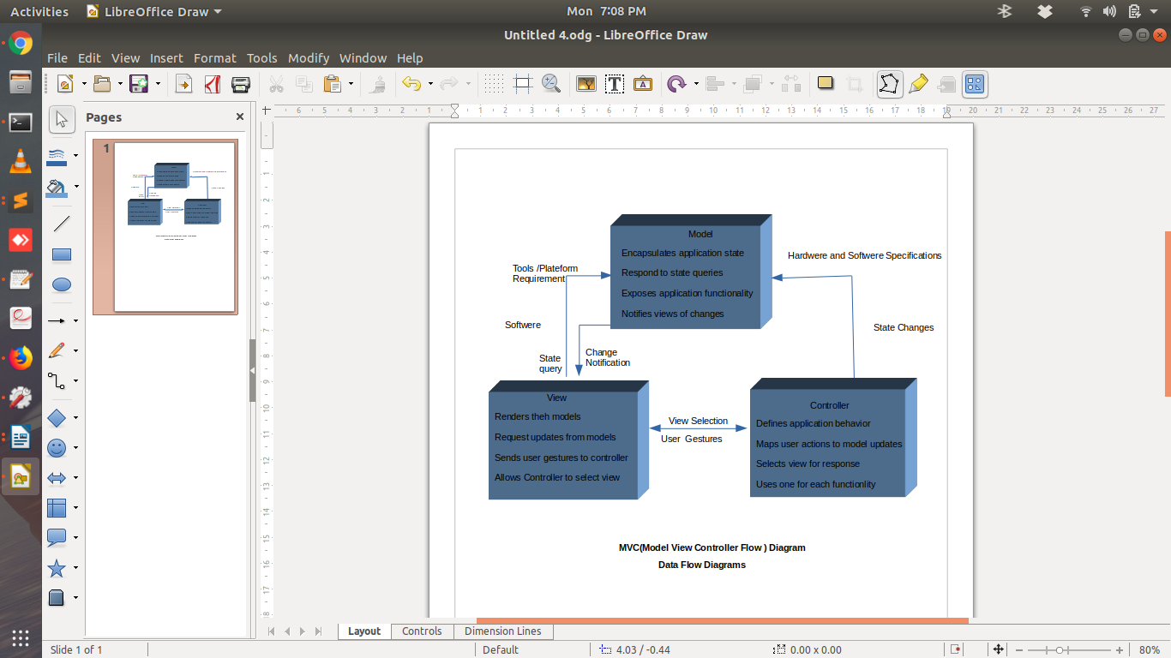

Data Flow Diagram

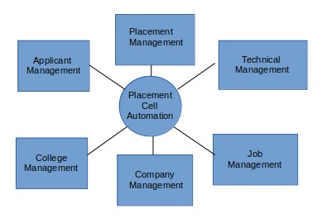
Zero Level DFD-Placement Cell Automation
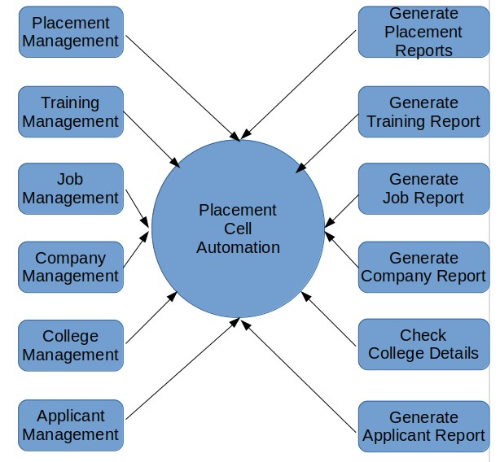
One Level DFD-Placement Cell Automation
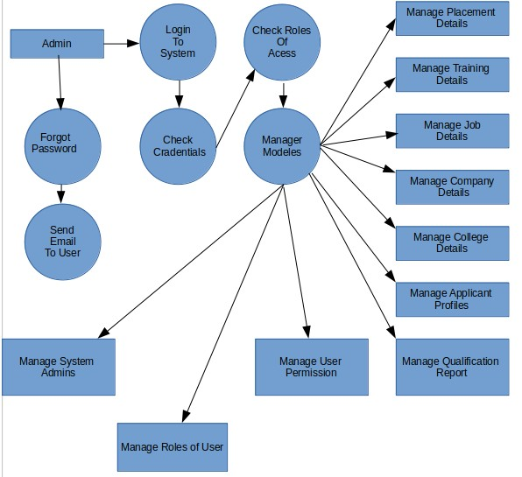
Second Level DFD-Placement Cell Automation
.

Proposed System
The proposed Training and Placement System meant to give more easiness to the users that they can add and retrieve information so quickly. Once you open this web application at the front end all the schedule/event are available to everyone. Also in the every current student login this schedule/event are available. There are mainly six types of users they are Current Student, Alumni, Training and Placement Officers (TPO) of the college, Training and Placement Staff, Departmental Staff and Companies. The administrator is the master user; he gets the most number of priorities than the other users. The different functions involve the case of an administrator are updating, approval. The administrator can view and approve the various application forms
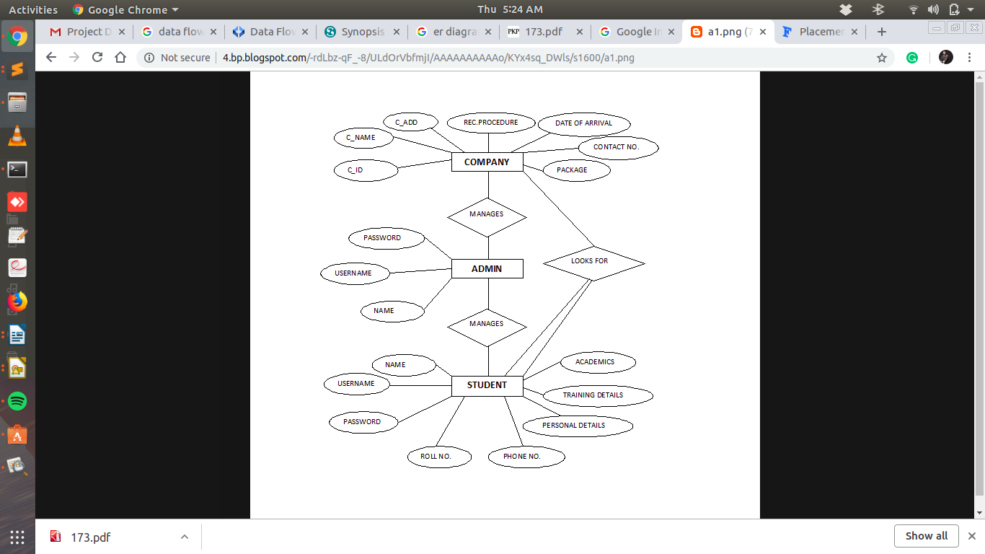
ER Diagram -Placement Cell Automation

