Results

SBERT

Atis_data
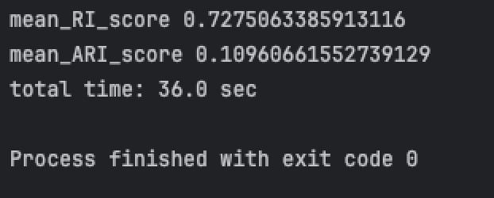

News_mix_data
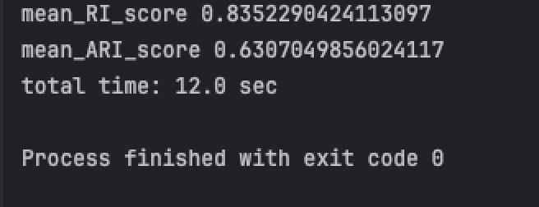

TFIDF

Atis_data
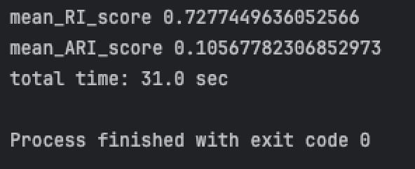

News_mix_data
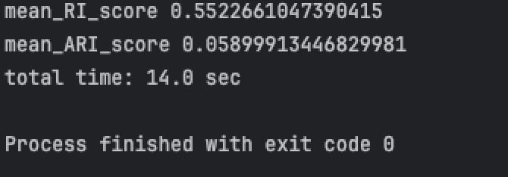

Performance difference
The dataset with the bigger performance gap between TF-IDF and SBERT is news_mix_data.
On the news dataset, SBERT clearly outperforms TF-IDF because news articles are longer and more diverse, and texts about the same topic often use different words. SBERT captures the semantic meaning of the text, while TF-IDF mainly relies on word overlap, which leads to poor clustering.

Clusters inspection

Example 1
- Text: Rachel Dolezal Faces Felony Charges For Welfare Fraud
- True Category: CRIME
- TFIDF: Clustered incorrectly
- SBERT: Clustered correctly
TF-IDF mainly relies on surface keywords such as “welfare” or “fraud”, which can also appear in political or social contexts, causing confusion. SBERT captures the overall meaning of the sentence and understands that it describes a criminal charge, so it places the text in the correct crime-related cluster.

Example 2
- Text: Hospice Overdosed Patients To 'Hasten Their Deaths,' Former Health Care Executive Admits
- True Category: CRIME
- TFIDF: Clustered incorrectly
- SBERT: Clustered correctly
TF-IDF is influenced by medical terms like “hospice” and “health care”, which can lead it to cluster the text with health-related articles. SBERT understands the semantic context of wrongdoing and admission of guilt, allowing it to correctly associate the text with criminal activity.

