When talking about how these metrics (rx_mbps, tx_mbps, rx_pps, tx_pps, rx_dropped, tx_dropped) are calculated and processed in script, it happens in two distinct mathematical stages:
- The Telemetry Delta Calculation: How Python script turns raw switch counters into rates over time.
- The Decision Tree Evaluation: How the model mathematically evaluates those calculated rates to make a split.

Phase 1: Mathematically Calculating the Metrics (Delta & Rate Formulas)
OpenFlow switches only report cumulative lifetime counters (e.g., total bytes since the switch booted up). Ryu controller cannot feed cumulative numbers into an ML model because a switch that has been running for a week will always have massive numbers, whether it's busy or idle.
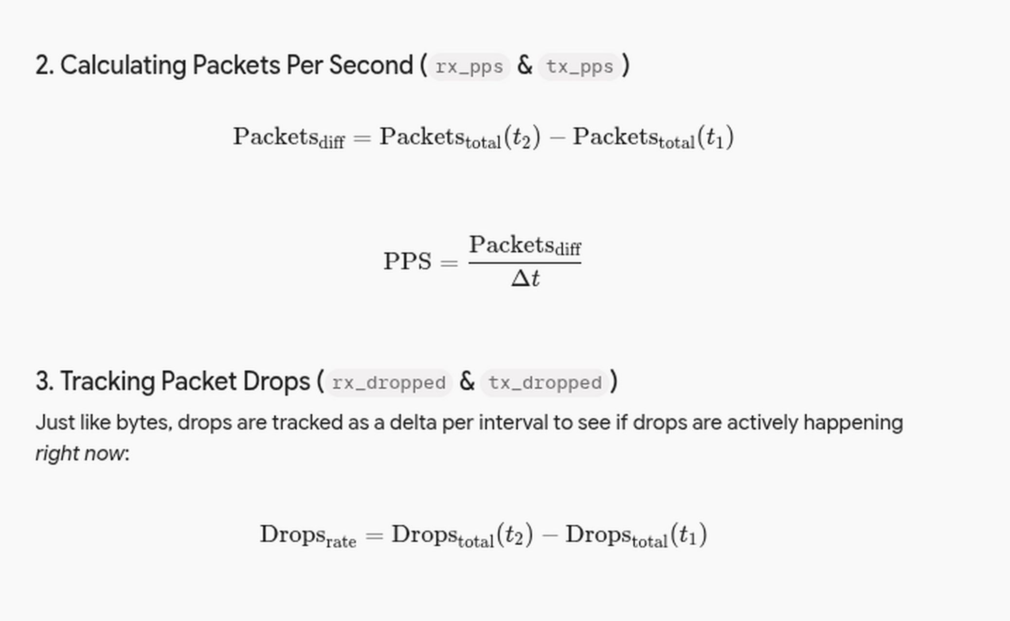
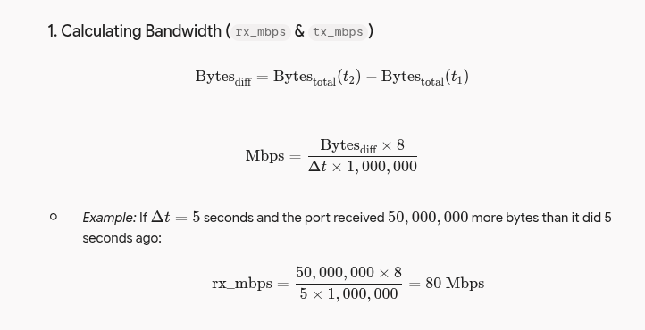
To fix this, script calculates rates by comparing two consecutive polling timestamps ($t_1$ and $t_2$, where time difference $\Delta t = t_2 - t_1$):

Phase 2: How Decision Trees Mathematically Process These Rates
Once script compiles these calculated values into a feature vector:
x = [rx_mbps, tx_mbps, rx_pps, tx_pps, rx_dropped, tx_dropped]
It passes into the Decision Trees of Random Forest.
Mathematically, a decision tree evaluates vector by passing it through optimized mathematical conditions (hyperplanes) learned during training:
- Threshold Comparison (The Split Node): Each node in a tree tests a specific feature against a mathematical threshold ($T$) derived from training data using Gini impurity reduction:
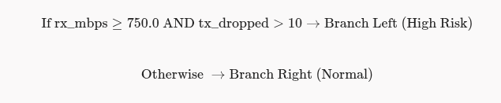
$$\text{Otherwise } \rightarrow \text{Branch Right (Normal)}$$
- Recursive Traversals: calculated feature vector drops down through multiple levels of these threshold checks (e.g., checking throughput first, then cross-referencing packet drop rates to rule out false alarms).
- Leaf Node Assignment: It ultimately lands on a terminal leaf node that outputs a probability or a hard classification label (0 or 1). Across all 100 trees in the forest, the votes are tallied up via majority mode to trigger network rerouting logic!

To see how the 100 trees actually manipulate and evaluate network metrics differently, let's look under the hood at three distinct trees inside Random Forest model (for example: Tree #1, Tree #45, and Tree #99).

Because of Random Feature Subsetting during training, each tree is forced to look at a different combination of 6 metrics (rx_mbps, tx_mbps, rx_pps, tx_pps, rx_dropped, tx_dropped).

Here is how they process the exact same live network snapshot.

The Live Telemetry Snapshot ($x$)
Imagine Ryu controller polls switch s3 right now, and calculates this feature vector:

- rx_mbps = 850.0

- tx_mbps = 100.0

- rx_pps = 15,000

- tx_pps = 2,000

- rx_dropped = 0

- tx_dropped = 120 (Queue is choking on output)

This exact vector is sent to all 100 trees simultaneously. Here is how three different trees manipulate and evaluate it based on their unique internal structures:

Tree #1: "The Bandwidth & Output Drop Specialist"
During training, Tree #1 happened to pull rx_mbps and tx_dropped as its primary split features.

- First Split Node:

  - Rule: Is rx_mbps > 800.0?

  - Evaluation: value is 850.0. (YES)

  - Action: It moves down the Left Branch.

- Second Split Node:

  - Rule: Is tx_dropped > 50.0?

  - Evaluation: value is 120.0. (YES)

  - Action: It moves down the Left Branch to a leaf node.

- Leaf Output: 1 (Congested)

Tree #45: "The Packet Rate Asymmetry Specialist"
During training, Tree #45 was built focusing heavily on packet rates (rx_pps vs tx_pps) and drop rates.

- First Split Node:

  - Rule: Is tx_dropped > 100.0?

  - Evaluation: value is 120.0. (YES)

  - Action: It moves down the Left Branch.

- Second Split Node:

  - Rule: Is rx_pps > 10,000?

  - Evaluation: value is 15,000. (YES)

  - Action: It moves down the Left Branch to a leaf node.

- Leaf Output: 1 (Congested)

Tree #99: "The Flow Gap Specialist"
Tree #99 was trained looking at the massive gap between incoming packets and outgoing traffic (rx_pps minus tx_pps), indicating a filling buffer queue.

- First Split Node:

  - Rule: Is (rx_pps - tx_pps) > 5,000?

  - Evaluation: $15,000 - 2,000 = 13,000$, which is > 5,000. (YES)

  - Action: It moves down the Left Branch.

- Second Split Node:

  - Rule: Is tx_mbps < 500.0? (Checking if the low output speed is causing the buildup)

  - Evaluation: value is 100.0. (YES)

  - Action: It moves down the Left Branch to a leaf node.

- Leaf Output: 1 (Congested)

What about a Dissenting Tree? (e.g., Tree #12)
Not every tree will blindly vote 1. For example, Tree #12 might have been trained primarily on rx_dropped instead of tx_dropped:

- First Split Node:

  - Rule: Is rx_dropped > 0?

  - Evaluation: value for rx_dropped is 0. (NO)

  - Action: It moves down the Right Branch.

- Second Split Node:

  - Rule: Is rx_mbps > 900.0?

  - Evaluation: value is 850.0. (NO)

  - Action: It moves down the Right Branch to a leaf node.

- Leaf Output: 0 (Normal)

The Final Tally Across All 100 Trees
When you scale this manipulation across all 100 trees:

- 88 trees (like Trees #1, #45, and #99) find matching patterns in throughput, output drops, and packet rate mismatches and vote 1.

- 12 trees (like Tree #12) look at features that didn't trip their specific thresholds and vote 0.

The algorithm aggregates them:

Final Score = \88 votes of 1/100 = 0.88 (88\% Confidence)
Since 0.88 > 0.5, the forest's final consensus is 1, successfully proving to Ryu controller that switch s3's port is heading into a choke point, triggering the dynamic route shift to s5-s6!
Visualization of Tree Diagram

Part 1: Visualizing the Decision Trees (ASCII Diagrams)
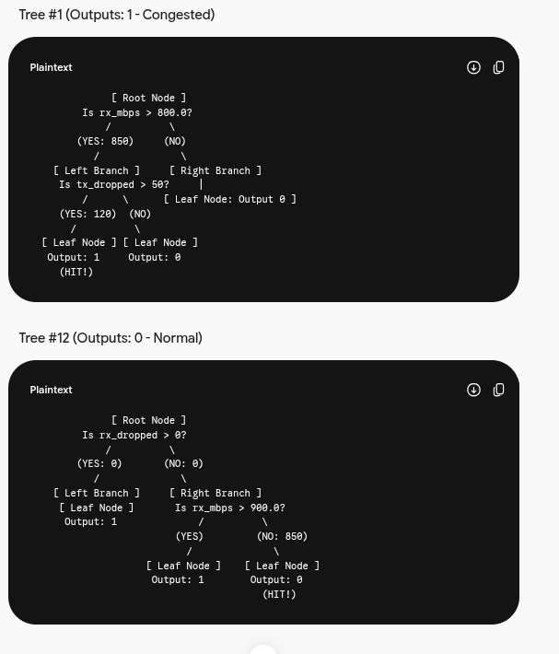
When live telemetry vector hits the forest, each tree acts like a branching flowchart. Let's look at how Tree #1 (which votes 1) and Tree #12 (which votes 0) process data:

Part 2: How the Final Prediction is Calculated Mathematically
Once all 100 trees finish evaluating vector ($x$), they each return a probability or a discrete vote (0 or 1).
Suppose the breakdown across 100-tree forest is:
- 88 trees follow paths similar to Tree #1 and output 1 (Congested).
- 12 trees follow paths similar to Tree #12 and output 0 (Normal).

Step 1: Summing the Votes or Probabilities
If the forest uses Hard Voting (majority rule of the binary outputs):
Total Votes for 1 = 88
Total Votes for 0= 12
If the forest uses Soft Voting (averaging the output probabilities of all trees):
- Let's say the 88 trees output high confidence scores (e.g., averaging 0.92), and the 12 dissenting trees output low scores (e.g., averaging 0.20).

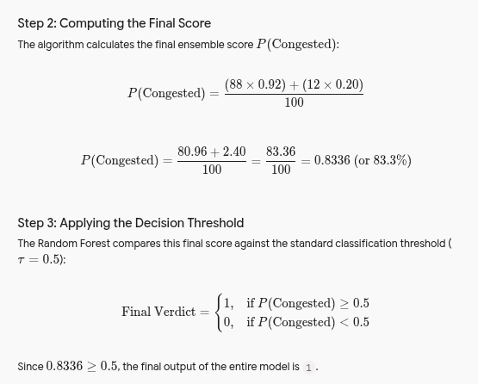

This final 1 is instantly returned to Ryu controller loop, triggering the cost re-evaluation and shifting traffic away from the bottlenecked switch to alternative path (s5 -> s6)

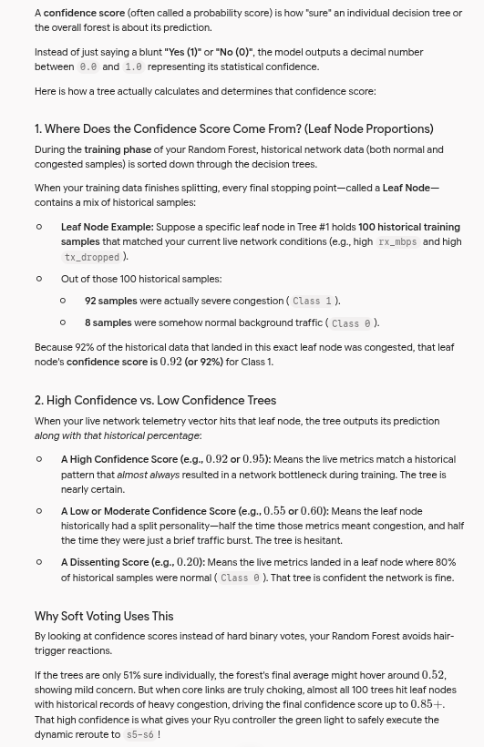
Confidence Score

