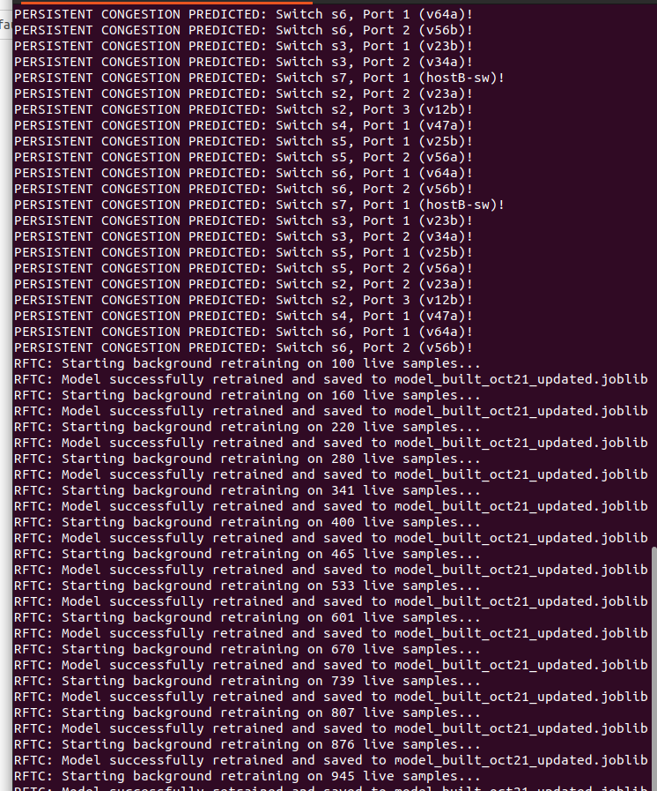

Log Message / Component | Meaning & Explanation
PERSISTENT CONGESTION PREDICTED: Switch s6, Port 2 (v56b)! | The Trigger: The system's predictive model has flagged a potential long-term bottleneck or traffic jam on Switch 6 (s6), Port 2, specifically impacting the link or virtual LAN segment v56b. This alert likely kicked off the automated background processes that follow.
RFTC | The Subsystem: Stands for Reinforced/Rapid Fine-Tuning & Continual (or Real-time Feedback Training / Retraining). This is the background service responsible for updating the machine learning model using live, newly gathered telemetry data.
Starting background retraining on $X$ live samples... | Incremental Learning Phase: As new network traffic data flows in, the system collects batches of live samples (starting at 100 and scaling up incrementally to 533). It uses these recent observations to update its understanding of network behavior.
Model successfully retrained and saved to model_built_oct21_updated.joblib | State Update: Once a batch of retraining finishes, the updated machine learning weights are serialized and saved using Python's Joblib library (.joblib), ensuring the system uses the freshest predictive model for future network states.

Key Takeaways
- Adaptive Learning: The system doesn't just raise an alarm; it actively learns from the ongoing congestion event in real-time.

- Progressive Scaling: The sample size grows with each iteration (from 100 up to 533), suggesting an accumulation of ongoing streaming data as the congestion persists on Switch 6.

