This is a simple Tic-Tac-Toe game implemented in Python using the Tkinter library. Here's a detailed breakdown of the code:

**Key Features:**

Canvas for the Game Board:

A 300x300 pixel grid is drawn on the Canvas widget, with dividing lines forming a 3x3 grid.

**Game Variables:**

self.current_player tracks whose turn it is ("X" or "O").

self.board is a 3x3 matrix representing the state of the game board.

**Player Interaction:**

Mouse clicks (<Button-1>) are bound to the click method.

Clicking within a grid cell determines which player places a mark ("X" or "O").

**Rendering Player Moves:**

"X" is drawn as two intersecting lines.

"O" is drawn as a circle.

**Game Logic:**

The check_win method checks if any row, column, or diagonal contains the same mark.

The check_tie method determines if the board is completely filled without a winner.

The game_over method displays a message in the center of the canvas when the game ends.

**Dynamic Turns:**

Players alternate between "X" and "O" after each valid move.

**Reset Option:**

Add a button to reset the board and start a new game.

**Visual Feedback:**

Highlight the winning row, column, or diagonal.

**Enhanced Win Messages:**

Correctly display the winner's name ("X wins!" or "O wins!").

**Refactor Code for Reusability:**

Extract repetitive drawing logic into helper methods for better maintainability.

**AI Opponent:**

Add single-player mode with an AI to make moves.

**Styling:**

Customize colors, fonts, and sizes for a more polished look.

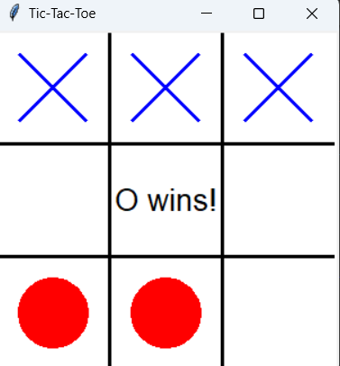**SCREENSHOTS**

