Module-1

1. what is software? what is software engineering?

(a)ans. software is a set of instruction,data,or programs that call computer and other devices how to do it that called a software.

(b) the engineering is a engineering branch related to he evoluction of software product using well defined scientific to come in the principles,procedures and techniques

2. expalin types of software ?

ans. thare are (4) types of software 1)presection layer 2)application layer 3)business layer 4)data base layer

expalin :-

(1)the presaction layer are use to the file transfar requst in the binary code so can receving to its was the translate to a application layer expects.

(2)business layers the it was a give for the access a data layers its the number of hierarchical levels or mangement tiers within the organization

(3)allows uesrs to application layer send to eich other files through a network

(4)data base layer a vital part of an application or organization that massages ,store ,and rertiver data

3. what is SDLC? explain each phase of SDLC?

ans . the SDLC are a one type of software cycle to add the any product to wedside it was the devlpoer are use to the SDLC cycle to etc

phase of SDLC

1. planning :- it was the first step of sdlc to make the any wedside it was a first anyy devloper are the make a planning it was planning was the most usesed step to make the wedside.

2. analysis :- it analysis are the use to what are the use to palanning was the make to it was the analysis to the all are right to come the next step to etc.

3. design :- create the architecture of the software this step includes system design and design of system comonents to make the website design.

4. implemention :- the devloper are the make to the design and it was analysis to the planning to its was the implementation the it was the implement the design to etc.

5. testing :- it was the website most of the complete to that time was the testing its was the use to the any coding was a not a prefect to it was the return to your website and it was a called to the testing.

6. maintenance:- the all step are the good to time the run a website to any website are the time to take it was the go to the under maintenance to it was a few minute go than etc.

4. what is DFD? Create the diagram DFD on flipkart?

Ans. DFD is the data flow diagram it was the easy to explain or preastion to the a any data to other to flow information.

diagram:-

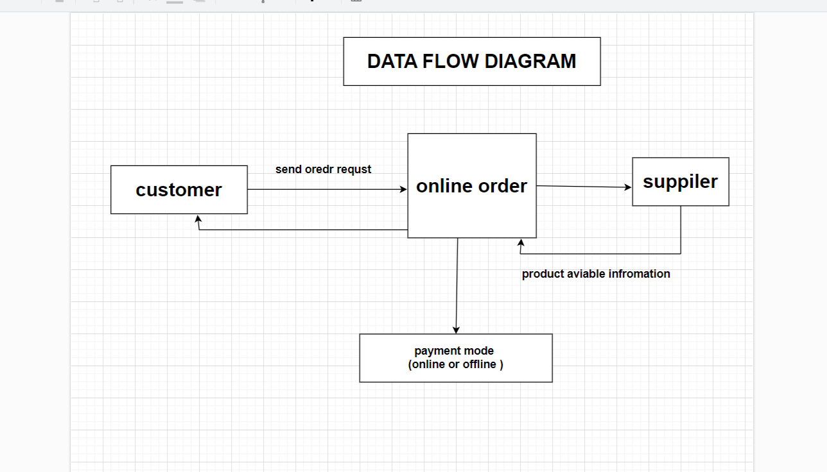

5. what is flow chat? Create a flow chart to make addition of two numbers

Ans. Flow chat is the a pictorial representation of algorithm because flowchart is made up of different shapes it is the easy to representation to data.

6. what is the user case diagram? Create a use case on bill payment on paytm?

Ans. 

