1. **Using photoshop show the gold bevel effect to a text “Gold Russ Jewelry”**

**STEPS:**

* Select File>Open on the Photoshop banner bar.
* Click on Goldstart.jpeg file to open.
* Text added to the file.
* New Text layer added over the Background layer.
* Click on Select>Load Selection on the Photoshop banner bar.
* Gold Rush Jewelry selected
* Click on Select>Modify>Contract on the Photoshop banner bar.
* Modify>Contract Control Panel open. Set contract to 5 pixels.
* Click on Edit>Copy on the Photoshop banner bar.
* Click on Edit>Paste Into on the Photoshop banner bar.
* Layers Palette open showing addition of New Layer
* Select>Load Selection from the Photoshop banner bar.
* Load Selection Control Panel open Select the Layer 1 Mask Channel.
* Select>Modify>Contract from the Photoshop banner bar.
* Select>Modify>Contract control panel open, set Contract amount to 3 pixels.
* Selection inside Text, 3 pixels smaller than original text.
* Select Edit>Copy from Photoshop banner bar.
* Select Edit>Paste Into from Photoshop banner bar.
* Layers Palette showing addition of another new layer. Layer 2
* Select Gold Rush Jewelry Layer, Click on Add a Layer Style Button, select Bevel and Emboss from popout menu.
* Layers Style Bevel and Emboss Palette showing:Depth: 331%Size: 2 pixels
* Gold Rush Jewelry Layer selected., Click on Add a Layer Style Button, select Color Overlay from pop out menu.
* Color Overlay control panel open showing default settings. Click on Color Swatch to select color from Color Picker.
* Color Picker open, select a Gold color. R= 198, G= 157, B= 33, you can also type the values into the RGB boxes.
* Color Overlay control panel open showing new setting. Color Swatch shows new Gold color from Color Picker.
* Layers Palette open showing Layer 1 selected (Blue Highlight). Also notice that the Gold Rush Jewelry layer has two Layer Style effects applied.
* Layers Palette open, click on Add a Layer Style button and select

Bevel and Emboss. Also you can Mouse Click and hold the Layer Styles then Drag and Drop them onto another Layer.

* Layers Palette open, three layers with Layer Styles applied.
* Results of Bevel and Emboss plus Color Overlay on the three layers, that make up the Gold Rush Jewelry text.
* Layers Palette open, select Layer 2 or the top layer on the stack of layers. Click on the layer link icon space and link the other two layers to Layer 2. Click on the small arrow at the upper right of the Layers Palette.
* Select Merge Linked in the pop out menu.
* Layers Palette showing the results of merging the linked layers.
* To add a bit more of a 3D look to the text, we add a Drop Shadow to the Merged Layers. Click on the Add a Layer Style Button, select Drop Shadow.
* Adjust the settings for the Drop Shadow so it gives the 3D impression.
* Layers Palette showing the addition of the Drop Shadow style to the layer.
* Drop Shadow style added to the text layer.
* Click on small arrow at upper right of Layer Palette select Flatten Image, or select Layer>Flatten Image from the Photoshop banner bar.
* Layers Palette showing Flattened Image with only a Background layer.
* Flattened Image can now be saved as jpeg,tif etc.

**OUTPUT:**



1. **Using photoshop show the shadow and lighting effect on a text “Shadow Rider”.**

**STEPS:**

* Select File >New from the Photoshop banner bar.
* New File control panel open, File size 4x6 inches at 200dpi Contents: White.
* New File, size 4x6 inches at 200dpi Contents: White
* Select Type Tool in the Photoshop toolbar, using a Bold Face font and Black for the Font color, add text to the image.
* Layers palette open showing the addition of a new text layer, Shadow Riders.
* Click on the small arrow at the upper right of the Layers palette,
* Select Duplicate Layer from the popout menu.
* Duplicate Layer control panel open.
* Layers palette showing addition of Shadow Riders copy layer.
* Select Edit>Transform>Flip Vertical on the Photoshop banner bar.
* Shadow Riders copy layer flipped vertically. Click on the Move tool or press the “ V “ key on the keyboard to select the Move tool. Move the Shadow Riders copy text down.
* Move the Shadow Riders copy text down until the bottom of the texts are still touching.
* Select Edit>Transform>Perspective, notice that the Perspective Transform function is grayed out and not available. This is because the Layer selected Shadow Riders copy is still in vector space.
* Shadow Riders copy layer still in vector space.
* Select Layer>Rasterize>Type from the Photoshop banner bar. This changes the vector text into a raster layer.
* Shadow Riders copy layer is now in raster space.
* Select Edit>Transform>Perspective, notice that the Perspective Transform function is now available.
* Perspective Transform function active around Shadow Riders copy layer, to give the text perspective, click on the lower outside handle and drag it to the side. If the perspective is not right click the ESC key on the keyboard and start over. When the perspective is right click the Enter key on the keyboard, this sets the perspective transform.
* Layers Palette open, Shadow Riders layer is active layer. Click on the Add a Layer Mask button at the bottom of the Layers Palette.
* Layers Palette open, Shadow Riders layer is active layer. Layer Mask has been added to the active layer. Layer Mask is selected, notice the mask symbol before the Layer.
* Select the Gradient Tool in the Photoshop toolbar, the gradient will be applied to the Shadow Riders copy Layer Mask instead of the Layer itself.
* Gradient Tool options in the Photoshop tool options banner bar. Select Black to White Linear Gradient
* Drag the Gradient tool from the bottom center of the Shadow Riders inverted text to the top of the inverted text. This fades the text the farther it is away from the original text.
* Layers Palette open Shadow Riders copy Layer Mask showing Gradient added to it.
* Select Filter>Blur>Gaussian Blur on the Photoshop banner bar. The Layer Mask for the Shadow Riders copy layer is still selected so the filter will blur the Mask.
* Results of Gaussian Blur on the Layer Mask for the Shadow Riders copy layer.
* Click on the Background Layer to select it.
* Select Filter>Render>Lighting Effects on the Photoshop banner bar.
* Lighting Effects control panel open, set the controls as shown. Color swatch is a Dark Orange
* Results of Filter>Render>Lighting Effects on the Background layer of the image
* Select Filter>Render>Lens Flare on the Photoshop banner bar.
* Lens Flare control panel open set the Lens Flare as shown.

Brightness: 49%, Lens type: 105mm prime. To move the flare click on it and drag the flare to a high center position.

* Results of Filter>Render>Lens Flare on the Background layer of the image.
* Flatten the Image and save as jpeg, tiff etc.

**OUTPUT:**

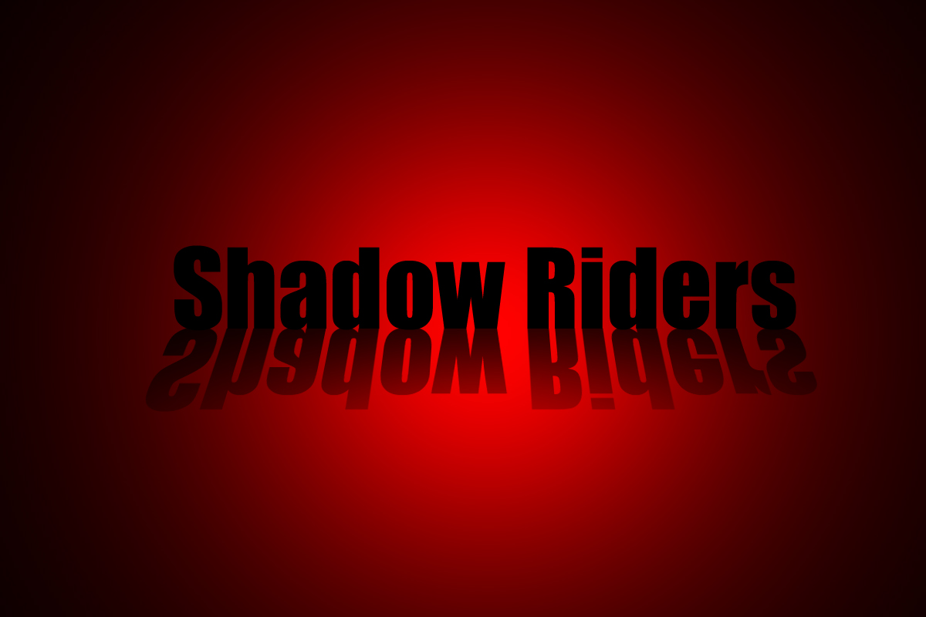

**3. Using photoshop show the glass like effect on the text “Black Hole Electronics”.**

**STEPS:**

* Open Background1.jpeg image.
* Select the type tool in the Photoshop tool bar, make the foreground color 1.Select File>Open on the Photoshop banner bar, open the White.Type in a text message on the image.
* Layers palette open showing the addition of a new text layer. Click on the Add a Layer style button at the bottom of the Layers Palette.
* Click on Bevel and Emboss in the pop out menu.
* Bevel and Emboss control panel open. Match the Settings in the control panel,Gloss Contour is Double Ring, Click on small arrow next to the contour to find it.Click OK
* Drag the slider for the Fill of the layer to 0%.
* Results of Bevel and Emboss and layer Fill at 0%
* Click on the small arrow at the upper right of the Layers Palette, select Flatten Image from the pop out menu.
* Image Flattened, save as jpeg,tiff etc.
* Final image with glass text.

OUTPUT:

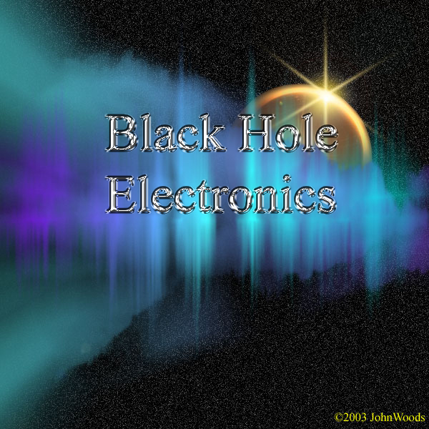

**4. Using photoshop create a metal mesh screen over the top of an image.**

**STEPS:**

* Select File>New on the Banner Bar
* File>New control panel open. Set the width and height to 25 pixels and the resolution to 50 pixels. Set the Contents to Transparent.
* Results of 25x25 pixels with Background Transparent.
* Select>All from the Banner Bar.
* Marching Ants around File
* Select Edit>Stroke from the Banner Bar
* Edit>Stroke control panel open, set the Width to 6 Pixels and the color to a medium gray color. Set the Stroke to Center
* Results of Edit>Stroke at 6 Pixels Medium Gray
* Select Edit>Define Pattern from the Banner Bar
* Define Pattern Name control Panel open, change the name to Small Wire Mesh.This sets the Small Square with the Transparent Background into the Pattern Pre­sets.
* .Select File>New from the Banner Bar
* File>New control panel open. Set the Width and Height to 4”x4” at 200 pixels per inch. Set the contents to Background Color. If you want the Background color Black Press the D key to set the Foreground and Background to default Black and White then press the X key to flip the default colors so Black is the Background color. Or select Edit>Fill with Black from the Banner Bar.
* .Results of File>New at 4”x4” at 200 pixels per inch.
* Select Layer>New from the Banner Bar
* Layer>New control Panel open, rename the layer Mesh Layer
* Mesh Layer added above the Background layer.
* Select Edit>Fill from the Banner Ba
* Select the Small Wire Mesh pattern that you created at the start of this tutorial.
* Mesh Pattern applied to the Mesh Layer
* Mesh Layer selected (Blue Highlight) Add a Layer Style popout menu open
* Mesh Layer selected (Blue Highlight) Add a Layer Style popout menu open Bevel and Emboss selecte
* Layer Style>Bevel and Emboss control Panel open, notice the Style is Inner Bevel, the size is 5
* Results of Bevel and Emboss Layer Style applied.
* Closeup of Bevel and Emboss Layer Style applied.
* Mesh Layer selected with the Bevel and Emboss Layer Style applied.
* Channels Palette open notice that there are three color channels and one master channel (RGB). There are no Selection channels at this time.
* Select>Load Selection from the Banner Bar.
* Load Selection Control Panel open, Select Mesh Layer Transparency
* Mesh Layer selected, marching ants are around the cross members of the Mesh.
* With the Mesh Layer selected and the marching ants around the cross members of the Mesh, Select>Save Selection.
* Save Selection Control Panel open, rename the selection Mesh Screen. Click OK
* Layers Palette Open with Mesh Layer Selected.
* Select Filter>Add Noise from the Banner Bar.
* Filter>Add Noise Control Panel open, noise added to grid. Click OK
* Click on Add Layer Style Icon, then Select Color Overlay
* Color Overlay Control Panel open, Click on Color Swatch to change overlay color.
* Color Picker Control Panel open, Select a Rusty Brown color R=143,G=111,B=56
* Color Overlay Control Panel open, color changed to Rusty Brown, and the Opacity of the Color Overlay has been lowered to 71%.
* Select>Deselect from the Banner Bar
* Channels Panel open, Color Overlay applied to the Mesh Layer.
* Metal Mesh showing Bevel and Emboss plus Noise and Color overlay added.

**OUTPUT:**

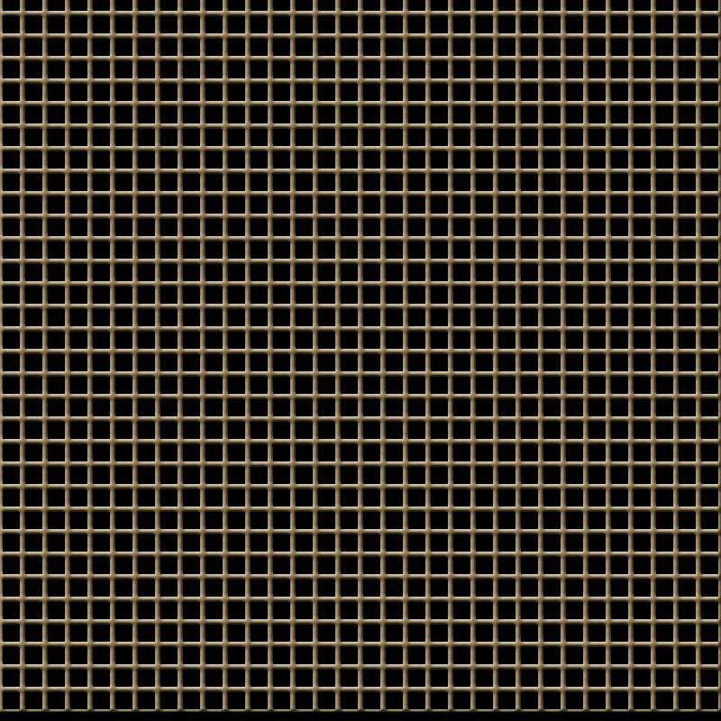

**5. Using photoshop, show the lighting effect of a given image.**

**STEPS:**

* Open the source_girl.jpeg image. The original photo is a bit dark and her skin is not bright and lovely enough. In this case, we can use **Channel Mixer** tool to enhance the colors separately. You can find this tool at the bottom of Layers tab If you are new to this tool, I wish to explain more about it. As you knew, a photo is based on three main colors (in RGB mode): red, green and blue. With the Channel Mixer tool, you can manipulate these raw channels separately. Notice that when choosing Channel Mixer tool, you will see there are 3 options in the Output Channel drop-down box corresponding to 3 main colors. And you can also notice that with each main color, the slider of that color will always be set to 100%, by default. For example, when you choose Red from Output Channel, you can see the Red slider are at 100% (while Blue and Green are at 0%). And by moving these sliders left or right, you can decrease or increase the amount of that color in the corresponding Output Channel.
* Press **Ctrl-Alt-Shift-E** to create a flatten image which is the result of the under layers. In this step, we will smooth her skin a bit by going to **Filter>Blur>Surface Blur**, set the **Radius of 2 pixels** and **Threshold of 4 pixels** Maybe you will not see any big changes but let's have a closer look. By using this tool with a small Radius and Threshold, you can make subtle changes without making it look fake
* Go to **Image>Adjustments>Curves** to brighten our photo a bit We are almost done, the photo now looks much better:
* The last thing we need to do is to add lighting focus to emphasize her beautiful face. Press **Ctrl-J** to duplicate the current layer and go to **Filter>Render>Lighting Effects** and use these settings:

Then change the Blending mode of this layer to **Soft Light** to make the colors "softer".

**OUTPUT:**

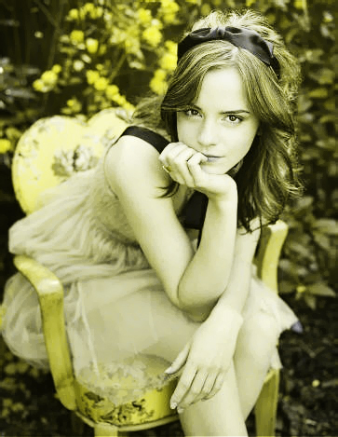

**6. Using photoshop, show the darken effect of a given image.**

**STEPS:**

* Open the source_girl2.jpeg image. Duplicate the layer by pressing Ctrl+J and go to

Filter> Blur> Gaussian Blur and apply these settings:

* Set the layer blending mode to 'Overlay'.
* Merge the layers together by pressing Ctrl+E. Again duplicate the layer and go to Filter> Blur> Motion Blur and apply these following setting:
* Set the layer blending mode to 'Overlay' and merge the layer together.After this your Image looks like this:
* Create a new layer and fill with white using Paint Bucket Tool.Set this layer mode to 'Overlay' and do not merge.
* Press 'D' to reset your color palette. Set your foreground color to #000099 and background to white. Create a new layer and fill with this color (#000099).
* Go to Filter> Render> Clouds. Set the layer blending mode to 'Overlay' and Opacity on this layer to 57%.
* In this step create a new layer again and fill it with white. Set the layer blending mode on this layer to'Difference'.
* In the Final step duplicate your background layer. Move this layer to 2nd from the top under white layer and set the layer blending mode to 'Darken'.

**OUTPUT:**

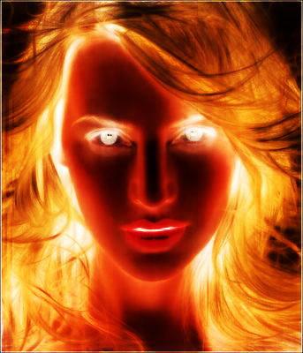

**7. Using photoshop, merge two or more images.**

**STEPS:**

* The first, you open Photo1, then open Photo2 and cut the model out
* Move the model to Photo1
* Now you will make the background brighter.

Select layer background, press Ctrl+M to open Curves, do as the picture below:

* Select layer model, press Ctrl+U to open Hue/Saturation
* Open Photo3, move it to your document, change Blend mode to Screen, adjust Opacity 50%
* Open Photo4, use Magic wand tool to cut the petals out of background. Change Blend mode to Screen.
* Create a new layer, use soft brush 100px, brush around the model then go to Filter -> Blur -> Radial Blur
* Change blend mode of layer brush to Screen, you will get:
* Create a new layer, fill layer with color #988675, change blend mode to Overlay and you will get:
* Merge Visible all layers, then press Ctrl+M to open Curves, set properties like this:
* Open Curves one more time and do as the picture below: You will get the final result:

**OUTPUT:**

