**Integration of TESTNG with WebDriver Using Chrome**

**Step – 1 Download the TestNG Jar**

<http://mvnrepository.com/artifact/org.testng/testng/6.7>

**Step -2 Add a TestNG Plugin in Eclipse**

Help🡪 Eclispe Market Place

**Step – 3 Download the Selenium Jar**

<http://www.seleniumhq.org/download/>

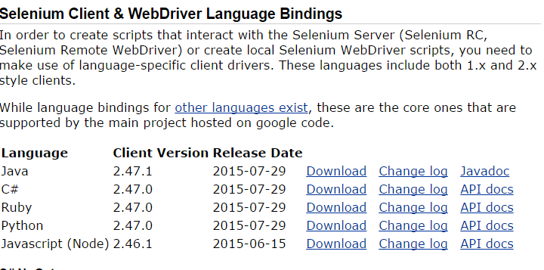

**Step-4 Download the Chrome Driver Exe**

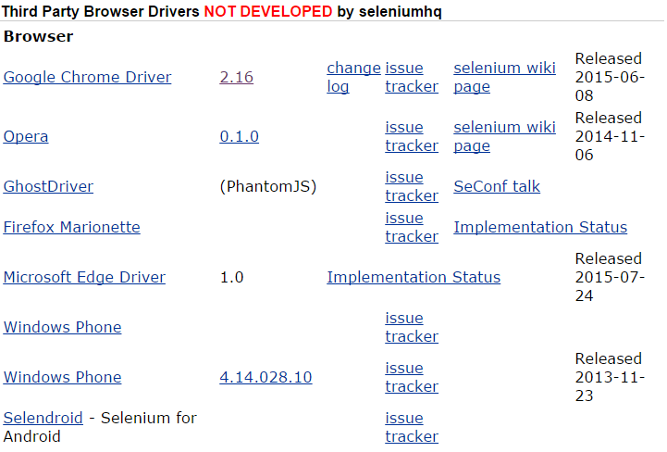

**Step -5 Create a New Project and Add Selenium Jars as Library + TestNG jars**

For Creating Library. Right Click on Project 🡪 Properties🡪Java Build Path 🡪 Click on Library Tab🡪 Click on Add Library Button 🡪 Choose User Library 🡪 Click on User Library Button 🡪Click on New Button 🡪 Specify the Library Name 🡪 Select the Library and Click on Add External jars 🡪 Select the Needed Jars