**ASSIGNMENT 1: MODULE-1**

**Que:1- What is SDLC?**

* **Its stand for SOFTWARE DEVELOPMENT LIFE CYCLE.**
* **It is essentially a series of steps, or phases that provide a model for the development and lifecycle management of an application or piece of software.**
* **It is structured process that enables the production of high-quality, low-cost software, in the Shortest Possible Production Time.**
* **The goal of SDLC is to produce superior software that meets & exceeds all customer expectations & demands.**

**Que:2- What is software testing?**

* **Testing is the process of evaluating a system or its components with the intent to find that whether it satisfies the specified requirement or not.**
* **Testing is executing a system in order to identify any gaps, errors or missing requirements in contrary to the actual desire or requirements.**
* **According to ANSI/IEEE 1059 Standard, Testing can be defined as A process of analysing a software item to detect the differences between existing and required conditions (that is defects/errors/bugs) and to evaluate the features of the software item.**
* **Software Testing is a process used to identify the correctness, completeness, and quality of developed computer software.**

**Que:3 - What is agile methodology?**

* **It is a way to manage a project by breaking it up into several phases.**
* **It involves constant collaboration with stakeholders and continuous improvement at every stage.**
* **Once the work begins, teams cycle through a process of planning, executing, and evaluating.**

**Que:4 - What is SRS?**

* **It stands for Software Requirement Specification.**
* **SRS is a complete description of an application which is to be developed.**
* **SRS contains use case diagram that describes all the interaction user wills have with the software application.**
* **FRS, BRS, FRD.**

**Que:5 - What is oops?**

* **OOPS is way of writing the program in organised way.**
* **Objects are like a black box where data are hidden.**

**Que:6 - Write Basic Concepts of oops.**

* **Class**
* **Object**
* **Inheritance**
* **Polymorphism**

1. **Over ridding**
2. **Over loading**

* **Encapsulation**
* **Abstraction**

**Que:7 - What is Object?**

* **It gives the permission to access functionality of Class.**

**Que:8 - What is Class?**

* **It is a collection of data member and member function.**

**Que:9 - What is encapsulation?**

* **The process of wrapping the data in a single unit.**
* **To secure the data from outside world.**

**Que:10 - What is inheritance?**

* **Making a class from an existing class.**
* **Deriving the attribute of some other.**
* **ADV- Redundancy, Extensibility**

**Que:11 - What is polymorphism?**

* **One name Multiple form.**

1. **Over ridding - Same name of function with same parameter but definition will be different.**
2. **Over loading - Function overloading: same function name but different parameter.**

**Que:14 - Write SDLC phases with basic introduction -**

* **There are seven type of SDLC phases –**

1. **Requirements collection/gathering: What is the problem?** 
   * + - * **Customer Needs**
         * **Requirement from stake holder, client, customer, CEO, etc.**
         * **Improvement in current software.**
2. **Planning/Analysis: What we want?**
   * + - * **Risk of the project**
         * **Cost of the project**
         * **Time for completion**
3. **Design: How can we get what we want?**
   * + - * **Design Architecture Document**
         * **Implementation Plan**
         * **Critical Priority Analysis**
         * **Performance Analysis**
         * **Test Plan**
4. **Implementation: Create what we want?**
   * + - * **In the Implementation phase, the team builds the components either from scratch or by composition.**
         * **Implementation – Code**
         * **Critical Error Removal**
5. **Testing: did we get what we want?**
   * + - * **We test the build to check for defect.**
         * **We report the defect and get it fixed.**
         * **We retest the build until it fulfils customer requirement.**
6. **Deployment:** 
   * + - * **PROJECT LIVE then it will become a product.**
7. **Maintenance:** 
   * + - * **Corrective maintenance: identifying & repairing defects**
         * **Adaptive maintenance: adapting the existing solution to the new platform**
         * **Perfective maintenance: implementing the new requirements.**

**Que:15 - Explain Phases of the waterfall model –**

* **Requirement collection/gathering**
* **Analysis/planning**
* **Design**
* **Implementation**
* **Testing**
* **Deployment**
* **Maintenance**
* **{ NOTE: All the phases of WATERFALL MODEL is same as SDLC phases. }**

**Que:16 - Write phases of spiral model –**

* **Four phases of Spiral model:**
* **Planning- determination of objectives, alternatives & constraints.**
* **Risk analysis- Analysis of alternatives and identification/resolution of risks.**
* **Engineering- development of the “next level” product.**
* **Customer resolution- assessment of the result of engineering.**

**Que:18 - Explain working methodology of agile model and also write pros and cons. –**

* **It is a combination of iterative & incremental model.**
* **It divides the software into small incremental builds, this build are provided in iterations, that means the big project are divided into small chunks(iterations).**
* **Each iteration is last about one to three weeks.**
* **Each iteration involves all the team members working simultaneously on areas like planning, requirements analysis, design, coding, unit testing and acceptance testing.**
* **At the end of the iteration the working product is displayed to the customer or the important stake holder and it is released in the market.**
* **After the release we check for the feedback of the deployed software.**
* **If any enhancements is needed in the project than it’s done and it’s re-released.**

**🡺 ADVANTAGE -**

* **Frequent delivery.**
* **Face to Face communication with the customer.**
* **Less time.**
* **Adaptability.**

**🡺 DIS-ADVANTAGE –**

* **Less time.**
* **Maintenance problem.**

**Que:12 - Draw Use case on Online book shopping.**

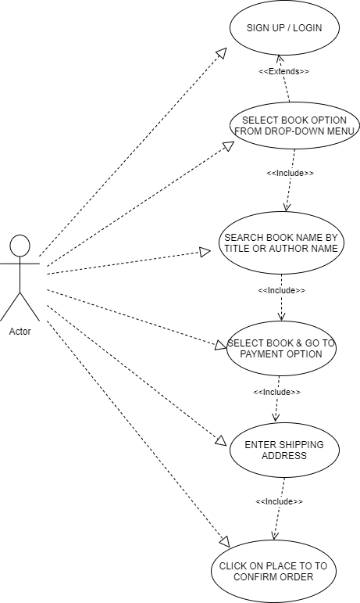

**Que:13 - Draw Use case on online bill payment system ( paytm ).**

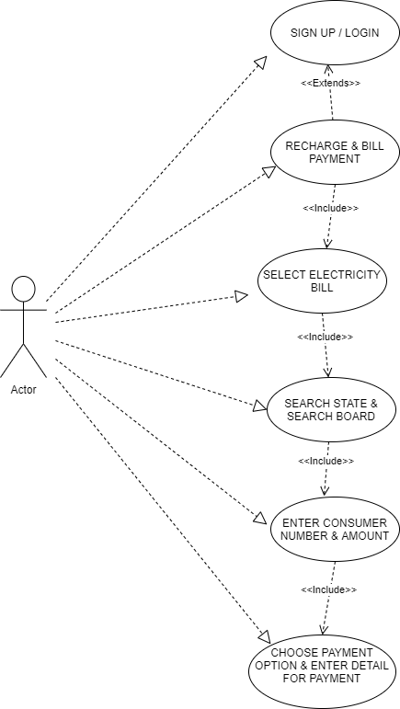

**Que:19 - Draw use case on Online shopping product using COD –**

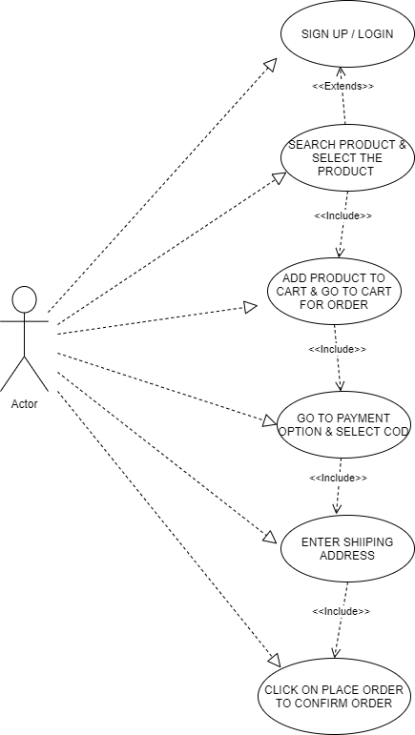

**Que:20-- Draw use case on Online shopping product using payment gateway -**

