**CS210: (Lab 15)**

**Computer Architecture Lab**

**Cache Performance Analysis and Branch Prediction**

**Task 1: (30 points)**

The task is to examine the accuracy of various branch predictors for the following repeating patterns (e.g., in a loop) of branch outcomes. Accuracy is defined as the percentage of guesses that are correct.

**Consider C codes below and write MIPS assembly code for the same**

*(a)*

*Int i;*

*Int b[100];*

*Int a[100];*

*for(i=0; i< 100; i++) {*

*b[i] = a[a[i]];*

*}*

**(b)**

**for(j = 0; j < 100; j++)**

**for(i = 0; i < 100; i++)**

**A[i] = i;**

**MARS->tools-> Branch History Table Simulator**

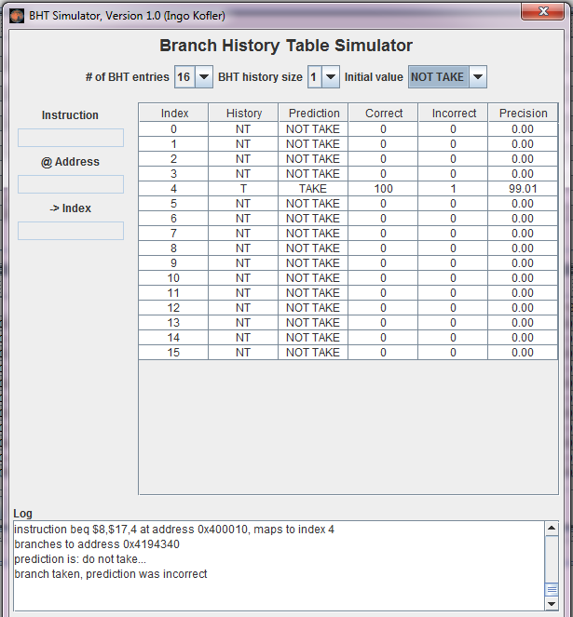

**Task 2: (25 points)**

**Complete the MARS tutorial Part 2.**

**Your Analysis Here:**

**Task 3: (45 points)**

**Create two examples algorithms which demonstrate efficient use of data cache ( for example Matrix multiplication, ). Conduct performance analysis on different parameters such as block size, cache replacement algorithms.**

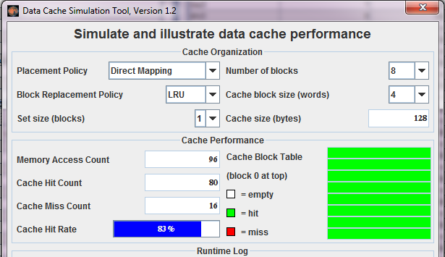

**Your Analysis Here:**

**Submission:**

**Demonstrate to TAs your results and**

Submit code and Report through

<https://u.pcloud.com/#page=puplink&code=m6wkZiR1xLpmF9TVKci3TqvWYvX4T8oBk>