# **Automatically update alternate contacts for newly created AWS Accounts**

**Prerequisites**

* Your AWS organization must have [all features enabled](https://docs.aws.amazon.com/organizations/latest/userguide/orgs_manage_org_support-all-features.html) (this is the default setting for almost all organizations).
* Enable the [AWS Account Management](https://docs.aws.amazon.com/accounts/latest/reference/accounts-welcome.html) service for your organization so that you can centrally manage alternate contacts. You can do this by using the following CLI command from the management account:

aws organizations enable-aws-service-access --service-principal account.amazonaws.com

Open Cloud Shell on Management Account

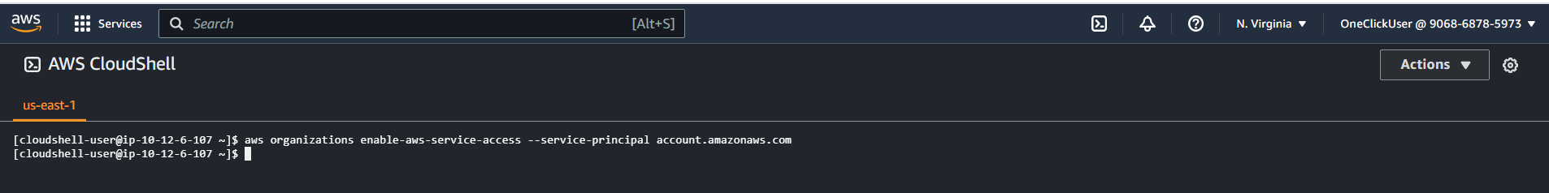

Only in management account.

Need to remove stack from all member accounts.

--- Create Bucket

[one-click-landing-zone-906868785973-us-east-1](https://s3.console.aws.amazon.com/s3/buckets/one-click-landing-zone-906868785973-us-east-1?region=us-east-1)

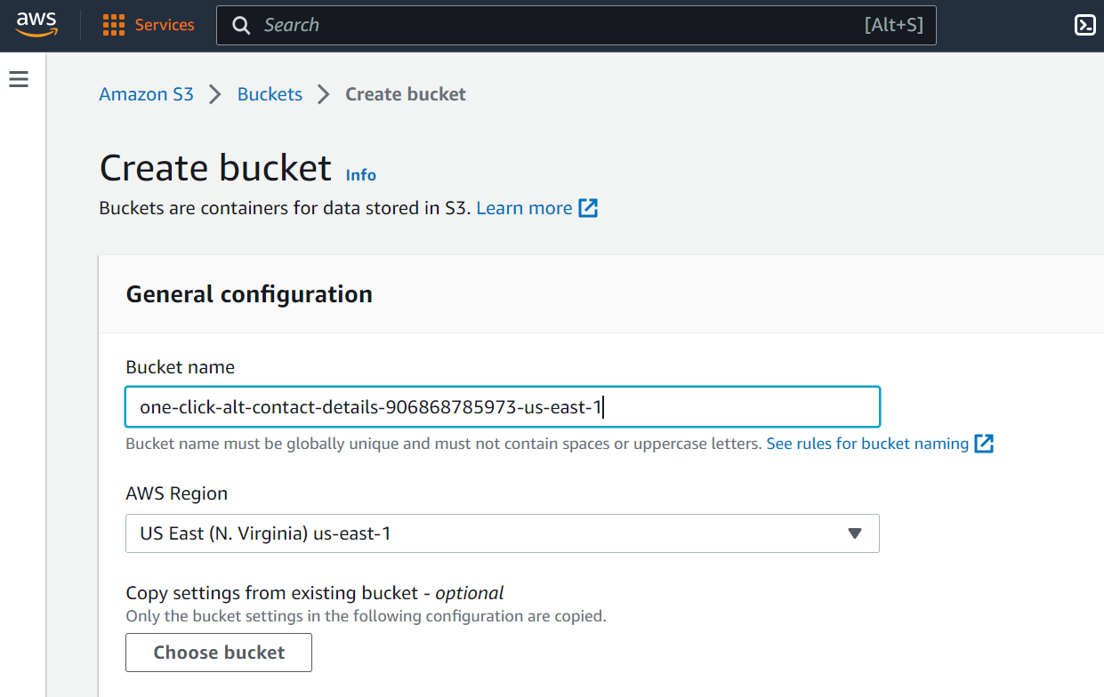

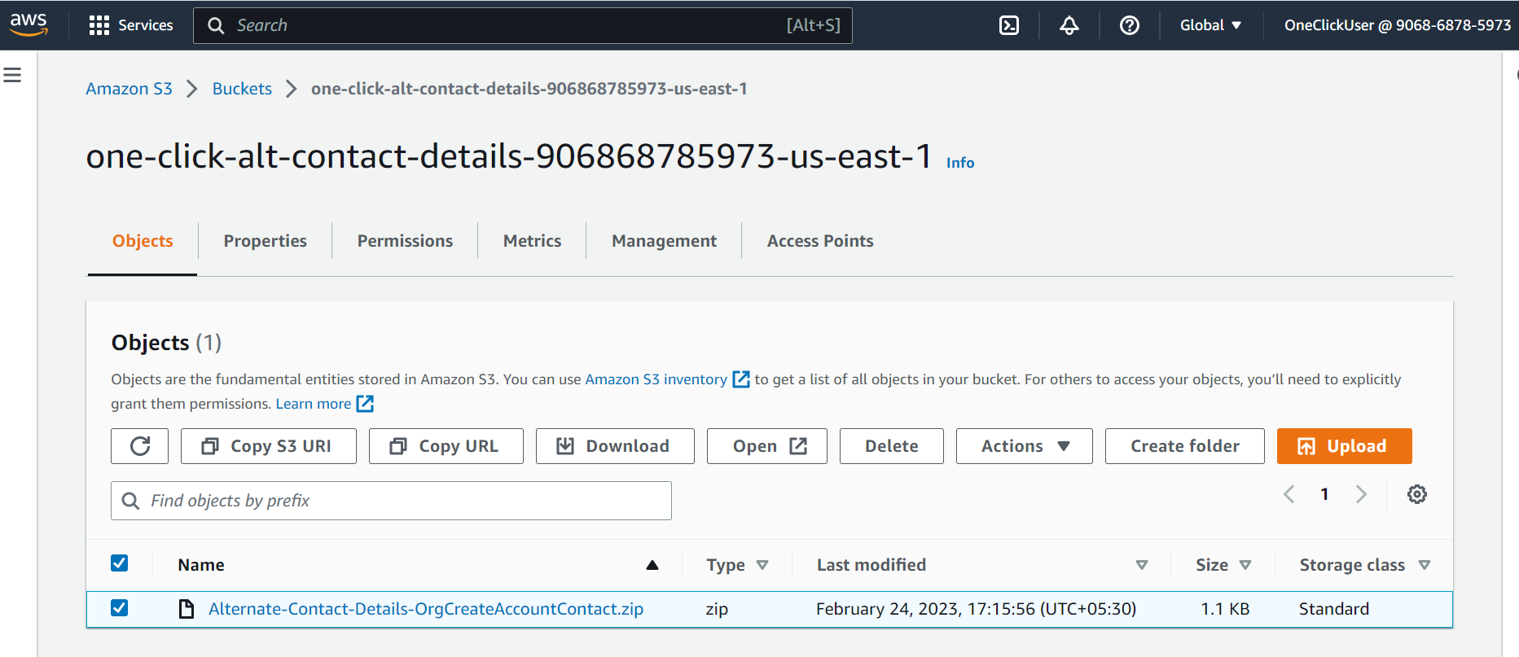

Copy URI

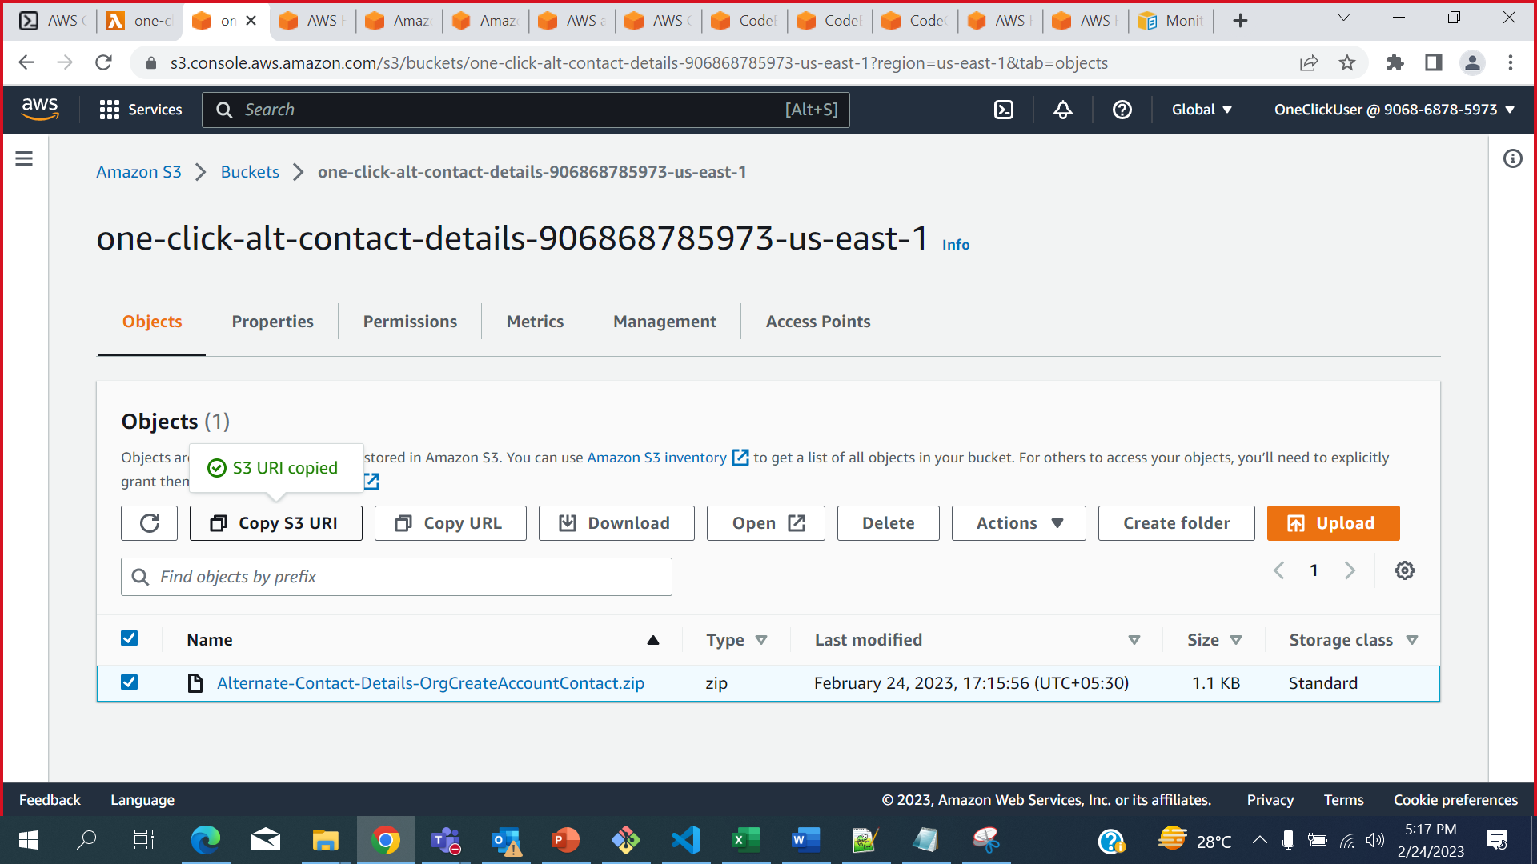

s3://one-click-alt-contact-details-906868785973-us-east-1/Alternate-Contact-Details-OrgCreateAccountContact.zip

s3://one-click-alt-contact-details-${AWS::AccountId}-us-east-1/Alternate-Contact-Details-OrgCreateAccountContact.zip

/aws/lambda/aws-controltower

Controltower

One-Click-Mulit-Account-Dashboard