**Problem statement**:

The company, named ABC Automotive Parts, supplies parts to auto manufacturers. Over the years, they’ve changed the way they receive orders several times.

Initially, orders were placed by uploading comma-separated value (CSV) files to an FTP server. The message format was later changed to XML. Currently they provide a website through which orders are submitted as XML messages over HTTP.

The company asks its new customers to use the web interface to place orders, but because of service level agreements (SLAs) with existing customers, they must keep all the old message formats and interfaces up and running. All these messages are converted to an internal Plain Old Java Object (POJO) format before processing.

The process flow diagram is as below.

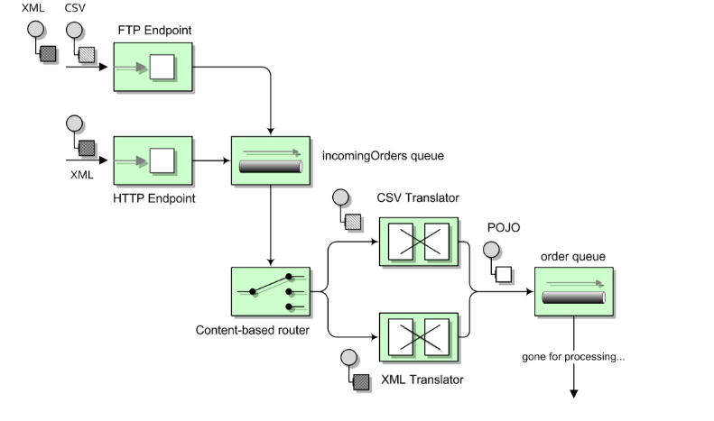

The end-product is a java object representing the actual order.

This transformed **Order** object should be processed and thereafter stored in MongoDB as **Processed Orders** collection.

Please make assumptions wherever required.

**POC component coverage :**

1. Spring Boot
2. Spring REST
3. Spring Data
4. ActiveMQ
5. Apache Camel
6. MongoDB
7. Logstash