# Abstract

Academics is alleged as a sector resistant to change, although at the same time faces a crunch of efficacy and competence. Innovation in teaching and learning could help increase the worth of education, as well as deliver “bang for the buck” in periods of rising demand and budget pressures.

# Keywords

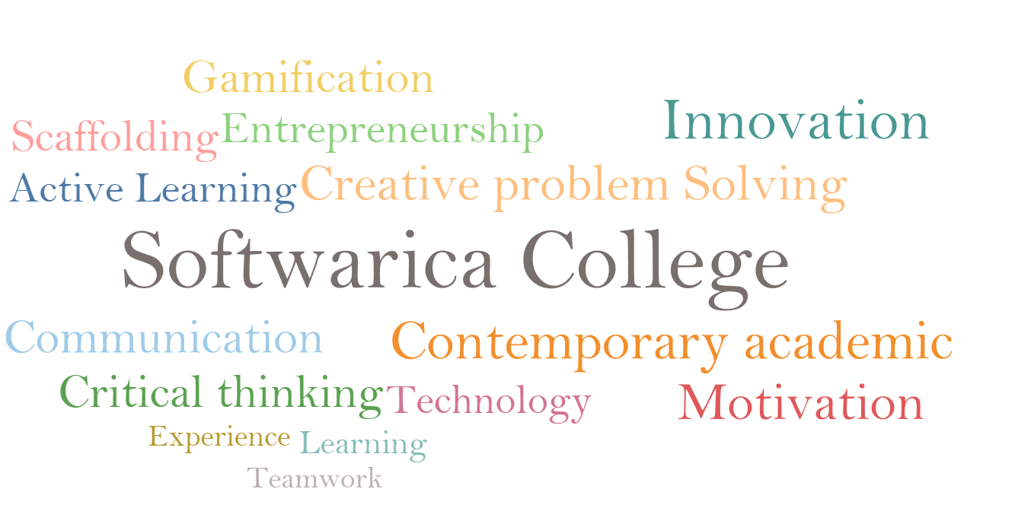

# 

**Word Count:**

**Table of contents: 41 words**

**Table of figures: 35 words**

**References: 377 words**

**Report: 2713 words**

Contents

Abstract 2

Keywords 2

Table of figures 4

Introduction 5

Strategic Context 7

Education and the fast-changing world 7

THE WRONG GAME 7

DEBUGGING THE SYSTEM 9

Active Learning and Scaffolding 10

Gamification 11

Entrepreneurship education 12

Motivation and development 13

Conclusion 14

References 15

# Table of figures

Figure 1: Contemporary Academic Learning 5

Figure 2: Academic Flaw 8

Figure 3: Active Gamified Entrepreneurial Learning 9

Figure 4: Active learning and Scaffolding 10

Figure 5: Gamification 11

Figure 6: Motivation and development 13

# Introduction

**“Knowing is not enough; we must apply! “**

* **Goethe**

Softwarica College is a forerunner in the introduction of British Education in Nepal. Established in 2010, the college has achieved substantial achievements. This is noticeable by the fact that the number of student is increasing exponentially due to the popularity of British education among students. Softwarica College is operates in partnership with Coventry University UK offering undergraduate programs in [BSc (Hons) Computing](https://softwarica.edu.np/bschons-computing/) and [BSc (Hons) Ethical Hacking & Cybersecurity](https://softwarica.edu.np/bsc-hons-ethical-hacking-and-cybersecurity/) (Softwarica College 2020).

Softwarica offers a contemporary academic, demanding, evidence-based experience rooted in a exciting research setting. The College demands its students exhibit conceptual understanding of their chosen discipline by approaching challenges with creativity, curiosity and critical thinking. The students are encouraged to innovatively apply their knowledge and skills to tackle real world problems with high efficacy and respect for different perspectives. The college aims to provide evidence based pedagogy with strong focus on preparing the students for the 21st century skills and considers educators as a source of cooperation, motivation and aspiration.

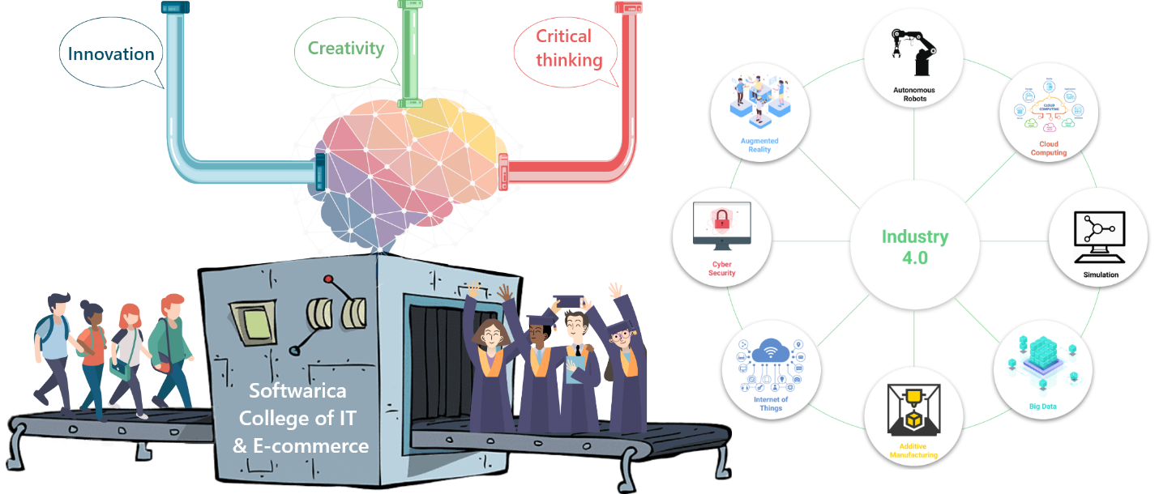

Figure 1: Contemporary Academic Learning

The college acknowledges that the current and future work and life demands students to continuously cultivate mastery of updated skills, knowledge, predispositions, literacies and competencies which were not a requisite for academic and professional success in the past. Learning and teaching has therefore entered an era of intense disruptive shift. Integration of technology in education can result into either result into disruptive or distractive innovation based on the manner of its use. The student engagement and performance can be expected to rise or fall depending upon the novelty and use case of the technologies and techniques as students consider computer technology as add-ons to their life instead of an academic tool which they can use to play video games or use to communicate among their peers. This low value use of technology is hardly a cause for celebration which reflects high optimism but low intentionality in academics. (Chew and Cerbin 2017)

The aim at softwarica is to break out of the cycle of distractive innovation and develop sustainable methods to improve instructional quality and student learning performance with the novel use of technology. Such use is expected to address the question of how to use these technologies for knowledge generation and representation for the third millennium students like to demonstrate what they know and be reflective of the digital context they are living in. With the future in mind Softwarica is helping students to begin a transition from low value use of technology to higher one which demands a change in the learning and teaching process as well as managing the transition from the old timid practices to the new ones. The belief in the false hope of technological determinism of just having access to technologies will lead to gains for student performance is demystified by understanding the role of technology and their impacts. Student’s previous experience and knowledge are considered foundation for the construction of new knowledge (Christensen 2015).

# Strategic Context

The college is already thriving to act collaboratively and dauntlessly and to advance in the design of a college extensive innovative attitude to untiring scholastic merit. The college is driven and have an upheld zeal for innovation. The strong belief of rather than being deskbound quietly and absorbing information quietly, an environment should be crated where students should be able to correlate their formerly actualized knowledge and the new information in significant ways contained by meaningful contexts. In order to develop an interactive landscape of knowledge generation, learning and teaching contexts is developed into an extremely participatory habitation where students can playfully and experientially form associations among new information, between their prior knowledge and the information, their teachers, among peers, and their own philosophical understandings. Teaching and learning is considered a contextual team sport (Dewey 1938).

## Education and the fast-changing world

Learner’s individual upbringing and interests impacts their experience and knowledge gained in the classrooms. Their cumulative experience creates a foundation for the new knowledge construction. It is therefore imperative that the teachers take into consideration their prior knowledge when possible to help learners explore the myriad relation between their existing knowledge and the new content they are experiencing. Learning experience can be optimized by the process of discussing and practicing the newly acquired content to create meaning in different contexts as well as reflect on the meaning of the new information and engage in collaborative application to solve problems relevant to the environment in which the students live, which improves their understanding of the world around them (Simkins et al. 2002). The college considers Higher education further than gaining information on particular discipline. Higher order skills, such as teamwork, communication, critical thinking, creative problem solving are considered predominantly treasured. As facts and information burgeon, the skill to steer across diversity of disciplines and analytically evaluate, extract and communicate sense have developed into indispensable traits for triumph. The college intends to prepare the students for such a society. (Couch and Towne 2018).

Increasingly, the utmost significant constituent of contemporary tutoring is not just the teacher’s diffusion of information and the student’s retention of facts. The students are taught how to grip and construe ideas, notions, evidence and how to reason and act as professionals and, eventually to harvest awareness and treasured knowledge. (Goldin and katz 2008)

## THE WRONG GAME

**“That’s what the personal computer can be—a mental bicycle. It’s the most remarkable tool in all of history.”**

* **Steve Jobs**

Jobs saw technology as an “amplifier for our intellect” in the same manner that a bicycle amplifies our physical ability. Not only would it take us faster and more efficiently to where we’ve already been, but it would also allow us to go beyond—to discover, create, and innovate like never before.

Most High school students, have certainly not known a world without the internet as they depend upon instant search engines like YouTube, Google, Bing or Wikipedia for answers. Technology is a part of their environment as these students do not use technology, it just exists for them. (Grivokostopoulou et al. 2019)

Digital natives process information in a profoundly different way and one of the principal problems with the education system is educators still using an obsolete, pre-digital linguistic struggling to teach a groups almost exclusively digital. The contemporary educational arrangement was intended to teach a very different groups, with very different needs, in a very different world. (Imperial College London n.d.)

The biggest flaw of our existing academic system is emphasis on teaching what to think, rather than how to think. Any attempt to memorize throughout academic and real life don’t work anymore as education is more than just memorizing, it’s about learning how to think.



Figure 2: Academic Flaw

The fact that modern students are frequently exposed to multisensory interaction with digital media in virtual environments is considered to have an optimistic impression on their readiness to learn. Perhaps, however, an argument could be made on the insufficiency of virtual environments in digital contexts, to deliver genuine understanding and learning. In the absence of meaningful reflection and application the learner’s interaction with technology tends to be largely trivial and banal. The accelerating technological change demands rewiring of education to integrate education, learning, and technology to adapt to the needs of the future. A truly tailored atmosphere is necessary so that every student is able to exploit their potential and try to change the world. (J. Lee and Hammer 2011)

# DEBUGGING THE SYSTEM

**“Our students have changed radically. Today’s students are no longer the people our educational system was designed to teach.”**

* **MARC PRENSKY**

**How do we change the system?**

It’s undeniably difficult, but Softwarica considers it very important to understanding psychology before understanding technology and a belief that all of them can learn and succeed. No student is written off as who “just don’t get it”. The initial emphasis is on students formerly as individuals leading to learning, teaching integrated with proper application of technology. The belief that innovation can breathe new life into stagnant academic systems, and act as a mechanism to augment the institution’s ability to adapt to shifting environments has triggered the implementation of **Active gamified entrepreneurial learning** designed to deliver efficient and immersive learning undertakings.

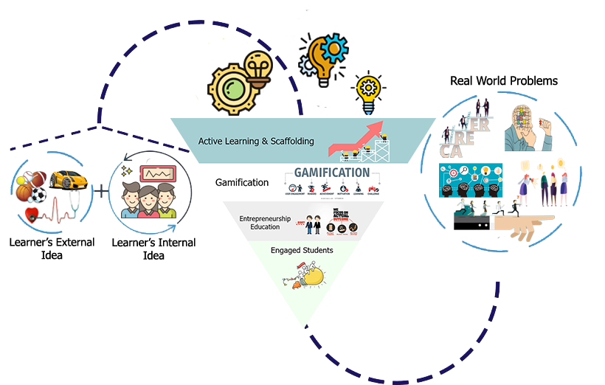

Figure 3: Active Gamified Entrepreneurial Learning

The game based activities help students gain essential skills, assisting them to tackle daily obstacles on their entrepreneurial pathways. The implementation of such techniques in teaching and learning revealed that the framework offers increases students’ motivation and assist in the formulation of entrepreneurship mentality, skills and competencies to improve the efficiency of the academic delivery by enhancing the academic in order to boost academic satisfaction and customize the education process. (Jobs for the Future n.d.)

## Active Learning and Scaffolding

As students absorb by scaffolding i.e. building on what they already know to what they need to know, with the help of adults. The instructions are tailored to individual learner’s needs by scaffolding the learner to complex levels of knowledge after establishing the learner’s existing level of understanding. Visual tools and techniques, real world scenarios to virtual scenarios are designed to scaffold students’ understanding according to their individual needs.

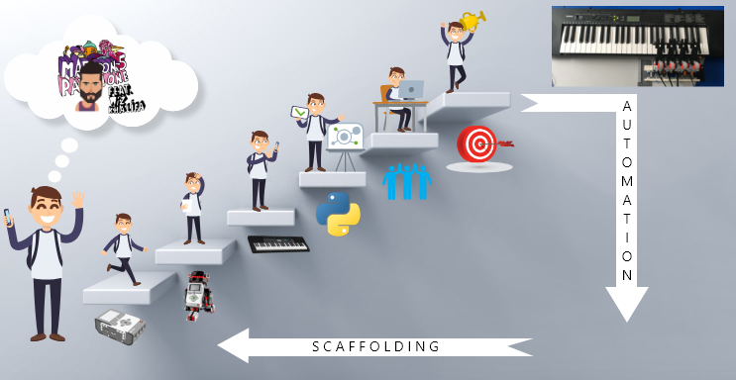

Figure 4: Active learning and Scaffolding

Students are allowed to determine what they will do as part of the project, the context in which these activities will take place community, technical labs or the classroom. Educators are allowed to decide the freedom provided to students in selecting and determining their undertakings. Teachers are required to design few projects in advance to certify that the activity is designed well, equipped effectively and conducted aptly and let the following projects leave substantial scope for students’ self-determination and creativity. There are numerous benefits of allowing students make choices about their projects. Students learn further by means of using their individual imagination and skills to complete laborious, enduring projects. As students navigate projects in the direction of their own interests, the projects become further applicable towards their everyday lives. The students are provided details on how and when their work will be evaluated as well as the guidelines which support them planning and conducting their projects. Projects are divided into manageable tasks and made to seem like real job. Assessment and continuous feedback enables to keep student projects on track and adjust their projects to meet expectations. The method is helpful especially to teachers to assess the projects and for the students as well to evaluate their individual evolution periodically (Langendahl et al. 2016).

## Gamification

Gamification is the practice of game dynamics, workings, and contexts to indorse anticipated performances, has already established its way into spheres like health and fitness as well as politics and gradually entering the education sector (OECD 2016). Visionary game developer Jesse Schell, foresees a gamepocalypse, a hypothetical future where daily activities like exercising to brushing teeth is gamified (Magaña n.d.). Gamification in education is an attempt to couple the motivational muscle of games and apply it to real world problems which in our instance is the lack of motivation among students. Implementing gamification in teaching and learning, therefore, means understanding the circumstances in terms of the social and emotional impacts under which elements of game can drive teaching and learning as disengagement from learning and also teaching materializes under social and emotional complications aggravated by the prescribed rules. Gamification can be used to transform the rules, that affect learner’s emotional experiences and their sense of identity. It offers the prospect to investigate social and emotional rules. In practice, however, there will ever be an opportunity to design the modules from scratch therefore a game layer is created on top of the existing module. The layer is an effort to foster tangible goal setting, strong communication, and the mindful enhancement of the learner’s uniqueness (Merle and Davis 2017).

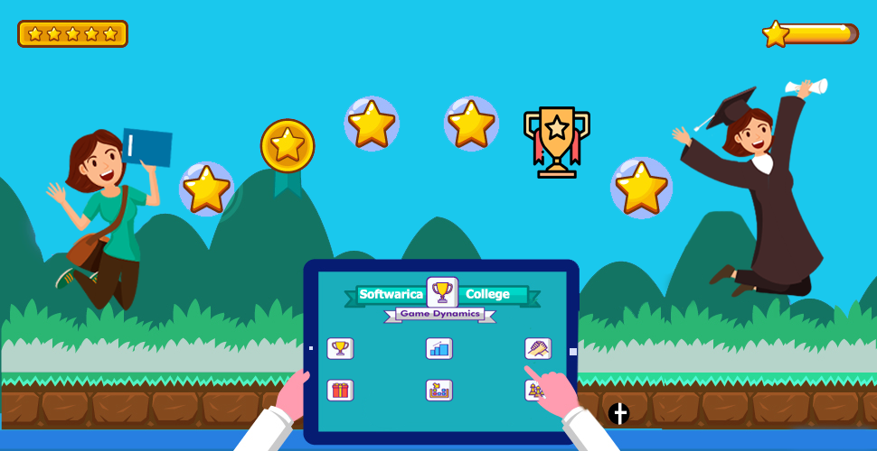

Figure 5: Gamification

Gamification also permits learners to visibly classify themselves as academics. Game participation provides them appreciation and social credibility of academic accomplishments, which might otherwise remain unseen or disparaged by their peers. Appreciation is provided by the teacher, but such practice also allows learners to compensate each other in terms of game currency. Such academic design inspires learners to emphasize the development of an academic identity themselves as well as their peers. Softwarica believes in harnessing the vigor, motivation and utter prospective of games and direct it to teaching and learning and achiever high scores and become leaders in actual life (Miller 2014).

## Entrepreneurship education

Fostering innovation through entrepreneurship training is considered an important task at Softwarica as innovative awareness and ability are the paramount for students’ innovative activities. The college intends to provide an academic milieu that may serve as a catalyst for technology startups. The theme that entrepreneurs are not born but created, by teaching the skills and knowledge required for a novel business endeavor (McKelvey 2020). This procedure involves creating novel knowledge through transforming experience and putting knowledge into practice. Such education would help develop students’ entrepreneurial skills, empowering them to deal with with uncertainties and challenges by being able to construe political skills from four dimensions, namely, sincerity, interpersonal influence, networking ability, and social astuteness. These political skills enhance the student’s aptitude to commendably comprehend others at work and use the knowledge to affect others to act in ways that improve one’s academic and personal objectives. (Ridley 2020).

# Motivation and development

The **Active gamified entrepreneurial learning** is envisioned in a way to engage educators in using projects to nurture learner’s achievement. Educators engage learners in seminars that immerses them in projects by enabling them to realize firsthand the skills and knowledge that can be learned and applied in real world contexts and help them analyze representative projects by giving them the opportunity to engage from the initial periods of project design. Teachers act as consultant offering open instruction in skills, such as establishing creative working clusters of individuals or familiarizing students to problem solving approaches upon which their work will be based. The teachers are provided special trainings from external consultants from different sectors to overcome challenges in executing projects and to practice assessment and supplementary approaches in teaching. These consultants are usually people from different sectors other than education which helps teachers gain understanding of what really is needed and happens when these students go to work after they complete their education. These consultants support teachers craft occasions like shows where the students can display their work to external visitors which boosts their confidence. The consultants also help the teachers gather confirmation of the impact on student learning. The college works with consultants to customize learning for their needs as it is very noteworthy to highlight together “why” and “how” based learning mechanism works and gives teachers passable provision in shifting in what way they teach. Sustained professional development with the alignment of professional improvement with the accountability procedures student learning and teaching. The college offers a sequence of professional development programs each year which embrace project-based learning (Roblyer 2016).

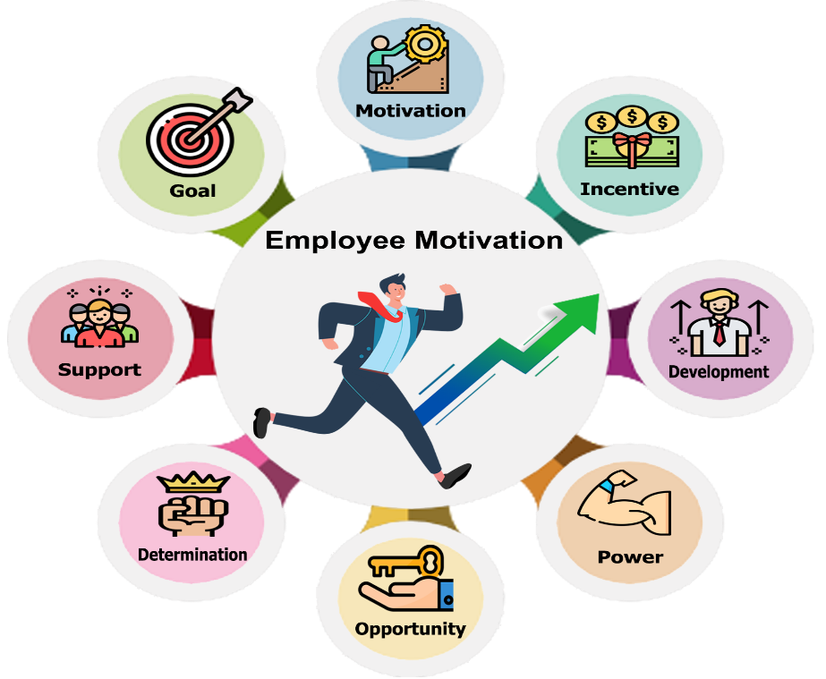

Figure 6: Motivation and development

**Most of teachers are allowed to have gigs** such as paid research, advisory work and consulting, Board positions, and speaking engagements, to promote their personal brand and at the same time augment their earnings (Mulcahy 2019). These side hustles help learners gain real world work experience through the teacher’s projection. This way students are exposed to real world practical experience. Since each project is a commitment typically spending four to five hours a week, and they can receive credit for it. These experiences are well aligned with student expectations and academic outcomes (Universities Should Be Preparing Students For The Gig Economy 2020).

# Conclusion

A worthy melody heightened by good harmonies marks a great musical composition. The foundation of any musical composition, as sung by the singer is enhanced by the high harmonies of supporting musicians and as a result the song becomes transcendent. Listening to either the harmonies or melody unaccompanied would infinitely weaken the experience. This can be considered an apt metaphor for effective learning and teaching. Good teaching is the melody, and integration of effective techniques integration augments the harmony, resulting into a superior impact.

One could rationally argue that such experiences might augment not only a learner’s interaction with that new information but also their natural disposition to engender and test extrapolations of entire experience.

# References

*Best IT College In Nepal - Softwarica College, Dillibazar, Kathmandu* (2020) available from <https://softwarica.edu.np/about-softwarica/> [1 June 2020]

Chew, S. and Cerbin, W. (2017) *Teaching And Learning: Lost In A Buzzword Wasteland* [online] available from <https://www.insidehighered.com/views/2017/12/05/need-theory-learning-opinion> [28 June 2020]

Christensen, T. (2015) *The Creativity Challenge: Design, Experiment, Test, Innovate, Build, Create, Inspire, And Unleash Your Genius*. Avon, Massachusetts: Adams Media

Couch, J. and Towne, J. (2018) *Rewiring Education*. 1st edn. Dallas, TX: BenBella Books, Inc

Dewey, J 1938, Experience & education.

Goldin, C. and katz, L. (2008) *The Race Between Education And Technology*. Cambridge, Massachusetts, and London, England: The Belknap Press of Harvard University Press

Grivokostopoulou, F., Kovas, K. and Perikos, I. (2019) *Examining The Impact Of A Gamified Entrepreneurship Education Framework In Higher Education*. Patras, Greece: University of Patras

*Innovative Teaching For World Class Learning. Learning And Teaching Strategy* (n.d.) Imperial College London

J. Lee, J. and Hammer, J. (2011) *Gamification In Education: What, How, Why Bother?*. Academic Exchange Quarterly

Jobs for the Future (n.d.) *Using Real-World Projects To Help Students Meet High Standards In Education And The Workplace*. Boston, MA: Jobs for the Future

Langendahl, P., Cook, M. and Mark-Herbert, C. (2016) *Gamification In Higher Education. Toward A Pedagogy To Engage And Motivate*. Uppsala: Online publication in Epsilon

Magaña, S. (n.d.) *Disruptive Classroom Technologies*. CORWIN A sage publishing company

McKelvey, J. (2020) *The Innovation Stack: Building An Unbeatable Business One Crazy Idea At A Time*. Penguin Random House LLC

Merle, M. and Davis, A. (2017) *Corporate Innovation In The Fifth Era: Lessons From Alphabet/Google, Amazon, Apple, Facebook, And Microsoft*. 1st edn. Corte Madera, CA: Cartwright Publishing

Miller, M. (2014) *Minds Online Teaching Effectively With Technology*. London, England: Harvard University Press

Mulcahy, D. (2019) *Universities Should Be Preparing Students For The Gig Economy* [online] available from <https://hbr.org/2019/10/universities-should-be-preparing-students-for-the-gig-economy> [28 June 2020]

OECD (2016) *Innovating Education And Educating For Innovation*. Paris: OECD Publishing

Ridley, M. (2020) *How Innovation Works And Why It Flourishes In Freedom*. 1st edn. Harpercollins publishers

Roblyer, M. (2016) *Integrating Educational Technology Into Teaching*. 7th edn. PEARSON

Simkins, M., Cole, K., Tavalin, F. and Means, B. (2002) *Increasing Student Learning Through Multimedia Projects* [online] available from <http://www.ascd.org/publications/books/102112/chapters/Making_a_Real-World_Connection.aspx> [28 June 2020]

*Universities Should Be Preparing Students For The Gig Economy* (2020) available from <https://hbr.org/2019/10/universities-should-be-preparing-students-for-the-gig-economy> [3 June 2020]