1. API build with 18 test cases successfully:

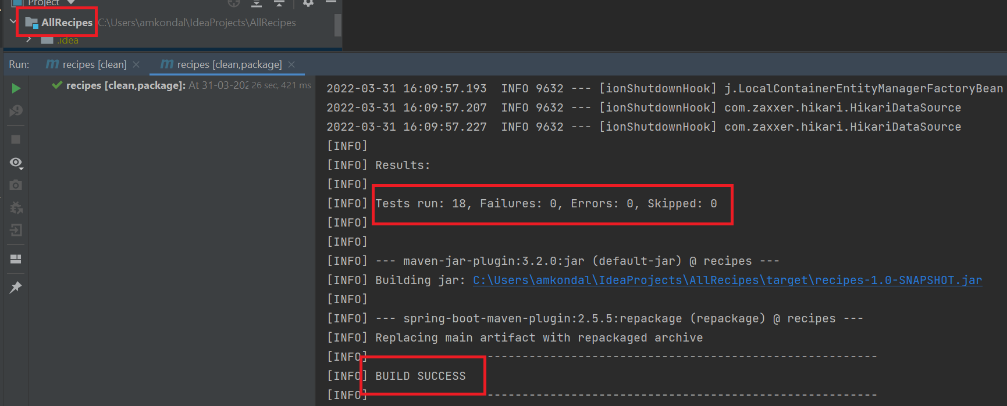

1. Authorization error for posting recipe without credentials:

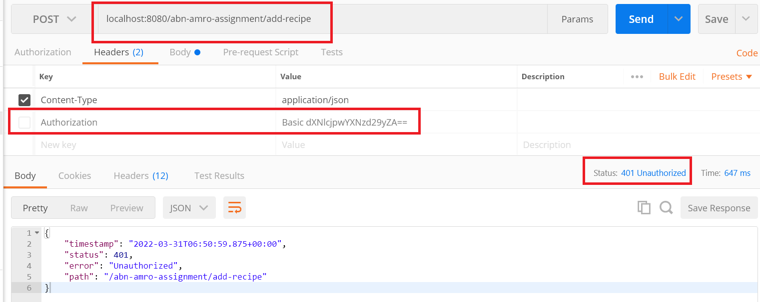

1. Posting request to ADD recipe with authorization credentials:
   1. EndPoint: localhost:8080/abn-amro-assignment/add-recipe
   2. Credentials: user/password

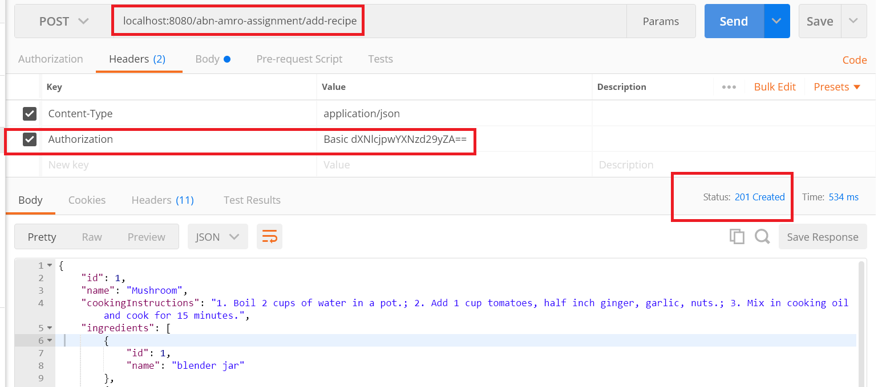

1. Posting request to UPDATE recipe with authorization credentials:
   1. EndPoint: localhost:8080/abn-amro-assignment/update-recipe
   2. Credentials: user/password

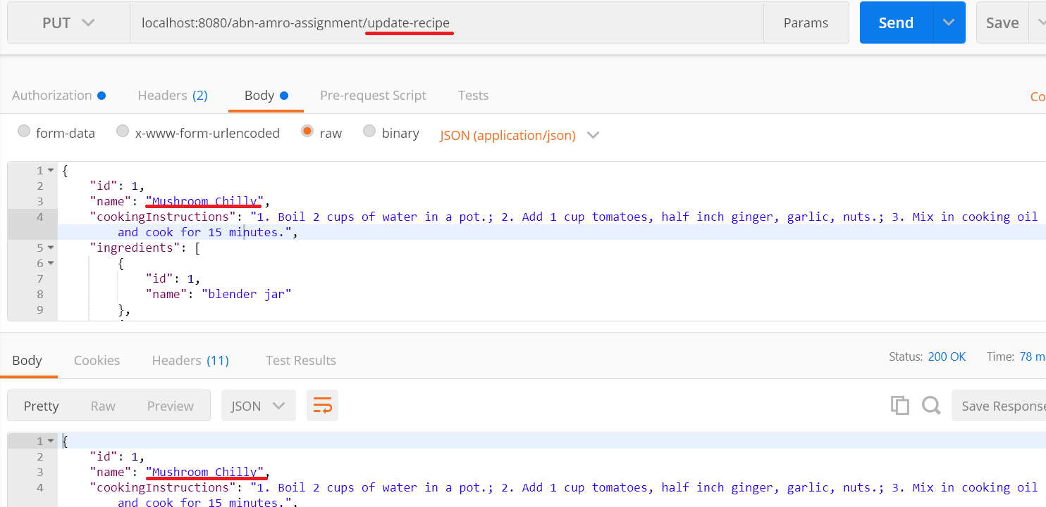

1. Posting request to SELECT with ID recipe with authorization credentials:
   1. EndPoint: localhost:8080/abn-amro-assignment/select-recipe/1
   2. Credentials: user/password

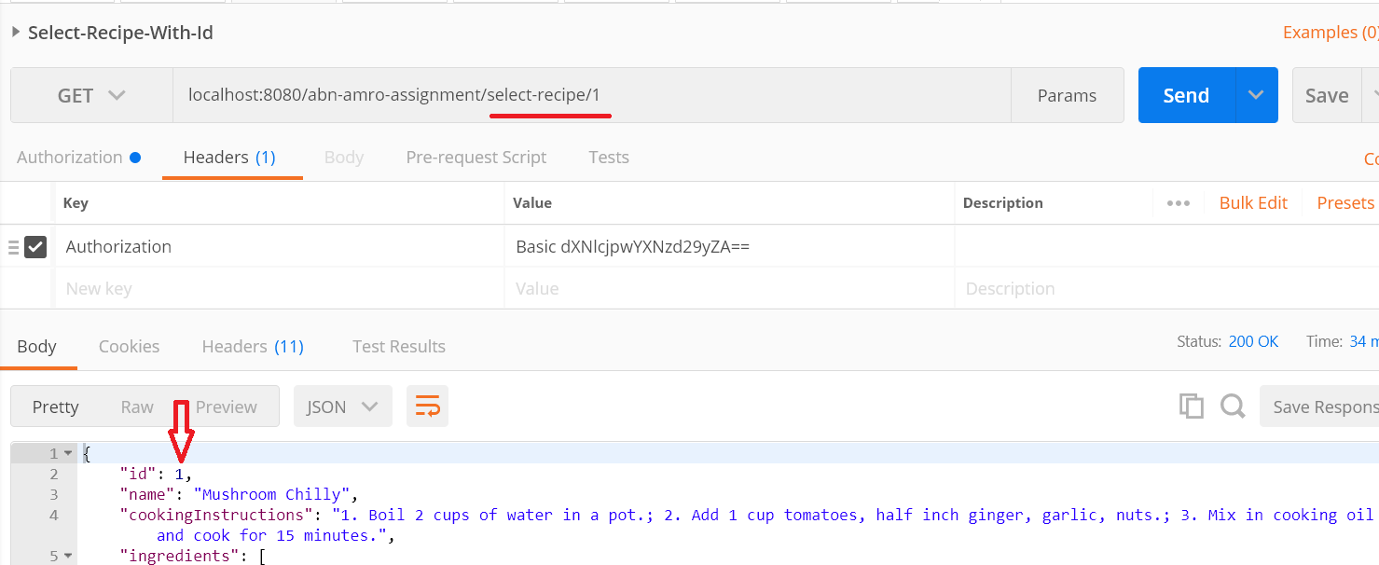

1. Posting request to SELECT ALL recipes with authorization credentials:
   1. EndPoint: localhost:8080/abn-amro-assignment/select-all-recipe
   2. Credentials: user/password

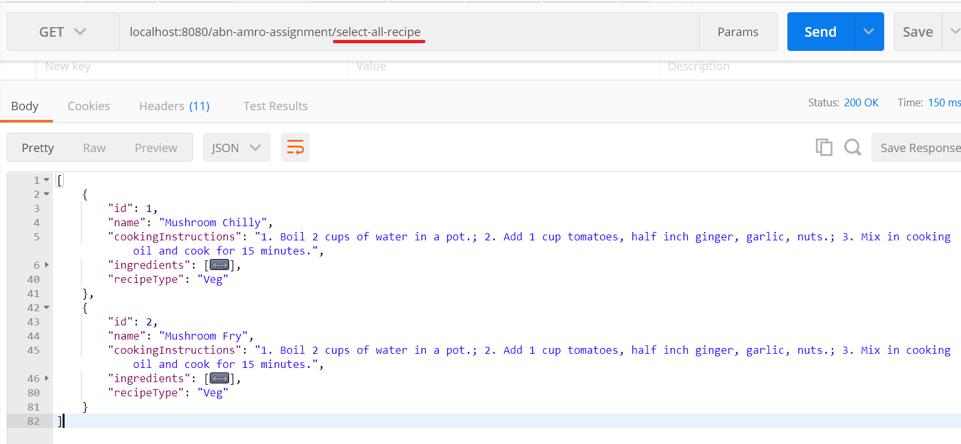

1. DELETE request to DELETE with ID recipe with authorization credentials:
   1. EndPoint: localhost:8080/abn-amro-assignment/delete-recipe/1
   2. Credentials: user/password

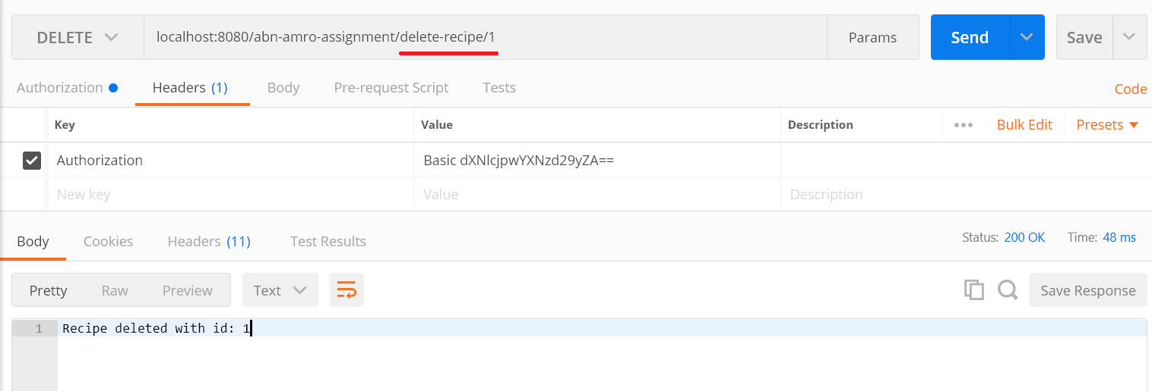

1. PUT request to UPDATE recipe which is not present with authorization credentials:
   1. EndPoint: localhost:8080/abn-amro-assignment/update-recipe
   2. Credentials: user/password

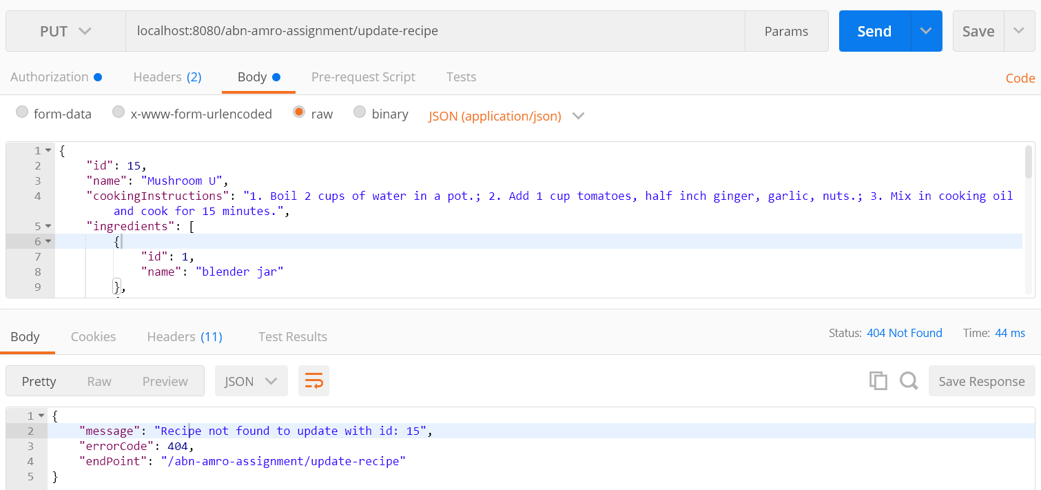

1. DELETE request to DELETE recipe which is not present with authorization credentials:
   1. EndPoint: localhost:8080/abn-amro-assignment/update-recipe
   2. Credentials: user/password

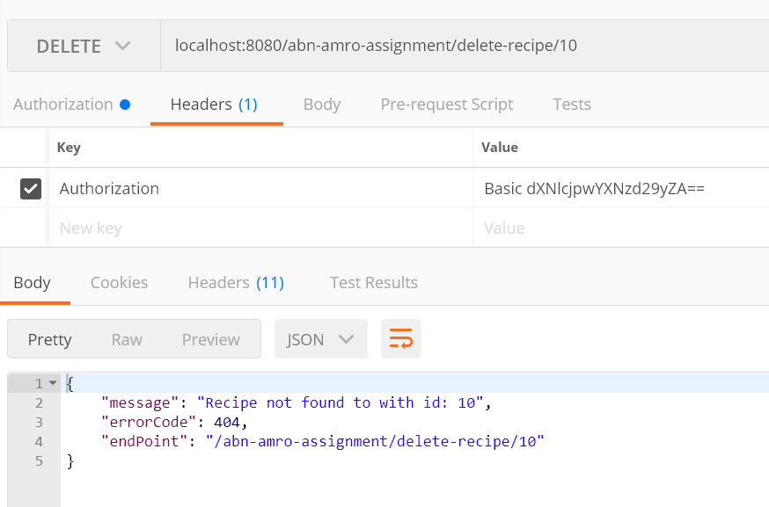

1. POST request to with invalid data and authorization credentials:
   1. EndPoint: localhost:8080/abn-amro-assignment/update-recipe
   2. Credentials: user/password

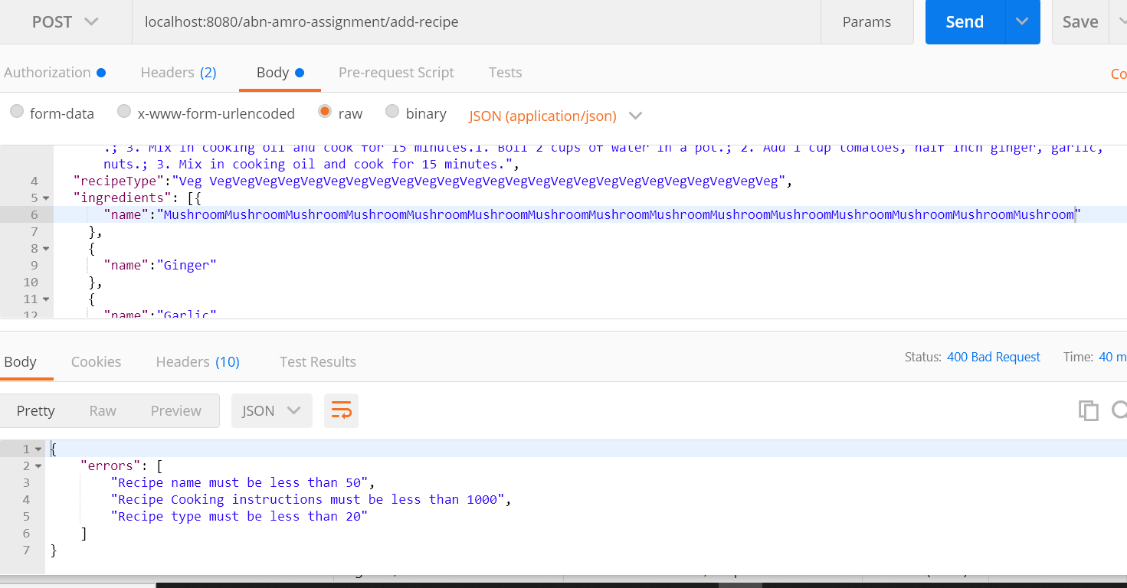

* Follow the below steps to execute the executable jar file :
  + Build the code.
  + Open CMD and open the project location.
  + Execute the below command:
    - Java -jar assignment-recipes-0.1

