To Do

* Scale down the size of the button image files, they are unnecessarily large and thus take more time to load
* Change all the webkit filters…to just the actual colors they render for the ROW BACKGROUND COLORS
* Not all browsers support webkit
* Date should be changed so its says “February 13th” instead of 2/13/15
* For adding new reservations, there should be dropdowns so we can PREDEFINE ALL THE OPTIONS USERS CAN TYPE
* Find an api which can list all the possible restaurants in a city
* We should ask the user for their current location, and then pull reservations from postal-codes near them
* **You can be a bit more descriptive with the entry names in user.js (routes) (these names correspond to name attribute at the end of userhome.jade)**

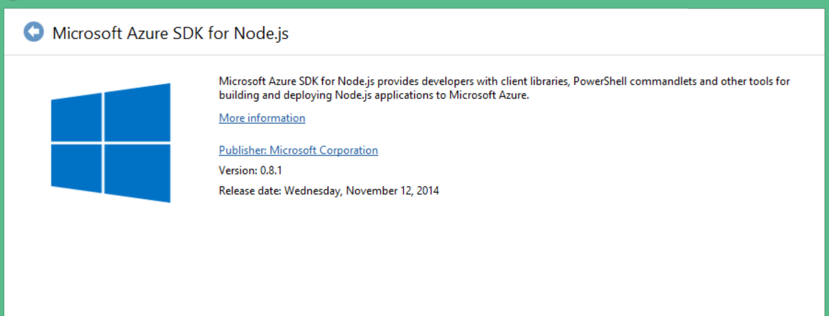

Cautions

* IMPORTANT – the partition key will be the POSTAL_CODE of the place where the restaurant is in
* MULTI-COLUMN SORT for the time and date properties in the table??
* You put a timer in user.js routes, I need to find the async function…
* Idea- store the all the user’s personal information in a cookie ??, although, I don’t think professional websites do that

A number of the API functions make the assumption that data storage it done on the client-side, rather than the server-side. As such functions such as fnAddData and fnDeleteRow will not effect the data held on your database. Indeed DataTables does not know if you are even using a database! **As such, you must make the required calls to the server to manipulate your data as required, and then simply redraw the table (fnDraw) to view the new data.’**

* in order for this to work, you must set serverside : true in the data table initialization

Database Storage Notes

User-Table

* PartitionKey : users’s email
* RowKey : “userinfo” –hardcoded
* *Rest of fields store info on the user

Market – HAVING TROUBLE WITH THIS

* PartitionKey : postalcode of reservation
* RowKey : *a number* representing the nth reservation this is in the partition
* *Rest of fields store info on the res*

Market – NEW SCHEME

* PartitionKey : email of person who made it
* RowKey : *a number* representing the nth reservation of this partition(or person)
* *Rest of fields store info on the res*

Questions To Arvind

* Can I query all entitities that have a name value pair of this…
* Right now, I am finding only ways to query entites based of off name, and not value
* How can a page *timeout*, because right now a page will continue loading forever if a match is found with a route, but no response is made by the server
* In dev.js, I thought I forced the post “dev/:tableName/delete-entries” route to be asynchrounous. So why is it not?, because after deleting like 10 entries, the page refreshes with only like 8 deleted. Only after refreshing again are all gone