Neuromatch Academy Teaching Assistant

*Teaching Demo Instructions*

As part of your application, we would like you to make a **4**​ **minute** video that showcases your teaching. We don’t want you to spend too long making this video, certainly no longer than 1 hour. You are not competing against others. We want as many qualified TAs as possible. Instead you are demonstrating to us that you are ready to teach! You can see a sample teaching demo here.

During the Neuromatch Academy summer course you will be leading hands-on tutorials live with a small group of students. Of course, in the Teaching Demo recording there will be no live students. But we’d like you to teach as if there were a live audience (though you do not need to interact with this fake audience).

In the remainder of this handout, we will provide a lesson plan / tutorial for ridge-regression, as well as detailed instructions about what we would like you to submit.

Background

For this tutorial you can assume that your students have just finished hearing a lecture on regularization in regression. Thus, they’ve been introduced to the use of lasso (L1) and ridge (L2) penalties in regression. This tutorial is a supplemental activity for that lecture and will be one of the first time that they apply regularization (in the form of ridge-regression) to data. At this point they’ve also had some experience in the form of lectures and tutorials with linear regression, dimensionality reduction, principal components analysis, and should be familiar with what an L1 and L2 norm are.

The learning objectives for this segment of the lesson (including the lecture) are:

• Define overfitting.

• Describe the motivation for regularization in regression and in other analysis techniques.

• Apply regression with regularization to neural data

• Compare regression analyses with and without

To be clear, we are not asking you to teach all of these concepts in 4 minutes. It’s nowhere near enough time. We have provided these to give you a sense of what knowledge acquisition you’re trying to support. Focus on one or two of these things as you walk your students through this example

Tutorial Description

The data provided for the tutorial are from an experiment ____ CARSEN BRIEF DESCRIPTION OF EXPERIMENT ____.

These data have already been pre-processed and analyzed some. We have identified a population of neurons that are NOT stimulus-selective. Now we are interested in finding out if the activity of these neurons are related to the animal’s behavior during the experiment. We have performed dimensionality reduction (PCA) on both the behavioral data (video of animal) and neural data (3 Hz 2-photon recording). We will now evaluate the strength of the relationship between the behavioral and neural data using ridge regression.

You can access the jupyter notebook containing the tutorial here: <https://github.com/kbonnen/NeuromatchTeachingDemo>

You can run the jupyter notebook any way that you’d like, but we recommend using google colab to run the notebook. You can import the jupyter notebook directly from github to colab. Go here: <https://colab.research.google.com/github/> and you should see the following screen:

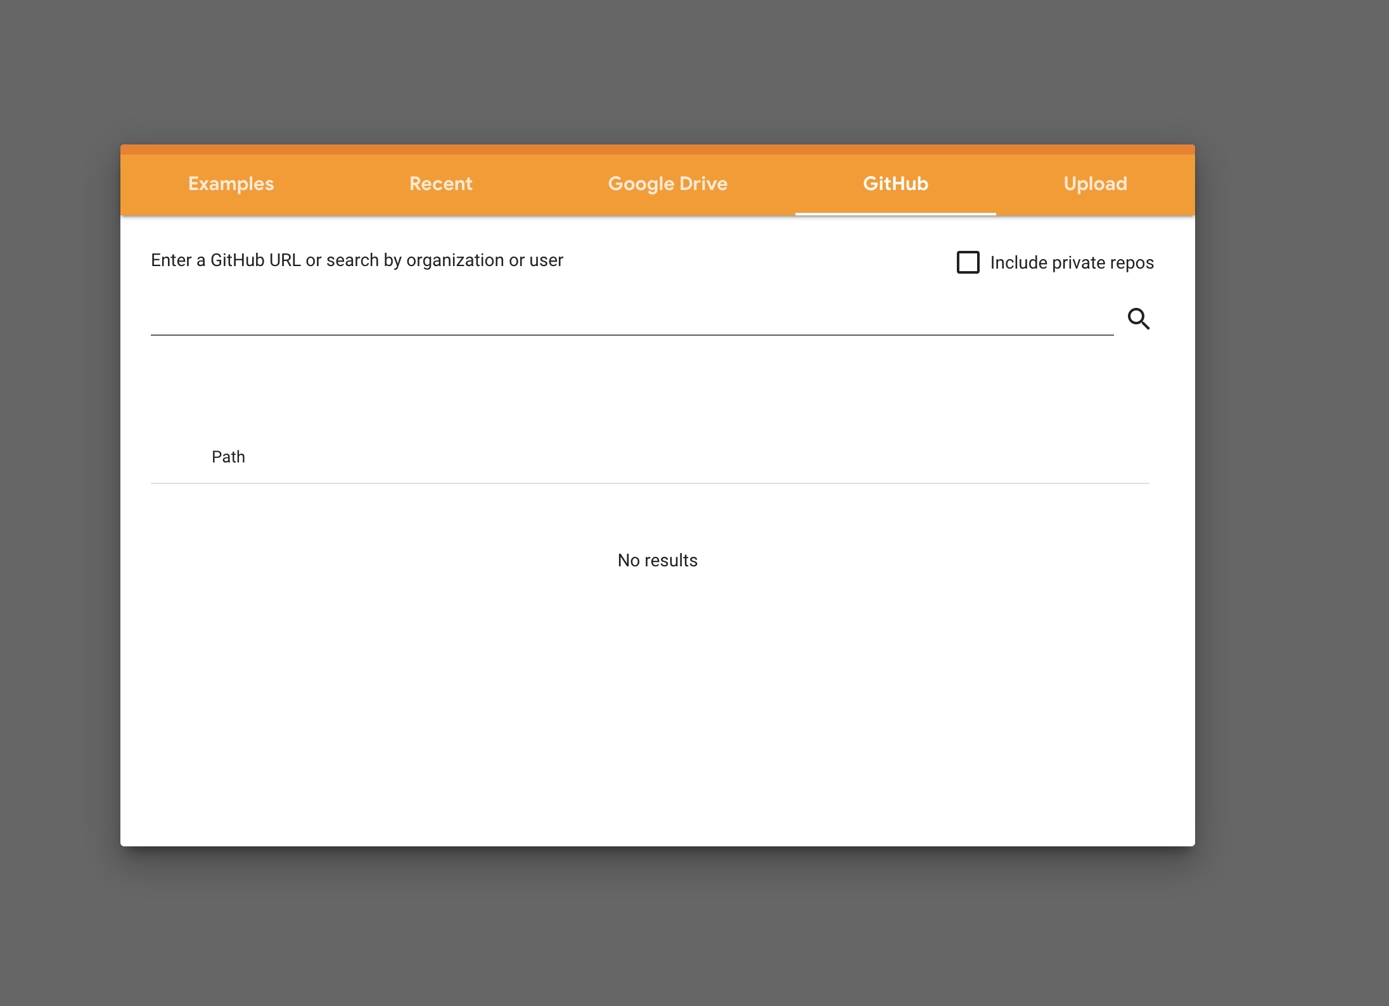

Now paste in the teaching demo git repository url: <https://github.com/kbonnen/NeuromatchTeachingDemo>

And that’s it! You’ve loaded the notebook into colab.

# Lesson Plan

You can structure your four minute video any way you like. Here is a sample minute by minute breakdown in case it is useful.

< 1 min: Introduce yourself. Give a few sentences about who you are!

< 1 min: Give a very brief recap of what regularization is why you might use it. While you should imagine that you are teaching a class of students, don’t feel the need to address them or ask them questions.

~3 mins: Work through the tutorial explaining the code and typing in solutions as you go.

# How we will evaluate your video

We are looking for people who know their content knowledge and who are able to communicate well. We’re looking for quality over quantity, so don’t feel pressured to rush through everything. Instead, make sure the content you do get to is clear and easy to follow.

# Recording the video

Don’t fuss about production quality! We are more interested in who you are than on the quality of your audio :-).

Because we are planning using Zoom during the Neuromatch Academy summer course, we’d like you to record your lesson using Zoom (instructions below). It should be a “single take” and you shouldn’t do any post-production work on the video.

# Uploading the video

In your round 2 TA application you will need to provide a link to your sample teaching video. You can do this however you like. Possible options include but are not limited to sending a link to a private Youtube video, providing a link to a Google Drive file, or providing a link to a dropbox file. ***Pease make sure the sharing settings are set so that we will be able to access the video if we have the link. ***

# Length of the video

As we mentioned we want the video to be 4 minutes long. You don’t have to conclude nicely -- feel free to cut the video at 4 minutes, even if you aren’t quite done. Do not feel the need to overproduce your video! We are trying to scale here, we hope you understand :-)

If you have any questions, please email , with subject line:

# Zoom Instructions

* Open Zoom and press “New Meeting” (or “Host a Meeting”).
* Make sure your microphone is unmuted and your video is on.
* Zoom has a variety of teaching tools you can take advantage of (though none in particular are required). Press the “Share Screen” button and select one of the following:
  1. Choose the window of an IDE you have previously opened if you want to write code

○ Choose “Whiteboard” if you want to use the built-in whiteboard feature. Feel free to record an actual whiteboard if you have access to that as well, or to not use a whiteboard at all!

○ Choose “iPhone/iPad” if you’d like to share work on an iPad (having an iPad is **not** required).​

* Some tips for sharing your screen:
  1. To change what screen you’re sharing, hover over the floating green bar with the meeting ID to bring up the menu and hit “New Share”.

○ You can stop sharing your screen/whiteboard with the red “Stop Share” button.

* When you’re ready to record, bring up the menu and (if you have screen sharing) press “More” then “Record on this computer” (or just “Record” and then “Record on this computer” if you’re starting without screen sharing).
* Once you’re finished, hit the square Stop symbol to stop the recording, and then “End Meeting.” Once you’ve ended the meeting, Zoom will save the recording and should automatically open up the folder it was saved to (if not, go to “Documents/Zoom/[insert date of recording + name of Zoom meeting room]”).
* Upload the mp4 file in that folder (which should be called zoom_0.mp4 or something similar).
* For more details or troubleshooting, see <https://support.zoom.us/hc/en-us/articles/201362473-Local-Recording>.​