# Moderate Solution Screenshots

Year:2016

Year:2015

Year 2014:

# Hard Solution Screenshots

Year:2016

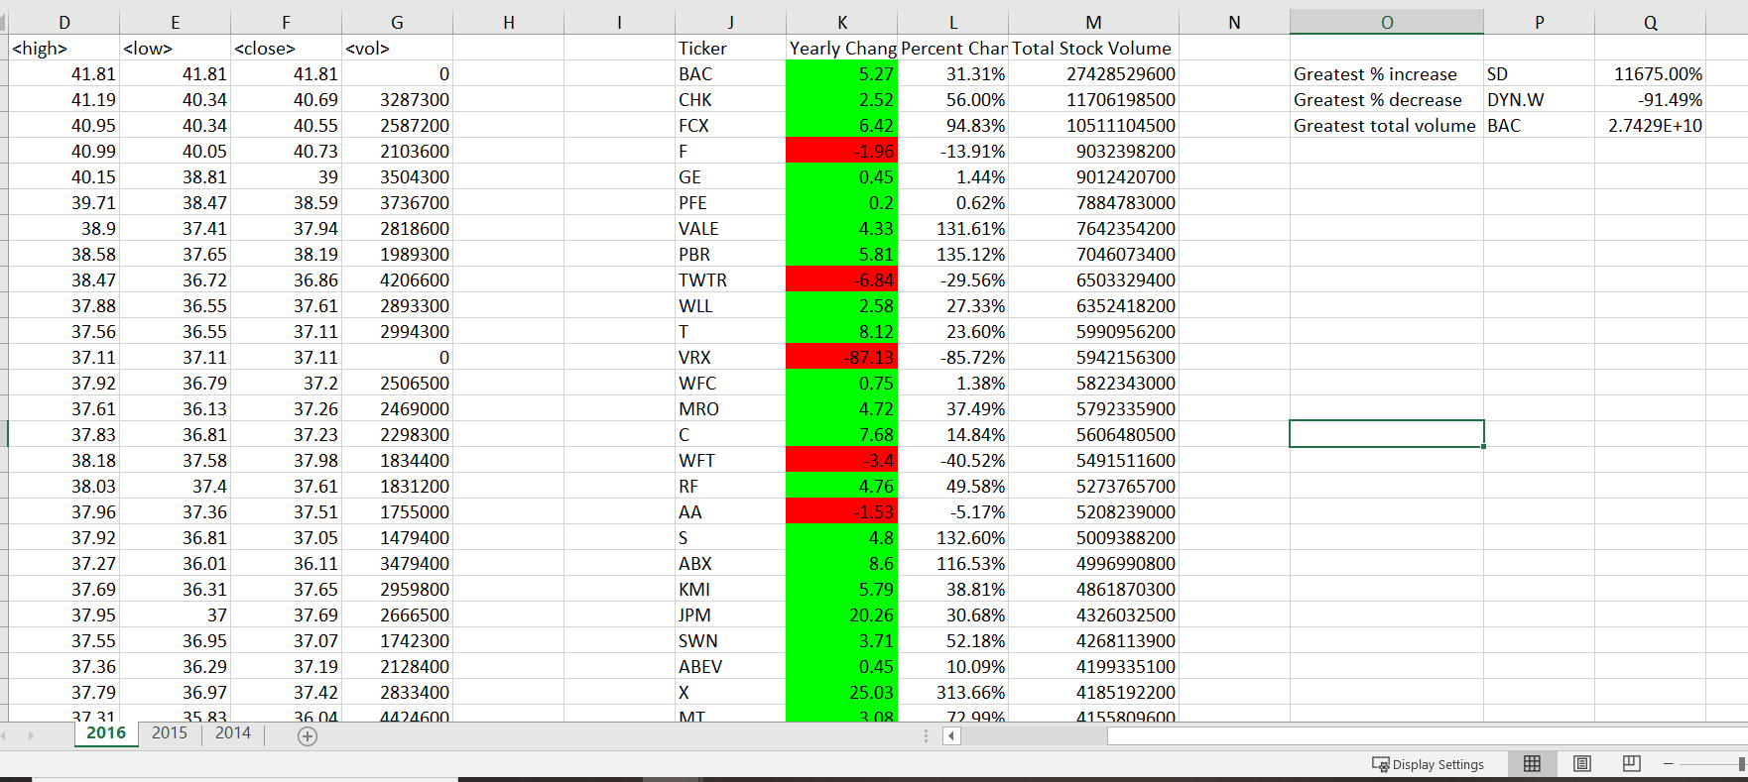

Year:2015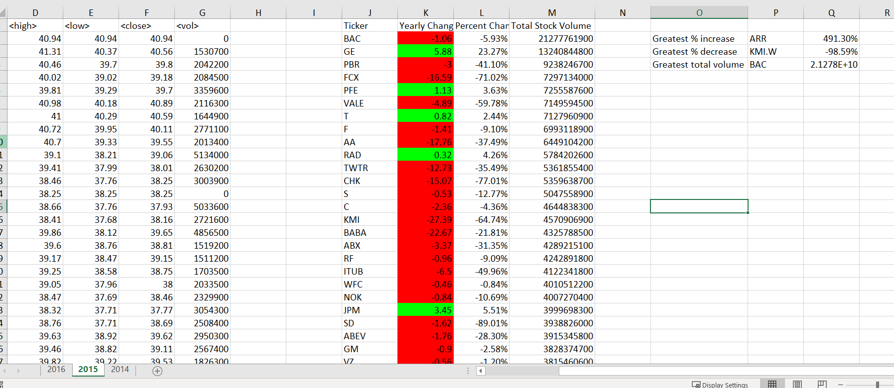

Year:2014

