BIG DATA ANALYTICS

ASSIGNMENT 8: Introduction to HBASE.

(Amitabh Saini, TY-E-4, 141541)

* **Introduction**

HBase is a distributed column-oriented database built on top of the Hadoop file system. It is an open-source project and is horizontally scalable.

HBase is a data model that is similar to Google’s big table designed to provide quick random access to huge amounts of structured data. It leverages the fault tolerance provided by the Hadoop File System (HDFS).

It is a part of the Hadoop ecosystem that provides random real-time read/write access to data in the Hadoop File System.

One can store the data in HDFS either directly or through HBase. Data consumer reads/accesses the data in HDFS randomly using HBase. HBase sits on top of the Hadoop File System and provides read and write access.

Applications such as HBase, Cassandra, couchDB, Dynamo, and MongoDB are some of the databases that store huge amounts of data and access the data in a random manner.

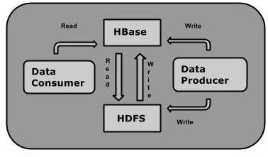

* **HBase and HDFS**

|  |  |
| --- | --- |
| **HDFS** | **HBase** |
| HDFS is a distributed file system suitable for storing large files. | HBase is a database built on top of the HDFS. |
| HDFS does not support fast individual record lookups. | HBase provides fast lookups for larger tables. |
| It provides high latency batch processing; no concept of batch processing. | It provides low latency access to single rows from billions of records (Random access). |
| It provides only sequential access of data. | HBase internally uses Hash tables and provides random access, and it stores the data in indexed HDFS files for faster lookups. |

* **Storage Mechanism in HBase**

HBase is a **column-oriented database** and the tables in it are sorted by row. The table schema defines only column families, which are the key value pairs. A table have multiple column families and each column family can have any number of columns. Subsequent column values are stored contiguously on the disk. Each cell value of the table has a timestamp. In short, in an HBase:

* Table is a collection of rows.
* Row is a collection of column families.
* Column family is a collection of columns.
* Column is a collection of key value pairs.

Given below is an example schema of table in HBase.

|  |  |  |  |  |  |  |  |  |  |  |  |  |
| --- | --- | --- | --- | --- | --- | --- | --- | --- | --- | --- | --- | --- |
| **Rowid** | **Column Family** | | | **Column Family** | | | **Column Family** | | | **Column Family** | | |
| **col1** | **col2** | **col3** | **col1** | **col2** | **col3** | **col1** | **col2** | **col3** | **col1** | **col2** | **col3** |
| 1 |  |  |  |  |  |  |  |  |  |  |  |  |
| 2 |  |  |  |  |  |  |  |  |  |  |  |  |
| 3 |  |  |  |  |  |  |  |  |  |  |  |  |

* **Column Oriented and Row Oriented**

Column-oriented databases are those that store data tables as sections of columns of data, rather than as rows of data. Shortly, they will have column families.

|  |  |
| --- | --- |
| **Row-Oriented Database** | **Column-Oriented Database** |
| It is suitable for Online Transaction Process (OLTP). | It is suitable for Online Analytical Processing (OLAP). |
| Such databases are designed for small number of rows and columns. | Column-oriented databases are designed for huge tables. |

The following image shows column families in a column-oriented database:

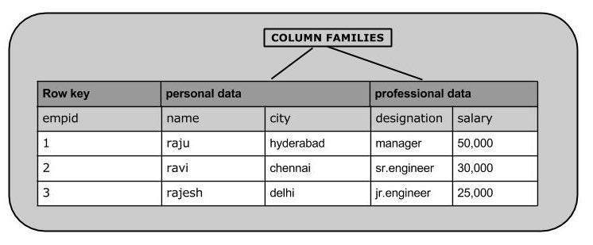

* **HBase and RDBMS**

|  |  |
| --- | --- |
| **HBase** | **RDBMS** |
| HBase is schema-less, it doesn't have the concept of fixed columns schema; defines only column families. | An RDBMS is governed by its schema, which describes the whole structure of tables. |
| It is built for wide tables. HBase is horizontally scalable. | It is thin and built for small tables. Hard to scale. |
| No transactions are there in HBase. | RDBMS is transactional. |
| It has de-normalized data. | It will have normalized data. |
| It is good for semi-structured as well as structured data. | It is good for structured data. |

* **Features of HBase**
* HBase is linearly scalable.
* It has automatic failure support.
* It provides consistent read and writes.
* It integrates with Hadoop, both as a source and a destination.
* It has easy java API for client.
* It provides data replication across clusters.
* **Where to Use HBase**
* Apache HBase is used to have random, real-time read/write access to Big Data.
* It hosts very large tables on top of clusters of commodity hardware.
* Apache HBase is a non-relational database modeled after Google's Bigtable. Bigtable acts up on Google File System, likewise Apache HBase works on top of Hadoop and HDFS.
* **Applications of HBase**
* It is used whenever there is a need to write heavy applications.
* HBase is used whenever we need to provide fast random access to available data.
* Companies such as Facebook, Twitter, Yahoo, and Adobe use HBase internally.