1. **CloudTrail**

AWS CloudTrail is a service that enables governance, compliance, operational auditing, and risk auditing of your AWS account. With CloudTrail, you can log, continuously monitor, and retain account activity related to actions across your AWS infrastructure. CloudTrail provides event history of your AWS account activity, including actions taken through the AWS Management Console, AWS SDKs, command line tools, and other AWS services. This event history simplifies security analysis, resource change tracking, and troubleshooting

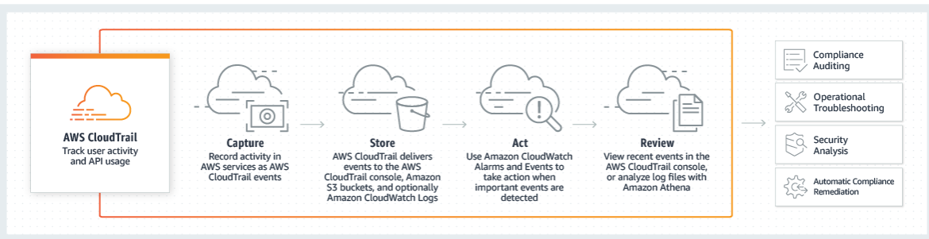

<https://blog.cloudconformity.com/aws-cloudtrail-vs-cloudwatch-why-not-both-43bafe41462>

1. **GuardDuty**

Amazon GuardDuty is a threat detection service that continuously monitors for malicious activity and unauthorized behavior to protect your AWS accounts and workloads. With the cloud, the collection and aggregation of account and network activities is simplified, but it can be time consuming for security teams to continuously analyze event log data for potential threats. With GuardDuty, you now have an intelligent and cost-effective option for continuous threat detection in the AWS Cloud. The service uses machine learning, anomaly detection, and integrated threat intelligence to identify and prioritize potential threats. GuardDuty analyzes tens of billions of events across multiple AWS data sources, such as AWS CloudTrail, Amazon VPC Flow Logs, and DNS logs.

**Top Amazon GuardDuty Alternatives**

ActivTrak

F-Secure

FortiGate

McAfee Threat Intelligence Exchange

Lookout

CylancePROTECT

Cisco Talos

Symantec Web Security Service

1. **Kinesis**

Amazon Kinesis makes it easy to collect, process, and analyze real-time, streaming data so you can get timely insights and react quickly to new information. Amazon Kinesis offers key capabilities to cost-effectively process streaming data at any scale, along with the flexibility to choose the tools that best suit the requirements of your application. With Amazon Kinesis, you can ingest real-time data such as video, audio, application logs, website clickstreams, and IoT telemetry data for machine learning, analytics, and other applications. Amazon Kinesis enables you to process and analyze data as it arrives and respond instantly instead of having to wait until all your data is collected before the processing can begin.

Can be replaced by KAFKA

<https://www.quora.com/Which-of-Amazon-Kinesis-and-Apache-Kafka-is-the-more-proven-and-high-performance-oriented>

1. **Redshift**

Cloud Datawarehouse solution. Amazon Redshift is a fully managed [petabyte](https://searchstorage.techtarget.com/definition/petabyte)-scale [data warehouse](https://searchdatamanagement.techtarget.com/definition/data-warehouse) service. Redshift is designed for analytic workloads and connects to standard SQL-based clients and business intelligence tools.

<https://www.flydata.com/amazon-redshift-vs-traditional-data-warehouses/>

Alternate Option: Snowflake or BIgQuery

Both Snowflake and Redshift offer on-demand pricing, but package associated features differently. Snowflake separates compute usage from storage in their pricing structure, while [Redshift bundles the two](https://aws.amazon.com/redshift/pricing/) together. Redshift offers users a dedicated daily amount of concurrency scaling, charging by the second once usage exceeds it; concurrency scaling is automatically included with all editions of Snowflake.

Redshift boasts the potential for deep discounts over the long term if you commit to a one- or three-year contract and offers the option to pay an hourly rate (by type and nodes in each cluster) or by the quantity of bytes scanned (a feature called Spectrum). [Snowflake offers five editions](https://www.snowflake.com/pricing/) with additional features tied to each ascending level of price, so you can opt out of the features that aren’t a good fit for your business. Editions are determined by volume and types of data, geographical regions, and AWS or Azure platform.

<https://www.stitchdata.com/resources/snowflake-vs-redshift/>

BigQuery is Google's fully managed, petabyte scale, low cost enterprise data warehouse for analytics. BigQuery is serverless. There is no infrastructure to manage and you don't need a database administrator, so you can focus on analyzing data to find meaningful insights using familiar SQL. BigQuery is a powerful Big Data analytics platform used by all types of organizations, from startups to Fortune 500 companies.

Redshift is more expensive. Per GB, [Redshift costs $0.08, per month](https://blog.panoply.io/data-engineers-guide-to-redshift-pricing) ($1000/TB/Year),

<https://hevodata.com/blog/amazon-redshift-pros-and-cons/>

1. **Simple storage Service(S3**)

Amazon Simple Storage Service (Amazon S3) is an object storage service that offers industry-leading scalability, data availability, security, and performance. This means customers of all sizes and industries can use it to store and protect any amount of data for a range of use cases, such as websites, mobile applications, backup and restore, archive, enterprise applications, IoT devices, and big data analytics. Amazon S3 provides easy-to-use management features so you can organize your data and configure finely-tuned access controls to meet your specific business, organizational, and compliance requirements. Amazon S3 is designed for 99.999999999% (11 9's) of durability, and stores data for millions of applications for companies all around the world.

<https://www.sumologic.com/insight/s3-cost-optimization/>

Data which are hardly being used and cannot be deleted ,can be moved to AWS GLACIER.Glacier cost is much lower compared to S3.

1. **SageMaker**

Amazon SageMaker provides every developer and data scientist with the ability to build, train, and deploy machine learning models quickly. Amazon SageMaker is a fully-managed service that covers the entire machine learning workflow to label and prepare your data, choose an algorithm, train the model, tune and optimize it for deployment, make predictions, and take action. Your models get to production faster with much less effort and lower cost

1. **Shield**

AWS Shield is a security service that protects web applications hosted on the Amazon Web Services public cloud against distributed denial of service (DDoS) attacks.A DDoS attack targets a particular computing resource, such as a server, and floods it with incoming traffic or connection requests, which negatively affects its performance. This causes a denial of service that prevents authorized users from accessing that resource.According to Amazon, AWS Shield detects and protects against the three types of DDoS attacks: infrastructure-layer attacks, including User Datagram Protocol (UDP) floods; state-exhaustion attacks, including SYN floods; and application-layer attacks, including HTTP floods.To mitigate DDoS attacks to the application layer, IT teams need to write and implement rules using the AWS Web Application Firewall service.

1. **DeviceFarm**

AWS Device Farm is an app testing service that lets you test and interact with your Android, iOS, and web apps on many devices at once, or reproduce issues on a device in real time. View video, screenshots, logs, and performance data to pinpoint and fix issues and increase quality before shipping your app. AWS Device Farm lets you test your application on a shared fleet of 2500+ devices or on your own private device lab in the cloud.

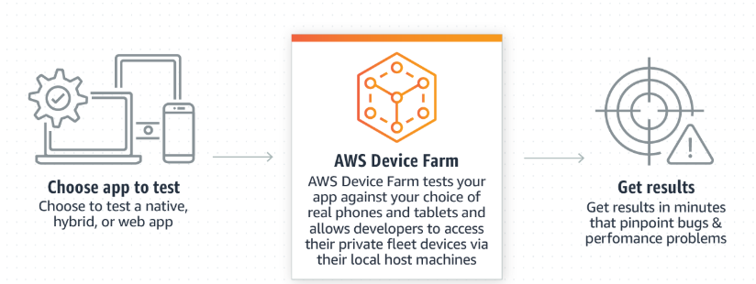

1. **CloudWatch**

Amazon CloudWatch is a monitoring service for AWS cloud resources and the applications you run on AWS. You can use Amazon CloudWatch to collect and track metrics, collect and monitor log files, set alarms, and automatically react to changes in your AWS resources. Amazon CloudWatch can monitor AWS resources such as Amazon EC2 instances, Amazon DynamoDB tables, and Amazon RDS DB instances, as well as custom metrics generated by your applications and services, and any log files your applications generate. You can use Amazon CloudWatch to gain system-wide visibility into resource utilization, application performance, and operational health. You can use these insights to react and keep your application running smoothly.

1. **MQ**

Amazon MQ is a managed message broker service for Apache ActiveMQ that makes it easy to set up and operate message brokers in the cloud. Message brokers allow different software systems–often using different programming languages, and on different platforms–to communicate and exchange information. Amazon MQ reduces your operational load by managing the provisioning, setup, and maintenance of ActiveMQ, a popular open-source message broker. Connecting your current applications to Amazon MQ is easy because it uses industry-standard APIs and protocols for messaging, including JMS, NMS, AMQP, STOMP, MQTT, and WebSocket. Using standards means that in most cases, there’s no need to rewrite any messaging code when you migrate to AWS.

1. **Elastic Search**

Amazon Elasticsearch Service is a fully managed service that makes it easy for you to deploy, secure, and operate Elasticsearch at scale with zero down time. The service offers open-source Elasticsearch APIs, managed [Kibana](https://aws.amazon.com/elasticsearch-service/the-elk-stack/kibana/), and integrations with [Logstash](https://aws.amazon.com/elasticsearch-service/the-elk-stack/logstash/) and other AWS Services, enabling you to securely ingest data from any source and search, analyze, and visualize it in real time. Amazon Elasticsearch Service lets you pay only for what you use – there are no upfront costs or usage requirements. With Amazon Elasticsearch Service, you get the ELK stack you need, without the operational overhead.

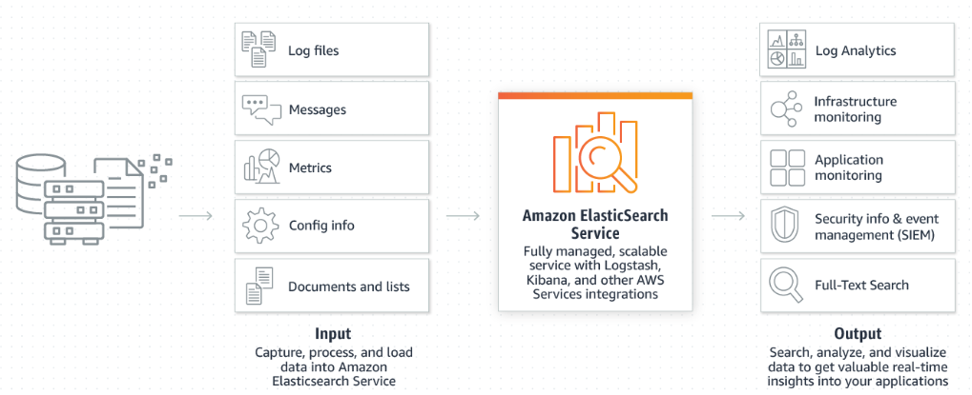

1. **ElasticCache**

<https://cloudacademy.com/blog/amazon-elasticache/>

Caching is a technique to store frequently accessed information in a temporary memory location on a server. Read-intensive web applications are the best use-case candidates for a cache service.

**Memcached:**Memcached is an open source, distributed, in-memory key-value store-caching system for small arbitrary data streams flowing from database calls, API calls, or page rendering. Memcached has long been the first choice of caching technology for users and developers around the world**.**

**Redis:**Redis is a newer technology and often considered as a superset of Memcached. That means Redis offers more and performs better than Memcached. Redis scores over Memcached in few areas .

* Redis implements six fine-grained policies for purging old data, while Memcached uses the LRU (Least Recently Used) algorithm.
* Redis supports key names and values up to 512 MB, whereas Memcached supports only 1 MB.
* Redis uses a hashmap to store objects whereas Memcached uses serialized strings.
* Redis provides a persistence layer and supports complex types like hashes, lists (ordered collections, meant for queue), sets (unordered collections of non-repeating values), or sorted sets (ordered/ranked collections of non-repeating values).
* Redis is used for built-in pub/sub, transactions (with optimistic locking), and Lua scripting.
* Redis 3.0 supports clustering.

Amazon ElastiCache is a web service that makes it easy to set up, manage, and scale a distributed in-memory data store or cache environment in the cloud. It provides a high-performance, scalable, and cost-effective caching solution. At the same time, it helps remove the complexity associated with deploying and managing a distributed cache environment. ElastiCache has features to enhance reliability for critical production deployments, including:

* Automatic detection and recovery from cache node failures.
* Automatic failover (Multi-AZ) of a failed primary cluster to a read replica in Redis replication groups.
* Flexible Availability Zone placement of nodes and clusters.
* Integration with other Amazon Web Services such as Amazon EC2, CloudWatch, CloudTrail, and Amazon SNS, to provide a secure, high-performance, managed in-memory caching solution.

Amazon ElastiCache provides two caching engines, Memcached and Redis. You can move your existing Memcached or Redis caching implementation to Amazon ElastiCache effortlessly. Simply change the Memcached/Redis endpoints in your application.

