# CAST CI Test cases

CAST CI Test cases 1

IM ACP DCP: 2

Bioassay ACP 3

NAB: 4

Concordance: 5

Assay Sensitivity: 6

Robustness: 7

Assay Precision 8

# IM ACP DCP:

|  |  |
| --- | --- |
| **Parameter** | **Value** |
| ACP Type | Depletion |
| File Type | EXCEL_TEMPLATE |
| Input File | Case5c_IM_ACPDCP_3VAR2pl.xls |
| Comparison Variable | None |
| Data Transformation | Determined by CAST |
| Experimental Design | 3VAR2pl |
| Var1:Analyst |  |
| Var2:Intrument |  |
| Var3:Conjugate lot |  |

# Bioassay ACP

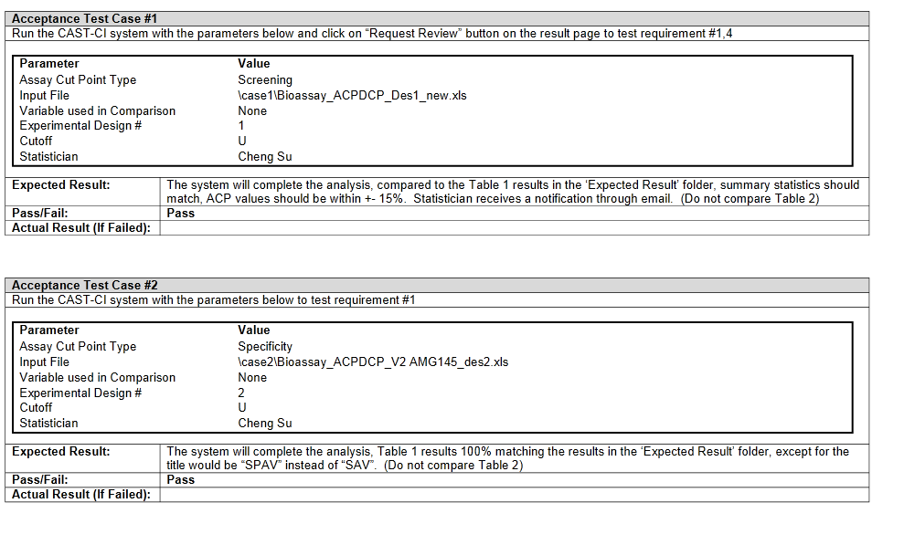

# NAB:

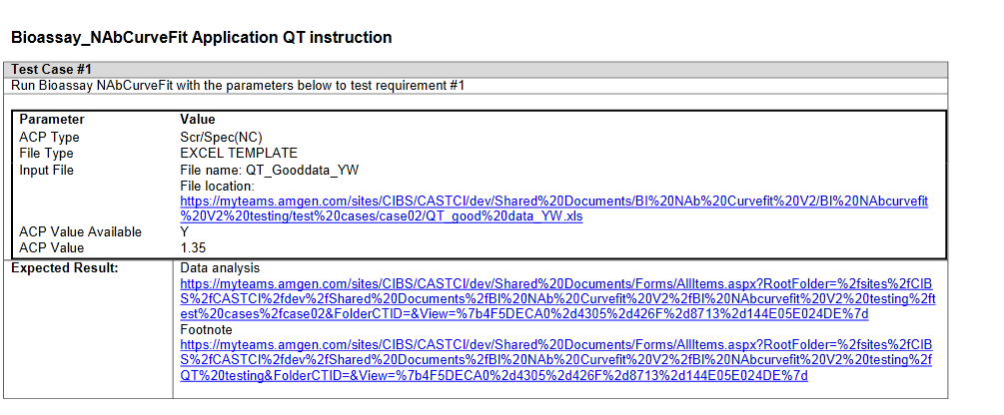

# Concordance:

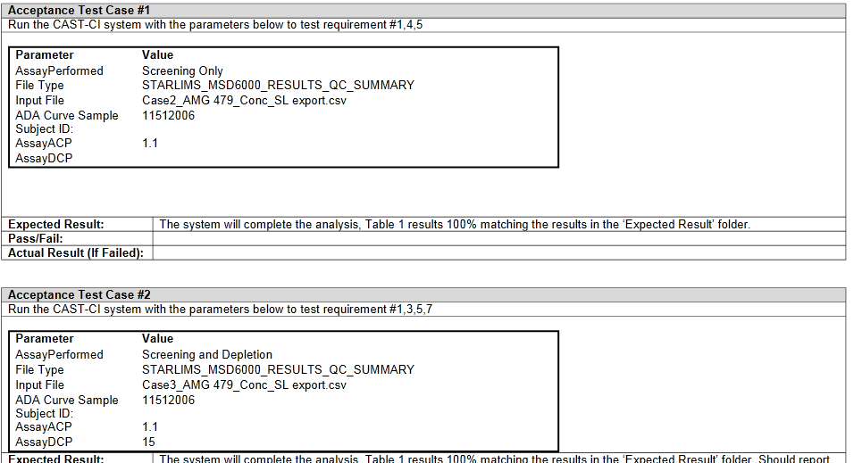

# Assay Sensitivity:

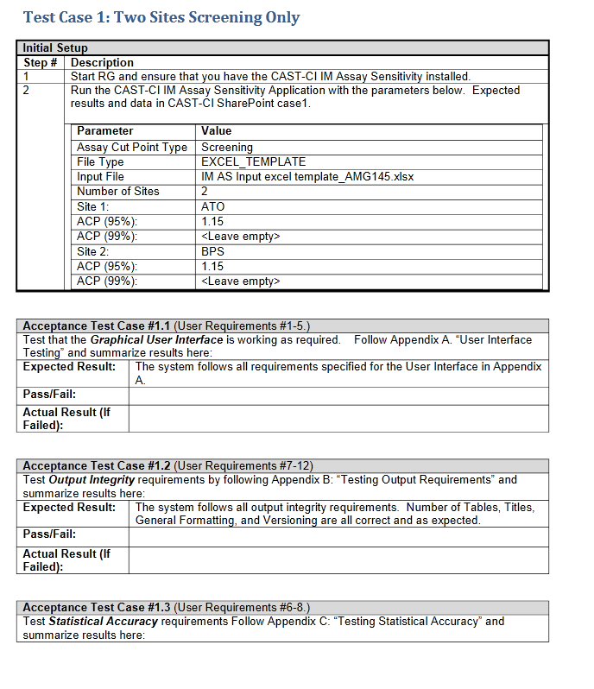

# Robustness:

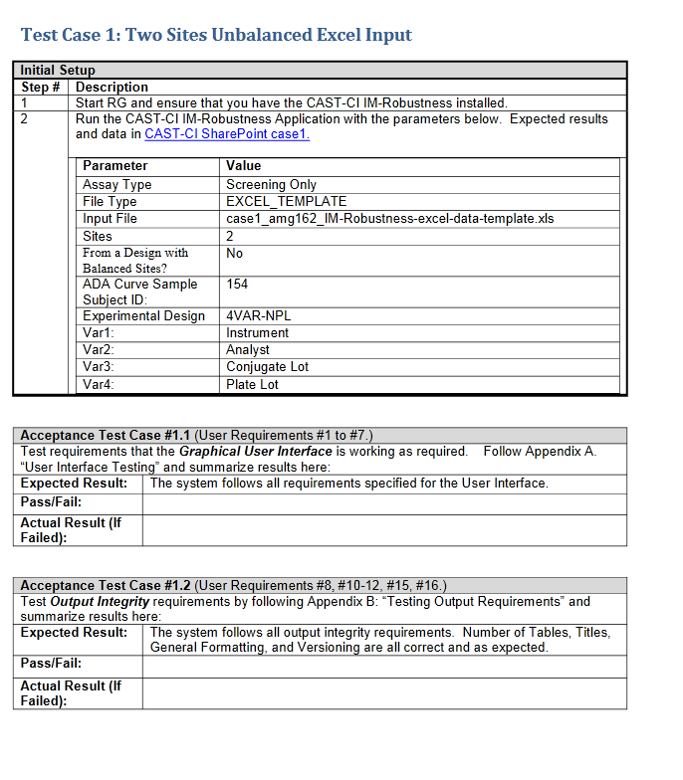

# Assay Precision

