Application Integration Strategy Template

Introduction: How to Use This Template

This template is an essential document for pulling together all of the work, planning, and investments completed through identifying your current environment, developing the future vision, performing a gap analysis, and building your roadmap. An AI blueprint is an overview of the primary elements and their relationships to each other; including applications, middleware, data, users, and external systems. Without an AI blueprint, the time and money your organization invests into your formal application integration strategy could be compromised due to disorganization and a lack of focus. As your environment evolves, update this blueprint to match the current environment and future needs.

To use this template, simply customize any text below in dark grey to fit the needs of your enterprise. Be sure to remove all introductory text in dark grey and convert the remaining text to BLACK prior to distribution.

This template uses the ABC Insurance Company as an example. Not all elements of their blueprint are elaborated, but placeholder diagrams, etc. are used to add context to the sections.

Contents

1. Executive Overview 3

2. Introduction 4

2.1 Scope 4

3. Current Environment 5

3.1 Business Environment 5

3.2 System Environment 5

4. Future Vision 6

4.1 Business Environment 6

4.2 System Environment 6

4.2.1 Context 6

4.2.2 Architecture Overview 7

4.2.3 Patterns 7

5. Implementation Plans 8

5.1 Gaps 8

5.1.1 People 8

5.1.2 Process 8

5.1.3 Technology 8

5.2 Strategic Initiatives 9

5.2.1 People 9

5.2.2 Process 9

5.2.3 Technology 9

5.3 Roadmap 9

5.3.1 Initiative Planning 10

# Executive Overview

E.g.: ABC Insurance Company focused on their customer service goals to align their AI strategy with the business. The claims process at ABC is associated with a high level of customer service and therefore it became the focus of ABC’s AI strategy. Stakeholder involvement starts at the top and moves down through the organization to gain buy-in and increase cooperation.

# Introduction

The primary purpose for the blueprint is to review the current state of integration at *ABC*, develop architecture for the future AI environment, and create a plan for implementing the environment.

This report is subdivided into the following sections:

* Section 1 Executive Overview – provides a high level summary of the content in the blueprint.
* Section 2 Introduction – describes the scope of the blueprint.
* Section 3 Current Environment – summarizes the primary elements in the current *ABC* AI environment.
* Section 4 Future Vision – summarizes the primary elements of the proposed *ABC* AI environment.
* Section 5 Implementation Plans – documents the gaps, issues, opportunities, and recommendations for the AI strategy, and creates a roadmap for implementing the proposed AI environment.

## Scope

The following elements are in scope for the blueprint:

E.g.: Activities ABC Insurance Company wants to integrate through AI:

* Investigate Claim
* Settle Claim
* Administer Claim

Out of scope for the blueprint:

E.g.: Activities ABC Insurance Company wants to leave untouched:

* Evaluate Claim
* Manage Claim
* Close Claim

# Current Environment

All departments need to be aware of the services supported by the IT department and how these services interact with each other. Catalogs can identify points where possible AI complications may occur and opportunities exist to reuse services.

Take inventory of your IT environment to determine your current state.

## Business Environment

Describe the business environment that is affected by the AI systems environment.

E.g.: ABC determined that the claims process was the best place to develop their AI strategy. The following will be affected by AI:

* Claims department is the most process-oriented relative to others.
* Aging legacy infrastructure is making ABC look at AI options for new technology solutions.



## System Environment

The current application integration environment at ABC is focused on providing application-to-application, business-to-business, and user-to-data integration.

Figure 1 illustrates the primary operational components that make up the current integration environment, overlaid on an integration architecture framework.

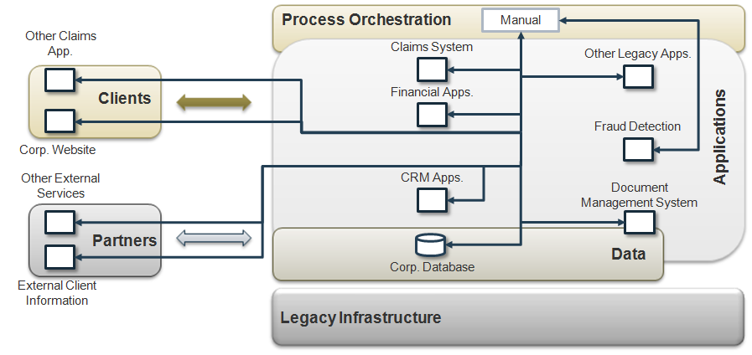

Figure 1 - Current AI Environment Building Blocks

Elaborate on components in the current architecture overview. Are there overlaps in capabilities, functionalities, or disconnects between primary application components, etc.?

The current configuration supports <<X>> environments: <<Development, QA, and Production>>. Elaborate on components in the operational model.

# Future Vision

## Business Environment

List the primary business drivers and strategic business initiatives that will have an impact on the AI systems environment. Align your business drivers with IT to fully leverage the benefits of an AI strategy.

Use a high level architecture overview to place the primary building blocks of your future AI functionality. Direct these solutions aimed at areas of needs and continuously narrow your focus.

Include external business partners as part of the future business environment, especially if the AI environment will need to support interactions with those partners.

## System Environment

Develop a future architecture vision based on the systems context in which AI will be required to meet the business drivers.

### Context

Document existing and future systems and users that will need to interact with the AI environment. A diagram is helpful, showing the AI environment at the center of the diagram, with external entities around the perimeter.

Figure 2 illustrates the system context diagram for the ABC Application Integration (AI) environment.



Figure 2 - ABC AI System Context

The AI system is treated as one object. All interactions with external systems are identified. The system context diagram should also identify strategic applications that may be introduced in the future.

### Architecture Overview

The architecture overview represents the governing ideas and building blocks of the AI system, communicating a simple overview of the target system.

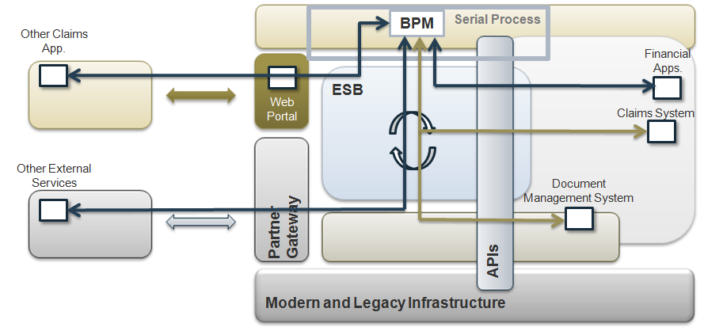

Figure 3 - High-Level Architecture Building Blocks

The primary elements of the target AI architecture include:

E.g.:

* An Enterprise Service Bus
* Process Services
* Application Connectivity Services
* Partner Gateway Services
* Extract, Transform and Load Services
* Process Modelling and Integration Development Services
* Common Infrastructure Services

### Patterns

Identify the primary interaction patterns across the environment and categorize the interfaces by pattern. Use this section to document the interactions and categorizations.

Consider the following patterns when documenting the application orchestrations in the environment:

* Direct Connection
* Broker
* Serial Process
* Parallel Process

Use the patterns to uncover non-functional requirements such as aggregate message volumes, component availability and failover requirements, and operational node backup/restore procedures.

E.g.: ABC observed Direct Connection patterns between the BPM, external business partners via the web portal and 3rd parties, and the financial systems. A Broker pattern was observed between the BPM, Claims, and Document Management System. Finally, a Serial Process pattern was being used to represent the Claims process.

# Implementation Plans

This section identifies the gaps between the current environment and the proposed vision. It uses these gaps to identify opportunities for initiatives required to build a high level plan for implementing the proposed architecture.

## Gaps

The following gaps have been identified between the current “as-is” AI environment and the proposed “to-be” vision of the AI environment, including people, process, and technology.

### People

|  |  |
| --- | --- |
| Gap | E.g.: ABC Insurance Company needs to educate the IT and business departments of changes to the IT environment and how AI will impact business processes. |
| Implication | Disruption of business operations. |
| Opportunities | Streamline business processes. |
| Recommendations | Training sessions and workshops. |
| Issues | Facilitating time and resources. |

### Process

|  |  |
| --- | --- |
| Gap | ABC does not have an enterprise level steering committee established for AI. |
| Implication | AI solutions will continue to be implemented on an ad hoc basis, without standardization or consistency making maintenance and management more difficult and as a result, more costly. |
| Opportunities | Implement a steering committee to promote consistency in AI solution development and management across the organization. |
| Recommendations | Include all relevant business and IT stakeholders. |
| Issues | Not everyone may want to participate. Will need executive backing. |

### Technology

|  |  |
| --- | --- |
| Gap | No integration middleware. |
| Implication | Interfaces will need to be hand coded in point-to-point fashion, restricting the flexibility, scalability, and maintainability of each interface. |
| Opportunities | Have an opportunity to invest in AI middleware technology for the Claims process and to re-factor existing interfaces for better maintainability. |
| Recommendations | Leverage the middleware for the Claims process optimization and refactoring of existing point-to-point interfaces into a more controlled, managed environment. |
| Issues |  |

## Strategic Initiatives

The following initiatives are required to fill the gaps

### People

|  |  |
| --- | --- |
| Initiative | E.g.: ABC Insurance Company holds training sessions to update IT and business departments of changes to business operations due to AI. |
| Gaps Addressed | Knowledge gap of employees |
| Priority | High |
| Related initiative(s) | Update service catalog and user manuals. |
| Issues | Constant monitoring of normal business operations after AI implementation. |

### Process

|  |  |
| --- | --- |
| Initiative | Establish an AI Steering Committee and Charter. |
| Gaps Addressed | Steering Committee |
| Priority | High |
| Related initiative(s) | Steering committee needs to provide overarching guidance to other People, Process, and Technology AI initiatives. |
| Issues | Need executive support. |

### Technology

|  |  |
| --- | --- |
| Initiative | Procure AI middleware. |
| Gaps Addressed | AI middleware missing. |
| Priority | High |
| Related initiative(s) | People training on new middleware technology. |
| Issues |  |

## Roadmap

This section illustrates a high-level roadmap diagram for development and deployment of the environment, and discusses the proposed initiative prioritization and timing.

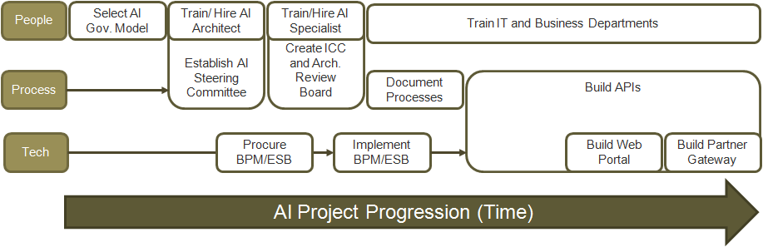

Figure 4 - Implementation Roadmap

### Initiative Planning

Discussion of the reasoning for placing initiatives in their requisite order on the roadmap and any additional implications this placement may have on implementation.

E.g.:

* After the AI steering committee, ICC, and architecture review board are in place, technical development and training happens simultaneously.
* Agents and adjusters activities are customer service focused areas of the Claims process. Since these activities are mostly done through the internet, ABC prioritized the development of web services over partner gateways.
* Every time a new component is added to the architecture, ABC needs to create or adapt APIs.

____________________________________________________

Info-Tech Research Group tools and template documents are provided for the free and unrestricted use of subscribers to Info-Tech Research Group services. Use this document either in whole or in part as a basis and guide for document creation. To customize this document with corporate marks and titles, simply replace the Info-Tech Information in the Header and Footer fields of this document.