|  |
| --- |
| **Restaurant recommender system** |
| Capstone Project |

We are working on developing Restaurant Recommendation System using machine learning for capstone project to IBM through coursera . It recommends restaurants based on user’s preferences and his previous interest data.

**Table of contents**

|  |  |
| --- | --- |
| **Topic** | **Page number** |
| Introduction section | 2 |
| Data section | 4 |
| Methodology section | 5 |
| Result section | 9 |
| Conclusion section | 10 |

1. **Introduction :**

**Problem background:**

Bangalore is considered as IT Hub as well as largest city of the Indian state of Karnataka. With a population of over 13 million, Bangalore is considered as the third largest city in India.

Bangalore can also be called a foodie's paradise because of its vast variety of foods and edibles with a touch of Bangalore's uniqueness and tradition. All kind of foods from Roadside vendors, tea stalls, South or North Indian, Chinese and Western fast food are popular in the city.

**Problem description:**

For any traveller or any new person food can be an important factor for decided how you rate your trips and plus also recommending it to the people. Food also plays a major factor in attracting various people around to globe. In such conditions it becomes utmost important to find the right place, at a reasonable cost. Below are few question which should be addressed, such as :

* Various cuisines available in the restaurant?
* Restaurants nearest to me?
* Rating of various restaurants? etc.

Our task is to find out solutions to these kinds of questions as well as build a system that can help in recommending new restaurants based on their rankings. We are expecting our recommendation system to address below mentioned issues:

* Types of restaurants are present in a particular area?
* Ranking of various restaurants based on different preferences? etc.

**Target Audience:**

We are targeting not just traveler but everyone who are new to the city. People might decide to look for a similar restaurant because they are comfortable with a specific cuisine. People will look for restaurants nearby them and all this could be easily handled by our recommender system. So our target is basically everyone who are exploring new places.

**Success rate:**

With restaurants evolving, we need a system that could help us access vast number of food varieties. With the help of Machine learning we will try to build our personal system which will guide us based on our likes and dislikes. As we are helping people by providing them with their personal assistance and so the success rate could certainly increase with time.

1. **Data :**

**Data requirements:**

For building an recommendation system we required below mentioned details:

Geographical Data :

To access location of a restaurant, its Latitude and Longitude is to be known so that we can point at its coordinates and create a map displaying all the restaurants with its labels respectively.

Demographic Data :

Population of the neighborhood where the restaurant is located, it helps us to determine the restaurant's growth and amount of expected customers who turn up to eat.

Financial Data :

Average income of neighborhood to know how much is the restaurant worth. Income is directly proportional to richness of a neighborhood. If people in a neighborhood earns more than an average income, then there is possibility that they will spend more however it is not always true.

FourSquare API :

We are using FourSquare API to fetch data for nearest locations so that we can use them to form a cluster.

1. **Methodology :**

**Exploratory analysis:**

Analyzing and Exploring the data is very important because it gives us insights and will help you to get partial idea of the data we are working with. While exploring the dataset, I found out that Indira-nagar has most number of venues while Varthur has the least.

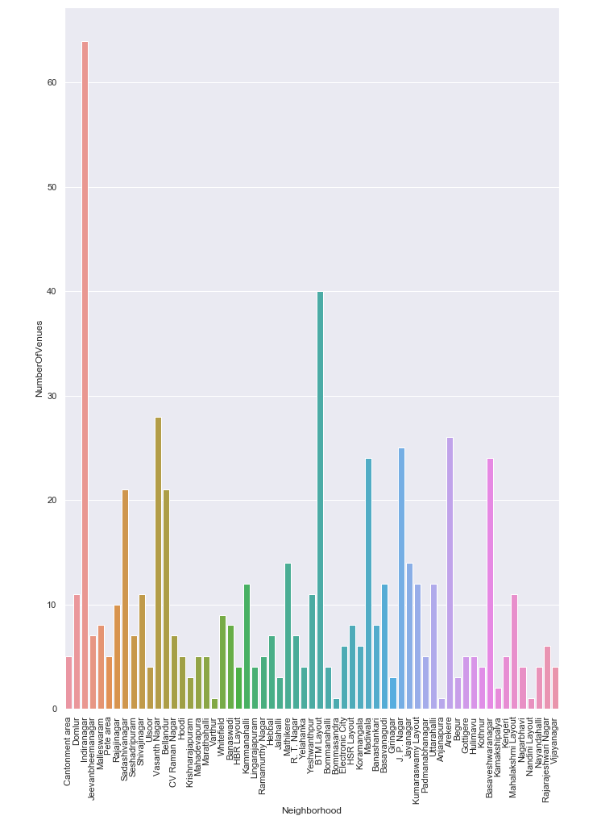

While analyzing further for Indiranagar we got below plots for Venue Category Count :

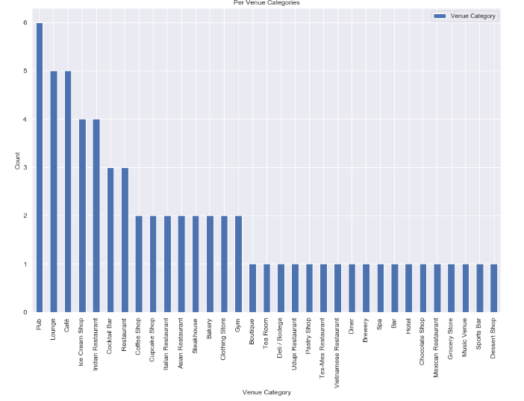

To find optimum number cluster we used Elbow method. We produced a graph to analyze all the values for the cluster, which will in turn help us select the n_cluster .

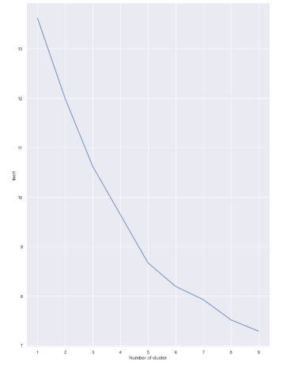

As well as we generated a Cluster map using folium for Bangalore city, which will help us give a general view on the cluster distribution across the city :

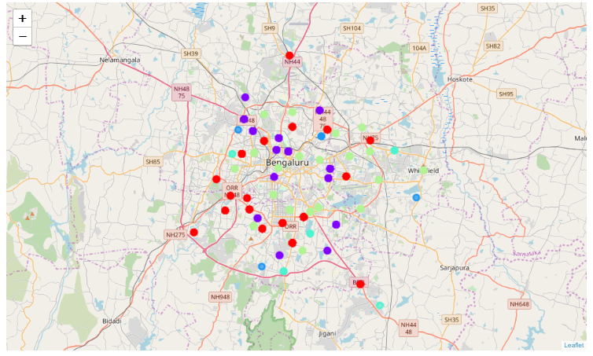

1. **Result :**

Using our recommender system we produced a list of top restaurants and the similar venues in accordance with the user’s input.

We have taken ‘Indiranagar’ as the neighborhood and with the help of our model we produced neighborhoods with similar characters, which we can recommend to the user .

The following image shows the result:

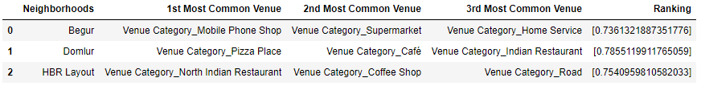

1. **Conclusion :**

The recommender system is a system that considers various factors such as population, income, cuisine, neighborhood etc. It is a powerful data driven model whose efficiency may decrease with more data but accuracy will increase. It will help users by recommending best restaurants according to their perception.