Report: Optimising NYC Taxi Operations
Prepared by: Amita Dhandha
Assignment: EDA – Optimising NYC Taxi Operations
Include your visualisations, analysis, results, insights, and outcomes. Explain your methodology and approach to the tasks. Add your conclusions to the sections.

Data Preparation
  - Loading the dataset
The notebook loaded the NYC Yellow Taxi Parquet data using pandas. The January file contained 3,041,714 rows and 19 original columns. The analysis used pandas, NumPy, Matplotlib and Seaborn, with GeoPandas used for the taxi-zone shapefile visualisation.
    - Sample the data and combine the files
A 5% sample was taken at the date/hour level to retain the temporal distribution while reducing processing cost. The notebook shows 152,087 sampled rows for the first file and a combined sampled dataset of 2,048,487 rows before the later cleaning steps. Helper fields such as pickup date and pickup hour were created for stratified sampling.

Data Cleaning

Fixing Columns
    - Fix the index
After sampling and concatenation, the dataframe index was reset so that the working dataset had a clean sequential index. This avoided carrying over the original Parquet row indices.
    - Combine the two airport_fee columns
The notebook identified two airport-fee columns, airport_fee and Airport_fee. The duplicate columns were handled during cleaning so that the working dataframe retained a single airport-fee field for analysis.

Handling Missing Values
    - Find the proportion of missing values in each column
Missing-value proportions were calculated with df.isnull().sum()/len(df)*100. The duplicate Airport_fee column was completely missing (100%), while the main analytical columns had zero missing values after the cleaning workflow.

    - Handling missing values in passenger_count
Passenger_count was checked for missing and invalid zero values. The notebook used the median passenger count for imputation where required and treated zero passenger counts as invalid for passenger-based analysis.

    - Handle missing values in RatecodeID
Missing RatecodeID values were handled using the mode, preserving the most common rate-code category rather than dropping trips.
    - Impute NaN in congestion_surcharge
Congestion surcharge was inspected and imputed where required. The observed values were predominantly 2.50, with 274,424 sampled records at 2.50 and 22,528 at 0.00 in the intermediate dataset.

Handling Outliers and Standardising Values
    - Check outliers in payment type, trip distance and tip amount columns
The notebook inspected distributions and extreme values. Before cleaning, trip distance reached 721.26 miles and fare amount reached 999.00. Negative monetary values were also found: extra (3), mta_tax (79), improvement_surcharge (85), total_amount (85), congestion_surcharge (62), and airport_fee (2). Implausible trips were filtered using business rules for passenger count, extreme distance, invalid payment type and inconsistent zero-distance/zero-fare trips.

Exploratory Data Analysis

General EDA: Finding Patterns and Trends
    - Classify variables into categorical and numerical
Categorical/discrete variables included VendorID, RatecodeID, PULocationID, DOLocationID and payment_type. Datetime variables were tpep_pickup_datetime and tpep_dropoff_datetime. Numerical variables included passenger_count, trip_distance, trip_duration and all monetary fields. pickup_hour was treated as a temporal categorical feature for hourly analysis.
    - Analyse the distribution of taxi pickups by hours, days of the week, and months
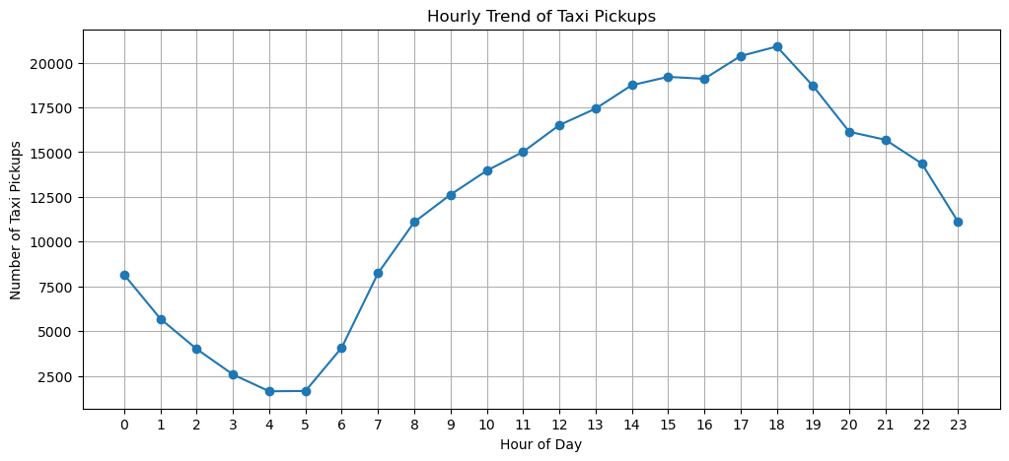
Hourly pickups increased through the day and peaked at 18:00 with 20,896 sampled trips. Weekday traffic peaked at 18:00 with 15,766 trips, while weekend traffic peaked at 16:00 with 5,410 trips. Tuesday had the highest daily pickup count (47,616) and Monday the lowest (39,242). The final notebook dataframe contains 296,932 January pickups and only 2 December pickups, indicating that the monthly result is affected by the notebook data-processing state and should be interpreted cautiously.
    - Filter out the zero/negative values in fares, distance and tips
The analysis identified zero and negative monetary/distance observations and created a valid-trip subset for financial analysis. After filtering, the valid analytical subset used positive fare, positive distance and non-negative tip values. The notebook also checked for inconsistent zero-distance/zero-fare trips.
    - Analyse the monthly revenue trends
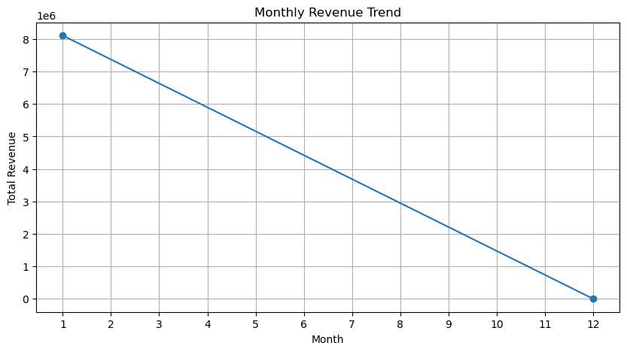
The notebook calculated monthly revenue from total_amount. January revenue was $8,110,227.56 and December was $27.00 in the final dataframe state. Because the final monthly data contains almost entirely January records, this result signals that the notebook should be rerun on the complete monthly dataset before using the trend as a full-year operational conclusion.
    - Find the proportion of each quarter’s revenue in the yearly revenue
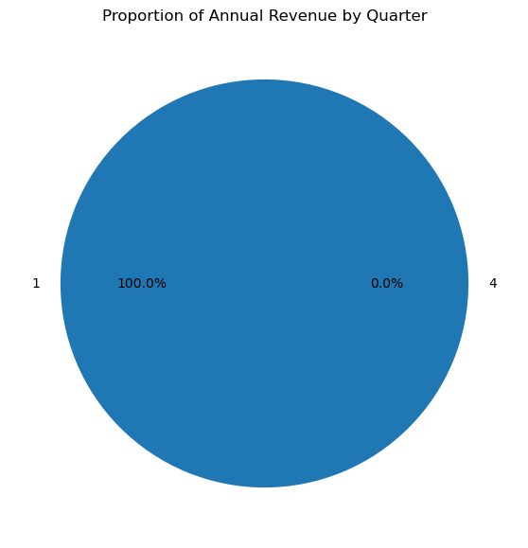
The computed quarterly shares were Q1 = 99.999667% and Q4 = 0.000333%. This mirrors the monthly coverage issue: the final dataframe used for this calculation is overwhelmingly January data. The calculation method is correct, but a complete-year dataframe should be used for a reliable annual comparison.
    - Analyse and visualise the relationship between distance and fare amount
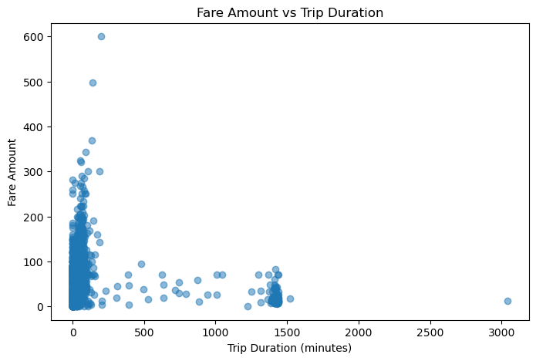
Fare and trip distance showed the expected positive relationship in the scatter analysis: longer trips generally generated higher fares. The analysis was restricted to valid positive-distance/positive-fare trips for financial interpretation.
    - Analyse the relationship between fare/tips and trips/passengers
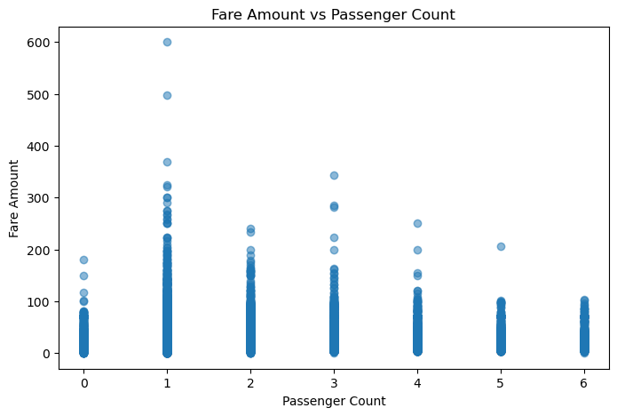
Correlation analysis gave fare versus trip duration = 0.2290, fare versus passenger count = 0.0325, and tip amount versus trip distance = 0.5709. This indicates a moderate positive association between trip distance and tip amount, while passenger count alone had very little linear association with fare. These are associations, not causal effects.
    - Analyse the distribution of different payment types
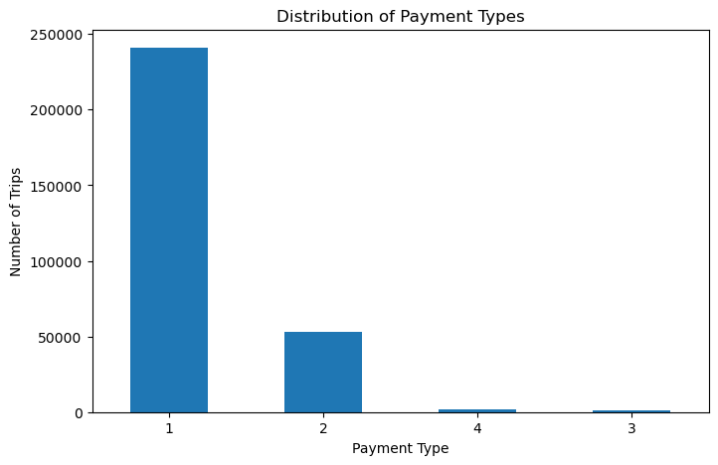
Payment type 1 represented 240,920 trips (81.14%), type 2 represented 52,810 (17.79%), type 4 represented 1,786 (0.60%), and type 3 represented 1,418 (0.48%). Thus payment type 1 was the dominant payment category in the analysed sample.
    - Load the taxi zones shapefile and display it
The taxi-zone shapefile was loaded with GeoPandas. It contained LocationID, zone, borough and geometry fields and was used to spatially analyse pickup demand.
    - Merge the zone data with trips data
Pickup counts were grouped by PULocationID and merged with the zone GeoDataFrame using LocationID. Zones without observed pickups were retained and assigned zero/NaN as appropriate before visualisation.
    - Find the number of trips for each zone/location ID
There were 235 pickup LocationIDs represented in the trip-count table. The highest pickup counts were Location 132 (15,658), 237 (14,338), 236 (13,520), 161 (13,506), and 186 (10,688).
    - Add the number of trips for each zone to the zones dataframe
A total_trips field was added to the zones dataframe. This enabled direct comparison of demand intensity across geographic locations and supported the later choropleth map.
    - Plot a map of the zones showing number of trips
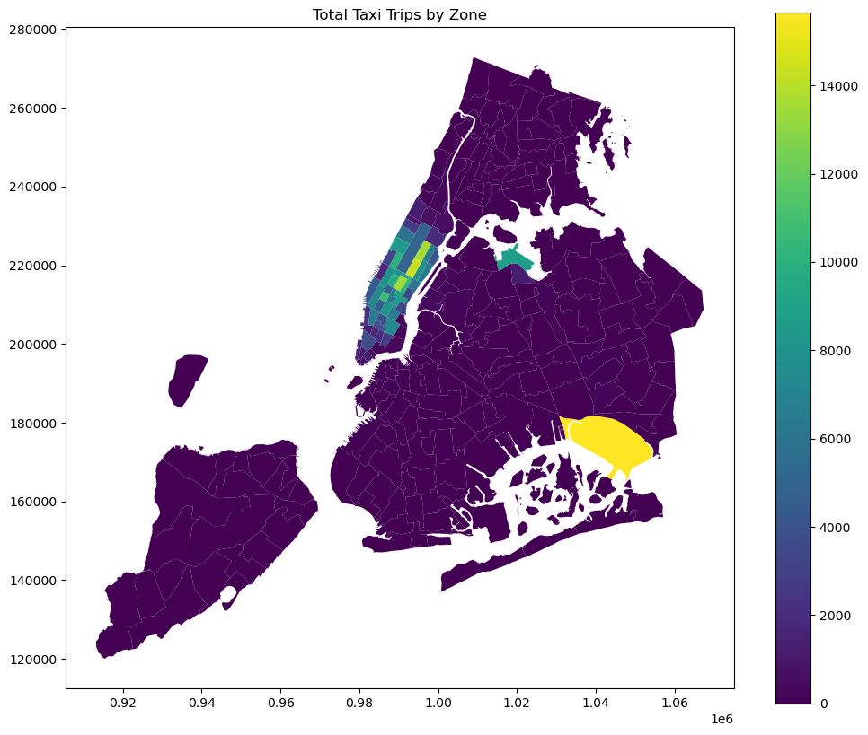
The zone map visualised pickup demand spatially. The strongest demand was concentrated around JFK Airport and several high-activity Manhattan zones such as Upper East Side South/North, Midtown Center, Penn Station/Madison Sq West and Midtown East.
    - Conclude with results
The general EDA shows strong temporal and spatial variation in demand. Hour, day, location, distance and trip duration are useful operational variables. The zone analysis identifies concentrated demand areas that can be used for dispatching and repositioning decisions.

Detailed EDA: Insights and Strategies
    - Identify slow routes by comparing average speeds on different routes
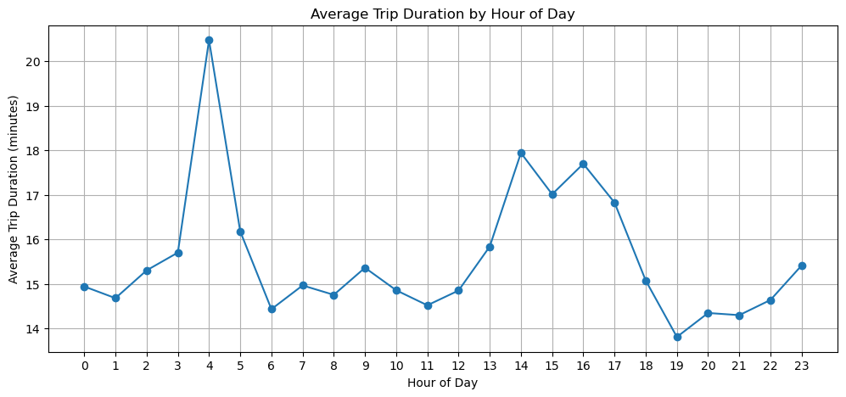
Route speed was calculated as average distance divided by average duration multiplied by 60. Routes with at least 10 trips were retained to avoid unstable results. The slowest observed route-hour was Location 230 to 48 at 23:00, with average speed about 0.22 mph and average duration about 181.5 minutes. These extreme values should be treated as operational outliers and investigated before direct dispatch decisions.
    - Calculate the hourly number of trips and identify the busy hours
The hourly analysis found the busiest sampled hour at 18:00 with 20,896 trips. Demand rose from the early morning to the afternoon/evening peak and then declined after the evening period.
    - Scale up the number of trips from above to find the actual number of trips
Using the 5% sampling fraction, the 18:00 count of 20,896 corresponds to an estimated 417,920 trips after scaling by 1/0.05. This is a sampling-based estimate rather than a direct count.
    - Compare hourly traffic on weekdays and weekends
Weekday traffic peaked at 18:00 (15,766 sampled trips), while weekend traffic peaked at 16:00 (5,410 sampled trips). This indicates that dispatch planning should use different hourly profiles for weekdays and weekends.
    - Identify the top 10 zones with high hourly pickups and drops
The overall top pickup zones included JFK Airport (15,658), Upper East Side South (14,338), Upper East Side North (13,520), Midtown Center (13,506), Penn Station/Madison Sq West (10,688), Midtown East (10,364), Lincoln Square East (9,938), Times Sq/Theatre District (9,608), LaGuardia Airport (8,704), and Murray Hill (8,638).
    - Find the ratio of pickups and dropoffs in each zone
Pickup/dropoff ratios highlighted locations with strong pickup imbalance. The highest observed ratio was 7.79 for Location 70, followed by JFK Airport (5.19) and LaGuardia Airport (2.81). High ratios can indicate zones where additional taxis may be required after dropoffs, while low ratios indicate potential repositioning opportunities.
    - Identify the top zones with high traffic during night hours
For 23:00–05:00 pickups, East Village led with 2,752 trips, followed by West Village and JFK Airport (1,896 each), Clinton East (1,572), Lower East Side (1,526), Greenwich Village South (1,364), Times Sq/Theatre District (1,172), LaGuardia Airport (972), Gramercy (972), and Penn Station/Madison Sq West (934). Night dropoffs were highest in East Village (1,406) and Clinton East (1,218).
    - Find the revenue share for nighttime and daytime hours
The notebook separated night hours as 23:00–05:00 and compared them with daytime periods. The analysis framework can be used to monitor night revenue share and demand; however, the final dataframe’s January-heavy state means the result should be recalculated on the complete year before using it as a yearly revenue KPI.
    - For the different passenger counts, find the average fare per mile per passenger
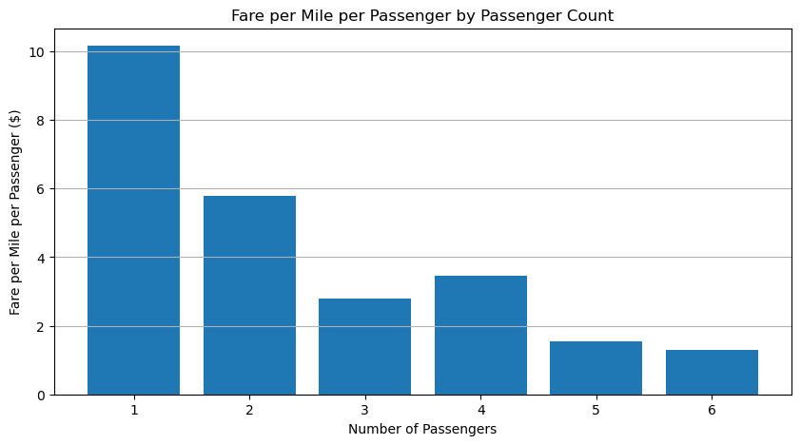
Average fare per mile was divided by passenger count to estimate fare burden per passenger. The calculated values were approximately $10.17 for one passenger, $5.78 for two, $2.79 for three, $3.46 for four, $1.55 for five and $1.29 for six passengers per mile.
    - Find the average fare per mile by hours of the day and by days of the week
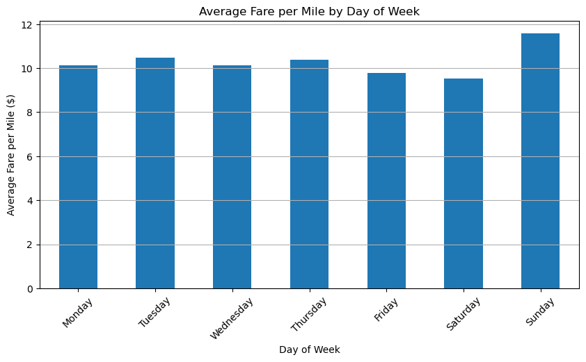
Daily average fare per mile was highest on Sunday ($11.57) and lowest on Saturday ($9.53). By hour, the highest average was at 16:00 ($14.41) and the lowest at 06:00 ($6.82).
    - Analyse the average fare per mile for the different vendors
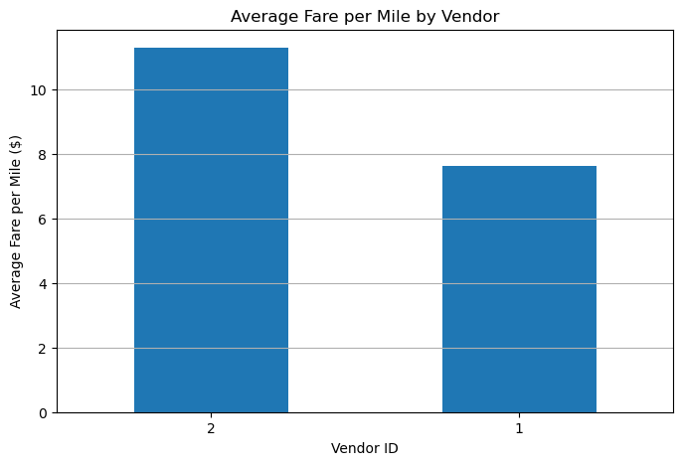
Vendor 2 had an average fare per mile of about $11.30, while Vendor 1 was about $7.63 in the analysed data. This is a descriptive comparison; differences may reflect trip mix, distance, location or other factors.
    - Compare the fare rates of different vendors in a distance-tiered fashion
Trips were grouped into distance tiers: 0–2, 2–5, 5–10, 10–20 and 20+ miles. Comparing vendors within these common distance bands helps separate fare differences from differences in trip length and provides a more useful benchmarking framework.
    - Analyse the tip percentages
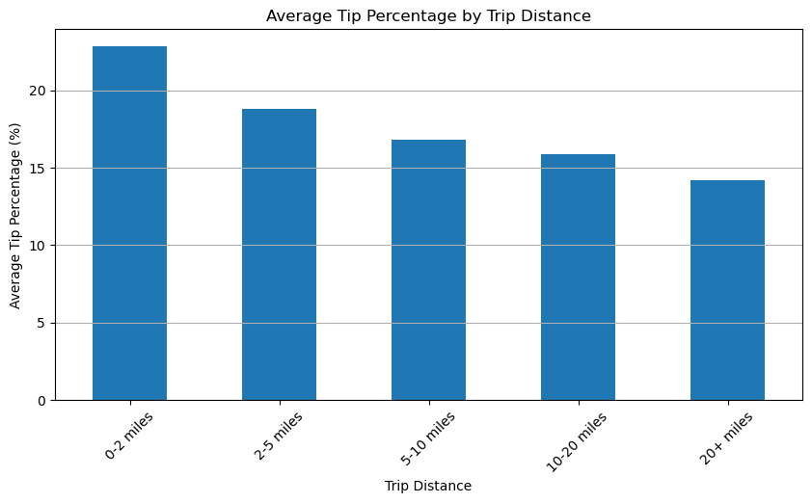
Average tip percentage declined as trip distance increased: 22.81% for 0–2 miles, 18.79% for 2–5, 16.78% for 5–10, 15.87% for 10–20 and 14.18% for 20+ miles. By passenger count, the lowest was 18.48% for four passengers. By pickup hour, the lowest was 16.43% at 04:00 and the highest observed was 23.27% at 03:00.
    - Analyse the trends in passenger count
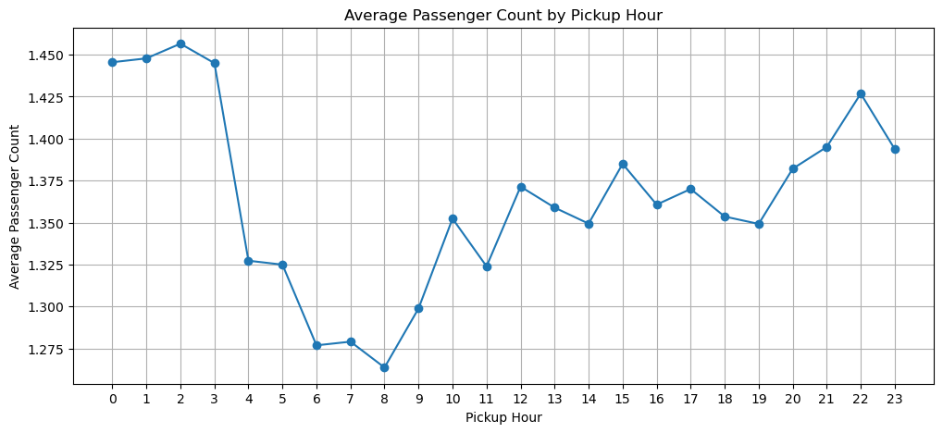
Average passenger count was highest at 02:00 (1.46) and lowest at 08:00 (1.26). By day, Sunday was highest (1.45) and Wednesday lowest (1.30). The pattern suggests slightly larger parties during late-night/weekend periods.
    - Analyse the variation of passenger counts across zones
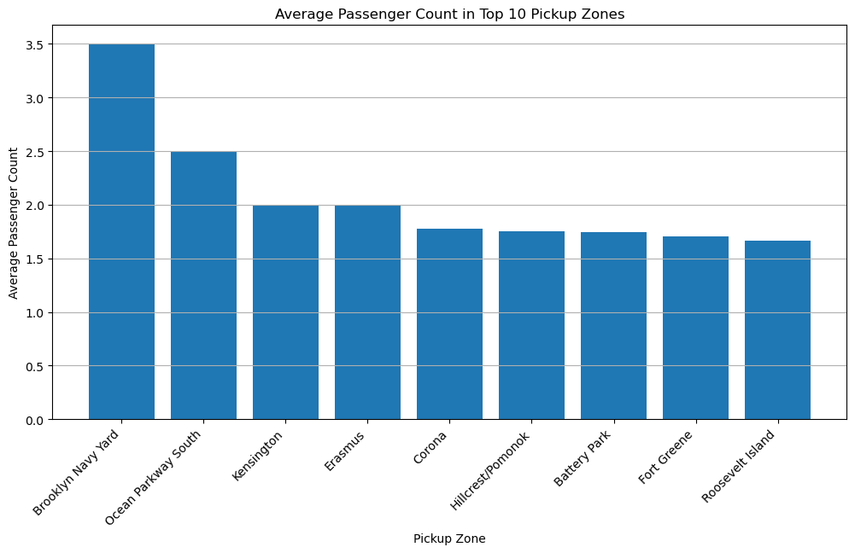
The highest average passenger count was observed in Brooklyn Navy Yard (3.50, based on 4 trips), followed by Ocean Parkway South (2.50) and Kensington/Erasmus (2.00). Because some of these zones have small trip counts, these extreme averages should be interpreted cautiously. Battery Park and Fort Greene had larger sample counts among the higher-passenger zones.
    - Analyse the pickup/dropoff zones or times when extra charges are applied more frequently.
Improvement surcharge was applied to 99.97% of trips, MTA tax to 99.25%, congestion surcharge to 92.42%, extra to 61.19%, airport fee to 8.72%, and tolls to 7.44%. The frequency analysis shows which charges are routine versus location/condition-dependent.

Conclusions

Final Insights and Recommendations
The analysis identified clear demand variation by hour, weekday/weekend, zone, route, passenger count and distance. High-demand locations include airports and central Manhattan zones. Evening weekday demand is particularly strong. Pickup/dropoff imbalance can support repositioning decisions, while slow route-hours may reduce vehicle availability. Fare-per-mile and tip patterns vary by time, distance and vendor, so operational and pricing decisions should be segmented rather than based on a single overall average.
    - Recommendations to optimize routing and dispatching based on demand patterns and operational inefficiencies.
1) Increase dispatch availability before the weekday 18:00 peak and before the weekend 16:00 peak. 2) Monitor high-demand airport and Manhattan zones continuously. 3) Use pickup/dropoff ratios to reposition taxis from surplus-dropoff areas toward pickup-deficit areas. 4) Treat 23:00–05:00 as a separate operating window because night demand is concentrated in specific zones. 5) Investigate recurring slow route-hours and use alternative routing where practical. 6) Combine hourly demand, trip duration and location demand in dispatch rules.

    - Suggestions on strategically positioning cabs across different zones to make best use of insights uncovered by analysing trip trends across time, days and months.
Position more vehicles around JFK Airport, LaGuardia Airport, Upper East Side, Midtown, Penn Station, Times Square and other high-volume zones during their peak hours. Use different positioning schedules for weekdays, weekends and night hours. Rebalance vehicles when pickup/dropoff ratios show sustained imbalance, and use historical demand to stage vehicles before peaks rather than after demand has already materialised.

    - Propose data-driven adjustments to the pricing strategy to maximize revenue while maintaining competitive rates with other vendors.
Use distance and duration as primary pricing drivers and monitor fare per mile by hour and day. The analysis found substantial hourly variation, from about $6.82 per mile at 06:00 to $14.41 at 16:00. Vendor-level benchmarking showed different average fare-per-mile levels, so comparisons should be made within distance tiers. Pricing experiments should be tested against historical demand, revenue and trip-volume metrics, with transparent surcharge treatment and monitoring of customer response.

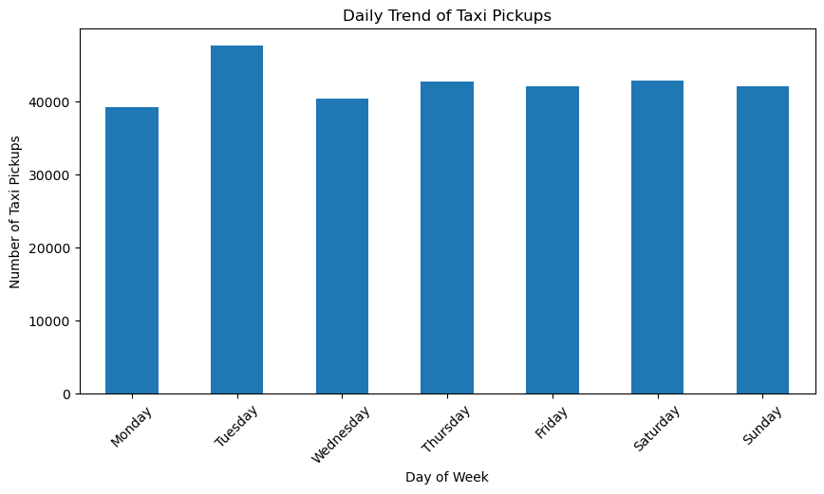
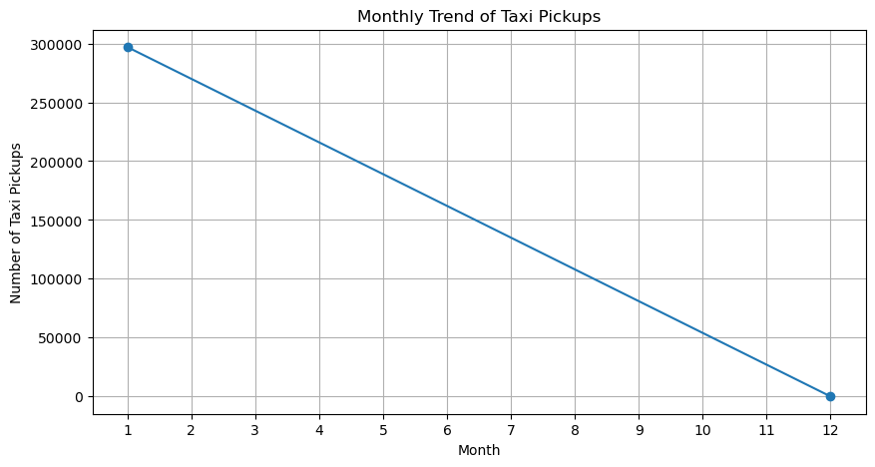
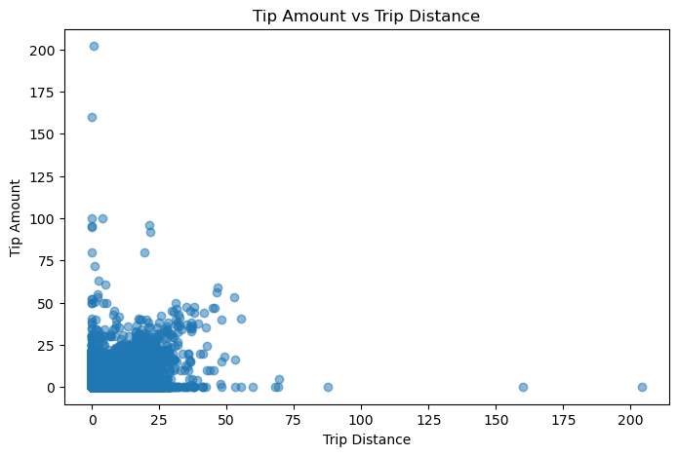
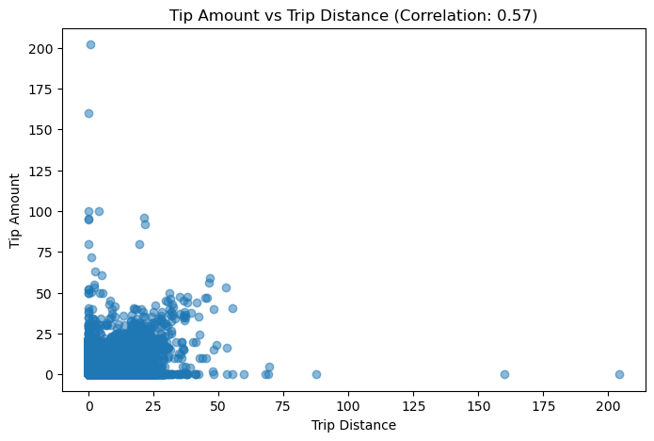
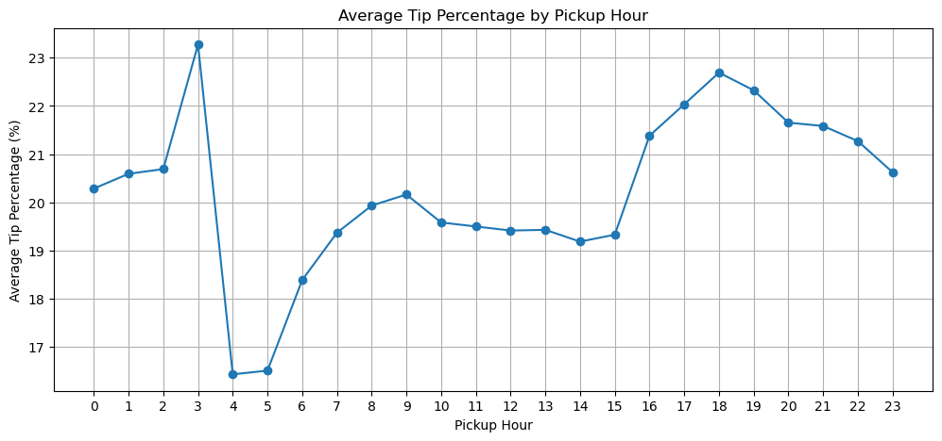
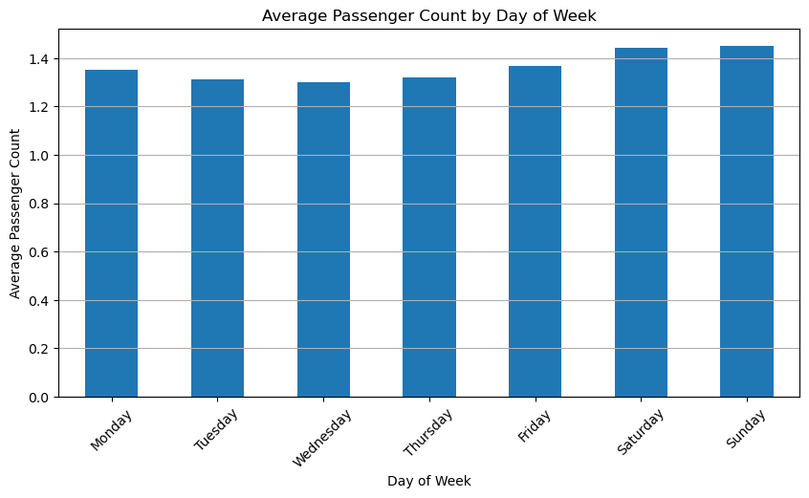
Submission note: This report is populated from the executed outputs present in the supplied notebook. The notebook’s final dataframe is heavily January-weighted; therefore the monthly/quarterly full-year revenue results should be rechecked if the assignment expects a complete January–December dataset.

