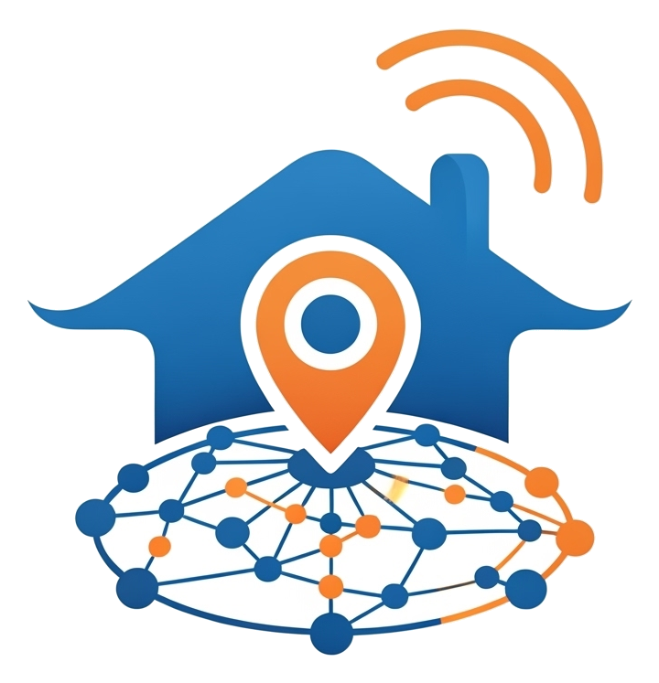
NestHub
Your Neighborhood. Verified. Trusted. Instant.
"Because the best help is the help you already trust."
[ Insert High-Definition Hero Image: A happy family greeting a
trusted, uniformed local vendor at their doorstep ]
The community app that turns strangers into your most reliable neighbors.
Available now for iOS & Android | www.nesthub.app

The 11 PM Problem
It's 11 PM. Your kitchen tap won't stop leaking. You open a search app and get twenty strangers with five-star ratings that feel... suspicious. Do you call the first name that pops up? Do you post in a WhatsApp group and wait? Do you just hope it can wait until morning?
Every single one of us has been there. Finding someone reliable — a plumber, an electrician, a tutor, a caterer — shouldn't feel like a gamble with your safety, your time, and your money. And in a real emergency, "searching online" is simply not fast enough.
The truth is simple:
The most trustworthy recommendation isn't a star rating from a stranger three cities away. It's a real neighbor, in your own community, who's already been there.
That's exactly the gap NestHub was built to close.

The NestHub Magic
NestHub isn't another directory of strangers. It's your own neighborhood, digitized — every trusted vendor, every verified review, every emergency contact, right where you live.
[ Insert HD Image: Clean, modern App Dashboard showing the Home screen ]

🏡 Know Exactly How Close Help Really Is
Every helper on NestHub is instantly tagged so you know at a glance: is this someone from your own building, a nearby community, or further out? No more guessing whether "local" actually means local.
- In-House: People already trusted and active in your own community.
- Nearby & Local: Verified helpers just a few minutes away.
- Extended Network: A wider circle of vetted professionals when you need more options.

🆘 One Tap. Instant Peace of Mind.
This is the feature that makes NestHub different from every other app on your phone. The moment something goes wrong, you don't scroll — you tap SOS. Your urgent request is broadcast instantly to every trusted helper covering your community, and the first one who can help claims it and reaches out. In an emergency, every second counts, and now every second is working for you.
[ Insert HD Image: SOS button glowing, with a notification confirming a vendor has responded ]

⭐ Reviews You Can Actually Believe
No anonymous internet strangers. No paid reviews. On NestHub, the only people who can review a vendor are the residents who live in that vendor's own community. That means every star rating you see is a genuine recommendation from someone who shares your street, your building, your everyday life.

🛡️ Verified Pros, Not Guesswork
Every business on NestHub is personally reviewed before they're allowed to appear in your search results. Look for our Verified badges — ID Verified and Society Regular — a simple, unmistakable signal that this person has earned the community's trust.

📣 Live Deals, Delivered to Your Door
Your favorite local businesses can now reach you directly — real-time offers, availability updates, and announcements, delivered straight to your Home screen the moment they're posted. No more missing out because you didn't happen to scroll past a flyer.

❤️ Your Go-To List, One Tap Away
Found a plumber you loved? Save them. Next time something breaks, your trusted favorites are waiting for you — no searching required.

🌐 Speak Your Language
NestHub welcomes every member of your community — with full support for English, Hindi, Telugu, Odia, and Marathi, switchable instantly, right from the Home screen.

📶 Never Left Stranded
Patchy signal? No problem. NestHub keeps your last search results ready so you're never stuck with a blank screen when you need help most.

Why Join Us?

For Residents: Safety, Simplicity, Community
- Real Safety Net: One-tap emergency alerts reach every trusted helper in your community instantly.
- Zero Guesswork: Every vendor is Admin-approved and neighbor-reviewed before they ever reach your screen.
- Total Convenience: From your morning tutor to your midnight plumber, everyone you need is in one place.
- A Real Community, Not a Crowd: See society-wide announcements, live vendor offers, and neighbor recommendations — all in one Home screen.
Bottom line for Residents:
You get the comfort of a small, trusted village — with the convenience of a world-class app.

For Vendors: Free Leads, Real Trust, Real Growth
- Leads, Not Ads: Get discovered by residents actively searching in your coverage area — no ad spend required.
- Instant Opportunity Alerts: The moment a nearby resident needs urgent help in your line of work, you're the first to know — and the first to respond wins the job.
- Build Real Trust, Fast: Earn Verified badges and Featured placement that make new customers choose you with confidence.
- See Your Growth: A simple dashboard shows you exactly how many neighbors are viewing your profile, calling you, and messaging you — every single day.
- Talk Directly to Your Customers: Post live updates and offers straight to the residents who matter most — the ones already near you.
Bottom line for Vendors:
NestHub turns your reputation into your #1 marketing engine — for free.

Your neighborhood is already here.
The only question is whether you're one tap away from it.
DOWNLOAD NESTHUB TODAY — IT'S FREE
[ Insert HD Image: App Store & Google Play download badges ]
Trusted neighbors. Verified vendors. One tap away.

