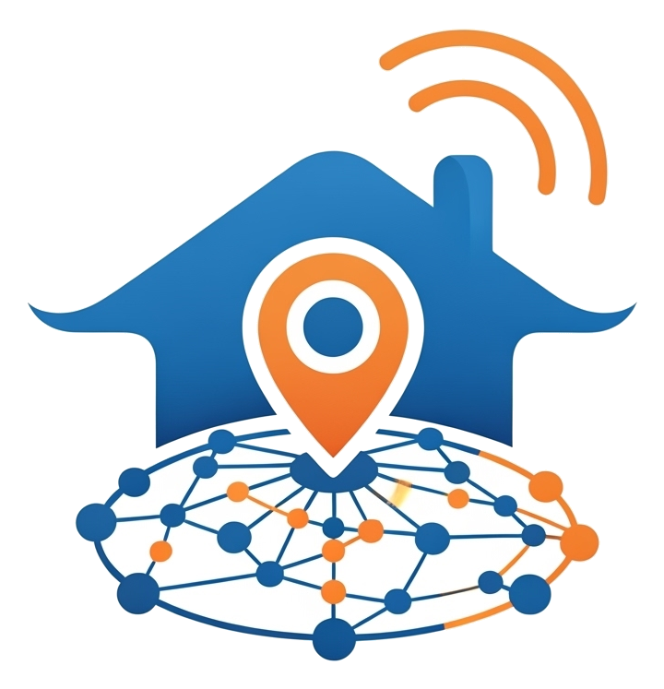
NestHub
The Complete NestHub User Guide
Simple steps. Real community. Zero confusion.
[ Insert High-Definition Hero Image: A happy family greeting a
trusted, uniformed local vendor at their doorstep ]
Everything you need to get the most out of your community app.
A guide for Residents, Vendors, and Community Administrators

What's Inside
- Part 1 — For Residents: Joining, finding help, and staying safe
- Part 2 — For Vendors: Building your profile and growing your business
- Part 3 — For Community Administrators: Keeping your neighborhood safe and organized

Part 1 — For Residents

Getting Started
- Create your account. Open the app, tap "Create an account," and enter your phone number and a password.
- Tell us where you live. On your first sign-in, you'll be asked to select your community, your block, your flat number, and your name. This one step is what unlocks neighbor-verified reviews and the SOS feature for your exact community.
- You're in! Your Home screen is now personalized to your own neighborhood.
[ Insert Screenshot: The 'Tell us where you live' onboarding screen ]

Finding a Trusted Vendor
- Open the Search tab. Type a name, a service (like "electrician"), or a category.
- Check the tier badge. Every result is tagged In-house, Nearby, or Other Society, so you instantly know how close they are to you.
- Look for the Verified badge. A shield icon means this vendor has been personally approved and vetted.
- Tap a profile to see their services, star rating, and reviews from your own neighbors.
- Call or WhatsApp them directly from their profile — one tap, no typing a number.
Tip:
Empty search box? You'll see your recent searches and trending categories as quick-tap shortcuts — perfect when you're not sure what to search for yet.

Saving Your Favorites
Found someone great? Tap the heart icon on their profile. They'll now appear under "My Favorites" on your Home screen, ready whenever you need them again.

Leaving a Review
After using a vendor's service, go back to their profile, choose your star rating, add a short comment, and tap "Submit review." Your review will only ever be shown to fellow residents of your own community — the people it actually helps.

Using SOS — Safely and Quickly
Important:
SOS is for urgent household needs (a burst pipe, a power outage, a broken lock) — not medical or life-threatening emergencies. For those, always call your local emergency number first.
- Open the SOS tab.
- Choose a category (Plumbing, Electrical, Home Maintenance, Appliance Repair, or Pest Control).
- Describe what's wrong in a sentence or two.
- Tap "Send SOS." Your request is instantly broadcast to every approved vendor covering your community in that category.
- Wait for a response. The first available vendor claims your request and reaches out to you directly.
Your Emergency Contacts card on the same screen also lists your society's watchman and office numbers, with one-tap calling — always available, SOS or not.

Staying in the Loop
- Vendor Updates: See live offers and announcements from vendors covering your community, right on your Home screen.
- Notifications: Tap the bell icon for a combined, chronological feed of every vendor update and society announcement.
- Society Announcements: Official notices from your community administrator — maintenance windows, events, and more.

Making NestHub Yours
Tap the globe icon on your Home screen at any time to instantly switch the app's language between English, Hindi, Telugu, Odia, or Marathi.

Learn More, Anytime
Tap "Help" from the sign-in screen for a plain-language walkthrough of every feature, or "Privacy Policy" and "Terms" to see exactly how your information is used and what to expect from every vendor interaction.

Part 2 — For Vendors

Setting Up a Winning Profile
- Register and choose "I'm registering as a vendor."
- Fill in your business profile: your business name, your WhatsApp number, and a short bio describing what you offer.
- Select the communities you serve. This single choice controls two things: which residents can find you in search, and which SOS requests get sent to you. Choose every community you genuinely want to serve.
- Submit for approval. A community administrator reviews every new profile before it becomes visible to residents — this is what keeps every vendor on NestHub trustworthy.
Why this matters:
Residents can immediately see whether you're In-house, Nearby, or Other Society relative to them. Selecting more communities means more residents see you as a close, convenient choice.

Responding to Urgent Leads
Open your SOS Leads tab to see every open, urgent request from residents in your coverage area matching your service category — updated the instant a resident sends one. Tap "Claim this lead" to let the resident know you're on it. Whoever claims first gets the job, so keep an eye on this tab during business hours.
[ Insert Screenshot: SOS Leads tab showing an open request card ]

Posting Updates & Offers
From your Dashboard, tap "Post update" to share a promotion, a new service, or an availability update. It's delivered instantly to every resident in the communities you cover — no extra cost, no waiting. Manage or delete your past posts any time from the same screen.

Tracking Your Growth
Your Dashboard shows a simple 30-day snapshot: how many residents viewed your profile, called you, or messaged you on WhatsApp. Use it to see what's working and when residents are most active.

Growing Your Reputation
- Verified badges (ID Verified or Society Regular) are awarded by your community administrator as you build a track record — look out for them on your profile.
- Featured placement gives top-performing vendors priority visibility at the top of search results.
- A Premium subscription is available for vendors who want to unlock additional visibility and growth tools.
- Every completed job is a chance to earn a five-star, neighbor-verified review — the single most powerful trust signal on NestHub.

Part 3 — For Community Administrators
As an Administrator, you're the reason NestHub stays trustworthy. Sign in at your community's Admin portal with your registered phone number and password.

Two Kinds of Administrators
- Central Administrators oversee the entire platform — every community, every vendor approval, every user account.
- Community Administrators are scoped to a single community — they manage their own residents, announcements, and emergency contacts, and see a Dashboard focused on just their neighborhood.

Approving New Vendors
Open "Vendor Approvals" to see every new business waiting for review. Check their profile details, then approve them to make them visible to residents — or leave them pending if something needs following up first. From the same screen, award Verified badges and Featured status to your top-performing, most trusted vendors.

Keeping Reviews Honest
"Review Moderation" lists every review a resident or vendor has flagged as inappropriate or fake. Read the flagged content and decide: keep it visible, or remove it. This keeps every review on the platform genuine and useful.

Managing Your Community
- Societies: Register new communities with their address and map location — the location is what powers accurate "Nearby" vendor matching for residents.
- Residents: See every onboarded resident in your community, with a link to reset passwords or suspend accounts if needed.
- Announcements: Post official notices — maintenance windows, events, updates — directly to every resident's Home screen.
- Emergency Contacts: Keep your community's watchman and office numbers current so residents always have one-tap access.

Your Dashboard, At a Glance
Your Dashboard opens with a real-time snapshot: total residents, vendor approvals pending, open SOS requests, and flagged reviews needing attention — plus a 7-day trend of SOS activity, so you can spot unusual spikes immediately. Central Administrators additionally see platform-wide vendor performance, including which vendors your residents favorite and engage with most.
[ Insert Screenshot: The Admin Dashboard with the SOS trend chart ]

Central-Only Tools
A few tools are reserved for Central Administrators to keep platform-wide consistency: managing the master list of service categories, all user accounts across every community, and the full system activity log.
Remember:
Every approval, every badge, and every moderation decision you make directly shapes how much residents can trust NestHub. Thank you for keeping your community safe.

