Step 1: Structure Chart
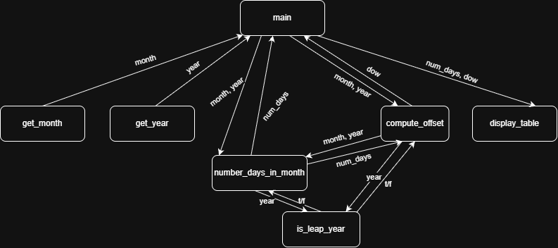

Step 2: Function Pseudocode
compute_offset(month, year)
elapsed_days <- 0
FOR current_year <- 1753 … year – 1
IF is_leap_year(current_year)
elapsed_days <- elapsed_days + 366
ELSE
elapsed_days <- elapsed_days + 365
FOR current_month <- 1 … month - 1
elapsed_days <- elapsed_days +
number_days_in_month(current_month, year)
position_shift <- elapsed_days MOD 7
beginning_day <- 1 + position_shift
return beginning_day MOD 7

Step 3: Function Flowchart
