Data Governance

Data is a critical aspect for any organization since major business decisions are made on available data which gives statistics of sales, marketing strategies required to increase profitability, who are the target users and so on. For this reason, it is necessary to keep data secure, consistent and trustworthy. Data Governance is nothing but a management of this data to make it available, secure and usable whenever required by managerial people to take important decisions. A typical data governance program involves a sequence of procedures, plan to execute the same and a governing body.

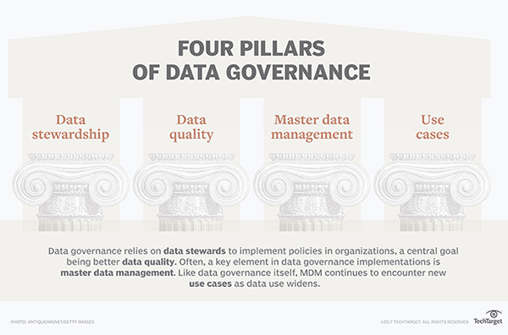

To implement data governance framework for any of the organization, the initial step is to understand who all are the owners of data in enterprise. This process is called “Data Stewardship” in which high-quality or valuable data is made available to business users. Quality of data is maintained to make it more consistent and complete; this can be achieved by applying some data cleansing techniques on data.

Since there can be various places where a single data is stored may be for security reasons or business needs, the major challenge when this data is used is consistency. Master Data management provides the synchronization of data, it creates one focal point which acts like a middleware where correct data can be available. It then plans to connect to other sources of data available in a system, it ensures the quality of data while doing the same.

**Companies need data governance solution for the following reasons:**

1. Data Sharing – With Data governance tools data can be find and shared quickly and easily among users within organization
2. Data Reusability – Same data can be shared multiple times over the period and users will be notified with the changes.
3. Data Analysis – Data analysis is critical part to take right business decisions, with tools provided by data governance it becomes easy to do correct data analysis.
4. Data Backup – With Master Data Management it becomes simpler to storage and backup of data
5. Data Security – It gives option for permission from external as well as internal members of organization to share and access files.

Product installed: **IBM InfoSphere Information Governance Catalog**

Installation of the above product was quite easy and straightforward. All the instructions displayed while installation was helpful enough to install successfully on my windows machine.

Prior to installation of IBM IGC Trial, the other two solutions (Oracle Virtual Box, Docker Toolbox and Docker Quickstart) were installed. In addition, bios Virtualization settings were ask to change and make it enable. After enabling virtualization, it allowed to install product, installation took around 15-20 minutes to complete.

After installation of the same, it provided one guided tour to help us use installed product. It gave a glimpse of product and asked to just follow the steps without making me understand information about what exactly it does. It would have been better if it can guide about the solution in more detailed way so that it will be used in a correct way rather than just following the steps.

**Collibra Data Governance tool (competitive application)**

* It allows to display informational policies at one place and can manage policies via policy management option.
* With catalog, data can be searched and used by analysts to use for business problems.
* At business glossary, entire data is defined or stored. It has approval workflow for data before it enters glossary.
* It provides sitemap so it’s easier to hop to any link which current product doesn’t give.
* It provides navigator which allows user to navigate easily within the tool.
* It allows user to define vocabulary with different rule sets; also, vocabulary can be imported or exported.
* It manages steward and stackholders of the system.
* It provides catalog which provides any of the logical or physical data model of the data.
* The current solution gives global and categorized search whereas Collibra gives tool wise search.

# References

(n.d.). Retrieved from http://www.itaz.com/blog/5-reasons-why-data-governance-is-becoming-more-important-for-your-business/

Margaret Rouse. (n.d.). *What is Data Governance?* Retrieved from searchdatamanagement.techtarget.com: http://searchdatamanagement.techtarget.com/definition/data-governance

*Youtube*. (n.d.). Retrieved from www.youtube.com: https://www.youtube.com/watch?v=SHAaD5pKDQo

# Picture References

Margaret Rouse. (n.d.). *What is Data Governance?* Retrieved from searchdatamanagement.techtarget.com: http://searchdatamanagement.techtarget.com/definition/data-governance