OrbitDesk Platform Architecture
Owner: Platform team (Daniel Okafor, CTO). Last reviewed: 12 January 2027.

Overview
OrbitDesk is Lumora's desk and meeting-room booking product, used by 140 enterprise customers. Clients talk only to the API gateway; each backend service owns its own data and publishes events for the others. The diagram shows the production layout.
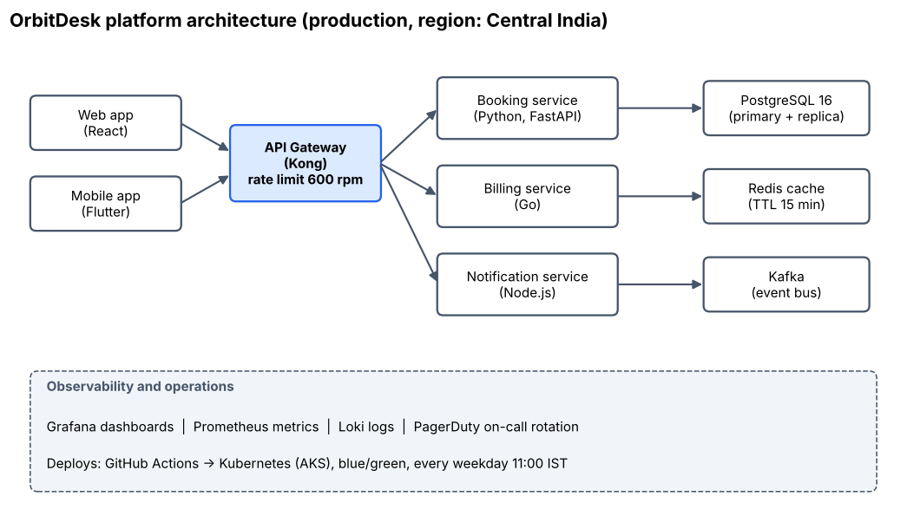

Service ownership
Service | Team | On-call Slack channel
Booking service | Team Atlas | #oncall-atlas
Billing service | Team Ledger | #oncall-ledger
Notification service | Team Echo | #oncall-echo

Availability targets
The booking API targets 99.9% monthly availability with p95 latency under 300 ms. Billing targets 99.95% because failed payments create support tickets. Database backups run every 6 hours and are kept for 35 days.

Incident response
Incidents are classified by severity. Response times and escalation paths are in the matrix below. Every SEV1 and SEV2 incident needs a written post-mortem within 5 working days.
