Overview - Model Tuning

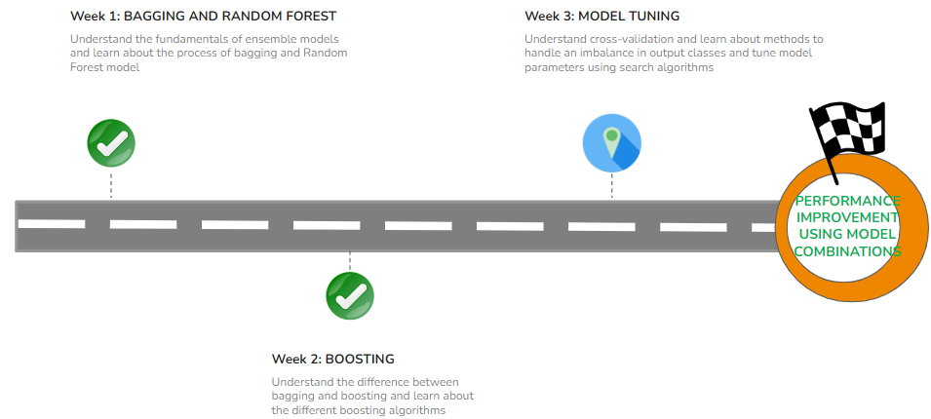

#### **QUICK RECAP**

In the previous week, we learned about the foundations of Boosting algorithms. Let us quickly recap what we have covered so far.

* Introduction to Boosting
* Introduction to Boosting Algorithms
  + Adaboost
  + Gradient Boosting
  + XGBoost
* Introduction to Stacking

#### **COURSE OVERVIEW**

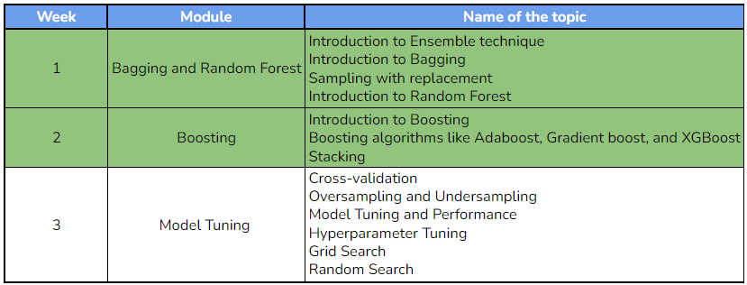

#### **WEEK 3 OVERVIEW**

This week, we will explore cross-validation and its significance, how to handle class imbalance using oversampling and undersampling techniques and understand the process of hyperparameter tuning. Additionally, we will be introduced to model tuning and performance evaluation using GridsearchCV and RandomsearchCV. The following topics will be covered in this module:

* Understand the importance of cross-validation and perform k-fold cross-validation
* Address class imbalance with oversampling and undersampling
* Tune a model's hyperparameters to improve its performance
* Introduction to model tuning and performance
* Use GridsearchCV and RandomsearchCV to tune models

#### **LEARNING INSTRUMENTS**

| **Week** | **Module** | **No. of videos** | **Total duration** | **No. of Test Your Understanding Quizzes** | **No. of Weekly Graded Quizzes** |
| --- | --- | --- | --- | --- | --- |
| **3** | **Model Tuning** | 9 | ~2.25 hour | 9 | 1 |

#### **Note: You will be required to spend approximately 1 hour/day along with practicing datasets and quizzes.**

**Power Ahead!**

#### **Kindly note the following point before proceeding to the weekly content for a better learning experience:**

1. In the weekly videos, the faculty refers to additional topics (like Regularization). These topics are covered in the videos available as additional content. They can be found under the section '***Week 3: Additional Learning Material***', along with the associated lecture material.
2. There are some additional content pages (like *Confidence Interval*) in between the videos that will help clarify additional concepts that will be referred to by the faculty. **We would strongly recommend going through these pages as and when they appear in the sequential order of the content to gain a stronger grasp of the concepts being covered.**

Week 3 - Lecture Video Materials

The following materials are highly recommended to be downloaded as these files are used in the hands-on lecture videos so that you can work simultaneously with the faculty while watching the video content.

The hands-on notebook is the same notebook that the faculty have used while teaching the concepts in the hands-on lecture videos. By downloading this notebook, you can work along with the faculty through the video content.

## **Hands-on Exercise - Feature Engineering and Cross-Validation:**

#### [**K fold cross validation.ipynb**](https://olympus.mygreatlearning.com/courses/111359/files/10044870/download?verifier=72kyqIWCKLcfYVwbr0p4gSmN4wTRlZudVOH5g1GP&wrap=1)

The above notebook has been used in the hands-on notebook week 3 that is shown in video **3.2 Hands-on implementation of k-fold cross-validation** by the faculty.

#### [**Oversampling_and_undersampling.ipynb**](https://olympus.mygreatlearning.com/courses/111359/files/10044869/download?verifier=ICZK7EGkqjvZL2V8wWFfKIid1tsdpx9dIAfCWJB8&wrap=1)

The above notebook has been used in the hands-on notebook week 3 that is shown in video **3.4 Hands-on oversampling and undersampling** by the faculty.

#### [**Hyperparameter tuning.ipynb**](https://olympus.mygreatlearning.com/courses/111359/files/10044837/download?verifier=SWyX1i9r1l4DOKcwj39EhU3Fs9eSZ8AyWIuWMhBS&wrap=1)

The above notebook has been used in the hands-on notebook week 3 that is shown in video **3.9 Hands-on GridsearchCV and RandomsearchCV** by the faculty.

## **Datasets used in the hands-on lecture videos:**

#### [**pima-indians-diabetes.csv**](https://olympus.mygreatlearning.com/courses/111359/files/10044861/download?verifier=J71WkggP5OsTjkVit5iDLIvQuv3FRAxMBUeFrJEf&wrap=1)

The above dataset has been used in the hands-on notebook week 3 that is shown in the video **3.2 Hands-on implementations of k-fold cross-validation** by the faculty.

#### [**Loanclients.csv**](https://olympus.mygreatlearning.com/courses/111359/files/10044872/download?verifier=4PSSi1VEqHDSanD7MAV3sMbAz3rQnbHEAVJLdCEl&wrap=1)

The above dataset has been used in the hands-on notebook week 3 that is shown in video **3.4 Hands-on oversampling and undersampling and 3.9 Hands-on GridsearchCV and RandomsearchCV** by the faculty.