Scan plan for Normal beam calibration
- TCG for Normal beam calibration
- To create TCG calibration it needed for a minimum three FBH 3/64" dia or as required with different distance?
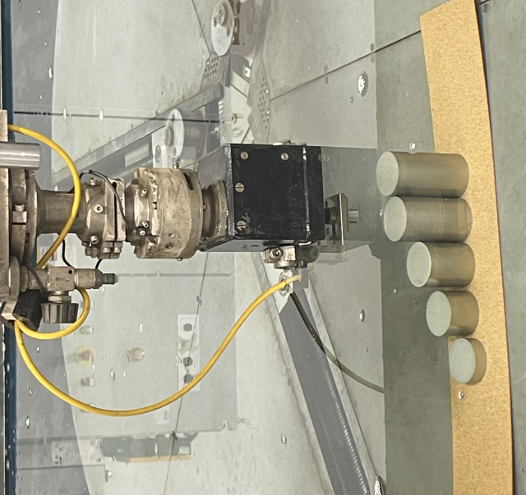
1
2
3
- Open scan master wizard and press Teach In
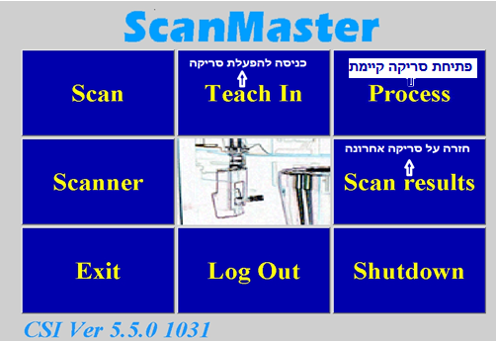
- Screen image will paper
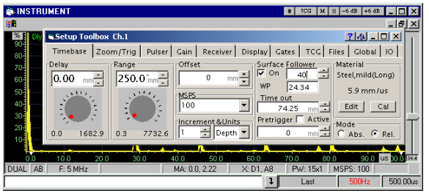

- To create TCG -
- Set all the parameters. start from basic parameters in the dialog box
- Move to the Hagit calibration block and set:
- material velocity-
- Range- Set the range until you get the back wall
- Gain- verified respond from 3/64" FBH
- Water path- set the distance of 76mm water path or according to the distance from the face of the transducer to the front surface of a part shall be such that the second front reflection from the test material does not appear between the first front and first back reflections. This distance (water travel) must be the same within ±1/4 inch for standardization, initial scanning, and final evaluation.
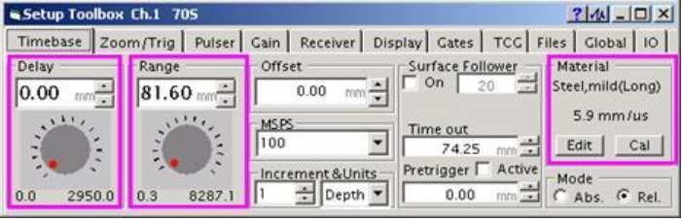

- Set a minimum tree calibration block with FBH 3/64 dia according to AMS STD E2154(ASTM E127) or other custom calibration block with tree FBH.
- Move to the first position (standard no 1)
  - Drag the yellow dot set on the respond peak and set with the Gain the amplitude responds from FBH to 80% FSH.
  - Save the first point by clicking 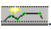on the toolbar setup.

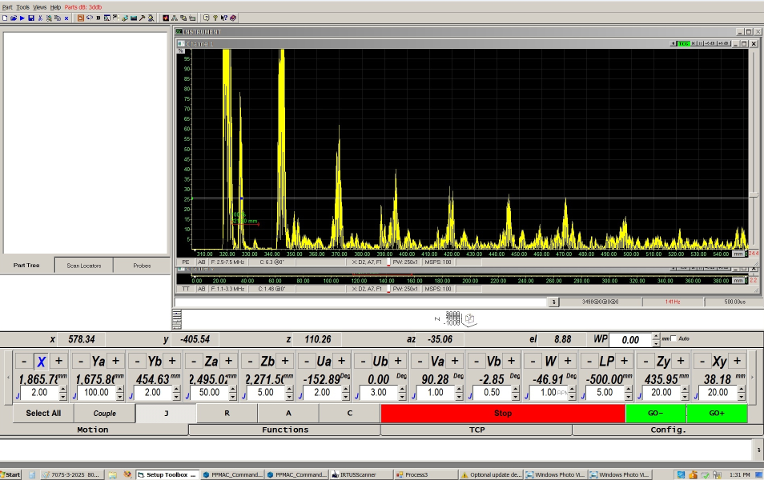
FBH respond from standard number 1#
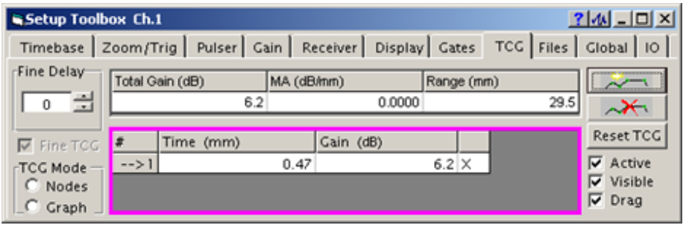
- Move to the second calibration standard and set the respond from the FBH to 80% FSH
  - Drag the second yellow dot set on the respond peak and set with the Gain the amplitude responds from FBH to 80% FSH
  - Save the second point by clicking on the toolbar setup
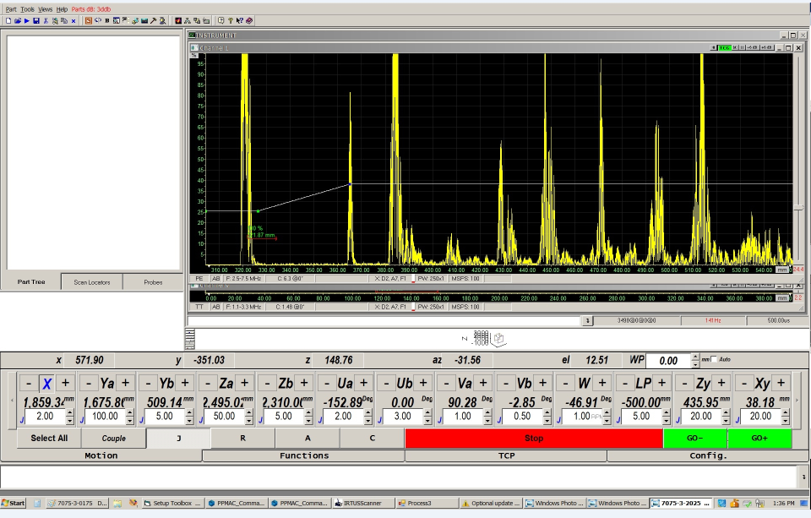
FBH respond from standard number 2#
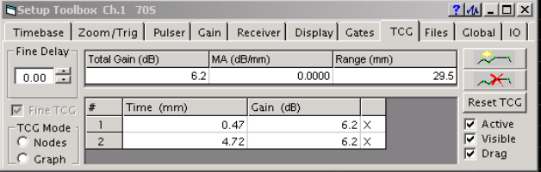

- Move to the higher calibration standard and set the respond from the FBH to 80% FSH
  - Drag the third yellow dot and set on the respond peak and set with the Gain the amplitude responds from FBH to 80% FSH
  - Save the third point by clicking on the toolbar setup
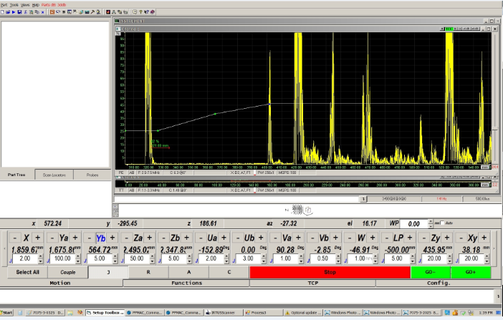
FBH respond from standard number 3#
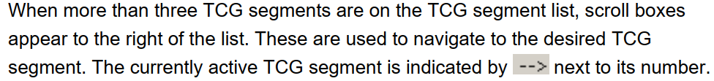
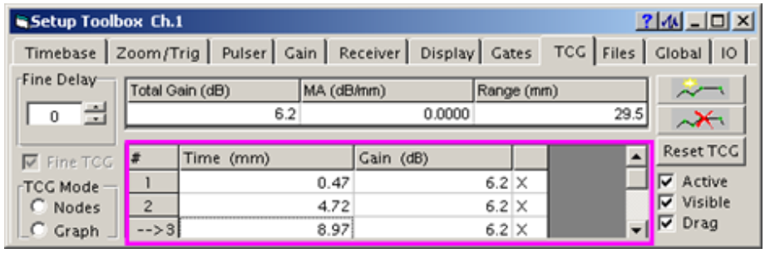
- If needed set another TCG point on back wall respond and set the gain to get 80% FSH
  - Click this bottom to set the first Point before the back-wall. pulse and the second after the beck wall pulse
  - Create additional points (At least four) in order to set the TCG from the back wall point as you can see in the picture below.
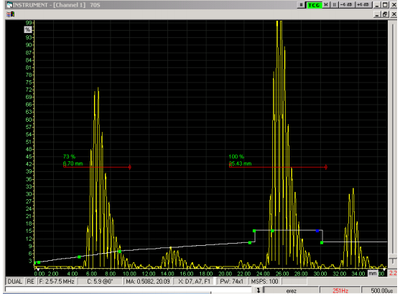
13. Saving TCG
Back wall responds
13.1 click save on the setup dialog box /TCG 