- TCG for shear wave calibration
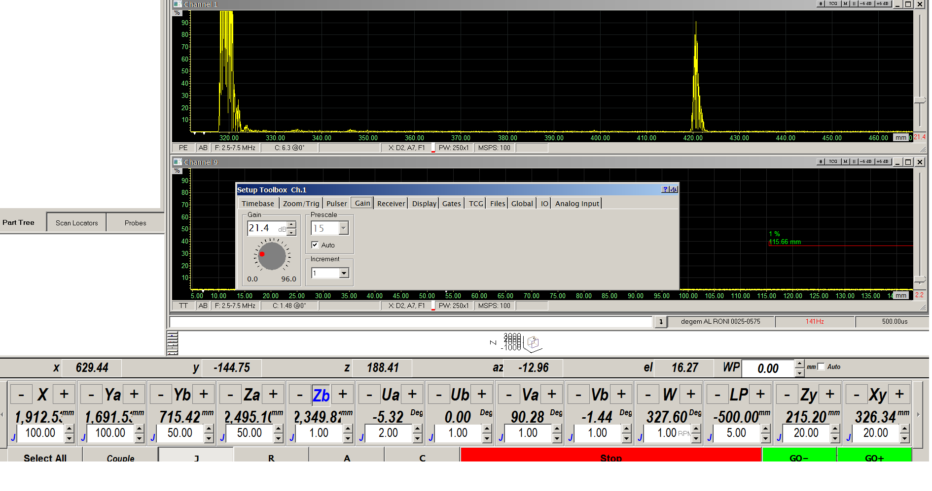
- open the setup toolbox and click TCG bar
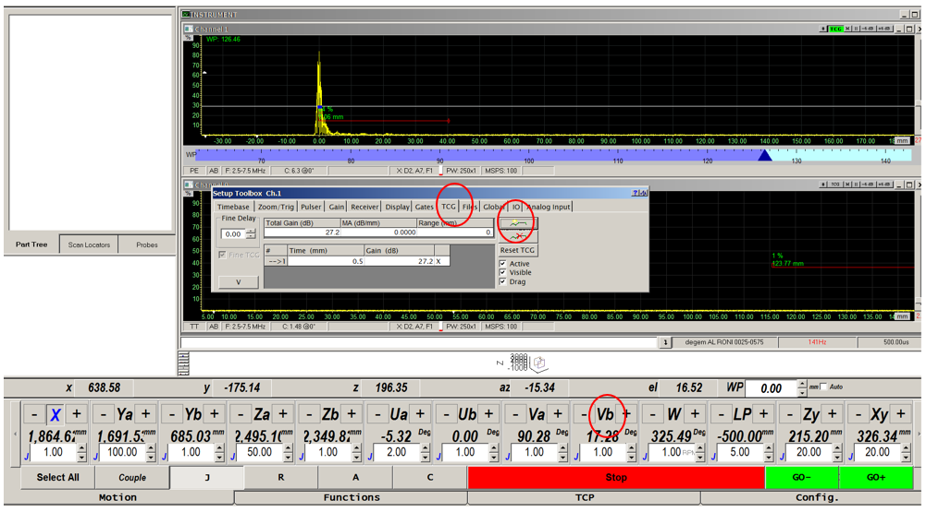

- move with the probe to the first FBH(the close on to the surface). With the motion function (vb/w/ and get the maximum respond from the FBH)
- click on the TCG bar to create the first TCG point.
  - drag the green dot and pot it on the first pulse and set it on at 40% FSH .
  - Set the amplitude to 80% FSH
- move with the probe to the second FBH (the middle one to the surface). With the motion function (vb/w/ and get the maximum respond from the FBH)
  - click on the TCG bar to create the second TCG point
  - drag the green dot and put it on the second pulse. and set it on at 40% FSH Set the amplitude to 80% FSH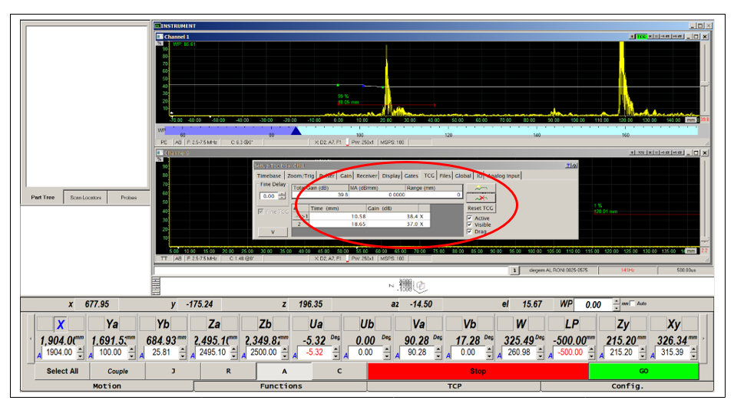
- move with the probe to the third FBH (the last one to the surface). With the motion function (vb/w/ and get the maximum respond from the FBH)
  - click on the TCG bar to create the third TCG point
  - drag the green dot and put it on the third pulse. and set it on at 40% FSH
  - Set the amplitude to 80% FSH

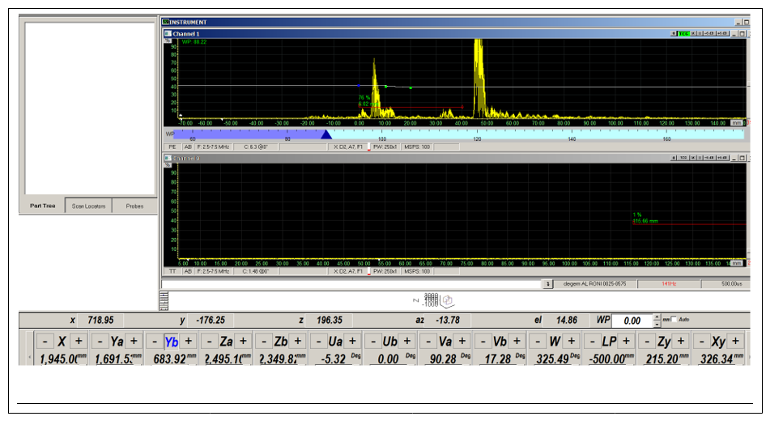
- Save

