 | UT TECHNIQUE SHEET | Document No: NDT-UT-787-001 Rev. C  Revision: C  Date: Dec 17, 2024

DOCUMENT SUMMARY

Customer | Boeing Commercial Airplanes | Purchase Order | PO-BCA-2024-15847
Part Number | LG-787-CYL-001 | Part Name | Main Landing Gear Actuator Cylinder
Material | Aluminum | Material Spec | AMS 4045 / QQ-A-250/12
Part Type | Tube | Drawing No | DWG-787-LG-2024-001
Process Spec | AMS-STD-2154E | Acceptance Class | AA
Inspection Type | Immersion | Criticality | Very Stringent

PART SKETCH / DIMENSIONS

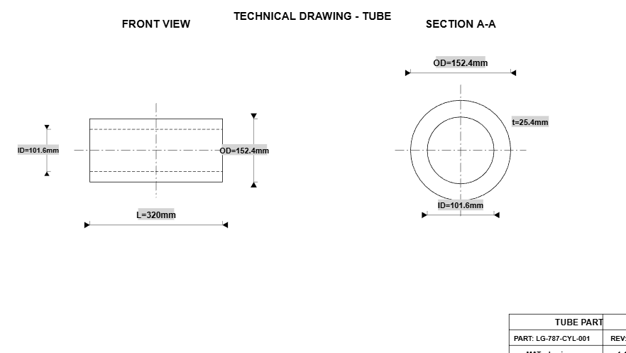

Key Dimensions: Thickness: 25.4 mm | Axial Width: 320.0 mm | Outer Diameter (OD): 152.4 mm | Inner Diameter (ID): 101.6 mm

TABLE OF CONTENTS

1. Part Information
2. Equipment
3. Scan Parameters
4. Acceptance Criteria
5. Scan Details & Directions
5.1 Scanning Directions
5.2 Technical Drawing
6. Documentation
7. Calibration / Reference Standard
7.1 FBH Table
7.2 Calibration Block Diagram
7.3 Angle Beam Calibration Block
8. Approvals & Signatures
Note: Page numbers may vary based on content.

1. PART INFORMATION

Parameter | Value
Part Number | LG-787-CYL-001
Part Name | Main Landing Gear Actuator Cylinder
Material | Aluminum
Material Specification | AMS 4045 / QQ-A-250/12
Part Type / Geometry | Tube
Drawing Number | DWG-787-LG-2024-001
Heat Treatment | T6 Solution Heat Treated and Aged

Dimensions

Thickness | 25.4 mm
Axial Width | 320.0 mm
Outer Diameter (OD) | 152.4 mm
Inner Diameter (ID) | 101.6 mm
Wall Thickness | 25.40 mm
Hollow Part | Yes

Material Properties

Material Density | 2700 kg/m³

2. EQUIPMENT

Parameter | Value
Manufacturer | Olympus NDT
Model | OmniScan X3 64
Serial Number | OSX3-2024-0847
Software Version | 5.2.1

Frequency | 2.25 MHz
Type | Immersion
Transducer Shape & Size | -
Element Diameter | 0.500 inches
Couplant | Deionized Water
Selection Notes | -

Performance Parameters

Entry Surface Resolution | 0.080 inches
Back Surface Resolution | 0.040 inches

Phased Array Configuration

Number of Elements | 64
Element Pitch | 0.60 mm
Wedge Model | SA32-N55S
Wedge Type | Normal Incidence
Delay Line | Water Path

3. SCAN PARAMETERS

Parameter | Value
Scan Method | Immersion
Technique | Conventional
Scan Type | Automated C-Scan
Scan Pattern | Raster
Coupling Method | immersion

Speed & Coverage

Scan Speed | 150 mm/s
Scan Index | 50 %
Coverage | 100%
Water Path | 25.4 mm

Instrument Settings

Pulse Repetition Rate (PRF) | 2000 Hz

4. ACCEPTANCE CRITERIA

ACCEPTANCE CLASS: AA (Very Stringent - Primary Structure)
Single Discontinuity | 3/64" (1.2mm) FBH response
Multiple Discontinuities | 2/64" (0.8mm) FBH (centers <1" apart)
Linear Discontinuity | 2/64" (0.8mm) FBH, 1/2" max length
Back Reflection Loss | 50%
Noise Level | Alarm level (see 5.2.3)

Special Requirements

Zone 1 (0-6mm from surface): No indications > #2 FBH equivalent. 100% coverage mandatory.
Standard Notes

For engine mounts, landing gear primary structure, rotor hubs
Table 6 — Ultrasonic Classes — Notes

1/ Any discontinuity with an indication greater than the response from a reference flat-bottom hole or equivalent notch at the estimated discontinuity depth of the size given (inches diameter) is not acceptable.
2/ Multiple discontinuities with indications greater than the response from a reference flat-bottom hole or equivalent notch at the estimated discontinuity depth of the size given (inches diameter) are not acceptable if the centers of any two of these discontinuities are less than 1 inch apart. Not applicable to class C.
3/ Any discontinuity longer than the length given with indications greater than the response given (flat-bottom hole or equivalent notch response) is not acceptable. Not applicable to class C.
4/ Loss of back reflection greater than the percent given, when compared to non-defective material in a similar or like part, is not acceptable when this loss of back reflection is accompanied by an increase or decrease in noise signal (at least double the normal background noise signal) between the front and back surface. Applicable only to straight beam tests.
5/ When inspecting titanium to class AA, the multiple discontinuity separation shall be 1/4 inch.
6/ For class AAA single discontinuity, 50% of 2/64 = 25% of 3/64.
7/ For class AAA linear and multiple discontinuities, 1/64 or 25% of 2/64 = 10% of 3/64.

5. SCAN DETAILS & DIRECTIONS

Scan Directions Overview

Dir. | Wave Mode | Angle | Freq. | Make | Probe/Size | Remarks
C | Longitudinal | 0° | 5.0 MHz | Olympus | V309-SU | OD straight-beam raster for wall volume coverage
D | Shear | 45° | 5.0 MHz | Olympus | SA32-N55S | Circumferential shear, clockwise, 45 deg for axial-oriented reflectors
E | Shear | -45° | 5.0 MHz | Olympus | SA32-N55S | Circumferential shear, counter-clockwise, 45 deg
F | Shear | 45° | 5.0 MHz | Olympus | SA32-N55S | Axial shear from OD, lead +45 deg
G | Shear | -45° | 5.0 MHz | Olympus | SA32-N55S | Axial shear from OD, lead -45 deg
H | Longitudinal | 0° | 5.0 MHz | Olympus | V309-SU | ID straight-beam follow-up for bore cleanliness and near-ID confirmation

Probe Parameters

Dir. | Part Number | Serial Number | Active Element | Bandwidth | Focus Size | Velocity | Near Field
C | V309-SU-05 | PRB-AL-24017 | 12.7 mm | high | 12 mm focus at 25 mm depth | 6320 m/s | 31.90 mm
D | SA32-N55S | ANG-24017-CW | 12.7 mm | medium | 45 deg wedge | 3130 m/s | 64.41 mm
E | SA32-N55S | ANG-24017-CCW | 12.7 mm | medium | 45 deg wedge | 3130 m/s | 64.41 mm
F | SA32-N55S | ANG-24017-AX1 | 12.7 mm | medium | 45 deg wedge | 3130 m/s | 64.41 mm
G | SA32-N55S | ANG-24017-AX2 | 12.7 mm | medium | 45 deg wedge | 3130 m/s | 64.41 mm
H | V309-SU-05 | PRB-AL-24017 | 12.7 mm | high | 10 mm focus at ID wall | 6320 m/s | 31.90 mm

U.T Parameters

Dir. | U.T Parameter | Range | Delay | Gate 1 | TCG
C | 300V square / 130ns / longitudinal | 80 | 4 | 4-30-20% | YES
D | SW 45 deg / TCG +6 dB | 110 | 8 | 10-40-30% | YES
E | SW 45 deg / reverse lead | 110 | 8 | 10-40-30% | YES
F | OD axial sweep / 45 deg | 105 | 10 | 12-38-30% | YES
G | OD axial sweep / reverse | 105 | 10 | 12-38-30% | YES
H | ID confirmation pass / 300V square | 80 | 3 | 3-28-20% | YES

6. DOCUMENTATION

Inspector

Inspector Name | Dr. Michael Chen
Certification Number | ASNT-TC-1A Level III
Level | Level III
Certifying Organization | ASNT

Customer & Document

Customer Name | Boeing Commercial Airplanes
Purchase Order | PO-BCA-2024-15847
Part Serial Number | SN-LG787-2024-0342
Inspection Date | Dec 17, 2024
Procedure Number | NDT-UT-787-001 Rev. C
Drawing Reference | DWG-787-LG-2024-001 Rev. B
Revision | C

Additional Notes

Critical flight safety component. Requires Level III review and customer witness point.

7. CALIBRATION / REFERENCE STANDARD

Parameter | Value
Standard/Block Type | Cylinder (Notched)
Reference Material | Aluminum 7075-T6
Block Dimensions | Curve (ID 101.6 mm, OD 152.4 mm, Thickness 25.4 mm)
Block Serial Number | CAL-AL-7075-001
Last Calibration Date | Nov 15, 2024
Metal Travel Distance | 12.7 mm

Flat Bottom Holes (FBH)

P/N | Δ Type | Ø FBH (inch) | Ø FBH (mm) | E (mm) | H (mm)
- | distance | 1/64 | 0.40 mm | 25.4 mm | 6.3 mm
- | dac | 3/64 | 1.19 mm | 25.4 mm | 12.7 mm
- | dac | 7/64 | 2.78 mm | 25.4 mm | 19.1 mm

Calibration Block Diagram

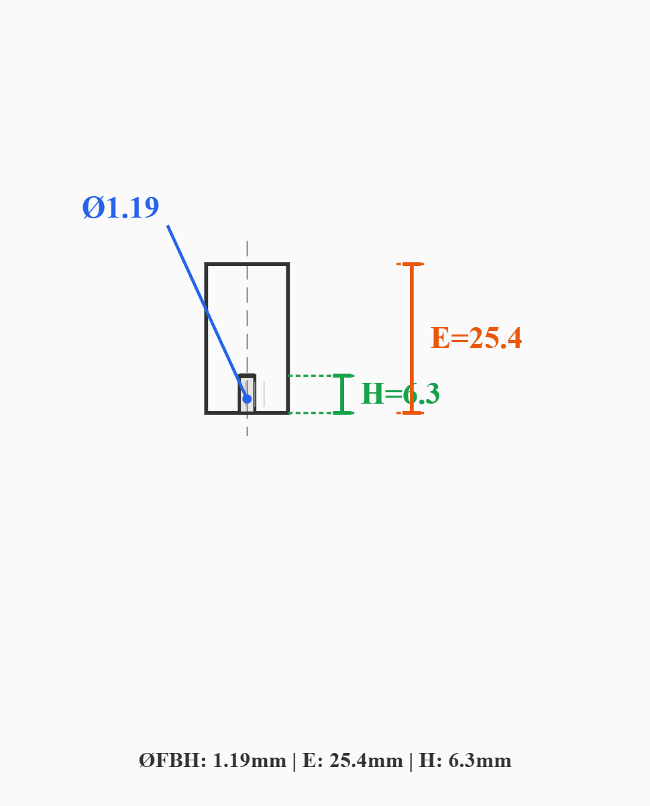

Angle Beam Calibration Block
Shear Wave / Circumferential Inspection Reference Block


TECHNICAL DRAWING



ASTM E2375 SCAN DIRECTIONS DIAGRAM
Standard Practice for Ultrasonic Testing of Wrought Products - Tube
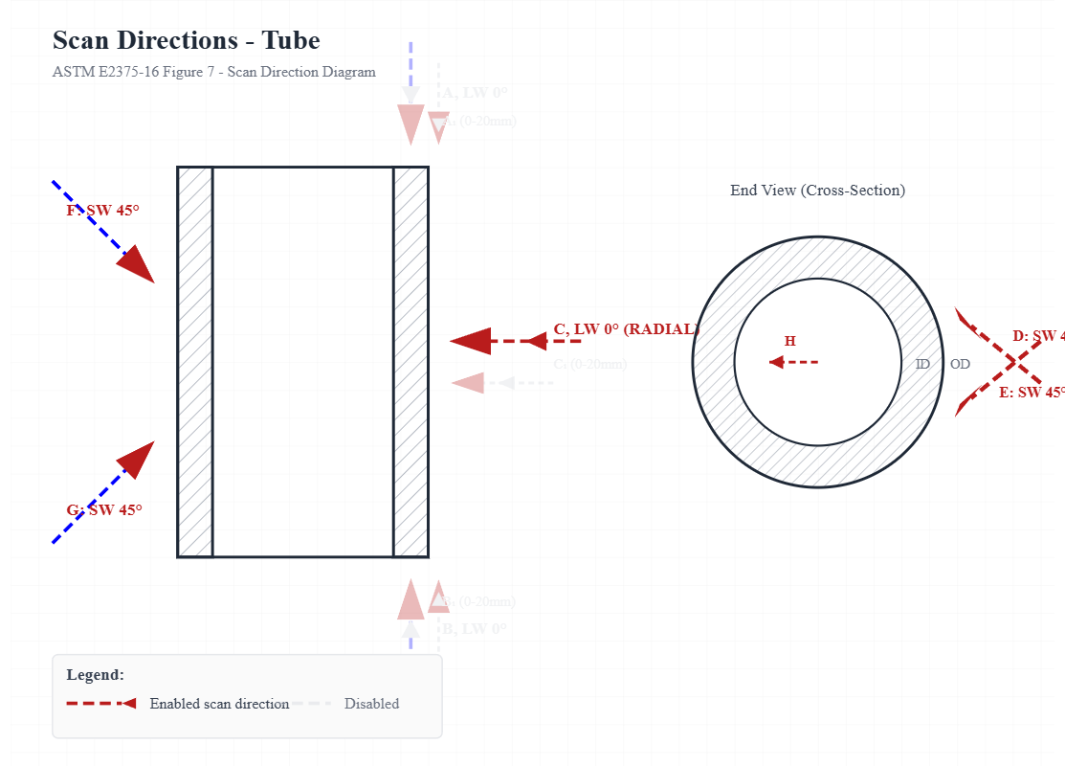
Reference: ASTM E2375-16 "Standard Practice for Ultrasonic Testing of Wrought Products"

8. APPROVALS & DOCUMENT CONTROL

Revision History

Rev | Date | Description | Prepared By | Approved By | Sign
C | Dec 17, 2024 | Initial Release | Dr. Michael Chen

Approval Signatures

Role | Name (Print) | Cert. Number | Date | Signature
UT Inspector (Level II) | Dr. Michael Chen | ASNT-TC-1A Level III | Dec 17, 2024
Level III Review |  |  | -
Quality Assurance
Customer Representative

⚠️ NOTICE: This technique sheet requires Level III approval before use in production.

DOCUMENT CONTROL
This is a controlled document. Unauthorized reproduction, modification, or distribution is strictly prohibited.
Printed copies are uncontrolled unless stamped "CONTROLLED COPY" with a valid date.
Document generated: March 21, 2026 | Scan-Master v1.0

