What is HTML?

* HTML stands for Hyper Text Markup Language
* HTML is the standard markup language for creating Web pages
* HTML describes the structure of a Web page
* HTML consists of a series of elements
* HTML elements tell the browser how to display the content
* HTML elements label pieces of content such as "this is a heading", "this is a paragraph", "this is a link", etc.

How to create html page :

Create a new file with .html extension

Write a code given in below example:

<!DOCTYPE html>  
<html>  
<head>  
<title>Page Title</title>  
</head>  
<body>  
  
<h1>My First Heading</h1>  
<p>My first paragraph.</p>  
  
</body>  
</html>

**Each line meaning is given as below:**

* The <!DOCTYPE html> declaration defines that this document is an HTML5 document
* The <html> element is the root element of an HTML page
* The <head> element contains meta information about the HTML page
* The <title> element specifies a title for the HTML page (which is shown in the browser's title bar or in the page's tab)
* The <body> element defines the document's body, and is a container for all the visible contents, such as headings, paragraphs, images, hyperlinks, tables, lists, etc.
* The <h1> element defines a large heading
* The <p> element defines a paragraph

**How to run the html page :**

Right click on the given file open with browser or run on browser.

## Web Browsers

The purpose of a web browser (Chrome, Edge, Firefox, Safari) is to read HTML documents and display them correctly.

A browser does not display the HTML tags, but uses them to determine how to display the document:

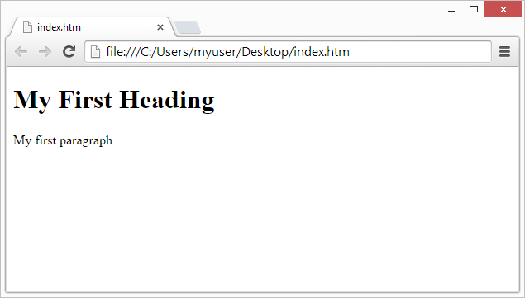

**Only the content inside the <body> section (the white area above) will be displayed in a browser.**

The HTML document itself begins with <html> and ends with </html>.

The visible part of the HTML document is between <body> and </body>.

## HTML Headings

HTML headings are defined with the <h1> to <h6> tags.

<h1> defines the most important heading. <h6> defines the least important heading:

**Code for headings:**

**<!DOCTYPE html>**

**<html>**

**<body>**

**<h1>hello cjc 1<h1>**

**<h2> hello cjc 2 </h2>**

**<h3> hello cjc 3</h3>**

**<h4> hello cjc 4</h4>**

**<h5> hello cjc 5</h5>**

**<h6> hello cjc 6</h6>**

**</body>**

**</html>**

## HTML Paragraphs

HTML paragraphs are defined with the <p> tag:

### Example

<p>This is a paragraph.</p>  
<p>This is second paragraph.</p>

## HTML Links

HTML links are defined with the <a> tag:

Example:

<a href="pqr.html">This is a link</a>

The link's destination is specified in the href attribute.

It is used used to swich from one page to another page.

Attributes are used to provide additional information about HTML elements.

HTML tables:

<html>

<head>

<title>title of abcd</title>

</head>

<body>

<table border="1">

<tr>table row

<th>Rollno</th> table heading

<th>Name</th>

</tr>

<tr>

<td>1</td>table data

<td>abc</td>

</tr>

<tr>

<td>2</td>table data

<td>abcd</td>

</tr>

</table>table end

</body>

</html>

* Use the HTML <table> element to define a table
* Use the HTML <tr> element to define a table row
* Use the HTML <td> element to define a table data
* Use the HTML <th> element to define a table heading

HtmlForms:

An HTML form is used to collect user input. The user input is most often sent to a server for processing.

The <form> Element

The HTML <form> element is used to create an HTML form for user input:

<form>  
.  
*form elements*  
.  
</form>

The <form> element is a container for different types of input elements, such as: text fields, checkboxes, radio buttons, submit buttons, etc.

## The <input> Element

The HTML <input> element is the most used form element.

An <input> element can be displayed in many ways, depending on the type attribute.

Here are some examples:

|  |  |
| --- | --- |
| **Type** | **Description** |
| <input type="text"> | Displays a single-line text input field |
| <input type="radio"> | Displays a radio button (for selecting one of many choices) |
| <input type=" checkbox"> | Displays a checkbox (for selecting zero or more of many choices) |
| <input type="submit"> | Displays a submit button (for submitting the form) |