**Project Synopsis**

**Automotive Insurance System**

Prepared by: Harsh Agarwal (B004), Amit Birajdar (B014), Manan Bolia (B015),

Vedang Gupte (B019)

Mentor: Prof. Anshul Vyas

**Motivation**

Assessing the damage for a car and knowing the approximate insurance value after studying all the aspects of the damage becomes a hideous process. To reduce the redundant aspect of human-work that goes into this process, a system can be developed a system to approximate the insurance amount that can be claimed against the damage in a very small amount of time as compared to the currently practised methods.

**Problem Statement**

To assess the overall damage of a car and approximate its insurance value using images of the superficially damaged area and additional details through user input, as data.

Damages like dents, scratches will be detected from an image submitted by the user. Internal damages that cannot be visualized from the images taken from the outside will be interpreted from a questionnaire answered by the user on the website. Further, insurance amount will be estimated for the overall damage that is estimated.

**Scope of the project**

* Detect superficial damages such as dents and scratches.
* Determine extent of internal damage
* Determine the approximate insurance amount that can be claimed
* List all the anomalies that are detected

**Project Details**

**Architecture**

Input events

View control

**CONTROLLER**

**VIEW**

Change notification

Update model

Query model

**MODEL**

**Model-view-controller pattern**

This pattern, also known as MVC pattern, divides an interactive application into 3 parts as,

1. **Model –** contains the core functionality and data
2. **View –** displays the information to the user (more than one view may be defined)
3. **Controller –** handles the input from the user

This is done to separate internal representations of information from the way information is presented to, and accepted from the user. It decouples components and allows efficient code reuse.

**Environment**

**Tools:**

* Beautiful Soup
* OpenCV
* Python
* HTML
* PHP

**USE CASE DIAGRAM**

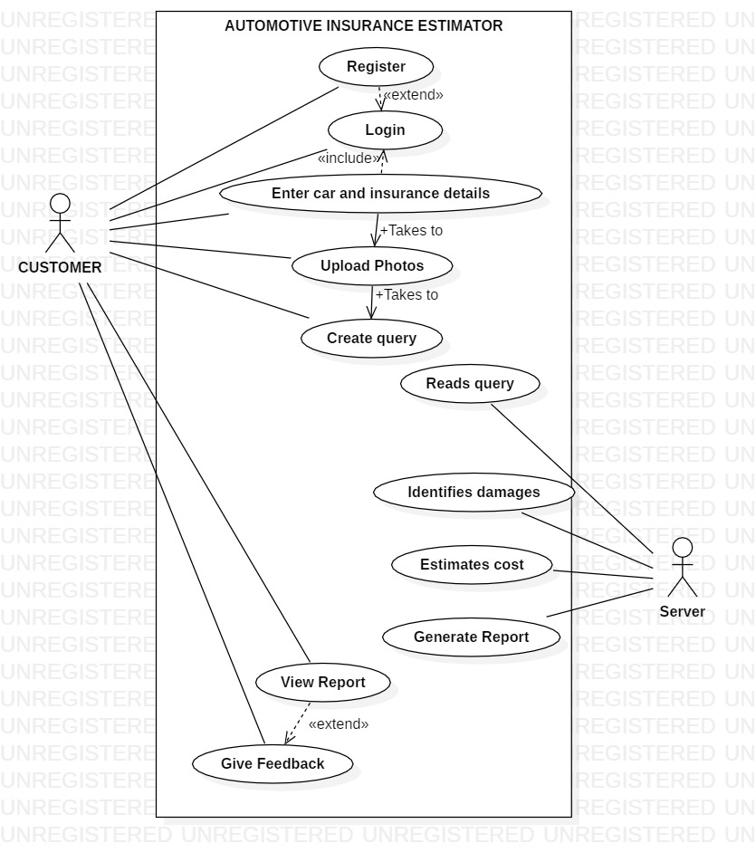

**Implementation Approach-**

Process begins with user uploading an image of the superficial damage area on the vehicle followed by the details of the vehicle and insurance.

If there exists any internal damage, the user will answer a questionnaire that would assist to interpret the possible internal damage.

The system will then detect the dents and scratches on the surface from the image uploaded by the user. It will also interpret the internal damage through the questionnaire.

It will then give a total insurance estimated value based on the damages.

**Deliverables and Timeline**

**August, 2019**

* Read research papers related to object detection and summarize them to draw out useful information conclusions.
* Study various machine learning algorithms and their applications
* Learn about creating a data set
  + data gathering
  + data cleaning
  + data normalization

**September, 2019**

* Data gathering – study web scrapping
* Data Cleaning
* Data Normalization

**October, 2019**

* Learning implementation of machine learning algorithms
* Learning about training the machine with the gathered data
* Testing different machine learning algorithms to check their effectiveness

**November, 2019**

* Summarize all the results in a paper and present a summary and a comparison between the efficiency of various algorithms
* Finalize the algorithms to be used and the flow of development for the system

**December, 2019**

* Start with implementation
* Data Cleaning
* Data Normalization
* Labelling and Annotations
* Implementing algorithms

**January, 2020**

* Website front end
* Implementing object detection for superficial damages
* Data training, testing and validation

**February, 2020**

* Integration of server-side processing and webpage
* Data gathering, cleaning for internal damage cost prediction
* Implementation of internal damage cost prediction
* Testing the accuracy of the algorithms individually

**March, 2020**

* Testing the system as a whole
* Preparing documentation

**Impact**

Automated detection of car exterior damages and subsequent quantification (damage severity) of those would help used car dealers (Marketplace) to price cars accurately and fast by eliminating the manual process of damage assessment.

The concept is equally beneficial for property and casualty(P&C) insurers, in terms of faster claim settlement and hence greater customer satisfaction.

**References**

1. https://www.sciencedirect.com/science/article/pii/S0278612517301085
2. <https://ieeexplore.ieee.org/document/903032>

**GANTT CHART**

