**Instructions**

1. Install Visual Studio 2019 or 2022 (not Visual Studio Code), community edition. It should install .NET 5 framework with it, If not please .NET 5 framework too.
2. Download the source code from the Github

<https://github.com/amitbirla/Azure_Iot_device_Simulator>

1. Double click on the BitsAssignment.sln file. If Visual Studio is installed then it should open new instance of Visual Studio (not Visual Studio Code).

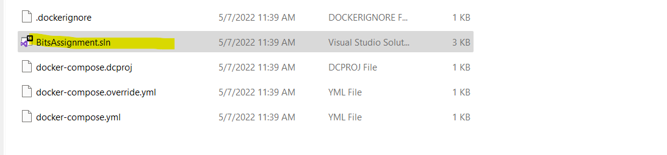

1. The solution should be visible in the solution explorer in Visual studio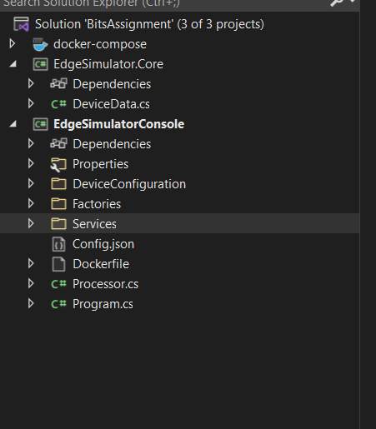
2. Open file PushToHubService.cs

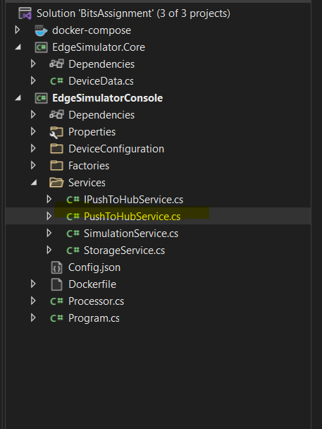

1. Paste the IoTHub connection string at the highlighted placeholder

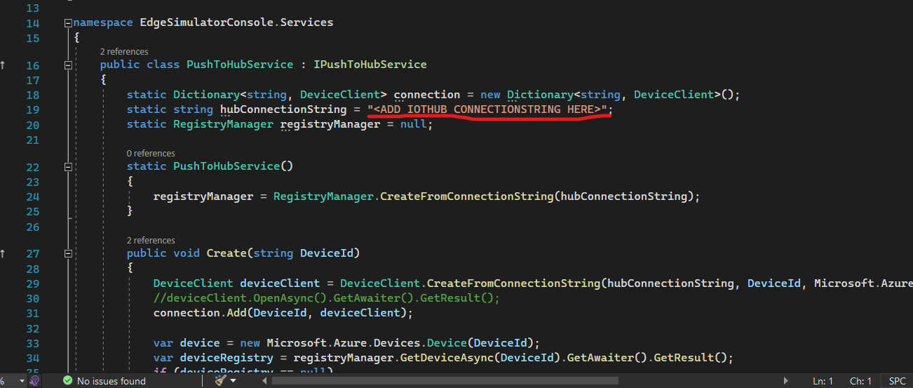

1. Login to Microsoft Azure portal, buy a valid subscription and then create IoTHub. The following tutorial should help

<https://learn.microsoft.com/en-us/azure/iot-hub/iot-hub-create-through-portal>