**Observations:**

1 > Sub-Urban area has moderate number of riders, but the average fair is area seems higher compared to Urban. Also the number or riders is higher than that of Rural. Urban area is saturated with high number of drivers. This also indicates that the rural/suburban area might have longer driving distance which add more to the fare. But if a drive wants to have more rides, urban area is a better option.

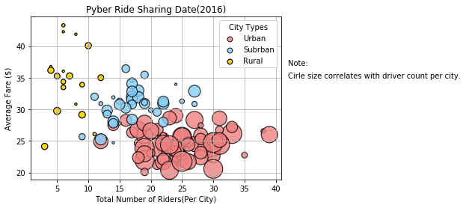

2> Sub-urban area sharing a good percentage of total fare but the number of drives are low compared to urban area. This makes Suburban area a good place for drivers to earn money.

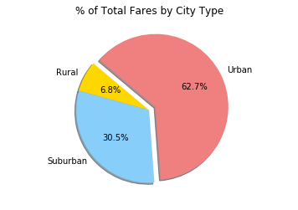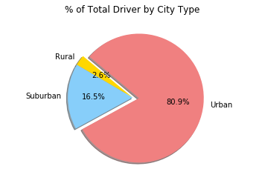

3> Suburban area shares a good number of % of rides making it a good option for drivers.

