We can make below three conclusions we can make about Kickstarter campaigns

* Theater is the most popular category with highest number of campaigns. Also, it has good success rate. Music category has the highest success rate among all categories. Technology has unique feature of almost equal chances of getting either success or failure. Surprisingly Journalism has no campaign that became successful. All projects under Journalism were cancelled.

Under Subcategory, plays (under Theater category) has the highest number of projects among all made it most popular category. But this category has around 30%failure rate. There are few subcategory Rock (Music category), documentary (film & video category), Hardware ( Technology) with 100% success rate. Video games ( games/video games category) , wearables (Technology Category ), web (Technology category) and World Music ( under Music) has no success.

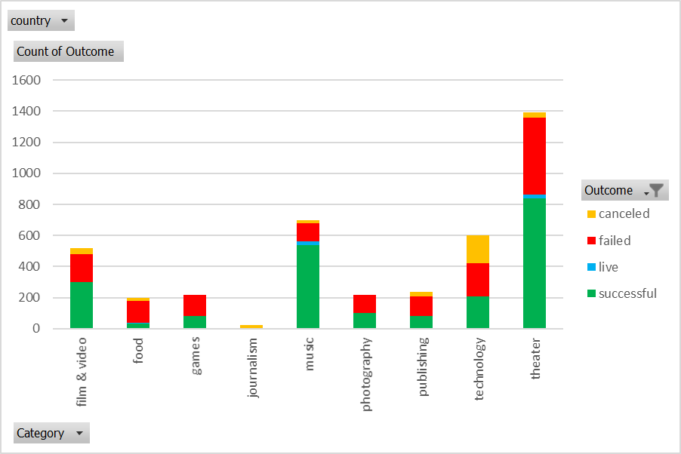

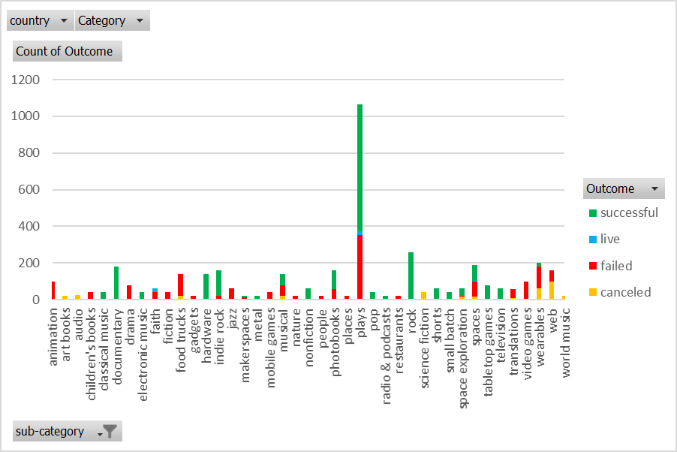

* A good time to initiate the campaign is the start of 2nd Quarter till the beginning of 3rd Quarter. As per graph most of the successful campaigns were launched between that period. At the end of 4th Quarter the success numbers falls below the failed numbers. The cancelled projects trend is same throughout the year.

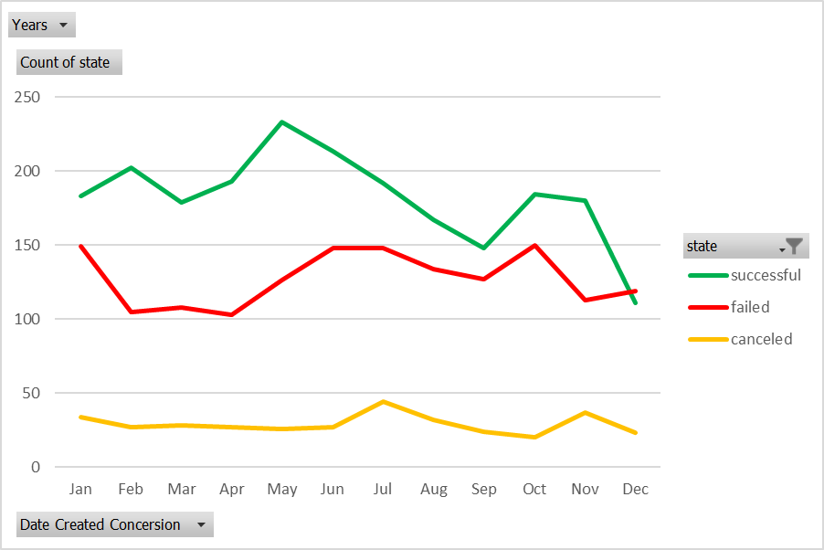

* Campaign success rate depends upon how big the goal is valued. Campaigns under $5000, has the success rate more than the failure rate. Campaigns between $10000 to $45000 has almost equal chances of success or failure. Hence campaigns more than $50000 has very high failure or cancellation rate.

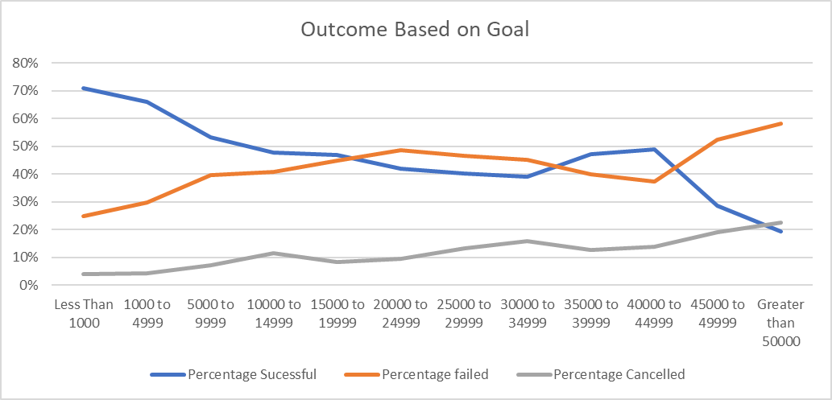

As far as limitations are concerned, the dataset is lacking below limitations

* The data that are provided don’t specify the exact geographical location of the projects. More than 80% of Kickstarter projects are from US, which is great, but we don’t know the information in terms of US state. IF we have the information, we could have analyzed more for each state and find out the success percentage per state.
* We don’t know how much engaged each project is. As per my understanding, campaigns with more active engagements (comments and updates) gets more success. The more people comment on a project, the more likely it’s going to succeed. Also, the more updates project creators provide on their project, the more likely it is going to succeed.

We could have created the below graphs

* Project duration graph vs the State graph which will give us an idea if duration of projects impacts the state.
* Project success rate on each category to find out the top successful project on each category.
* State vs the number of bakers graph to find out if more number of bakers on each campaign leads to success.