Observation:

* As we move from negative latitude (South) to equator , we can see the rise in Max Temperate and the peak is at right in equator (0). As we move from equator (0) to positive value, the max Temperature drops again.

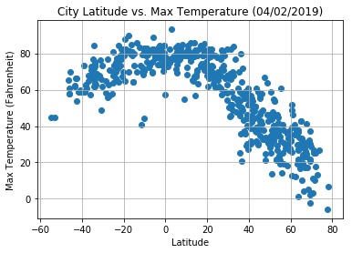

* As we move more to equator, the humidity value increases which is maxed at (0). The far we move from equator (both negative and positive Latitude , the humidity level decreases)

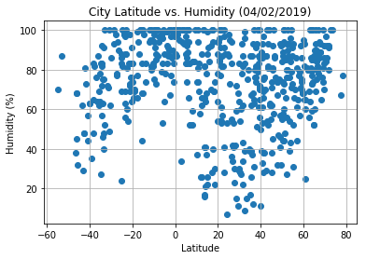

* The cloudiness increases near the equator and generally low at the end of latitude in both direction.

