Architecture & LLD - Solution 4
ALB -> private S3 via S3 interface endpoint for the UI; ALB /api/* -> private API Gateway via execute-api interface endpoint
Prepared for internal design review
Ranking for this option: Okay. Assumption: internal-only Angular SPA for corporate users over Direct Connect/VPN, with a private REST API behind API Gateway.

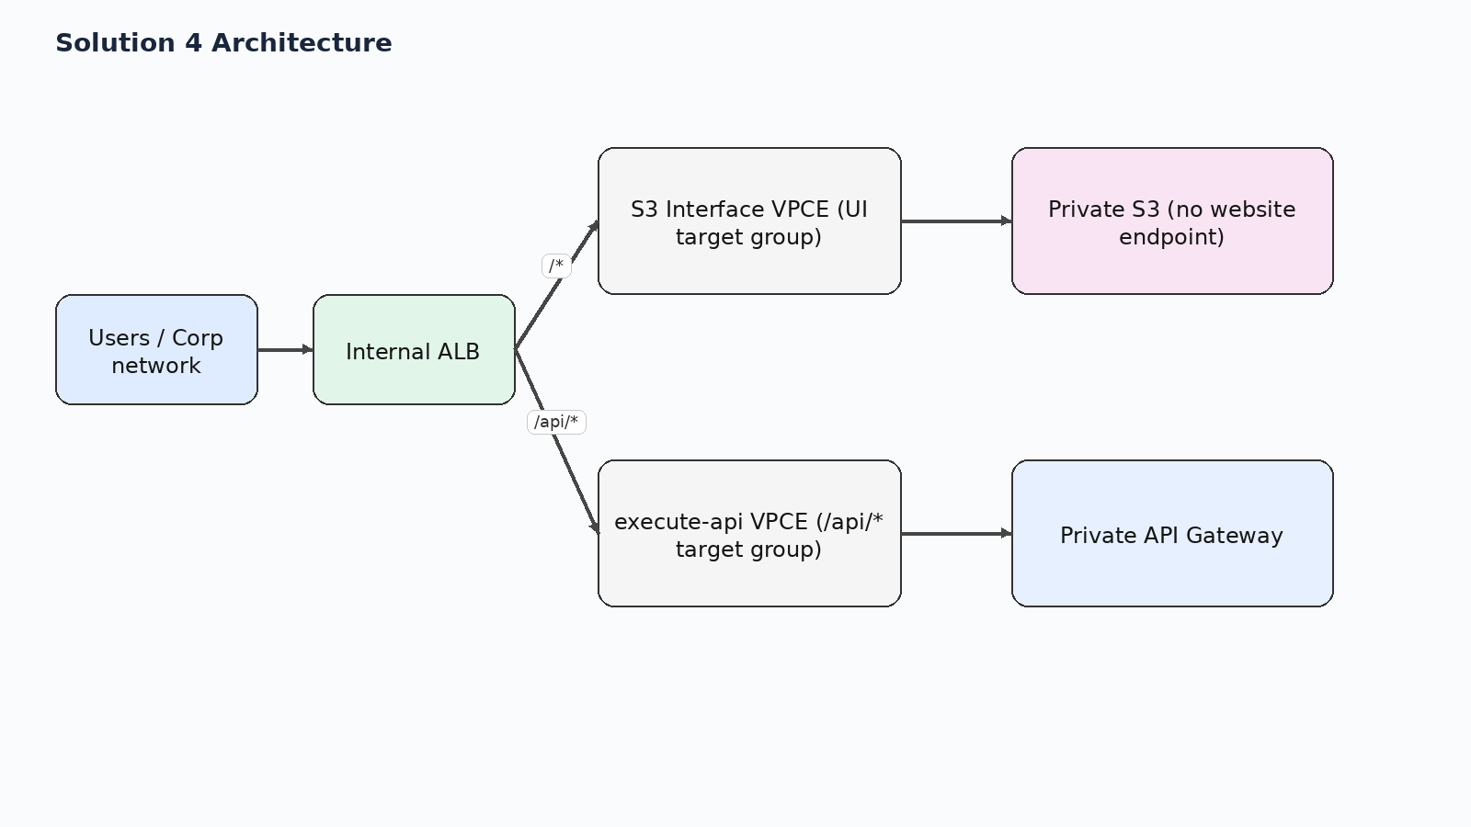
Figure 1. High-level request path for solution 4.

1. Executive summary
No web server tier. The internal ALB path-routes to two IP target groups: S3 interface endpoint ENIs for UI requests and execute-api endpoint ENIs for /api/*.
Why it sits at this rank: Elegant from an infrastructure and cost perspective, but weak for Angular History API routes. It works best for simple static sites or SPAs that use hash routing. Pretty-route SPA support is the main reason it ranks below the NGINX-based designs.

2. Relative ranking across all five options
Rank | Solution | Option
Best | Solution 3 | ALB -> ECS Fargate NGINX (serves Angular itself) -> private API Gateway
Next to Best | Solution 2 | ALB -> ECS Fargate NGINX (serves Angular locally, synced from S3 at deploy/startup) -> private API Gateway
Good | Solution 1 | ALB -> ECS Fargate NGINX (proxy only) -> private S3 + private API Gateway
Okay | Solution 4 | ALB -> private S3 via S3 interface endpoint for the UI; ALB /api/* -> private API Gateway via execute-api interface endpoint
Avoid | Solution 5 | Private API Gateway -> /web ANY -> Lambda -> S3

This document focuses on Solution 4.

3. Low-level design
- Browser reaches a single internal ALB hostname.
- The ALB listener routes /api/* to an IP target group made from execute-api VPC endpoint ENI addresses.
- The default listener action routes all other paths to an IP target group made from S3 interface endpoint ENI addresses.
- The browser still sees one origin, but the S3 REST endpoint only returns real objects; it does not behave like an SPA-aware web server.

4. Design scenarios covered
Scenario | What happens
CORS | No browser CORS issue if the browser still uses a single ALB hostname and /api/* is routed internally.
SPA routing | Weak. ALB can route to S3, but it cannot natively do 'if object missing then return /index.html' the way NGINX can. Refreshing /users/123 usually fails unless the app uses hash routing or a carefully constrained URL strategy.
Security boundary | Strong. Both S3 and API remain private via interface endpoints.
Performance | Potentially very efficient, but only for static object paths that map directly to real S3 keys.
Operational fit | Good for simple sites, not ideal for a modern Angular SPA with pretty URLs.

5. Pros and cons
Pros | Cons
No ECS service or web server to operate. | Poor fit for Angular deep links unless the app uses hash routing or accepts routing workarounds.
Uses AWS-native private endpoints only. | ALB listener rules are not a full web-server rewrite engine.
Clear separation between UI and API target groups on the ALB. | Managing interface endpoint IP targets can be awkward if endpoints are recreated.
Good fit for simple internal static sites. | Debugging S3 REST endpoint behavior is less intuitive than a normal web server.

6. Key design decisions
- Avoid a web-server tier completely.
- Use ALB listener rules and IP target groups for both endpoint types.
- Constrain the UI to routes that map to real objects, or use hash routing.
- Automate endpoint-IP registration in target groups.

7. Selected AWS references used for this design
- AWS ECS Developer Guide / Use an Application Load Balancer for Amazon ECS — Application Load Balancer with ECS and path-based routing
- AWS API Gateway Developer Guide / Private REST APIs in API Gateway — Private REST APIs are reachable through interface VPC endpoints
- AWS S3 User Guide / AWS PrivateLink for Amazon S3 — S3 interface endpoints are reachable from on premises over VPN or Direct Connect
- AWS VPC Guide / Gateway endpoints for Amazon S3 — Gateway endpoints do not support on-premises access; interface endpoints do
- AWS Networking Blog / Hosting Internal HTTPS Static Websites with ALB, S3, and PrivateLink — ALB plus S3 PrivateLink internal site pattern
- AWS Prescriptive Guidance / Deploy an API Gateway API on an internal website using private endpoints and an ALB — ALB to private API Gateway via endpoint IP target group

