Architecture & LLD - Solution 3
ALB -> ECS Fargate NGINX (serves Angular itself) -> private API Gateway
Prepared for internal design review
Ranking for this option: Best. Assumption: internal-only Angular SPA for corporate users over Direct Connect/VPN, with a private REST API behind API Gateway.

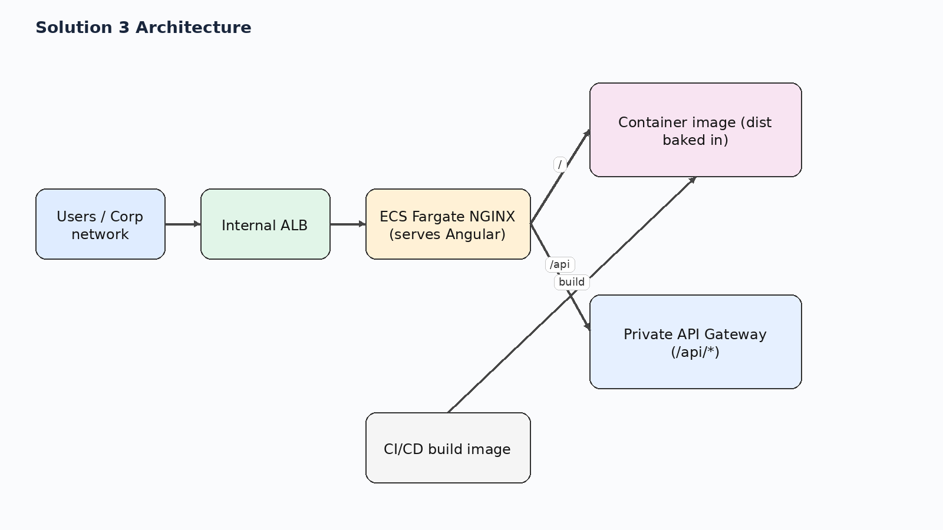
Figure 1. High-level request path for solution 3.

1. Executive summary
The Angular dist output is baked into the NGINX image. NGINX serves the UI directly and proxies /api/* to private API Gateway.
Why it sits at this rank: Cleanest design for an internal Angular SPA. It gives the best routing behavior, predictable deployments, easy rollback, and no extra dependency on S3 in the runtime path. It only drops to second place if there is a hard policy that UI artifacts must live only in S3.

2. Relative ranking across all five options
Rank | Solution | Option
Best | Solution 3 | ALB -> ECS Fargate NGINX (serves Angular itself) -> private API Gateway
Next to Best | Solution 2 | ALB -> ECS Fargate NGINX (serves Angular locally, synced from S3 at deploy/startup) -> private API Gateway
Good | Solution 1 | ALB -> ECS Fargate NGINX (proxy only) -> private S3 + private API Gateway
Okay | Solution 4 | ALB -> private S3 via S3 interface endpoint for the UI; ALB /api/* -> private API Gateway via execute-api interface endpoint
Avoid | Solution 5 | Private API Gateway -> /web ANY -> Lambda -> S3

This document focuses on Solution 3.

3. Low-level design
- CI/CD builds the Angular app and bakes the dist output into the NGINX image.
- Browser reaches the internal ALB and all requests are served by the ECS/NGINX service.
- NGINX serves UI files directly from the image and proxies /api/* to the private API Gateway.
- NGINX uses try_files to return /index.html for SPA routes.

4. Design scenarios covered
Scenario | What happens
CORS | No browser CORS issue when Angular calls relative /api/* paths on the same internal host.
SPA routing | Best coverage. NGINX native fallback makes refreshes and bookmarked deep links work reliably.
Security boundary | Strong and simple: only the ALB is exposed internally; API remains private behind execute-api.
Performance | Best among the five options because the UI is served directly from the local web server.
Operational fit | Recommended default for an internal Angular application unless a hard S3-only policy overrides it.

5. Pros and cons
Pros | Cons
Simplest runtime data path for the UI. | Every UI change requires a new container image build and deployment.
Best SPA support: NGINX serves files directly and falls back to /index.html. | Does not satisfy a strict 'UI must only be in S3' governance requirement.
Single browser origin avoids CORS without API Gateway CORS complexity. | Requires a standard CI/CD flow for container builds.
Easy immutable deployments and rollbacks with container image tags.
No runtime dependency on S3 for page loads.

6. Key design decisions
- Use immutable container images for UI deployments.
- Prefer the simplest runtime data path.
- Use NGINX native SPA routing.
- Keep the API private and same-origin from the browser view.

7. Selected AWS references used for this design
- AWS ECS Developer Guide / Use an Application Load Balancer for Amazon ECS — Application Load Balancer with ECS and path-based routing
- AWS API Gateway Developer Guide / Private REST APIs in API Gateway — Private REST APIs are reachable through interface VPC endpoints
- AWS S3 User Guide / AWS PrivateLink for Amazon S3 — S3 interface endpoints are reachable from on premises over VPN or Direct Connect
- AWS VPC Guide / Gateway endpoints for Amazon S3 — Gateway endpoints do not support on-premises access; interface endpoints do
- AWS Networking Blog / Hosting Internal HTTPS Static Websites with ALB, S3, and PrivateLink — ALB plus S3 PrivateLink internal site pattern
- AWS Prescriptive Guidance / Deploy an API Gateway API on an internal website using private endpoints and an ALB — ALB to private API Gateway via endpoint IP target group

