Architecture & LLD - Solution 5
Private API Gateway -> /web ANY -> Lambda -> S3
Prepared for internal design review
Ranking for this option: Avoid. Assumption: internal-only Angular SPA for corporate users over Direct Connect/VPN, with a private REST API behind API Gateway.

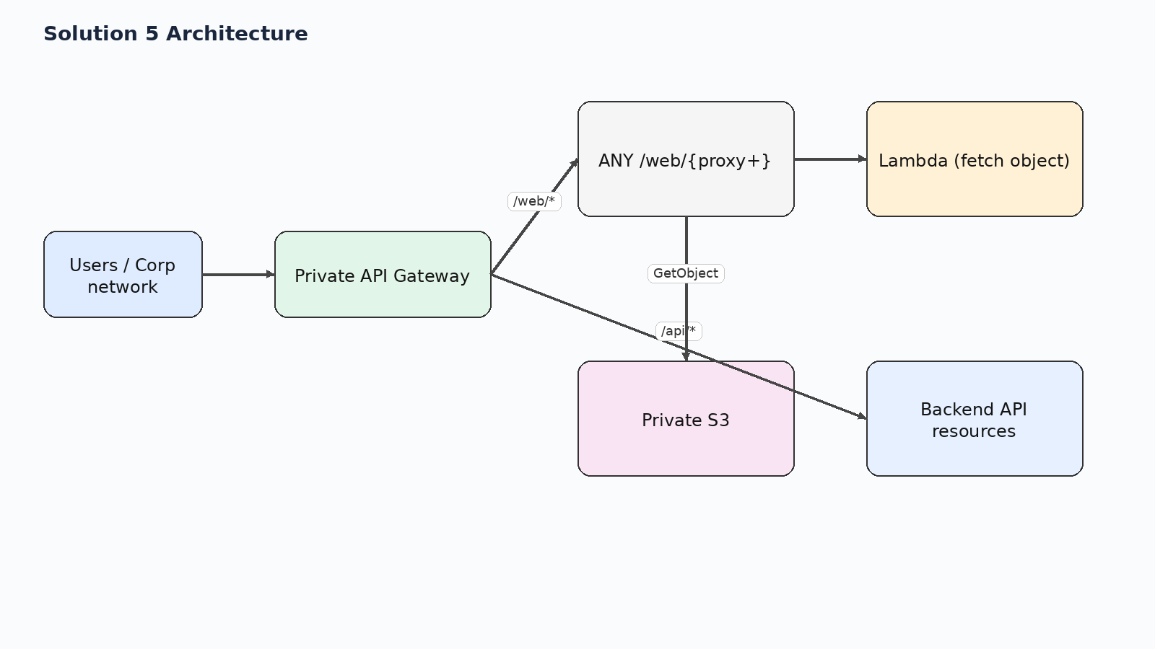
Figure 1. High-level request path for solution 5.

1. Executive summary
A private API Gateway resource such as /web/{proxy+} invokes a Lambda function. The function fetches objects from S3 and returns them to the browser, while the rest of the API continues to serve backend routes.
Why it sits at this rank: Technically possible but the least desirable option for a UI. It turns static asset delivery into API Gateway requests plus Lambda invocations, which increases cost, latency, size-limit exposure, and operational complexity.

2. Relative ranking across all five options
Rank | Solution | Option
Best | Solution 3 | ALB -> ECS Fargate NGINX (serves Angular itself) -> private API Gateway
Next to Best | Solution 2 | ALB -> ECS Fargate NGINX (serves Angular locally, synced from S3 at deploy/startup) -> private API Gateway
Good | Solution 1 | ALB -> ECS Fargate NGINX (proxy only) -> private S3 + private API Gateway
Okay | Solution 4 | ALB -> private S3 via S3 interface endpoint for the UI; ALB /api/* -> private API Gateway via execute-api interface endpoint
Avoid | Solution 5 | Private API Gateway -> /web ANY -> Lambda -> S3

This document focuses on Solution 5.

3. Low-level design
- Browser reaches a private API Gateway hostname and requests /web/* for the UI shell and assets.
- A Lambda proxy integration receives the path and maps it to an S3 key.
- Lambda reads the object from S3, sets content type headers, and returns the payload through API Gateway.
- If the key is missing, Lambda can intentionally return index.html to emulate SPA fallback.

4. Design scenarios covered
Scenario | What happens
CORS | No browser CORS issue if the app is served from the same private API hostname. The problem is not CORS; it is unsuitable delivery mechanics.
SPA routing | Possible because Lambda can implement catch-all logic, but this is an expensive and code-heavy way to solve routing.
Security boundary | Private by design if API Gateway is private and S3 access is scoped.
Performance | Worst of the five for static UI delivery because of the Lambda hop on every request.
Operational fit | Only acceptable as a temporary workaround or for very small, low-traffic administrative UIs.

5. Pros and cons
Pros | Cons
Can be implemented without introducing ALB or NGINX. | Every asset request becomes API Gateway + Lambda + S3, which is costly and slower.
Lambda can emulate SPA fallback by returning /index.html when an object is missing. | Binary assets require careful API Gateway binary media type handling and base64 responses.
Stays fully private if the API is private and Lambda reads from private S3. | Payload size limits become relevant for larger bundles or media files.

6. Key design decisions
- Use Lambda as an application-layer file server.
- Accept API Gateway and Lambda limits for UI delivery.
- Handle binary media types and content types explicitly.
- Keep this only for niche or temporary use.

7. Selected AWS references used for this design
- AWS ECS Developer Guide / Use an Application Load Balancer for Amazon ECS — Application Load Balancer with ECS and path-based routing
- AWS API Gateway Developer Guide / Private REST APIs in API Gateway — Private REST APIs are reachable through interface VPC endpoints
- AWS S3 User Guide / AWS PrivateLink for Amazon S3 — S3 interface endpoints are reachable from on premises over VPN or Direct Connect
- AWS VPC Guide / Gateway endpoints for Amazon S3 — Gateway endpoints do not support on-premises access; interface endpoints do
- AWS Networking Blog / Hosting Internal HTTPS Static Websites with ALB, S3, and PrivateLink — ALB plus S3 PrivateLink internal site pattern
- AWS Prescriptive Guidance / Deploy an API Gateway API on an internal website using private endpoints and an ALB — ALB to private API Gateway via endpoint IP target group
- AWS S3 User Guide / Website endpoints — S3 website endpoints do not support HTTPS or access points
- AWS API Gateway docs — API Gateway Lambda proxy binary handling and 10 MB payload limit
- AWS Lambda API / Invoke — Lambda synchronous invoke payload limit is 6 MB

