Architecture & LLD - Solution 2
ALB -> ECS Fargate NGINX (serves Angular locally, synced from S3 at deploy/startup) -> private API Gateway
Prepared for internal design review
Ranking for this option: Next to Best. Assumption: internal-only Angular SPA for corporate users over Direct Connect/VPN, with a private REST API behind API Gateway.

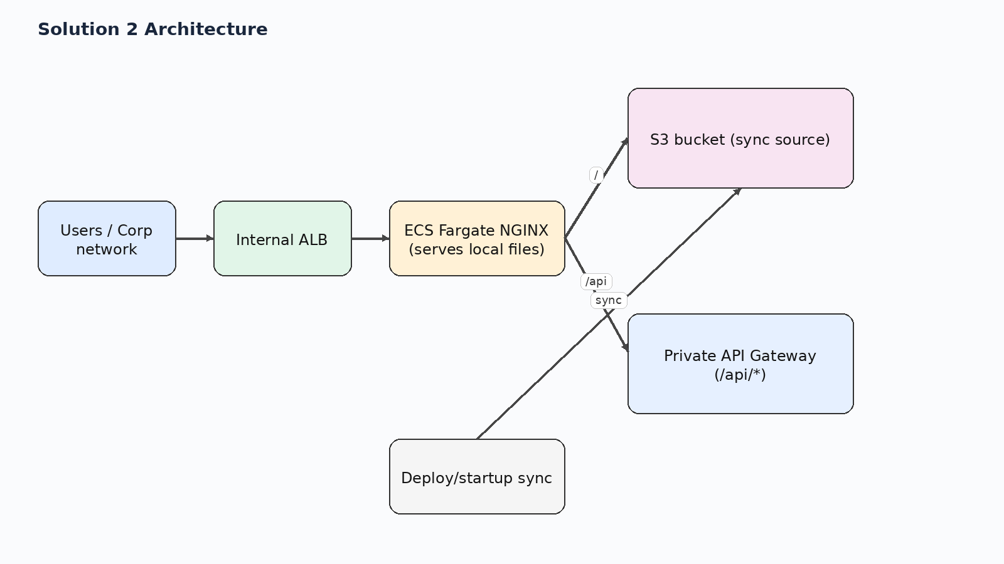
Figure 1. High-level request path for solution 2.

1. Executive summary
S3 is the source of truth for the UI package, but NGINX serves files from local container storage after a deployment-time or startup sync. /api/* still proxies to private API Gateway.
Why it sits at this rank: Very strong compromise when S3 must remain the source of truth but you still want web-server behavior and good SPA handling. Slightly more complex than baking artifacts into the image because startup and rollout depend on the S3 sync step.

2. Relative ranking across all five options
Rank | Solution | Option
Best | Solution 3 | ALB -> ECS Fargate NGINX (serves Angular itself) -> private API Gateway
Next to Best | Solution 2 | ALB -> ECS Fargate NGINX (serves Angular locally, synced from S3 at deploy/startup) -> private API Gateway
Good | Solution 1 | ALB -> ECS Fargate NGINX (proxy only) -> private S3 + private API Gateway
Okay | Solution 4 | ALB -> private S3 via S3 interface endpoint for the UI; ALB /api/* -> private API Gateway via execute-api interface endpoint
Avoid | Solution 5 | Private API Gateway -> /web ANY -> Lambda -> S3

This document focuses on Solution 2.

3. Low-level design
- CI/CD uploads the build package to S3. At deploy time or task startup, the container syncs the chosen release into /usr/share/nginx/html.
- Browser reaches the internal ALB and all traffic lands on the ECS/NGINX service.
- NGINX serves local UI files directly and proxies /api/* to private API Gateway.
- NGINX uses try_files to fall back to /index.html for SPA routes.

4. Design scenarios covered
Scenario | What happens
CORS | No browser CORS issue when the app uses relative /api/* paths and NGINX proxies to the private API Gateway.
SPA routing | Covered. Local NGINX files plus try_files provide the cleanest History API behavior for Angular pretty URLs.
Security boundary | Strong. Only the ALB is user-facing; S3 and API Gateway remain private.
Performance | Better than solution 1 because most requests are served from local container storage after sync.
Operational fit | Best when the organization insists that the artifact of record is S3 but still wants normal SPA hosting behavior.

5. Pros and cons
Pros | Cons
Preserves S3 as the canonical artifact store. | Adds a sync/init step during deployment or task startup.
NGINX serves static files locally, reducing per-request latency compared with S3 proxy mode. | Startup failures can occur if S3 permissions, endpoint, or object paths are wrong.
SPA deep links are handled cleanly with try_files ... /index.html. | Rollbacks must manage both application versioning and synced artifact versioning.
Single browser origin avoids CORS when /api/* is proxied. | Slightly more moving parts than baking the compiled UI directly into the container image.
Operationally safer than fetching every static object from S3 at request time.

6. Key design decisions
- Treat S3 as release source of truth but not as the runtime asset server.
- Sync artifacts before NGINX serves traffic.
- Use local web-server fallback for SPA routes.
- Proxy API calls at the same origin.

7. Selected AWS references used for this design
- AWS ECS Developer Guide / Use an Application Load Balancer for Amazon ECS — Application Load Balancer with ECS and path-based routing
- AWS API Gateway Developer Guide / Private REST APIs in API Gateway — Private REST APIs are reachable through interface VPC endpoints
- AWS S3 User Guide / AWS PrivateLink for Amazon S3 — S3 interface endpoints are reachable from on premises over VPN or Direct Connect
- AWS VPC Guide / Gateway endpoints for Amazon S3 — Gateway endpoints do not support on-premises access; interface endpoints do
- AWS Networking Blog / Hosting Internal HTTPS Static Websites with ALB, S3, and PrivateLink — ALB plus S3 PrivateLink internal site pattern
- AWS Prescriptive Guidance / Deploy an API Gateway API on an internal website using private endpoints and an ALB — ALB to private API Gateway via endpoint IP target group

